Stephen C. Rankin
GRA 410 Process Book
stephen.rankin@snhu.edu

SiteMap: Rankinfile Portfolio

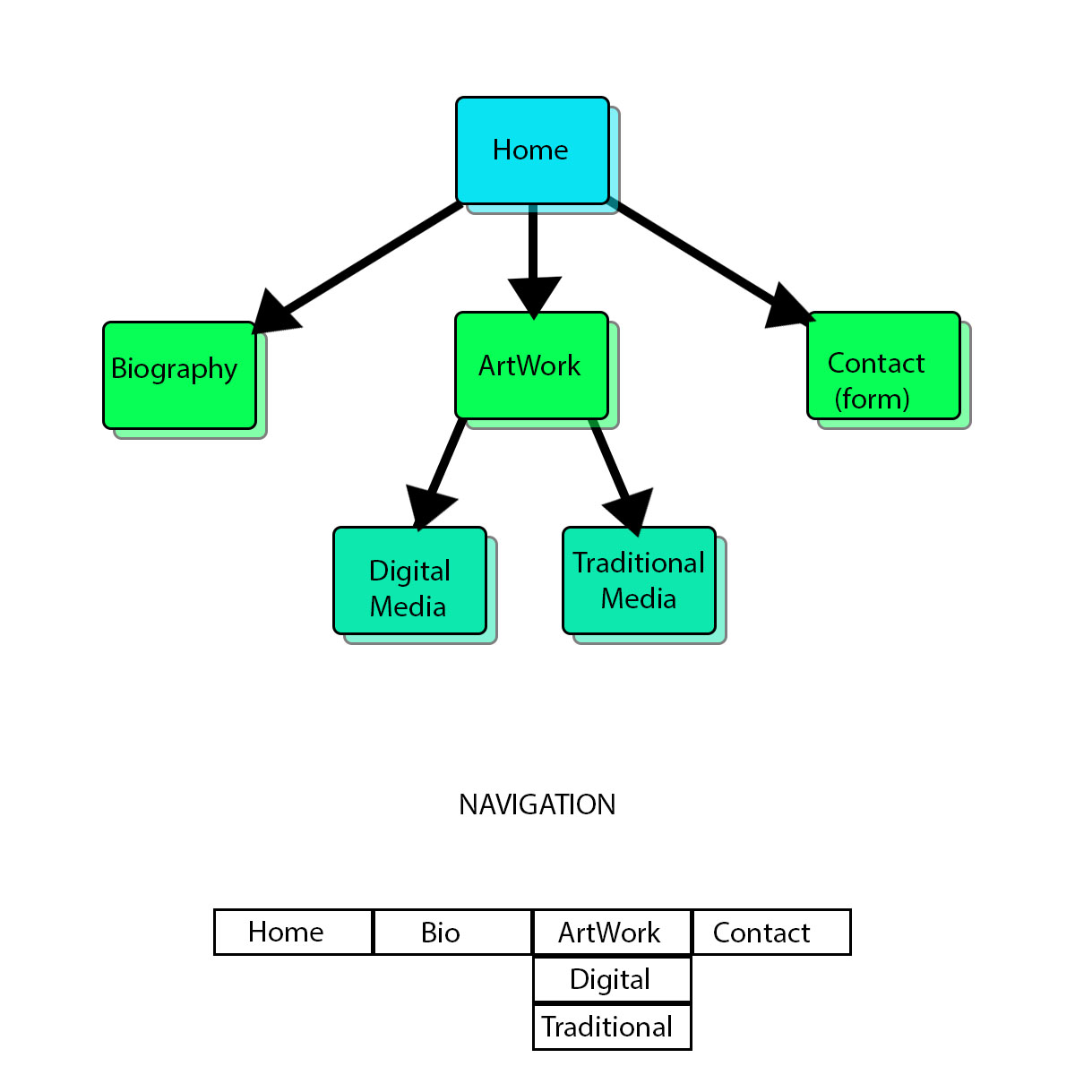

Resume will be contained within part of biography and the biography, digital media, and traditional media will be available as print ready PDF format.

Wireframe for Computer 1024x800 px

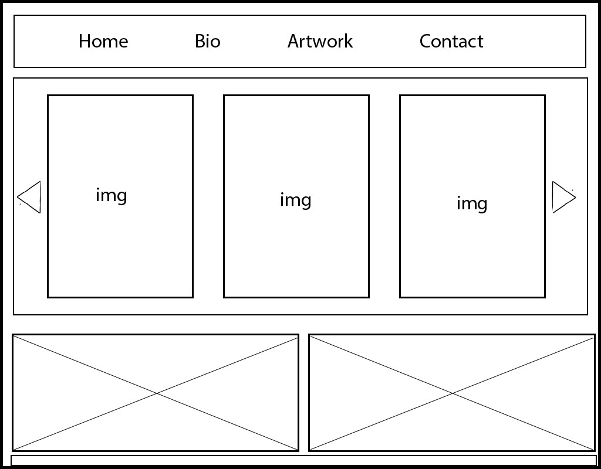

Wireframe for Tablet 768x1100 px

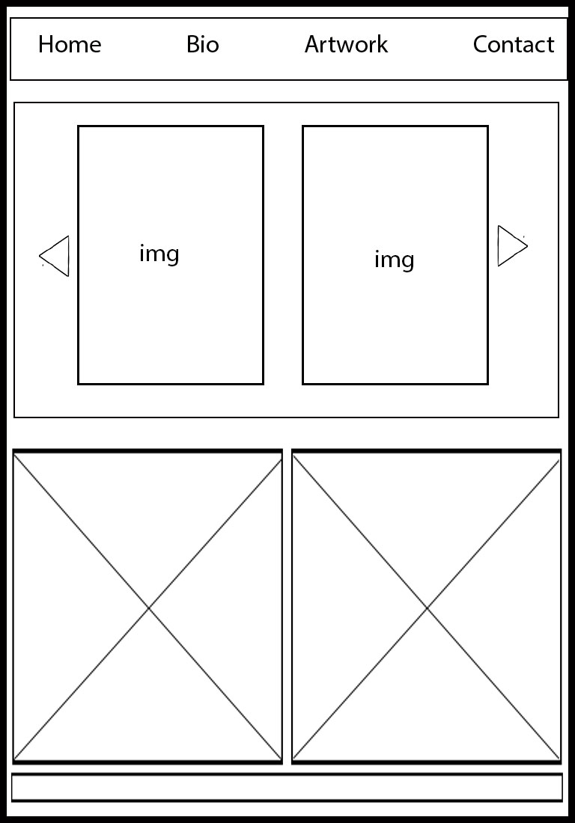

Wireframe for Cellular phone 300 x 600 px

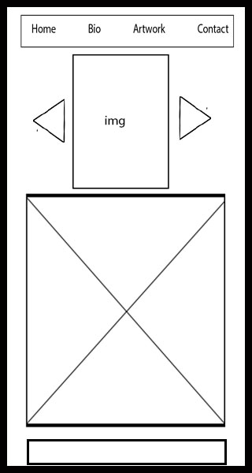

Digital Mock-ups

1024 px x 800 px (Desktop)
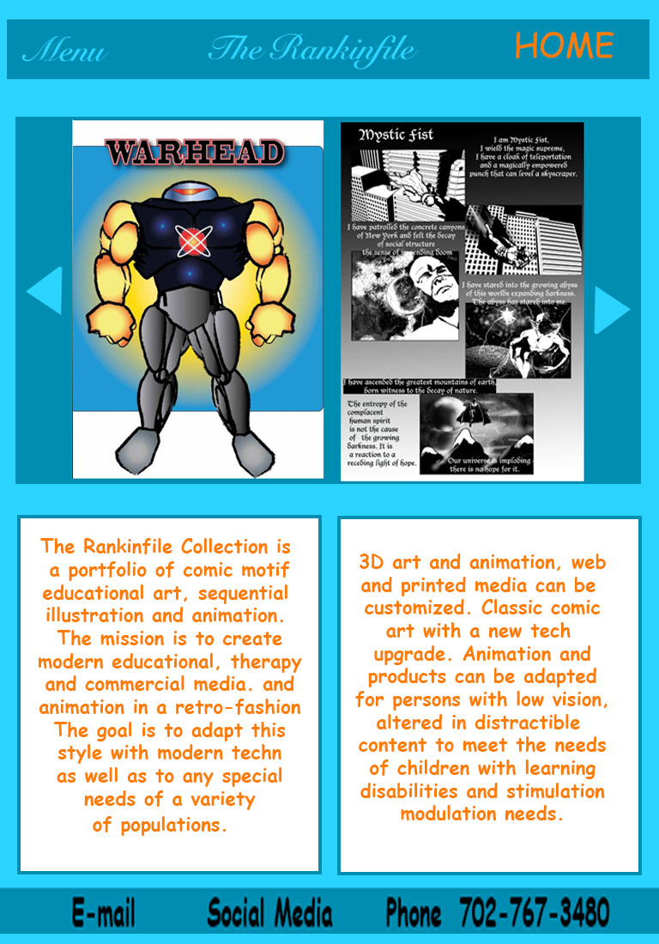

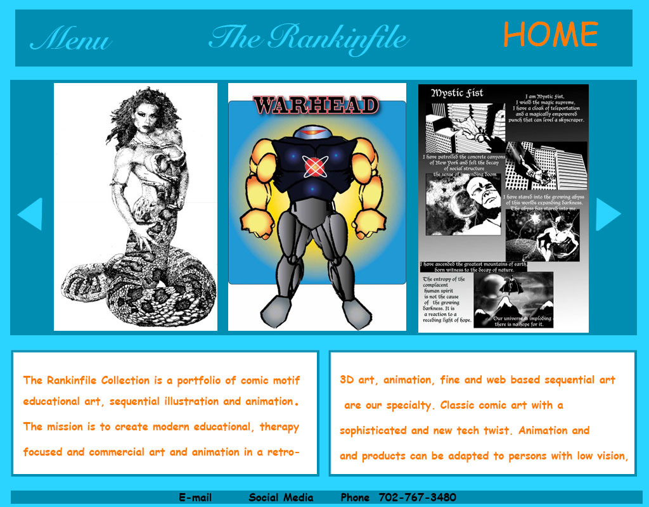
768px x 1100 px (Tablet)

320 px x 600 px (Mobile)

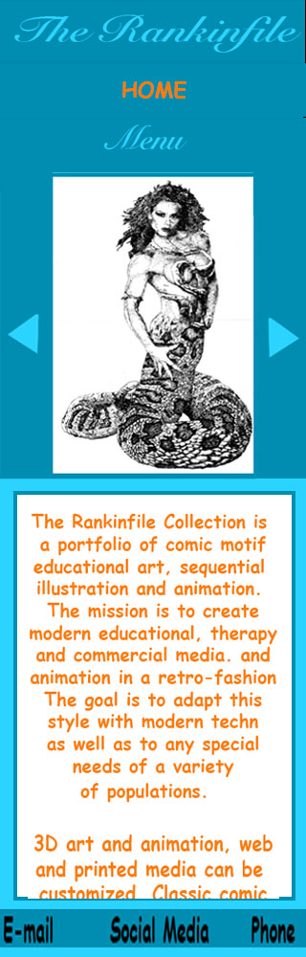

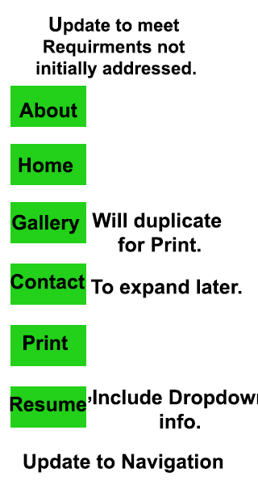

Updates to initial design were necessary as requirements were met. I added contact and dropdown sections to further develop even if they are not contributory to grade.
Altered Pages were made. The initial design was criticized heavily, and my initial design did not
Include the required print and resume’ links. They were added later. See updated
screenshots below:

Printable Materials

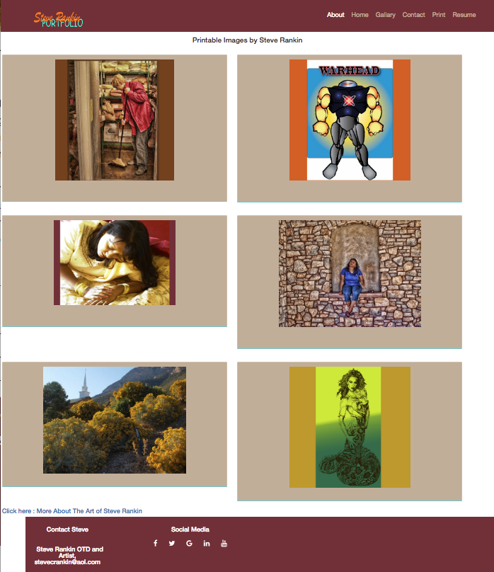

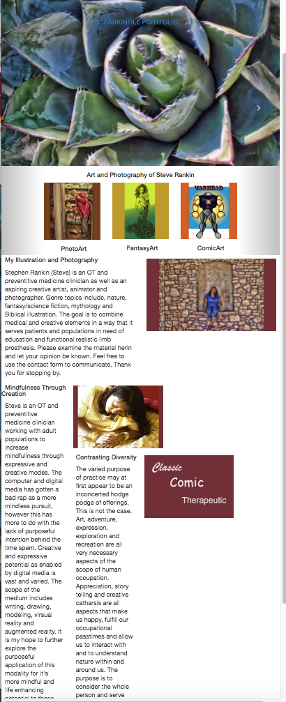

The Homepage, is very different from the original criticized concept and I created necessary navigation and gallery carousel at the top and redesigned to footer to reflect more real world
interface.


A Contact page was included but not really detailed. Modifying that template was not completed but I was not aware it was not a requirement early on.

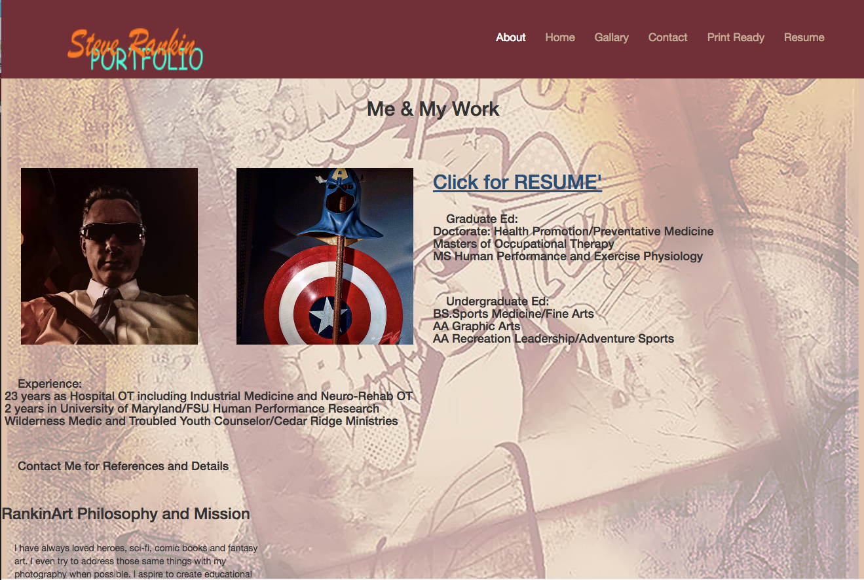

I also had not included the resume’ page in the original design.

Overall my lack of attention to design content requirements and comments by the instructor led to a significant redesign of content and design.

