Taking into account the feedback received in relation to the company wanting alternative software to produce websites and edit the images, I have to provide a server for the company and therefore I have selected an Apple Mac Pro server to try and meet these requirements.
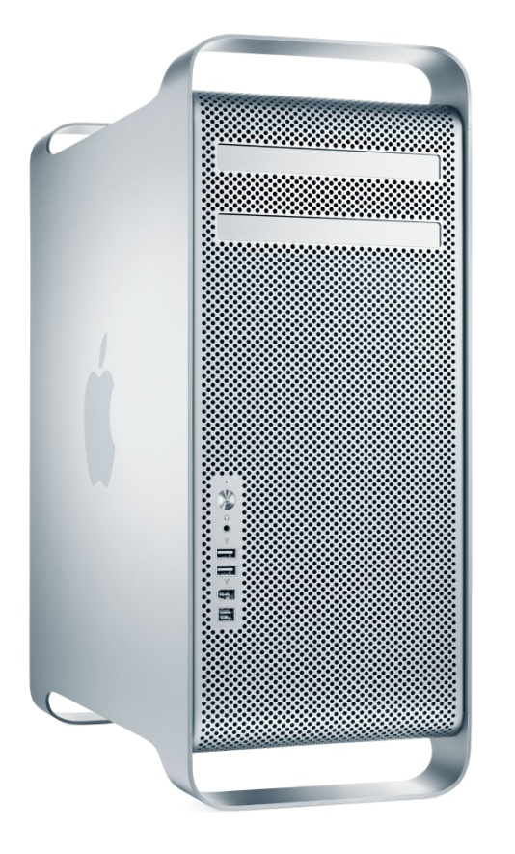
Mac Pro Server

- 12 Intel Xeon “Westmere” core processors
- The speed of the processor is 2.93GHz, allowing functions to be carried out at a high speed
- It has 32GB of memory (RAM), which will allow a large amount of data and information to be stored without slowing other functions down
- It has 4 x 2TB hard drives allowing a lot of memory space and fast functioning abilities
- 2 x Optical Drive (18x double-layer SuperDrive)
- It can be brought with the ATI Radeon HD 5770 Graphics Upgrade Kit for Mac Pro; a graphics card/processor which includes 1GB of GDDR5 memory
- Operating system- Mac OS X Snow Leopard
- It can also be brought with ADOBE Photoshop Elements 9 & Premiere Elements 9, photo and video editing software which will enable the company to edit images and videos in order to customize them to their needs.
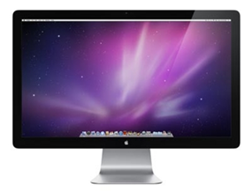
APPLE LED Cinema Display 27" Widescreen LCD Monitor

- -It can be brought with this Apple Led screen, which is 27 inches. This will enable the people working within the company to see the websites and graphics that they are designing in great detail; therefore allowing them to make the necessary changes in order to meet their requirements.

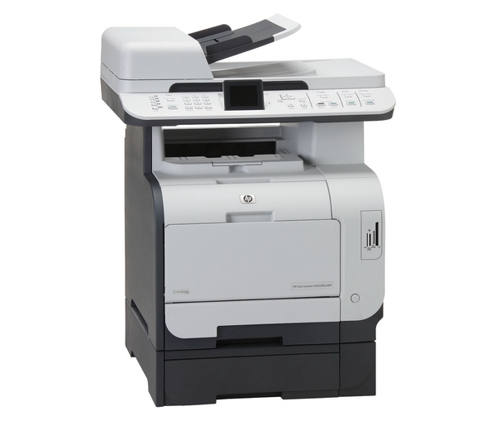
HP LaserJet CM2320fxi Multifunction Laser Printer

- The server can be brought with this multi function laser printer. It will allow the user to print, scan copy and fax documents and has four separate laser ink cartridges, enabling a lot of documents to be printed without the ink running out.
- With it being a laser printer, it will produce high quality images; something that is essential for the company as they specify in high resolution graphics and video.
- Having a multi function laser printer would also be beneficial to the company as it will save them time and money; they wouldn’t have to look for separate scanners and fax machines, which could be essential for prototypes and samples to be sent to clients that are hiring them to design a website.
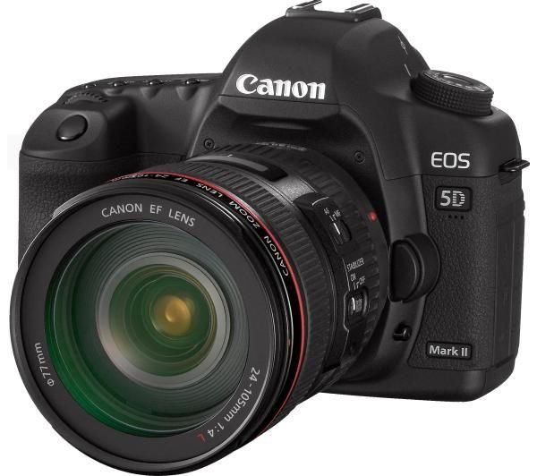
CANON EOS 5D Mark II Digital SLR Camera with EF 24-105mm f4L IS USM Lens

- This camera will be compatible with the server and the computers that are operating with the server as it works with MAC OS X Snow Leopard. It has a wireless function for photos and videos to be transmitted and also comes with its own software, therefore images and videos can be uploaded via an interface.
- The camera has 21.1 mega pixels; enabling the user of it to produce very high quality images; something that is essential for the company as they specialise in high resolution graphics and video.
- The camera can be brought with interchangeable lenses, enabling the user to produce images and videos of a very high standard as they will be able to focus on the subject.

