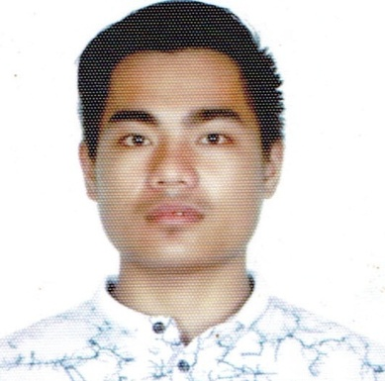
ELMER A. BELIGAN
Brgy. Kadayakan Maria Aurora, Aurora
Contact No: 09087842760
E-mail Address:elmerbeligan@yahoo.com

OBJECTIVES
To work, with full dedication, determination and enthusiasm in order to contribute to the attainment of the vision, mission, goals and objectives of a respectable company where I belong, and achieve an organizational, as well as personal goals.

EDUCATIONAL BACKGROUND
TERTIARY : Bachelor of Science in Computer Science
Wesleyan University-Philippines
2012- On going

SECONDARY : Bayanihan National High School
Brgy. Bayanihan Maria Aurora, Aurora
2007-2012

ELEMENTARY : Kadayakan Elementary School
Brgy. Kadayakan Maria Aurora, Aurora
2001-20067

SEMINARS ATTENDED

September 12-13, 2015 : Responsible Web Development Seminar
Workshop.
September 4, 2015 : SAITE 2015-“Embrace Success, Embrace I.T”
Wesleyan University-Philippines, Cabanatuan City

January 17, 2015 : Basic Android Applications Development
Wesleyan University-Philippines, Cabanatuan City

September 07, 2013 : Web Design and Development
Audio Visual Room
Wesleyan University-Philippines, Aurora Campus

September 20, 2012 : Music and Video Editing
Audio Visual Room
Wesleyan University-Philippines, Aurora Campus

PERSONAL BACKGROUND
Age : 20 yrs. Old
Gender : Male
Birth-date : Auust 24, 1995
Birth-place : Brgy. Kadayakan Maria Aurora, Aurora
Civil Status : Single
Religion : Roman Catholic
Citizenship : Filipino

CHARACTER REFERENCES

Rev. Nerissa S. Palafox
University Chaplain
Wesleyan University-Philippines
Maria Aurora, Aurora

Dr. Ferdinand E. Romano
OIC-School Administrator
Wesleyan University-Philippines
Maria Aurora, Aurora

Prof. Marlon M. Sumait
Program Coordinator
College of Computer Science
Wesleyan University-Philippines
Maria Aurora, Aurora

I hereby certify to the correctness and appropriateness of the above information.

ELMER A. BELIGAN

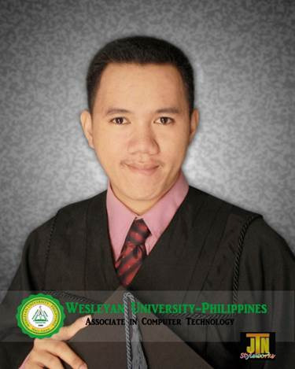

RONNEL TAGARE BERGANTIÑOS
Brgy. 02 Maria Aurora, Aurora
09087842760
E-mail Address:ronnel_0098@yahoo.com

_________________________________________________________________________
OBJECTIVES
To work, with full dedication, determination and enthusiasm in order to contribute to the attainment of the vision, mission, goals and objectives of a respectable company where I belong, and achieve an organizational, as well as personal goals.

EDUCATIONAL BACKGROUND
TERTIARY : Bachelor of Science in Computer Science
Wesleyan University-Philippines
2012- On going
Associate in Computer Technology
Wesleyan University- Philippines
2012- Graduate

VOCATIONAL : Computer Hardware Servicing (NC-II)
Maria Aurora Skills Development Center

SECONDARY : Maria Aurora National High School
Brgy. San Joaquin Maria Aurora, Aurora
2006-2010

ELEMENTARY : Wesley Kiddie Development Center
Brgy. 02 Maria Aurora, Aurora
2000-2006

SEMINARS ATTENDED

September 12-13, 2015 : Responsible Web Development Seminar
Workshop.

September 4, 2015 : SAITE 2015-“Embrace Success, Embrace I.T”

January 17, 2015 : Basic Android Applications Development
Wesleyan University-Philippines, Cabanatuan City

September 07, 2013 : Web Design and Development
Audio Visual Room
Wesleyan University-Philippines, Aurora Campus

September 20, 2012 : Music and Video Editing
Audio Visual Room
Wesleyan University-Philippines, Aurora Campus

PERSONAL BACKGROUND
Age : 22 yrs. Old
Gender : Male
Birth-date : MARCH 15, 1993
Birth-place : Brgy. 02 Maria Aurora, Aurora
Civil Status : Single
Religion : Pentecostal
Citizenship : Filipino

CHARACTER REFERENCES
Rev. Nerissa S. Palafox
University Chaplain
Wesleyan University-Philippines
Maria Aurora, Aurora

Dr. Ferdinand E. Romano
OIC-School Administrator
Wesleyan University-Philippines
Maria Aurora, Aurora

Prof. Marlon M. Sumait
Program Coordinator
College of Computer Science
Wesleyan University-Philippines
Maria Aurora, Aurora

I hereby certify to the correctness and appropriateness of the above information.

RONNEL TAGARE BERGANTIÑOS

