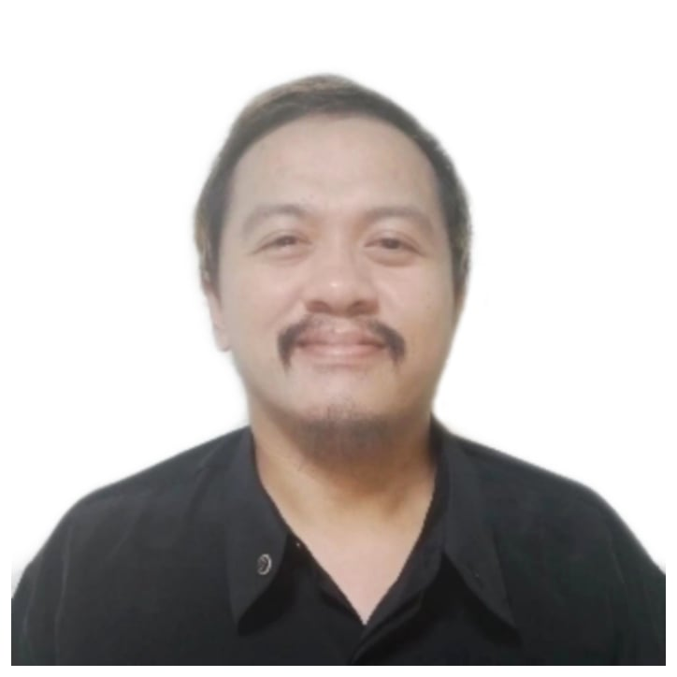
E.Sabellano St. Quiot, Cebu City
+639224290375

Summary
Prepare a rought cut, or commonly known as an assembly edit, of the program/film. This enables me to determine the exact cutting for the next and/or final output of the video.
Reorder and fine-tune the content. This ensures that there is logical sequence in the final film/video.

Renato M. Mahilom Jr.

Highlights
- Able to assemble raw footage with camera shots, either recorded or transferred onto video tape to prepare inputting into the computer.
- Able to cut digital files to put together the sequence of the film. Doing so enables me to decide what is usable in the final output.
- Knowledgeable with Adobe Indesign, Photoshop and other related tools
- Highly developed English verbal, written and interpersonal communications skills
- High organizational skills - ability to set well-considered timelines and to meet the agreed deadlines
- Can ensure compliance with company guidelines and design standards

Experience
SELF-EMPLOYED (OWNED COMPUTER BUSINESS)
CEBU , PHILIPPINES
- More than 5 years computer technician
- I have more than 4 years experience in video editing. I also freelanced in some web page design projects.
- Provided technical assistance and resources on a regular basis.
- Excellent client service history
- Reliable for completing projects on time and accurately

COMPUTER TECHNICIAN
CEBU , PHILIPPINES
- Fluent in tools necessary for installing patches and updates.
- Installed and maintained computer operating systems hardware and software packages.
- Maintained and updated Windows operating system monitors platforms and network infrastructure.

Education
BACHELOR’S DEGREE – COMPUTER SCIENCE
University of Cebu
MECHANICAL ENGINEERING
Cebu Institute of Technology - University

