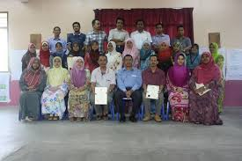

SMK Pelong consist of 36 teachers. Most of them are graduate teachers with wide experience in teaching. The teachers are very helpful and dedicated to ensure the success of the students both in academics as well as curriculum.

MAIN PAGE

