SMK PELONG
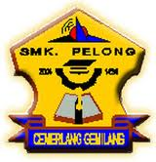

SMK Pelong is located in Setiu, Terengganu. It is a single session school with 16 classes. It is surrounded with greeneries; beautiful plants and flowers. I love my school very much.

MAIN PAGE

