PRAMOTH.R
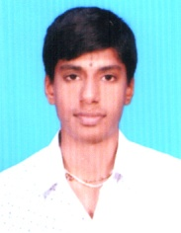
B.E., ELECTRONICS &COMMUNICATION ENGG.
11, SHESHADRI STREET, RENGA NAGAR,
SRIRANGAM, TRICHY-620006.
Mail: karthikpramodh7@gmail.com. PH: 9159348847
OBJECTIVE:
To pursue a challenging career by exploring my technical skills and creativity with strong team work, thereby navigate towards the goal.
HIGHLIGHTS:
- http://www.geocities.ws/pramodh/ Group of webpages which exhibits my interest on web design, a simple creation.
- ‘A’ grade in a BUSINESS ENGLISH Program conducted by INFOSYS.
- Five days vocational training on fiber optics based TELECOM TECHNOLOGIES in BSNL, Trichy.
KEY CHARACTERISTICS:
- Mission-driven
- Resilience
- Effective Communication
- Innovation
ACADEMIC QUALIFICATION:
Jayaram college of Engg., & Tech., B.E., Electronics&communication Engg.
Thuraiyur, Trichy (2011-2015) 7.0/10 (up to 6th semester)

The Higher Secondary School for Boys, HSC - Science Stream (2010-2011)
Srirangam, Trichy 82.25%

Sree Vaijayanthee Vidyalaya Matric Hr., SSLC- Matriculation (2008-2009) School, Srirangam, Trichy 83.00%
POSTS HELD:
- PRESIDENT-IETE STUDENTS CHAPTER Organized Technical Quiz & soft skill sessions.
- TREASURER -YOUTH EXNORA Budget plan & Funds handling.
- PLACEMENT REPRESENTATIVE Collection, filtration, updation and maintenance of student’s data in huge numbers.
- VICE CAPTAIN-BADMINTON Organized intra college tournaments and fixture scheduling.
ACHIEVEMENTS:
- Presented a paper on “Nuclear Power plant issues” at Oxford Engineering College, Trichy and secured first place.
- Presented a paper on “CLEAN ENVIRONMENT” organized by Rotract club and secured first place.
- Achieved first prize in various non-technical events such as TREASUE HUNT, MARKETING at different venues.
- Won Winner title twice in intra-college BADMINTON tournaments.
CO-CURRICULAR ACTIVITIES
- Star performer on the English drama “HELL’S CHILD” for NAAC and Tamil drama “YAMA’S DATABASE” for cultural
- Anchored college inauguration day, sports meet and hosted numerous events including debates.
- Being the representative of the class ushered to solve the grievances of the students.
- Attended many webinars being a member of MICROSFT STUDENT ASSOSIATE CLUB
- Associated with JRC in school days, endeavored to motivate rural children on education, attended rallies and cleaning programs.
PERSONAL SUMMARY
- Date of Birth : 26-12-1993
- Sex : Male
- Father : Raman. V
- Mother : Ramadevi.R
- Languages : English(SRW), Tamil(SRW), Marathi(S), Kannada(S).
- Native : Trichy, Tamilnadu.

DECLARATION
Here by I declare that the above information are true and to best of my Knowledge.
Thank You
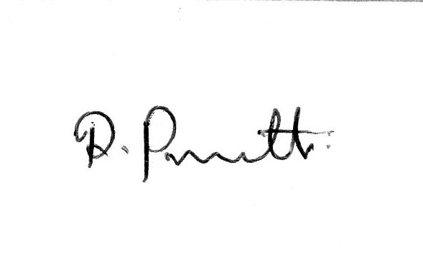 R.PRAMOTH

