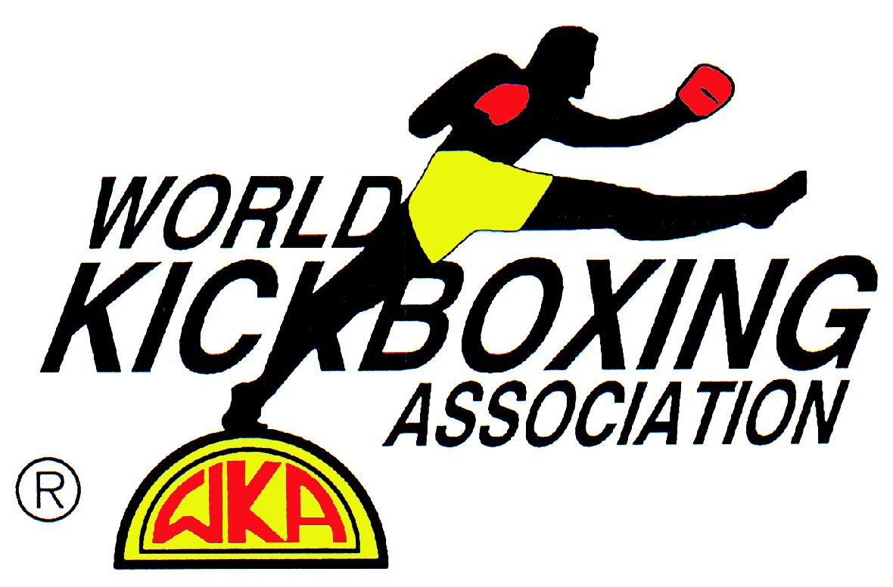 WORLD KICKBOXING ASSOCIATION

NSW REPRESENTATIVE: Paul Grima 28a Hampden Road, South Wentworthville N.S.W. 2145.

Phone / Fax: 96883197 Mobile:0417446438. Email: pitbullkickboxing@email.com

NEW SOUTH WALES NEWSLETTER

ISSUE twenty two

A WORD FROM THE STATE REPRESENTATIVE:
Firstly I would like to apologise for the major delay in the release of this newsletter as I normally have a newsletter ready every two months. The main cause for the hold up apart from a tedious workload of being a trainer, promoter and sanctioning body representative and trying to split my time between Kickboxing and my family, is once again my disillusion with the sport in general. I am find it very hard to motivate myself probably because I am just fed up with all politics and bickering and backstabbing within the industry. Not to mention having to deal with the Department of Sport and Recreation / Boxing Authority of New South Wales and the some what out dated and ridiculous legislation that governs our sport this state THE BOXING AND WRESTLING CONTROL ACT 1986.

Also here are some other examples of my frustrations dealing with the job I do. On Monday the 6th of February the letter below was faxed to the Boxing Authority of New South Wales to be tabled at the next boxing Authority meeting. Which was the next day. I have had no response from this letter, or from follow up phone calls I have made regarding this issue.

Monday 6th February 2006
To the Secretary Boxing Authority New South Wales

Dear Sir

I wish to apply to the Boxing Authority of New South Wales for the opportunity to allow the World Kickboxing Association to sanction Professional Oriental Rules and Muay Thai bouts. The Martial Arts Board of Victoria and also the Boxing and Martial Arts Committee of South Australia sanction these rules. I have researched thoroughly through the New South Wales Legislation, ‘The Boxing and Wrestling Control Act of 1986’ and cannot find anything to state that these types of rules cannot be sanctioned by the Boxing Authority New South Wales and the organization I work for.

I look forward to a positive response from you and your office regarding this issue.
Yours Sincerely

Paul Grima
New South Wales Representative
World Kickboxing Association

On Thursday the 20th April I was at the Boxing Authority / Department of Sport and Recreation of New South Wales to re-register as a Professional promoter and registering a professional fighter from Queensland. While I was there I ask if it was possible to speak with Mr. Sefan Couani who is the new Manager for Regulation and Executive Support for Programs and Partnerships. On at least three occasions Mr. Couani refused to meet with me until I stated I would not leave until my request was granted. Finally Mr. Couani agreed to meet with me but could not answer one of the many questions that were asked of him satisfactorily. My main question being the above letter had not responded to adequately.

I have also had discussions with another gentlemen Mr. Polo Giulbert-Wright as far back as December 1st of last year. I have spoken to Mr. Giulbert-Wright on several occasions regarding these matters after December 1st again with no satisfaction after any of these conversations. One of the tasks I did ask Mr. Giulbert-Wright to do for me was have Mr. Couani send me copy of the rules for professional Kickboxing governed by the Boxing Authority of New South Wales. I did receive a set of rules some weeks later the only problem being that they were the rules for professional boxing not kickboxing. So once again the department shows its incompetence regarding matters concerning our sport.

It’s a sad state of affairs when a government body that governs the professional side of our sport and the Ministers of Sports Office cannot answer justifiable questions from a representative of one of the of the most active Sanctioning bodies in the state. To express your concerns regarding this matter please feel free to call the Boxing Authority of NSW on 9006 3700. The man to speak with is Executive Office Boxing Authority NSW Mr. David Moreland. Or the honourable Minister for Sport Sandra Nori’s office on 92285055.

Disrespectful Behaviour from Corner Crews
Dear trainers again I have received complaints regarding abuse and threats from corner crews to ring officials. So much so that some Ring officials are refusing to work on certain promotion due to this type of incident occurring. If this occurs again the fighter could first have a point deducted and if it continues the offending corner person will be removed from the ring area and possibly suspended from working the in corner for a period of time determined by a panel of senior Ring Officials. If a corner person has a compliant it should be brought to my attention in a civil manner verbally, then put in writing. Insulting current official is definitely not the way to handle these matters.

WKA RING OFFICIALS WORKING ON NON BONA-FIDE organizations promotions

It has been brought to my attention that WKA Amateur Ring Officials have been officiating on non bona-fide Sanctioning Bodies amateur promotions. If this continues these Officials could find them selves excluded from officiating on WKA Sanctioned events. These organizations do nothing to train officials. Neither do they conduct refresher courses to keep current officials up to date with correct judging procedure. My main reason for this apart from being in the WKA rules is that now it is being used against the WKA. For example when there has been a problem with the judging on these particular promotion the sanctioning body representative has said that they are using WKA ring Officials. In most cases the officials were not accredited by the WKA or only one of them was actually an accredited WKA Ring Official.

Industry Participants Accreditation Course
Again I have had many enquires regarding when is there going to be another WKA Ring Officials Course, so the next WKA accreditation for Ring Officials will be on Sunday 2nd July 2006 at the Pitbull Kickboxing & Muay Thai Gym. The address is 28a Hampden Rd, South Wentworthville. This course will help to accredit you as a Ring Official. It will cover the Judging & Refereeing of Kickboxing, Muay Thai and Oriental Rules styles of fighting. It also will educate you in how the Judges score a bout. This helps you train your fighters, when you can explain to them what the judges are looking for in a winning fighter. It will also help add to the dwindling number of Ring Officials there are available. A lot of the people who have done these courses in the past have not yet put their hand up to shadow judge at any of the promotions I have been at. If they haven’t shadow judged real fights, how can I be expected to be use these people as Ring Officials if they are not putting into practice what they have learnt at the course and shown that they are creditable officials. This will also keep our current officials up to date with the correct judging and referring procedure. Current Ring Officials that constantly fail to attend these courses may result in your suspension from officiating on WKA promotions. Everyone in attendance will receive the Official WKA Rule Books, for both Kickboxing and Muay Thai. They will also receive an official WKA Ring Official logo card to keep the promotions they have worked on record. There will also be a multiple-choice test on completion of the course to ensure everyone has an understanding of what is required to make a good Ring Official.

It will start at 9.30am and finish at 5.00pm, there will be break for lunch and sausage sizzle included in the cost. On conclusion of the course each person that attends will receive a Certificate of Attainment and a W.K.A Ring Official’s Polo Shirt. This will also help separate WKA promotions from other organizations that sanction Kickboxing and Muay Thai where the logo can be seen clearly on all our Ring Officials. So I will also need to know your Size to order your shirt well before. The cost is $100.00 and booking can be made, by phoning on Paul Grima, on 0417446438. If you wish to do the course and already have the rulebooks and don’t want another Polo shirt the cost will be $55.00. If you want another Shirt but not the rule books it will cost $75.00.

WKA TITLE BELTS – PRICING JANUARY 2006
*The WKA since early 2000 has been producing quality Title Belts for both Kickboxing and Muay Thai Titles around Australia which have become recognised by fighters by fighters and trainers alike nationwide.

*These belts will continue to be produced in the same high quality materials as in previous years, but unfortunately the manufactures have increased costs noticeably over this six-year period.

*Due to the above plus extra freight costs the costing for belts will be as follows.

KICKBOXING TITLE BELTS:
*State & Eastcoast Title Belts: @ $250.00
*National & Above Title Belts: @ $275.00
THAI BOXING TITLE BELTS:
*State & Eastcoast Title Belts: @ $175.00
*National & Above Title Belts: @ $200.00

All prices include freight costs but 10% GST musted be added.

Results From N.S.W. WKA Promotions:

Super Fight Promotions Waves Night spot 17th february 2006
Cuong Tran from Ultimate Muay Thai Victoria defeated Laurie Lepard from Boxing Works by unanimous decision in a Middleweight Kickboxing bout.
Simon Patmore from Boxing Works defeated Robert Golf from Double Dragon Martial Arts by unanimous decision in a Super Welterweight Kickboxing bout.
Rob Davidson from the Black Butt Gym defeated Shannon White from Team Ink by unanimous decision in a Welterweight Kickboxing bout.
Atdthe Bunjaku from Ultimate Muay Thai Victoria defeated Tony Kerr from Cobra Muay Thai Tasmania by unanimous decision in a Welterweight Kickboxing bout.
Jason Henry from the Black Butt Gym defeated Ahmet Temur from Team Jez by unanimous decision in a Super Heavyweight Kickboxing bout.
Sean Brown from Badato’s Full Force defeated Josh Waine from Team Ink by Majority decision in a Welterweight Kickboxing bout.
Tomas Vysokai from Boxing Works defeated Aaron Ryan from Team Jez by KKO in the second round of a Super Welterweight Kickboxing bout.
Tim Hately from Ultimate Muay Thai Victoria defeated Ashley Ryan from Super-Fight Gym by unanimous decision in a Super Welterweight Kickboxing bout.
Stacey Willis from Full Strength Gym defeated Henry Pinto from Badato’s Full Force by split point decision to capture the vacant WKA Middleweight Kickboxing Title.

Zen Training Centre Panthers Port Macquarie 25th March 2006
Shawn Majeski who is self trained defeated Ben Lazarus from the Zen Training Centre by unanimous decision in a Super Middleweight Kickboxing bout.
Chris Atkins from the Zen Training Centre defeated Ryan James from Bulldog Gym (Manly HQ) by unanimous decision in a Super Bantamweight Kickboxing bout.

James Beard from Bulldog Gym (Manly HQ) defeated Evan Davis from Kumiai Ryu Muay Thai by unanimous decision in a Super Light Heavyweight Kickboxing Bout.
James Vidulich from Kumiai Ryu Muay Thai defeated Kev ‘The Anvil’ Aurisch from Anvil’s Kickboxing & Muay Thai by majority decision in a Light Heavyweight Kickboxing Bout.
Eric Nosa from Bulldog Gym (Manly HQ) defeated Ben Clayton from the Zen Training Centre by TKO in the first round of a Super Heavyweight Kickboxing Bout.
New South Wales WKA Light Heavyweight Kickboxing champion Owen Gardner from Blackbelt Pro successfully defended his title for the first time against former champion Brendan Ponman from the Zen Training Centre with a unanimous decision victory over four rounds.

Bulldog Promotions Manly Leauges Club 07th april 2006
Lee Kelly from Reflex Martial Arts defeated Josh Payne from the Lion’s Den by unanimous decision in a Super Welterweight Kickboxing bout.
Jeremy Webb from K-Box Studios defeated Ty Webber from Crockers Gym by unanimous decision in a Super Middleweight Kickboxing bout.
James Beard from Bulldog Gym (Manly HQ) defeated Dean Ryan from Bulldog Quenbeyan by unanimous decision in a Super Light Heavyweight Kickboxing Bout.
Tanner Siper from White Tigers defeated Jono Nosa from Bulldog Gym (Manly HQ) by unanimous decision in a Super Heavyweight Kickboxing Bout.
Roland Senathirjah from Bulldog Gym (Castle Hill) defeated Marsleno Joseph from Elite Martial Arts by unanimous decision in a Super Welterweight Kickboxing bout.
Eric Nosa from Bulldog Gym (Manly HQ) defeated Bobby Tuimauiluga from Heng Kuai Fighting Arts by majority decision in a Super Heavyweight Kickboxing Bout.
Chris Palmer from Bulldog Gym (Castle Hill) defeated Dean Hudson from Zenith Kickboxing by unanimous decision in a Middleweight Kickboxing bout.
Theo Tsakirakis from the Lion’s Den defeated Matt Langlands from Crockers Gym by KO in the 2nd round of a Super Light Heavyweight Kickboxing Bout.
Peter Shuetrim from Kickboxing Elite defeated Ben Reid from Bulldog (ACT) by unanimous decision to capture the vacant WKA NSW Light Heavyweight Thai Boxing Title.
Morgan Bison from Manly Fight Gym fought to a split draw with Richard Liszikam from Zenith Kickboxing in a Super Middleweight Kickboxing bout.
Andrew Berridge from Kickboxing Elite defeated Duane Sheppard from Black Dragons by unanimous decision to capture the vacant WKA Eastcoast Lightweight Thai Boxing Title

Pitbull Fight Promotions Castle Hill RSL Club 23rd april 2006
Mike Larcher from Northern Dragons defeated Aaron Cheeny from Street Alert Muay Thai by unanimous decision in a Middleweight Kickboxing bout.
Joseph McCuenny from Boxing Works defeated Michael Begley from Pitbull Kickboxing & MuayThai by unanimous decision in a Middleweight Kickboxing bout.
Nick Chiew from Northern Dragons defeated Sid Kapukotawa from the Dandy Fight Centre after the referee stopped the contest in the second round due to injury, in a Super Middleweight Kickboxing bout.
Eidrees ‘The Prince’ Popal from Pitbull Kickboxing & MuayThai defeated Adam Poole from Zenith Kickboxing by KO in the 1st round of a Super Cruiserweight Kickboxing bout.
Jullian Phillips from AKIBO defeated Emmanual Laris from Johnno’s Boxing & Kickboxing by TKO in the 3rd round of a Super Welterweight Kickboxing bout.
Simon Patmore from Boxing Works defeated Andrew ‘Fairy Floss’ Webb from Pitbull Kickboxing & MuayThai by unanimous decision in a Super Welterweight Kickboxing bout.
Chris Atkins from the Zen Training Centre fought to a unanimous draw with Jake Marks from Street Alert Muay Thai in a Super Featherweight Kickboxing bout.
‘Tiger’ Tom Lambert from Northern Dragons defeated Ron Garsuta from Badato’s Full Force by majority decision in a Super Featherweight Kickboxing Bout.

James Briener from Phoenix Kickboxing fought to a majority draw with Reece Lewis from Street Alert Muay Thai in a Super Welterweight Kickboxing bout.
‘Mighty’ Mec Willcocks from Zenith Kickboxing defeated Eddy Button from Boxing Works by unanimous decision in a Welterweight Kickboxing bout.
Clint Little from the Dandy Fight Centre defeated Gareth Rees from Phoenix Kickboxing by majority decision in a Super Light Heavyweight Kickboxing Bout.
Henry Pinto from Badato’s Full Force defeated Jon ‘Chocko’ Desira by majority decision to capture the vacant WKA Eastcoast Middleweight Kickboxing Title.
Jason Baltovska from Super-Fight Gym defeated Michael Badato from Badato’s Full Force by majority decision to capture the vacant WKA Australian Super Middleweight Kickboxing Title.
Jason ‘Mr. Smiley’ Edwards from Pitbull Kickboxing & MuayThai defeated Luke Maddison from Fire & Ice by KO in the 3rd round to win the vacant WKA Australian Middleweight Kickboxing Title.
Tim Drury from 108 Supalek successfully defended his WKA Professional South Pacific Welterweight Kickboxing against Wayne Meade from Lighting Strike Gym by unanimous decision over 10 rounds.

N & J PROMOTIONS Tuggeranong Vikings Rugby Union Club 29th APRIL 2006
Warrick Harrington from Bulldog (ACT) defeated Jamie Faris from AIM Academy by KO in 2nd round of a Super Middleweight Kickboxing bout.
Lara Aloha from Bulldog Gym (Manly HQ) defeated Michelle Sweeny from Bulldog (ACT) by TKO in the 3rd round of a Super Bantamweight Kickboxing bout.
Graeme Crater from Bulldog (ACT) defeated Rick Christy from AIM Academy by unanimous decision in a Light Heavyweight Thai Boxing Bout
Sandy Furner from Fite Right defeated Wendy Dimond from BJC Muay Thai by KO in 2nd round of a Welterweight Kickboxing bout.
Luke Jocovelli from Bulldog (ACT) defeated Dean Ryan from Bulldog Quenbeyan by KO in 1st round of a Cruiserweight Kickboxing bout.

Jeff Boreham from Kyukoshin Karate defeated Terry Rankin from Oh Do Kwan by KO in 2nd round of a Light Heavyweight Kickboxing bout.
Ben Reid from Bulldog (ACT) defeated Adam Beniamini from Bulldog Quenbeyan by unanimous decision in a Super Cruiserweight Kickboxing bout.

Adam Bodycott from Phoenix Kickboxing defeated George Tanevski from Kyukoshin Karate by unanimous decision in a Light Heavyweight Kickboxing bout.
Semisi Vakalahi from Oh Do Kwan defeated Adrian ‘The Terror’ Talbot from The People’s Gym by unanimous decision in a Super Heavyweight Kickboxing bout.
Sharon Anderson from Phoenix Kickboxing defeated Maria Pittigilo from Roin Sage by Split decision in a Super Featherweight Kickboxing Bout.

Nsw promotion DATES 2006

DATE PROMOTER VENUE BODY
9th June Super-fight Promotions Waves Nightspot WKA
10th June Heng Kuai fighting arts Newcastle Panthers ISKA
24 June Phoenix TBA (ACT) ISKA
1st July Holy Trinity Petersham RSL Club WKA
4th August Bulldog Manly Leagues Club WKA
13th August Pitbull Castle Hill RSL Club WKA
9th September Heng Kuai fighting arts Wyong Leagues Club ISKA
16th September Phoenix TBA (ACT) ISKA
29th October Pitbull Castle Hill RSL Club WKA
4^{th /}12th November Heng Kuai fighting arts Newcastle Panthers ISKA
18th November Chan Cronulla ISKA
? November, Bulldog (ACT) Tuggeranong Vikings Rugby Union Club WKA
1st December Bulldog Manly Leagues Club WKA

