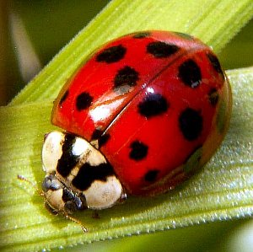Ladybugs
By: Julia Klein
There are many different types of ladybugs. The ladybug that we really know is the seven spotted ladybug.
The ladybug’s life cycle is not much different from a butterfly’s life cycle. First is an egg, next are the larvae, then comes the pupa, last comes the adult ladybug.
Most ladybugs look oval. A ladybug is an insect so it has six legs. Also, the legs are short. The seven spotted ladybug has a shiny red or orange body with black spots. Ladybugs have black heads with white patches on either side.
Most ladybugs eat aphids and other plant eating bugs. Ladybugs lay eggs on leaves where aphids go. When the eggs hatch, the larvae will eat the aphids. This is good for people and farmers. But some ladybugs are not helpful to farmers because they eat the plants.
Ladybugs are colorful for a reason. Their marking tells predators, “Don’t eat me, I taste terrible!” When ladybugs are frightened they let out an oily, disgusting, fluid from joints in their legs. Ladybugs may also play dead.
Ladybugs live in lots of places like grasslands, forests, cities, suburbs, and along rivers. Ladybugs live in Europe and were brought to North America.
Ladybugs make a chattering sound that people can’t hear.
Interesting Information
Ladybugs flap their wings 85 times per second when they fly.
Ladybugs lay 5,000 eggs or more.
As ladybugs get older the color of their spots fade away.

