Type 1:-

How can you Find Job vacancies?
Step 1:- visit in.indeed.com
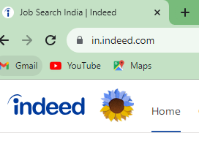
Step 2:- enter your job title for example “digital Marketing Fresher” and choose location as shown below for example Mumbai
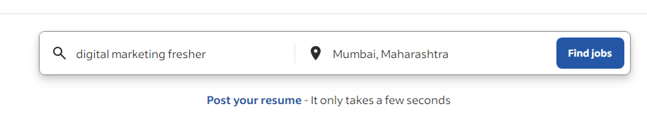
Step 3:-
Then you will see vacancies list and click and apply .
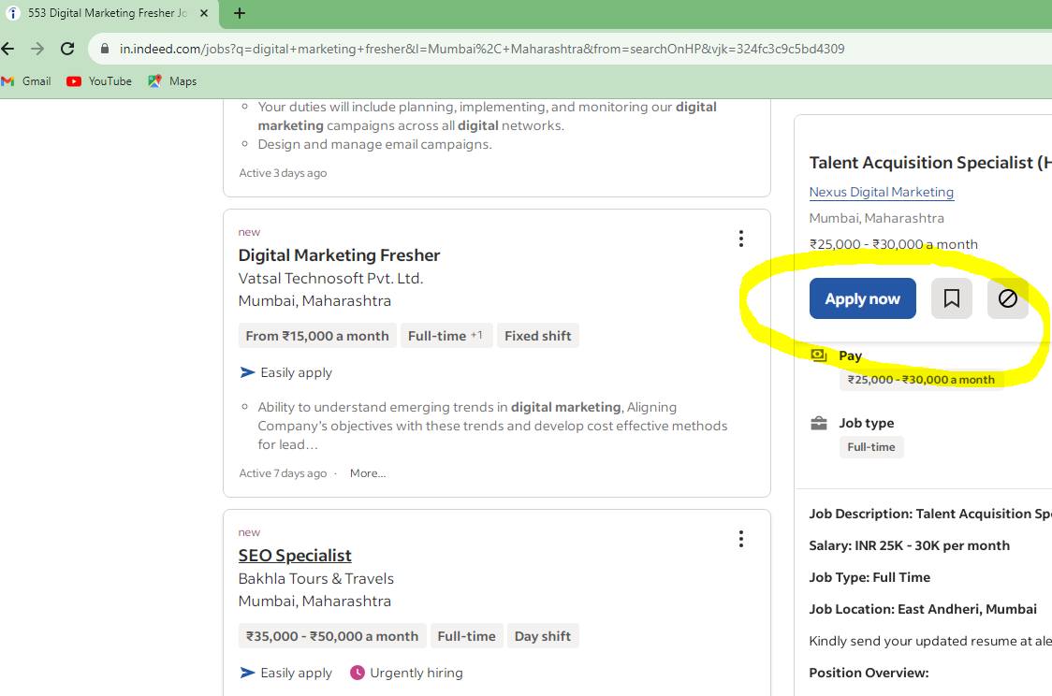

Type 2:-

How to find job on LInkedin.com?

Step 1:- visit linkedin.com/jobs/

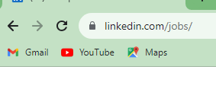
Step 2:- then enter job title for example “digital Marketing Intern “ and then enter location for example Mumbai as shown below then click on search .
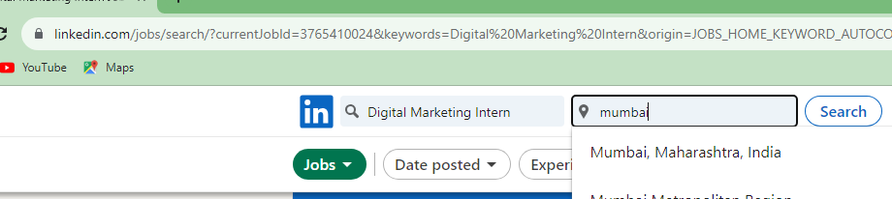

Step 3:-
Finally click on Apply.
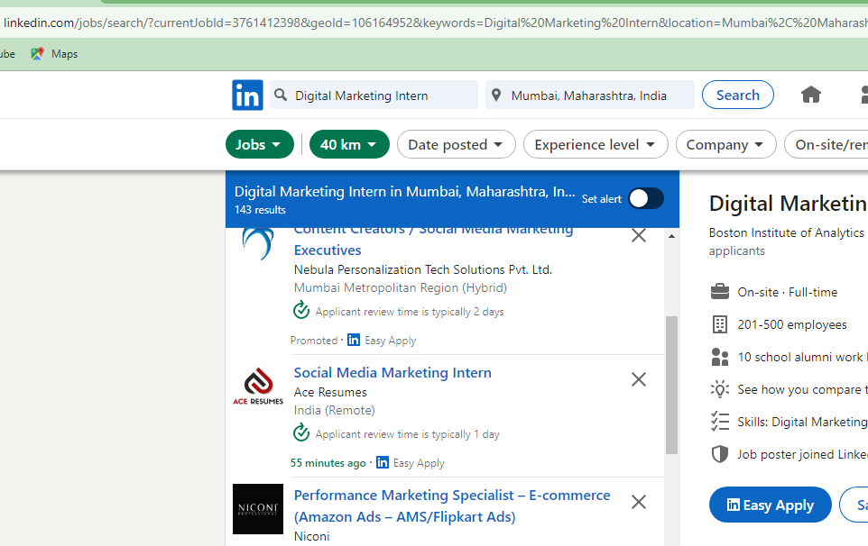

Type 3:-

How to find company list from Google search?

Step 1:-
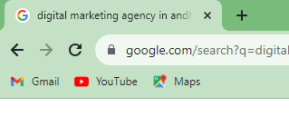
Step 2:- search for company with your topic for example if you are looking for digital marketing company then search
“Digital marketing agency “
As shown below
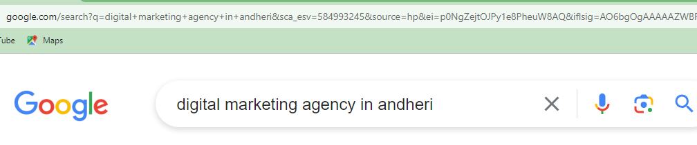

Step 3:-
Visit their website and take contact number and call on it and
Call and start from greetings for example:-
Good afternoon!
And introduce about you that you have completed digital marketing certification.
And looking for Internship in “digital marketing “.

