1)python -m venv env
2)env\Scripts\activate
3)pip install django
4)django-admin startproject my_django_app
5)python manage.py startapp hello
6)python manage.py runserver.

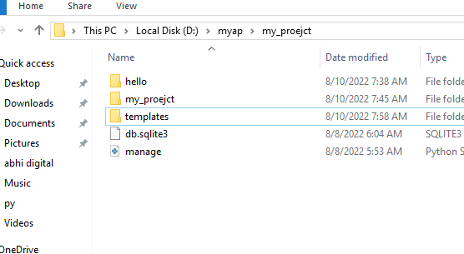

Step 1:-
project folder (my_proejct) urls.py code:-

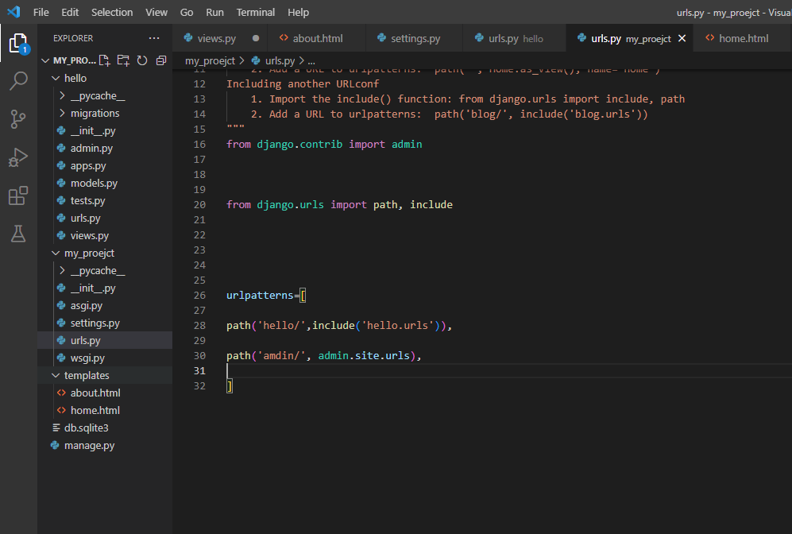

Step 2:-
Urls.py (hello ) app folder code:-
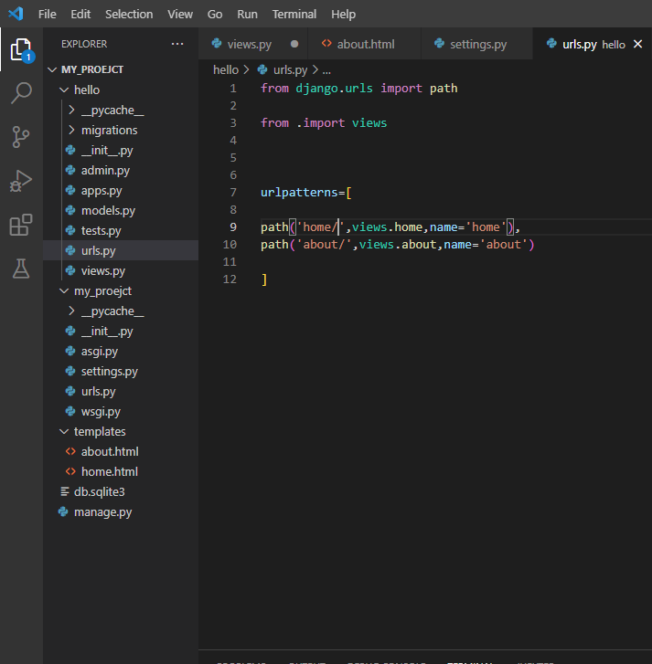

Settings.py file code :-
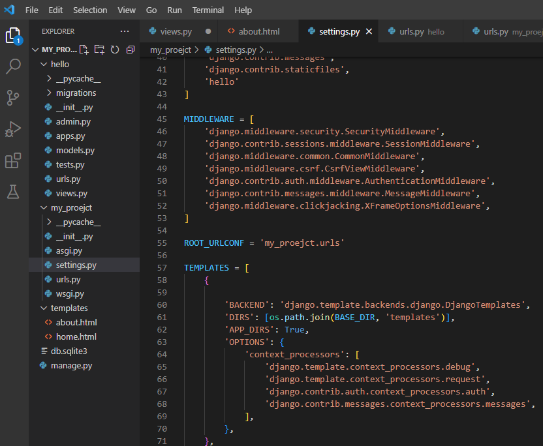

Now views.py (hello) app folder code
:-
