Step 1:- urls.py file code in your app folder :-
from django.urls import path

from .import views

urlpatterns=[
path('',views.index,name='index'),
path('editemp/<int:id>', views.editemp, name='editemp'),
path('updateemp/<str:course>', views.updateemp, name='updateemp'),

]

Step 2:- views.py file code in your app folder:-
from django.shortcuts import render

def index(request):

return render(request, "home.html")

def editemp(request,id):
data={'id':id}
return render(request, "edit.html",data)

def updateemp(request,course):
data={'course':course}
return render(request, "update.html",data)

step 3 :- Create edit.html file in your templates fodler.
{{id}}

Step 4:-
Create update.html file in your templates fodler.
{{course}}

And then run py manage.py runserver in your command prompt or in terminal
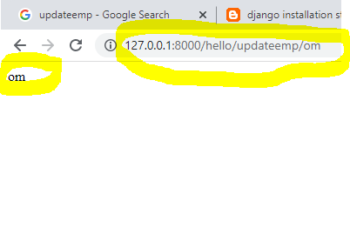
And to check editemp url with id
