Step to install Django open your command prompt and type following step by step
1) python -m venv env
2) env\Scripts\activate
3) pip install django
4)django-admin startproject my_proejct
5)python manage.py startapp hello
6)python manage.py runserver.
After that you will see your proejct sturcture look like this
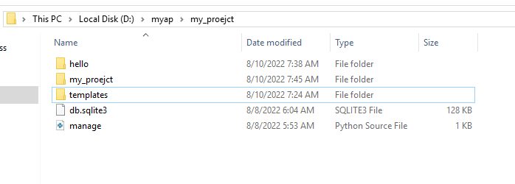

Now coding steps to display record from database tables.

Step 1:-

Write code for models.py fil e:-
from django.db import models

# Create your models here.

class ContactForm(models.Model):
fullname= models.CharField(max_length=100)
email= models.EmailField()
contact= models.CharField(max_length=50)
message= models.CharField(max_length=200)

write code for admin.py file code.
from django.contrib import admin
from .models import contactEnquiry,ContactForm,editupdaterecord

# Register your models here.

admin.site.register(contactEnquiry)
admin.site.register(ContactForm)
admin.site.register(editupdaterecord)

Now run command :-

py manage.py makemigrations
py manage.py migrate

write code for views.py file :-

from django.shortcuts import render
from hello.models import ContactForm,contactEnquiry
from hello.forms import FormContactForm
from django.http import HttpResponse
def home(request):
serviceData=ContactForm.objects.all()
data={'serviceData':serviceData
}

return render(request,"home.html",data)

write code for home.html file :-
<html>
<head>
{% load static %}

<link rel="stylesheet" href="{% static 'ok.css' %}"">

</head>
<body>

<h1 class="myclass">hello world how are you

</h1>
<div>

{% for n in serviceData %}

<span class="{{n.fullname}}"> {{n.fullname}}</span>

<span class="{{n.email}}">{{n.email}} </span>

<p> {{n.contact}} </p>

{% endfor %}
</div>
</body>
</html>

Write code for urls.py file code (under hello app):-
from django.urls import path

from .import views

urlpatterns=[
path('',views.index,name='index'),
path('home/',views.home,name='home'),

]

Write code for urls.py file (my_proejct) folder :-
from django.contrib import admin

from django.urls import path, include

urlpatterns=[

path('hello/',include('hello.urls')),

path('admin/', admin.site.urls),

]

