Step 1:-
create static folder inside your project folder (my_proejct)

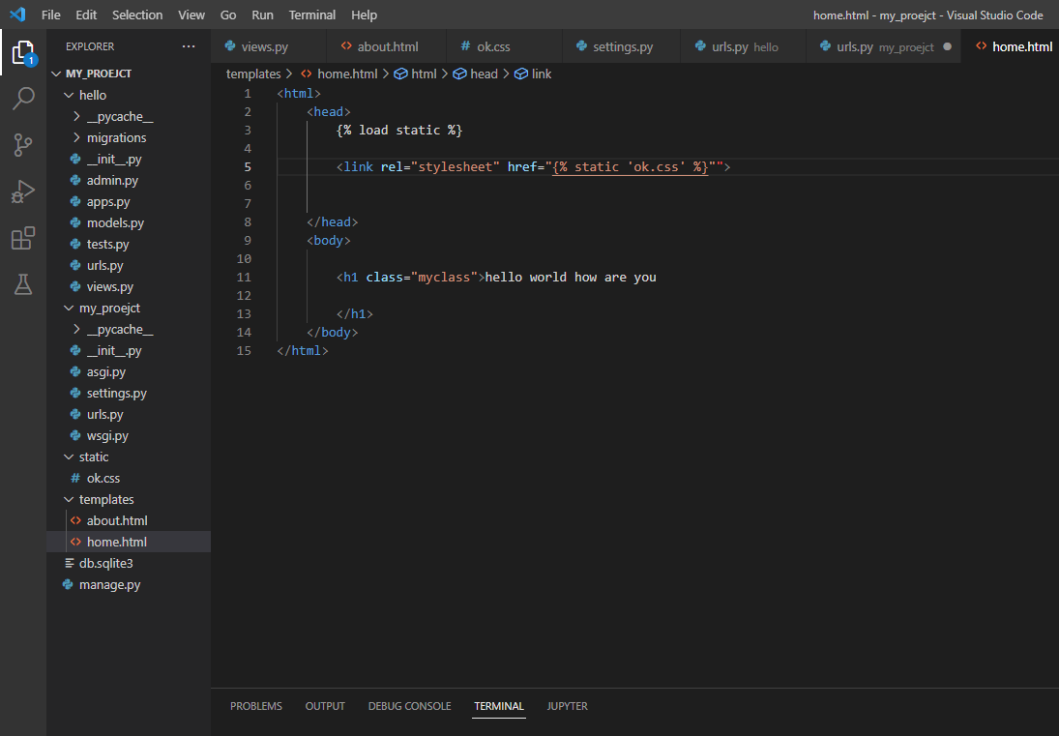
Step 2:-
Create ok.css file under static folder :-
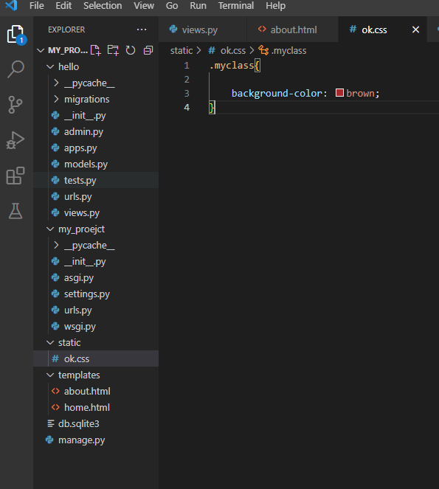

And in settings.py file change following code :-
