Catching Other Hawaiian Reef Fish
By Nicolai Barca
There are many other fish to catch from shore other than ulua, moi, and bonefish. The more commonly caught of these fish are briefly covered in these pages. There are many other types of fish, which are normally speared, not mentioned in these pages.

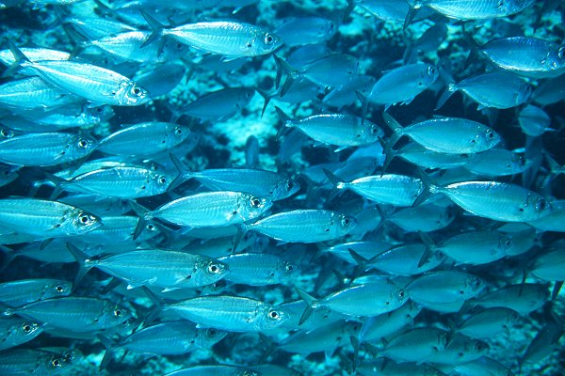
Akule (Big-eyed Scad)
During the summer months, dark clouds of akule can be spotted near the shore in harbors and bays. These schools will often draw a crowd of fishermen hoping to catch some of the popular food fish. Young akule are known as halalu. They are most often caught by whipping grubs and plastic strips behind an egg sinker, but as fishing pressure gets heavy, it is often necessary to make your leader at least 8 feet in length. This is because the lead will spook the school causing them to spread out around it, but with the long leader, the bait will still be in the school where they will hit it. You can also catch akule on bait and a proven night fishing methods is to attach a glow-stick to a bobber with your bait suspended under it. Flesh of nenue, hammerhead shark, and white eel hangs onto the hook very well but many other baits will work. The bobber sits out on the water until a fish takes the bait and pulls the bobber deep under the surface. Akule are good fighters but are small with thin lips so light tackle should be used. Tackle in the 2 to 8# class is adequate and offers a fun fight. Akule are a popular food fish and also make great bait for ulua and kahala.

Large Gamefish

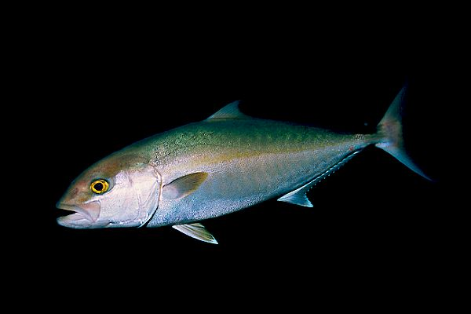
Kahala (Amberjack)
Kahala are commonly caught by ulua fishermen and are almost always present around the akule schools that gather close to shore during the summer months. They will take a variety of baits just like ulua but are rarely caught on lures while whipping. Kahala average aroung 15 pounds but can achive weights of well over 100 pounds. Kahala is good eating but often caries large white worms in the flesh and has a chance of carrying the ciguatera fish toxin. The worms are disgusting but harmless. You can pull them out before you eat the meat and a ciguatera testing kit can be purchased to check for the toxin.

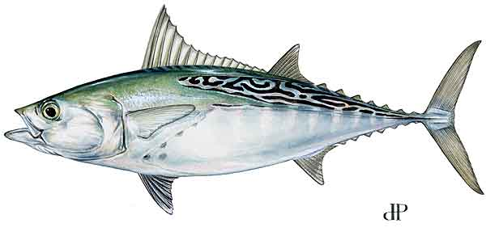
Kawakawa (Little tunny, false albacore, wavy-back tuna)
During the summer months, akule schools can attract kawakawa to the shoreline where they might also feed on oama. Just at daybreak, lit up bright turquoise, kawakawa might be seen prowling the shoreline for oama. Catching one from shore is most often a freak occurrence. They take hooks well and can give the shore fisherman a memorable fight and a surprising finish, as it is not often that one catches a tuna from shore. Bird piles chasing tuna schools, which pass close to shore are likely to be chasing after kawakawa, the only shallow water tuna in Hawaii. Kawakawa mainly inhabit waters of less than 200 feet; too shallow for ahi and aku. They make for good eating, tasting more fishy than ahi but less fishy than aku and are small, averaging 12 pounds. That state record was 22 pounds.

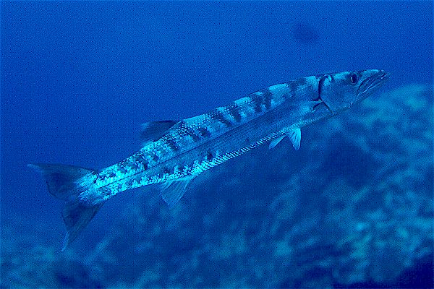
Kaku (Barracuda)
Barracuda are sometimes caught by ulua fishermen and on lures while whipping. Small kaku are common in protected waters such as harbors, brackish estuaries, and shallow reefs. Larger kaku are mostly present offshore but can occasionally be caught from the shoreline. They tend to carry the ciguatera fish toxin making them less desirable as a food fish but still, they make for decent table fare. Ciguatera testing kits can be purchased to check for the toxin.

Nenue and Kala

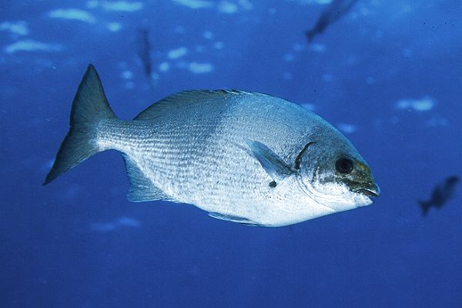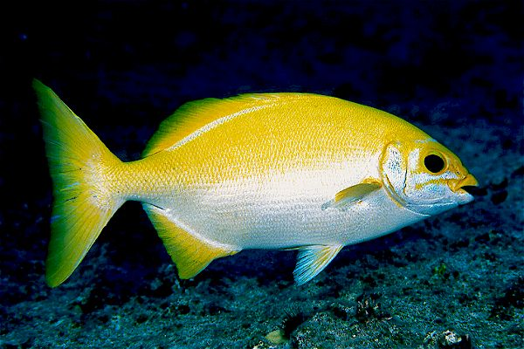
Nenue (Rudderfish, Grey Chub)
Probably the most under rated fish in Hawaii is the nenue. Regarded as a junk fish by most people, the nenue is not the anything special in terms of eating qualities and is very easy to spear, but hook one on rod and reel and you are in for a battle. They eat limu (seaweed) and can be caught while using limu kala as bait. They can also be chummed up and caught on bread and will occasionally take other baits such as crab leg, shrimp, tako leg, and squid. They can grow to weights of over 10 pounds and average around 4 or 5 pounds. Their strength, teath, and their habit of running your line around rocks when hooked makes them a difficult fish to catch. Catching a 5 pound nenue makes you a good angler in anybody’s book. Line should be at least 15# with a heavier leader to protect againts their teeth which can sometimes bite your line instantly. Limu can be free drifted, weighted, or suspended under a bobber, whichever you prefer. Find the limu kala and you are likely to find nenue. They are present on all reefs and even though they are primarily day feeder, they sometimes bite at night. Nenue make good poke and can make a quick meal on the beach by simply tossing them in the fire, pealing off the skin, adding some salt and soy sauce, and picking the meat right off the bones.
The nenue also will school up around the rare golden nenue, which is believed to be the queen nenue. If you happen to catch a golden nenue, please let it go. I have caught 3. Keeping the queen nenue is looked down upon, could bring you bad luck, and breaks up the school. Though another nenue will turn golden to replace the other.

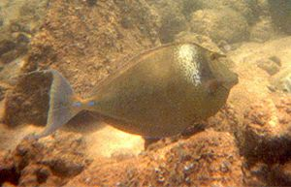
Kala (Unicorn fish)
The feeding habits and size of kala are very similar to that of the nenue except that they only eat sea weed. They have rough skin like a shark, a horn on their forehead, and knives on their tail making them a unique fish. They are good eating and commonly shot by spear fishermen. They fight very similar to the nenue and will also run into rock caves where they jam themselves into holes. They will appear to be stuck but give them a minute and they will come out. Another sign that you have a kala on is if you feel them hitting the line with their horn. Kala are good eating.

The Goafish Family

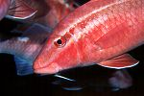
Kumu
One of the better eating of the reef fish is the Kumu. Unlike other members of the goatfish family, they are largely nocturnal and grow to some good sizes averaging 2 pounds. Dunking baits on reefs or around boulders is the way to catch them, but they are a difficult fish to find. You need to know where to fish and a lot of luck is involved. They are more often caught while spear fishing than they are caught on rod and reel.
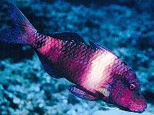
Moana can be easily caught while whipping on reefs. They are small fish averaging 6 or 7 inches in length and take lures and bait well. They make good ulua bait and are small but good eating.
Moana-kali and Moana-Kea (not shown), like the kumu, are not as common as the moana but average larger. They sometimes are even caught while whipping for ulua but are caught purely by chance.

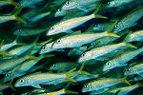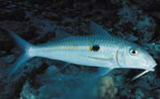
Oama and Weke
Oama is the name of the baby weke which school up in the shallows during the summer months. They are caught on small hand poles with 1 and 2# line. Very small strait-shank hooks should be used and a container should be handy to put the fish that you catch into. Small bits of shrimp tail, crab leg, or the flesh of the oama it’s self should be used. The oama can be deep fried whole but are also the best papio bait around and there are few fish that can resist them. Oama are 3 to 5 inches in length; any larger and they are considered weke.
Weke are found in sand environments or sand pockets in the reef. They school up and are a common fish to see while diving. However, catching them on a rod requires the dunking of shrimp or crab meat on light line. They average around 10 inches and are excellent fighters for their size. Weke are not a common fish to catch unless you are trying directly for them. They tend to be line shy as well so 2 to 6# line should be used in order to draw a strike. They are sometimes caught while whipping small lures but not often.

Aholehole, Menpachi, and Aweoweo

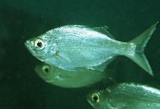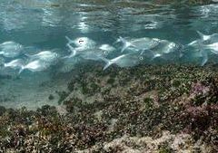
Aholehole (Hawaiian Flagtails)
Aholehole are common fish throughout Hawaii’s inshore water. They inhabit tide pools, brackish estuaries sandy shorelines, rough surf, and in caves. Large flagtails known as ahole move into the surf break to feed at night and hide in tidal pools and caves during the daylight hours. These can be up to and over 1 pound but most will likely be around 6 inches in length. The smaller aholehole can be found taking shelter close to the shoreline and are also present in brackish estuaries and up rivers. Ahole are commonly netted and speared during the day when they hide in caves but they also take bait well. They are often caught while whipping for menpachi and aweoweo, which are found in the same areas. They can also be caught with a bobber and glow stick, dunking rigs, and on the same whipping rigs as menpachi are caught on. At night, a lantern lowered close to the water can draw fish in. Crab, shrimp, squid, and sand turtles work good for bait. Smaller aholehole love bread.

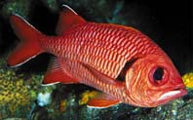
Menpachi or U’u(Soldierfish)
These nocturnal fish are great eating and make good ulua bait. Menpachi average 6 inches but can grow to well over 1 pound. They live in the reef during the day and feed on small fish, bugs, and crustaceans at night. They can be caught while whipping small flies, curlytail grubs, and plastic strips a few feet behind an egg sinker. On dark nights, they sometimes can be caught with bait under a bobber and glowstick. A lantern can be lowered close to the water to attract bugs, which will attract all three fish: aholehole, aweoweo and menpachi. Long 13’ poles with light line called “menpachi rods” are used and can cast a small weight a long distance.

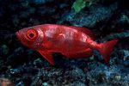
Aweoweo
Aweoweo are very similar to menpachi in their habits and how they are caught. They might average somewhat larger and on occasion, can grow much bigger in size.

Perch

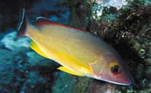
To’au
To’au were introduced many years ago and have since become a welcomed catch for most fishermen. They averaging just under a pound and can grow to some nice sizes with the state record being 4lb 2oz. To’au put up a good fight and can give you some action while waiting for the moi and o’io to bite. Try dunking baits like shrimp, squid, crab, and sand turtles. They are found almost everywhere but prefer some sand mixed with reef or rocks. They are also found up brackish water estuaries, canals, and harbors. River and stream mouths attract a lot of fish and are good places to try. Sandy reef and sand with boulders also hold good numbers of to’au. They are nocturnal but can be caught during the day as well, especially in brackish water. They are really good to eat steamed with ginger and soy sauce.

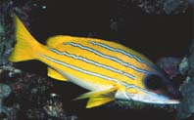
Ta’ape (Blue-lined Snapper)
Unlike to’au, the introduced ta’ape school up and are hated by Hawaii’s anglers. They dominate reefs and can wreak havoc on fishermen who are trying to catch other species of fish. Ta’ape are believed to compete with more desired fish species because of their large numbers and voracious appetite. They come out mostly at night and are easily caught while dunking bait on reefs. They can be fun to catch but a fisherman will eventually get sick of them. They are a good fish for children and tourists to catch. Ta’ape are a little too small to be attractive as a food fish but please, kill as many as you can. The fillets might even make good eating or at least make some decent dried meat. The flesh can be used to catch other ta’ape. Kill ’em, kill ’em all!

Hinalea
Mamo
Kupipi
Po’o pa’a or Opukai
Roi

