printable version

A-chords
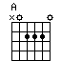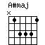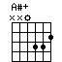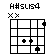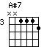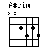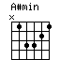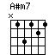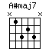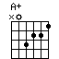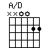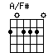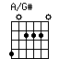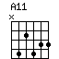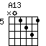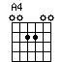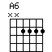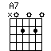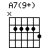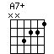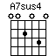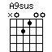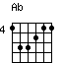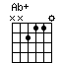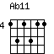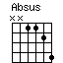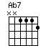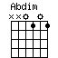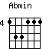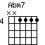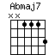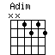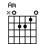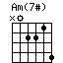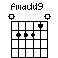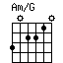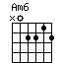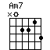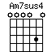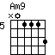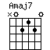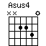

B-chords
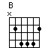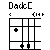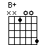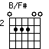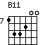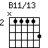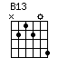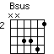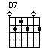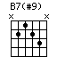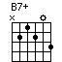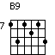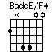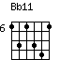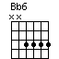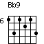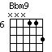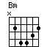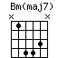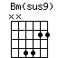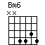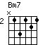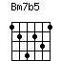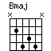

C-chords
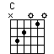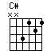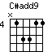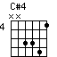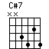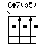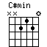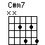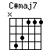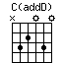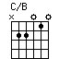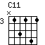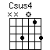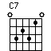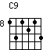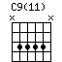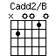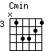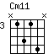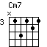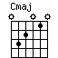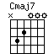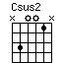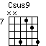

D-chords
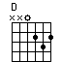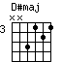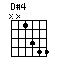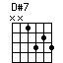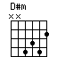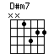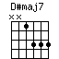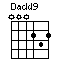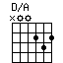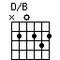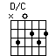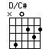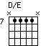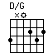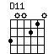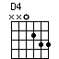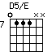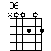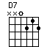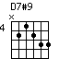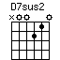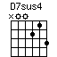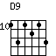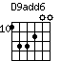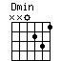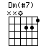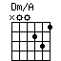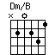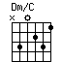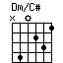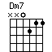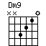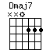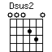

E-chords
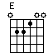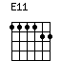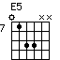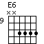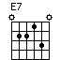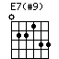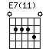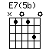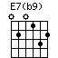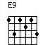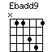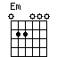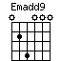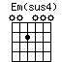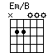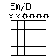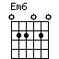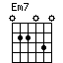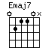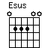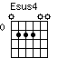

F-chords
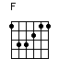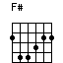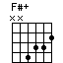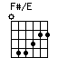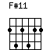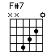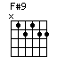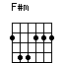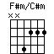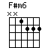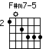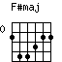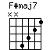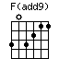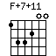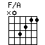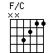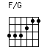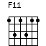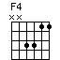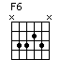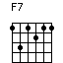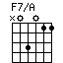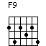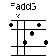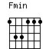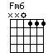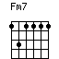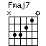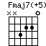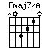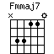

G-chords
