 | D
Take the ribbon from your | hair

 | G
shake it loose and let it | fall

 | A | A7
playing soft against your | skin

 | D
like the shadows on the | wall

 | D
Come and lay down by my | side

 | G
till the early morning | light

 | A | A7
all I'm taking is your | time

 | D | G | D
help me make it through the | night

 | G
I don't care if it's right or | wrong

 | D
I don't try to under | stand

 | E
let the devil take | tomorrow

 | A
'cause tonight I | need a friend

Yesterday is dead and gone

and tomorrow's out of sight

and it's sad to be alone

help me make it through the night

Yesterday is dead and gone

and tomorrow's out of sight

I don't wanna be alone

help me make it through the night

 | A
I don't wanna be | alone

 | G | D
help me make it through the | night

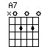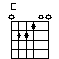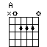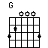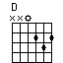  Transpose down one semitone or up one semi tone.
  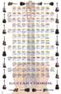
  Buy this Guitar Chord Poster at AllPosters.com

