Northeastern Michigan Association of Horse Clubs

(NEMAHC)

By-Laws
Rules and Regulations

Revised 2008

ARTICLE I – Name, Purpose, and Coverage of Association 4
Section 1 – Name 4
Section 2 – Purpose 4
Section 3 – Coverage 4
Section 4 – Principle Business Office 4
Section 5 – Disbandment 4
ARTICLE II – Membership, Dues, and Voting Privileges 4
Section 1 – Membership 4
Section 2 – Membership Dues 4
Section 3 – Membership and Voting Privileges 4
ARTICLE III – Age Limitations 5
Section 1 – Exhibitor Age 5
Section 2 – Children and Adult Age Divisions 5
Section 3 –Pony Size and Age of Rider 5
Section 4– Leadline Handler 5
Section 5 – Stallion Handler 5
Section 6 – Helmet Required in Speed 5
Section 7– Horses Ages 5
ARTICLE IV – Officers and Delegates 5
Section 1 – Governing Board of the Association 5
Section 2 – Officer and Delegate Eligibility 6
Section 3 – Election of Officers 6
Section 4– Appointment of Officers 6
Section 5 – Duties of Officers 6
Section 6 – Officer and Delegate Vacancy 7
Section 7 – Suspension 7
Section 8 – Exemption From Dues 7
Section 9 – Delegate Appointments 7
Section 10 – Duties of the Governing Board 7
ARTICLE V – Meetings 8
Section 1 – General Membership Meetings 8
Section 2 – Governing Board Meetings (Officers and Delegates) 8
Section 3 – Special Meetings 8
ARTICLE VI – Show Approval 8
Section 1 – Application for Show Dates and Fees 8
Section 2 – Approved Show Privileges and Representation 9
Section 3 – Judge Requirements 9
Section 4 – Showbill Requirements 9
ARTICLE VII – Novice Program 10
Section 1 – Description of Program 10
Section 2 – Eligibility 10
Section 3 – Application 10
Section 4 – Classes 10
ARTICLE VIII – Points 11
Section 1 – Eligibility for Point Accumulation 11
Section 2 – Horses Accumulating Points 11
Section 3 – Point System 11
Section 4 – Point Approved Classes 11
ARTICLE IX – Trail Riding/Driving Program 13
Section 1 - Eligibility 13
Section 2 – Trail Riding/Driving Point Collection 13
ARTICLE X – Awards 13
Section 1 – Annual Awards 13
Section 2 – Certificate of Merit (COM) Awards 13
ARTICLE XI – General Show Rules 14
Section 1 – Entry of NEMAHC Approved Classes 14
Section 2 – Right of Refusal 14
Section 3 – Proper Attire and Tack 15
Section 4 – Use of Entire Ring 15
Section 5 – Leadline Handlers 15
Section 6 – Stallion Handlers 15
Section 7 - Age of Horse 15
Section 8 – Protests 15
Section 9 – Judge Decisions and Decorum 15
Section 10 – Speed Class Official 15
Section 11 – Acceptable Bits and Bosals and Bit Inspections 15
Section 12 – Splitting of Classes 16
Section 13 – Pony Requirements 16
ARTICLE XII – Operating a NEMAHC Approved Show 16
Section 1 – Entry Forms, Closure of Class, and Number of Horses in Class 16
Section 2 – Reporting Points to NEMAHC 17
Section 3 – NEMAHC By-Laws 17
Section 4 – Class Entry Fees and Class Awards 17
Section 5 – Show Committee 17
ARTICLE XIII - Description of NEMAHC Approved Classes 18
Section 1 – Halter 18
Section 2 – Longe Line Yearling 18
Section 3 – English Performance 18
Section 4 – Pony Pleasure 19
Section 5 – Western Performance 19
Section 6 – Gaited Performance 22
Section 7 – Pleasure Driving 22
Section 8 – Speed Classes 22
Section 9 – Showmanship 25
Section 10 – English Equitation 25
Section 11 – Western Equitation – Horsemanship and Stockseat 26
Section 12 – Leadline Equitation 26
Section 13 – Walk Trot Equitation 27
ARTICLE XIV – Amendments to NEMAHC By-Laws 27
Section 1 – Changes to the By-Laws 27
Section 2 – Word Clarifications 27
APPENDIX 1 – NEMAHC Area Map 28
APPENDIX 2 – Glossary of Terms 29
APPENDIX 3 – Pony Height Measurement 30

Footnote: The year that an item has been inserted or amended in the by-laws has been placed in parenthesis in italic.
ARTICLE I – Name, Purpose, and Coverage of Association

Section 1 – Name (1969, incorporated 1988)
This organization shall be known as the Northeastern Michigan Association of Horse Clubs, Inc. It shall be a non-profit organization without capital stock and shall not own property, real or personal. Hereinafter, the name Northeastern Michigan Association of Horse Clubs shall be referred to as Association or NEMAHC.

Section 2 – Purpose
The purpose of the Association shall be to promote, create and stimulate the interest in horsemanship and riding as a recreational activity and to encourage the training of all horses for horse shows, to assist clubs wishing to sponsor point-approved shows, to effect better understanding among those holding competitions and exhibitions and to accomplish the aforesaid purpose without pecuniary gain or profit to any of its members.

Section 3 – Coverage (1992)
The Association shall encompass all counties who are, in whole within the area that is bordered by the south of Ogemaw and Iosco county lines and in part on the west by I-75. These counties being in whole Presque Isle, Montmorency, Alpena, Oscoda, Alcona, and Iosco and in part Ogemaw, Crawford, Otsego, Cheboygan and Roscommon (refer to map, Appendix 1).

Section 4 – Principle Business Office
The principle office and place of business of the Association shall be the home address of the current recording secretary.

Section 5 – Disbandment
In case the Association should disband at any time for any reason, any remaining funds shall be turned over to the U.S. Olympic Equestrian Team fund.

ARTICLE II – Membership, Dues, and Voting Privileges

Section 1 – Membership

a. An Association member shall be defined as any person who has applied for membership on a form provided by the Association, paid the current annual membership fees as an individual or part of a family, and who agrees to abide by the rules and regulations of the Association.
b. Any minor, male or female, may qualify for membership by consent of parents or guardian to become a member therein.
c. A family membership constitutes all adults and children within the family household, unless the children are self-supporting.
d. Riders in Leadline and Walk Trot classes need not be NEMAHC members to accumulate points for awards if sponsored by a NEMAHC member and riding a member’s horse. (1990)

Section 2 – Membership Dues
a. All dues terminate at the end of each calendar year, which ends on December 31st of each year.
b. Regardless of age, an individual may become a member of the Association upon paying membership of $10.00 per year.
c. A family may become members of the Association upon paying membership dues of $20.00 per year.

Section 3 – Membership and Voting Privileges
a. Any person or family can make application for membership upon remittance of proper dues to the Association Treasurer, acceptance of which shall entitle said applicant to privileges not available to non-members including:
1. Eligibility to compete for points at all Association point approved shows and win Association awards.
2. Rule book.
3. Eligibility to attend the Annual Business Meeting with the right to vote on proposed issues, amendments to the rules and regulations, and the election of officers.
A. In a family membership, all members aged 16 years and older shall have voting privileges. (1993)
4. Past year members shall be mailed the first showbill.

ARTICLE III – Age Limitations

Section 1 – Exhibitor Age
For horse show purposes, whatever age you are as of January 1 of the show year, you will ride in that group. Any exhibitor is responsible for his/her age eligibility in any approved event and is subject to forfeiture of entry fees, points, prizes and will be suspended from the approved show of that day upon improper entry.

Section 2 – Children and Adult Age Divisions
a. In showmanship, equitation, and horsemanship classes which are divided by the age of the exhibitor, the divisions shall be as follows:
1. 11 years and under
2. 12 – 15 years
3. 16 – 20 years
4. 21 years and over
b. Lead Line equitation exhibitors shall be 8 years and under.
c. Walk Trot equitation exhibitors shall be 11 years and under.
d. Novice showmanship and equitation shall have no age limitation.

Section 3 –Pony Size and Age of Rider
a. Ponies will be 54" and under with riders 11 years old and under.
b. Anyone over 11 years and riding/showing ponies will compete in their regular age division for showmanship, horsemanship and equitation or the open performance classes. (1978)

Section 4– Leadline Handler (1996)
Lead line handler must be 16 years or older.

Section 5 – Stallion Handler (1999)
All handlers/riders of a stallion, of any age, must be 18 years or older.

Section 6 – Helmet Required in Speed (1999)
Any contestant under eighteen (18) years of age must wear an approved SEI safety helmet in all speed events.

Section 7– Horses Ages
a. Ages of all horses shall be determined as of January 1, starting with one (1) following the year in which they were foaled.
b. Horses six (6) years old and over will be considered Senior Horses. (2000)
c. Horses five (5) years old and under will be considered Junior Horses. (2000)
d. Proof of age will not be mandatory unless to settle a protest. (2000)

ARTICLE IV – Officers and Delegates

Section 1 – Governing Board of the Association
The officers of this Association shall be the President, Vice-President, Recording Secretary, Point Secretary, Treasurer, Certificate of Merit (COM) Secretary, Trail Riding/Driving (TR/D) Secretary, two delegates from the TR/D members group, and two delegates from each member club paying a show approval fee and sponsoring a show during the current year. (2006)
Section 2 – Officer and Delegate Eligibility
To hold office or be a delegate or committee member in the Association, the individual must be a member at the time of election or appointment and a member during the year in which the individual will serve. (1972)

Section 3 – Election of Officers

a. Officers will be elected at either the Annual Business Meeting or the Annual Awards Banquet by a majority vote on private ballot by individual Association members and shall hold office during the ensuing year and until their successors are duly elected. Each member shall be entitled to one vote per issue. No proxy votes will be allowed. Decision as to when the election is to take place is left to the discretion of the governing board.
b. Elected offices include President, Vice-President, Recording Secretary, Point Secretary (1999), and Treasurer.

Section 4– Appointment of Officers
The COM Secretary (1975) and Trail Secretary (2002) shall be appointed by the NEMAHC officers and delegates.

Section 5 – Duties of Officers
a. President: The President shall preside at all Association meetings, perform all duties incidental to such office and such other and further duties as may from time to time be required of him/her by the Association, appoint special committees and cast ballot in case of tie vote.
b. Vice-President: In the absence of the President, the Vice-President shall perform all the duties and exercise all powers of the President.
c. Recording Secretary (1983):
1. The Secretary shall give notice of all meetings and shall take minutes of same.
2. Shall keep the Correspondence of the members.
3. Keep up-to-date a master copy of the official rules and regulations of this Association inserting all new changes voted to approval by the membership. This master copy shall be present at all meetings and a copy issued to all Association participating clubs.
4. The Recording Secretary cannot approve two shows on the same date except at the same location, i.e., double judged show.
d. Point Secretary:
1. Shall keep an accurate record of each member's points and his/her horse's points won at each approved show.
2. The NEMAHC Point Secretary shall keep on hand all the original scorecards for a period of one year and all records are available for inspection by Association members.
3. All records to be kept on file for a period of one year and are available for inspection by Association members.
4. The Point Secretary shall prepare and maintain show committee kits. Use of the kit is mandatory at all approved NEMAHC shows.
5. A final listing of points earned by Association members and member’s horses during the show season shall be mailed to all governing board members by September 10th of each year.
6. Entry/Hold Harmless forms shall be kept on file with the Point Secretary for a period of 5 years.
e. Treasurer:
1. This office shall collect all monies due the Association.
2. Shall have the care and custody of and responsibility for the funds of the Association which shall be deposited in the name of the Association in such bank and shall keep proper and accurate books of account, showing the disposition of all funds that shall pass through said hands.
3. All books shall be open for inspection and examination by the governing board or any committee of members appointed for the purpose.
4. The Treasurer shall make a full report in writing covering the financial condition of the Association at each Annual Business Meeting and at such times as is requested.
5. The treasurer’s and the president’s names will be placed on the checking account.(1985)
6. The Treasurer must maintain the incorporation papers.
7. At the expiration of said term, the Treasurer shall deliver all monies, property and rights of the Association in said hands to the successor to the office.
f. The COM Secretary:
1. Keep records of all NEMAHC members and horses and a running record of all points earned.
2. Records shall be kept by horse's name, owner's name and registration numbers when possible. Grade horses will be recorded by horse's name, owner's name and other distinct markings.
3. Records to be audited at the end of each show season by the NEMAHC governing board and a report given to members.
4. The COM Secretary will keep track of novice points and will notify treasurer when 200 points have been reached in any respective novice class. (2006)
g. The Trail Riding/Driving (TR/D) Secretary (2002):
1. Mail Trail Riding/Driving Log Sheet and instructions to each TR/D member.
2. All completed TR/D Log Sheets shall be returned to the TR/D Secretary.
3. The TR/D Secretary shall calculate each member’s TR/D points for the year and shall report TR/D points to the Association Point Secretary for year-end awards and to the COM Secretary for COM awards.

Section 6 – Officer and Delegate Vacancy
a. Any vacancy in the offices during the year may be filled by appointment of the officers and delegates. The person appointed by the officers and delegates shall fill the vacancy until his/her successor is duly elected.
b. If for any reason said delegates should cease to be delegates, others may be appointed by their represented member club for the remainder of the year and the Association Recording Secretary shall be notified of the same.
c. No temporary/alternate delegate can be appointed for one said meeting to vote. (2006)

Section 7 – Suspension
Any governing board member who fails to attend more than two consecutive meetings without reasonable written excuse may be suspended from office. (2006)

Section 8 – Exemption From Dues
All current year officers, COM Secretary, and Trail Riding/Driving Secretary will be exempt from paying single or family memberships the year(s) they serve. (2002)

Section 9 – Delegate Appointments
a. Each member club affiliated with the Association by the paying of a show approval fee shall be privileged to appoint two (2) delegates to attend all Association meetings.
b. Those delegates must be Association members for the year in which they will serve.
c. A delegate may represent only one member club.
d. The Secretary of each member club shall send to the Association Recording Secretary a certification of the delegates who have been appointed to represent them at all Association meetings for the ensuing year by January 1.

Section 10 – Duties of the Governing Board
a. To propose changes of rules to be acted upon by the members at the Annual Business Meeting. Such proposals are to be in writing and must be approved by a majority vote of the governing board not less than thirty days before the Annual Business Meeting. (2006)
b. The governing board may appoint any eligible individual member to fill any vacancy or unexpired term of any officer, either temporary or permanent.
c. Approve all judges. Approval to be established by majority vote of the governing board.
d. Approve all committees appointed by the President.
e. To manage all affairs, enforce the rules and regulations governing horse shows by member clubs, adjustments of disputes among such members or between such members and exhibitors and such other decisions as they may deem expedient for the promotion of objects of this Association.
f. Members of the governing board have authority to set budgets and shall pre-approve allocations of funds for operations of association with majority vote required. Payment of funds shall be rendered with proper receipts.
ARTICLE V – Meetings

Section 1 – General Membership Meetings
a. There are to be two (2) general meetings of the Association. The Annual Business Meeting shall be held on or before the 20th of March (1985, 2004) and the annual Awards Banquet shall be held between the last show of the season and the 31st of January of the following year (1984, 2005).
b. The Recording Secretary shall give at least 14 calendar days notice to all member clubs and all individual and family members not affiliated with a member club.
c. For purpose of promoting the objects of the Association, the Recording Secretary should send notification of the Annual Business Meeting to all riding clubs and individuals not affiliated with the Association who have during the preceding year shown an interest in the Association.
d. The order of business at all meetings shall be as follows:
1. Roll call of officers and delegates.
2. Reading of minutes of previous meetings.
3. Treasurer's report.
4. Communications and notices.
5. Committee reports.
6. Unfinished business.
7. New or miscellaneous business.
8. Election of officers (Annual Awards Banquet or the Annual Business Meeting). (1978)

Section 2 – Governing Board Meetings (Officers and Delegates)
a. Governing board meetings shall be held at least quarterly throughout the year and at any time upon call of the President or at the request of a majority or more of delegates. (2006)
b. Notice of said meeting is to be transmitted to each officer and delegate by the Recording Secretary at least 14 calendar days prior to briefly state the object of said meeting, with the exception of an emergency meeting in accordance with Article V, Section 3(a).
c. No meeting of the governing board shall be constitutional unless all members of board have been notified of said meeting.
d. At all meetings, a majority of all governing board members officially reported to the Recording Secretary, with the exception of the president, shall constitute a quorum. In the event a quorum shall not be present, such meeting shall be adjourned by the President to a future date, notice of which shall be given at least 14 calendar days in advance to all board members. (1981, 2006)

Section 3 – Special Meetings
a. At the discretion of the President, an emergency meeting to approve horse show dates or judges may be held at horse shows without 14 calendar days notice. (1985)
b. Special meetings may be called by 1/3 (one third) of membership. (1978)

ARTICLE VI – Show Approval

Section 1 – Application for Show Dates and Fees
a. Only a member club or member in the Association may claim to operate an Association point approved show under the rules of the Association.
b. All member clubs or members desiring to sponsor Association point-approved shows will obtain approval by:
1. A written notification of the member club or member’s desire to retain protected show dates must be submitted and received by the Treasurer before the February meeting of the governing board. After the February meeting of the governing board, requests for shows shall also be made by written notification to the Treasurer and will be approved upon availability. If two or more shows have requested the same date, the earliest postmarked request will be granted the available date. (2006)
2. Show approval fees shall be paid to the Association Treasurer by June 30th of each year.
A. Paying approval fee of $50.00 for one day show and $75.00 for shows on two consecutive days, payable in advance, for each member club or member to sponsor an Association point approved show. (2001)
B. A separate approval fee shall be paid for speed shows of $50.00 for one day show and $75.00 for shows on two consecutive days. (2001)
3. Member Clubs, who have in past years had annual shows on certain weekends shall have preference on those said weekends, unless notification is given to the governing board by member club/member. (2006)
4. All show bills and judges must be presented to the officers and delegates for approval at least 45 calendar days before the scheduled show date. (1978)
c. Any member club may sponsor more than one show a year if it is approved by the Treasurer and pays the additional fees.
d. Each member club or member sponsoring a show may elect to have a Halter and Performance Show or a Speed Show or a show that is both Halter/Performance and Speed upon approval of the Association. (1979)

Section 2 – Approved Show Privileges and Representation
a. If a member club’s show dates are not approved and show approval fees paid by June 30th, they lose privileges of delegate representation in the Association. (1985)
b. Member clubs and members paying show approval fee enjoy privileges not available to non-members including:
1. Representation at all Association meetings by two delegates who are both members of the Association.
2. Representation at the Annual Business Meeting and Awards Banquet by Association members who have the right to vote on proposed issues, amendments to the rules and regulations, and the election of officers.
3. Rule book.
4. Date protection of approved shows for two years unless otherwise notified by the member club/member.

Section 3 – Judge Requirements
a. A recognized judge must be selected. Suggested, but not required to be from list of state judges published by MSU and available from the Cooperative Extension Service. (2000)
b. The proposed show judge shall be approved or disapproved by the officers and delegates. (1971)
c. In case of an emergency the President, with the concurrence of 2 delegates, may appoint a judge.
d. A judge may preside at only one (1) Association point approved show every other show year. (1992)
e. As soon as the judge for an approved show is selected, and confirmation is received from the Association Secretary, he/she should immediately be mailed a copy of the current Association Rules and Regulations by the member club or member sponsoring the show. The judge is obligated to adjudicate each class as they appear in the Association rulebook. He/she is expected to be proficient and to possess a thorough knowledge of the rules of the Association.

Section 4 – Showbill Requirements
a. All show bills are to be mailed out to Association members by the member club sponsoring said show at least fourteen (14) calendar days prior to show date. A list of Association members will be provided by the Association Recording Secretary. (1998)
b. The following statements or requirements must appear on all showbills of shows approved by NEMAHC:
1. “NEMAHC Point Approved.”
2. All NEMAHC point approved classes as listed in Article VIII, Section 4.
3. NEMAHC point approved classes must be indicated on the showbill.
4. The approved judge's name for the show must appear on the day's show bill.
5. Telephone number of the Show Secretary.
6. "Exhibitor may be denied privilege of showing if their horse is considered dangerous, or for abusive treatment of their horse, or for unsportsmanship behaviors."
7. “Lead Line handler must be 16 years or older.”
8. “All handlers/riders of a stallion must be 18 years or older.”
9. “Junior Horse: 5 years and under.”
10. “Senior Horse: 6 years and older.”
11. “WARNING, under the Michigan Equine Activity Liability Act, an equine activity sponsor and/or NEMAHC is not liable for an injury to or death of a participant in an equine activity resulting from an inherent risk of the equine activity.”
ARTICLE VII – Novice Program (1996, 2002)

Section 1 – Description of Program
a. The intent of these classes is to encourage a broader equine participation in Northeast Michigan.
b. All general NEMAHC rules apply to Novice exhibitors.
c. Stallions are not eligible for Novice classes.

Section 2 – Eligibility
a. To be eligible for all novice classes, the individual must become a NEMAHC member, pay membership fees, and apply for “Novice Status” prior to registering for any novice classes.
b. Novice classes are not restricted by the age of the exhibitor and are only restricted by showing experience.
c. To be eligible for novice status in each of the novice classes the member must meet the following criteria:
1. Have not accepted money or gifts for showing for someone other than self.
2. May not give riding lessons.
3. May not train horses for someone other than self.
4. May not judge horse shows.
5. May not have earned 200 or more NEMAHC points in any regular age division class, during the past five years, of which you are applying for novice status (showmanship, stock seat equitation or english equitation).
d. If the member shows in Novice classes, he/she MAY NOT SHOW in any “age” division of Showmanship, Stock Seat Equitation, or English Equitation. The novice member may, however, show in any halter or performance class, if desired that the novice member is eligible for.
e. A Novice Card holder may be eligible from year to year depending on the prior year’s success, i.e. if you were to accumulate 200 NEMAHC points or more in any one of the three Novice classes you would no longer be eligible for that novice class the following year, but could be eligible for the other two novice classes.
f. If a Novice Card holder changes divisions and enters a non-novice class in Showmanship, Stock Seat Equitation, or English Equitation, he/she must forfeit all points earned in that Novice class for that year.

Section 3 – Application
a. To enter Novice classes the member must show his/her “Novice Card” to the show secretary when you enter the Novice classes. These cards will be issued by NEMAHC.
b. Members must apply each year for Novice status for each of the three novice classes, therefore, the novice card expires at the end of each show year.
c. If at any time after application for novice status is made, it is brought to the NEMAHC officers and delegates attention that the novice member does not meet any of the criteria listed in Section 2, the novice member will be notified and will be given the opportunity to negate or explain the alleged violation of criteria. The NEMAHC officers and delegates will then decide if the alleged violation is legitimate. If the violation of criteria is found to be legitimate, all novice points earned in the current or past years will be lost and the member will not be eligible to enter the novice class (or classes) for the remainder of the show season and will not be eligible to re-apply for a period of five (5) years.

Section 4 – Classes
Novice Showmanship
Novice Stockseat Equitation
Novice English Equitation
ARTICLE VIII – Points

Section 1 – Eligibility for Point Accumulation
a. Before an individual can accumulate points toward Association awards in an Association point approved show, the individual must be a member of the Association.
b. Before a horse can accumulate points toward Association awards in an Association point approved show, the horse owner must be a member of the Association.
c. Association points shall begin accumulating on the date membership fees are received by the Association. Any Association point approved classes placed in by the individual or the individual’s horse on a date prior to the individual’s date of membership will not accumulate Association points.
d. An official lease and/or lease purchase of a horse shall be construed as bonafide ownership. To be official, a certified copy of the lease must be registered with the Association. (1970)
e. To qualify for a year-end award, a member or a member’s horse must have shown at a minimum of 50% shows in the respective class, however, horses may still accumulate COM Points. (1993, 2006,2007)

Section 2 – Horses Accumulating Points
a. Pleasure Type Horses – some examples are: Arabian, Morgan, American Saddlebred, Tennessee Walker, Paso Fino, other gaited horses, etc.
b. Stock Type Horses – some examples are: Quarter Horse, Appaloosa, Paint, etc.
c. The Exhibitor shall make the decision as to which "type" and show his horse accordingly. Exhibitors will choose to enter either Stock Type or Pleasure Type and show in that division the entire season.
d. A horse can be shown in one type in Halter and a different type in Performance classes.
e. Exhibitors may, if they desire, choose to switch horse divisions during show season, but in doing so, they lose their accumulated points for the year-end awards in the division that they switched from.
f. Points acquired in all Association point approved classes shall be earned by the horse and not the rider, except in Equitation, Horsemanship and Showmanship classes.
g. Points earned in halter and performance classes, (pleasure, reining, driving) will stay with the horse regardless of ownership. (1974)
h. Any exhibitor in a point approved show who is showing a member’s horse which is accumulating Association points, need not be an Association member. (2001)

Section 3 – Point System (1969, 1975)
a. In all approved classes, an Association member performing or contesting receives points for the position in which he or she places regardless of the position won ahead of him/her by non-members of the Association (i.e. if an Association member places third, he/she gets points for third place).
b. Should the show of the day select a Grand and Reserve Champion, these positions will not be awarded Association points.
c. Points will be awarded in all approved events held at approved shows in the following manner:
First place - 4 x number shown in that class
Second place- 3 x number shown in that class
Third place - 2 x number shown in that class
Fourth place- 1 x number shown in that class

Section 4 – Point Approved Classes
a. Additional classes at the discretion of the member club sponsoring the day's show are allowed.
b. All following halter classes are mandatory. No minimum of entries.
1. Stallion – Open
2. Weanling - Stock type
3. Yearling - Stock type
4. Weanling & Yearling - Pleasure type
5. Two Year Old - Stock type (1971)
6. Two Year Old - Pleasure type
7. Mares 3 yrs. & over – Stock Type
8. Mares 3 yrs. & over – Pleasure Type
9. Geldings 3 yrs. & over – Stock Type
10. Geldings 3 yrs. & over – Pleasure Type
11. Pony – mares & geldings (1971)
12. Youth (age 15 & under) Stock Type – mares & geldings, any age (2005)
13. Youth (age 15 & under) Pleasure/Gaited Type - mares & geldings, any age (2005)
14. Color Class – 70% color/30% conformation (1997)
c. All following performance classes are mandatory. No minimum of entries.
1. Leadline Equitation, (English or Western) Walk Only - Rider 8 years old and under, not riding in any other NEMAHC approved class. Handler 16 years or over. (1980, 2000)
2. Walk Trot Equitation (English or Western) – Rider 11 years old and under, not riding in any other NEMAHC approved class. (1990)
3. Longe Line - Yearling
4. Showmanship 21 & over
5. Showmanship 16 – 20
6. Showmanship 12 – 15
7. Showmanship 11 & under
8. Novice Showmanship – NEMAHC card required
9. English Pleasure Senior Horse – any type (2005)
10. English Pleasure Junior Horse – any type (2005)
11. English Pleasure Huntseat – any age (2005)
12. English Pleasure Saddleseat/Gaited – any age (2005)
13. English Pleasure Youth (age 15 & under) – mares & geldings, any type or age (2005)
14. English Equitation 21 & over
15. English Equitation 16 – 20
16. English Equitation 12 – 15
17. English Equitation 11 & under
18. Novice English Equitation – NEMAHC card required
19. Pony Pleasure - rider 11 & under, English or Western
20. Western Pleasure Senior Horse – any type (1974, 2005)
21. Western Pleasure Junior Horse – any type (1974, 2005)
22. Western Pleasure Stock Type – any age (2005)
23. Western Pleasure Pleasure/Gaited Type – any age (2005)
24. Western Pleasure Youth (age 15 & under) – mares & geldings, any type or age (2005)
25. Horsemanship 11 & under
26. Horsemanship 12 – 15
27. Stockseat Equitation 16 – 20
28. Stockseat Equitation 21 & over
29. Novice Stockseat Equitation – NEMAHC card required
30. Reining Open
31. Driving Open
d. All the following speed classes are mandatory if club is sponsoring a speed show (2000):
1. Pole Bending - Adult - 21 years and over
2. Pole Bending - Senior Youth - 16-20 years
3. Pole Bending - Junior Youth - 15 years and under
4. Pole Bending - Pony (54 inches and under) 11 years and under
5. Speed and Action - Adult - 21 years and over
6. Speed and Action - Senior Youth - 16-20 years
7. Speed and Action - Junior Youth - 15 years and under
8. Speed and Action - Pony (54 inches and under) 11 years and under
9. Keyhole - Adult - 21 years and over
10. Keyhole - Senior Youth - 16-20 years
11. Keyhole - Junior Youth - 15 years and under
12. Keyhole - Pony (54 inches and under) 11 years and under
13. Cloverleaf - Adult - 21 years and over
14. Cloverleaf - Senior Youth - 16-20 years
15. Cloverleaf - Junior Youth - 15 years and under
16. Cloverleaf - Pony (54 inches and under) 11 years and under
ARTICLE IX – Trail Riding/Driving (TR/D) Program (2002)

Section 1 - Eligibility
a. Must be a NEMAHC Member and pay all TR/D fees.
b. To participate in the TR/D program, members shall pay an additional annual fee of $5.00.
c. TR/D members may nominate one or more horses to collect points for annual and COM awards for an additional annual fee of $5.00 per horse. (2004)
d. There shall be two age divisions in the TR/D program for annual and COM awards:
1. Adults-age 16 years and over.
- Youth-age 15 years and under.
- Horse – Adult – TR/D 16 years and over. (2008)
- Horse – Youth – TR/D 15 years and over. (2008)
e. Association membership and the additional TR/D fee will expire with the calendar year (January 1st through December 31st).
f. To collect points for annual or COM awards during the TR/D year, an individual must have a current membership with a current paid TR/D fee for any days that hours are reported on the individual’s log sheet. FOR EXAMPLE: An individual pays membership and TR/D fees on March 1, 2002. The individual logs and reports hours from March 1, 2002 through September 30, 2002 for year-end and COM awards. The individual then starts a new log beginning October 1, 2002 and logs hours until December 31, 2002. If the individual does not pay membership and TR/D fees again until March 1, 2003, the individual may not log any hours ridden between January 1, 2003 and February 28, 2003. The individual may begin logging hours again on March 1, 2003.

Section 2 – Trail Riding/Driving Point Collection
a. The TR/D year and point collection shall begin October 1st and end September 30th of the following calendar year.
b. Time shall be reported on log sheets supplied by the Association. Time shall be reported in hours and minutes with minutes rounded to the next quarter hour. One hour of riding or driving on the trail shall equal 1 point.
c. Only hours reported on the trail shall be logged and will count towards annual or COM awards. Riding time spent in lessons, showing, and other arena exercises will not be accepted.
d. To be eligible for annual and COM awards, log sheets must be submitted to the TR/D Secretary by the date specified on the log sheet and instructions. Log sheets received by the TR/D Secretary after the specified date will not be accepted.

ARTICLE X – Awards

Section 1 – Annual Awards
a. The member or member’s horse accumulating the highest number of points in each Association point approved class (as listed in Article VIII, Section 4(b), (c), and (d)) for the year will receive the Grand Champion award.
b. The member or member’s horse accumulating the second highest number of points in each Association point approved class (as listed in Article VIII, Section 4(b), (c), and (d)) for the year will receive the Reserve Champion award.
c. Annual awards of Grand Champion will be given to the TR/D adult, the TR/D youth, and the TR/D nominated adult horse and TR/D youth horse with the highest number of points collected during the TR/D year. (2004)(2008)
d. Annual awards of Reserve Champion will be given to the TR/D adult, the TR/D youth, and the TR/D nominated horse with the second highest number of points collected during the TR/D year. (2004)

Section 2 – Certificate of Merit (COM) Awards
a. Certificate of Merit (COM) is a special award program adapted by NEMAHC delegates in 1975. Its purpose is to recognize horses and horsemen who have exhibited continuous abilities.
b. Points earned in NEMAHC approved classes and TR/D program will carry over from year to year and will count towards COM awards.
c. Points earned by a horse stay with the horse regardless of ownership or change of ownership.
d. Horses earning points must belong to members of NEMAHC.
e. A special certificate will be presented to the owners of the horse or person once he/she has obtained the necessary points to qualify him for the COM.
f. This award will then be presented at the end of the year in which the horse or person earns the COM.
g. If the present point system is revised or altered a new slate of COM points will have to be revised to correspond to the new point system which is approved. Changes of COM rules and regulations can be made by the NEMAHC governing board.
h. There is no limit to the number of COM awards that may be received by a horse or person.
i. If a TR/D youth has not received a COM before entering the adult division, the points earned as a youth may be carried over and applied to the adult COM. If a youth receives a COM while in the youth division, his/her COM points for the adult division will begin at zero.
j. The following points must be earned in each respective category for the horse or exhibitor to earn a COM:

POINTS NEEDED FOR COM
COM Award | Points | Classes Eligible
Pony Halter | 300 | Pony Halter
Horse Halter | 600 | Any horse halter class
Color Halter | 600 | Color Halter class
Performance | 1400 | Western Pleasure, English Pleasure, Reining, Advanced Reining, Driving (since 1990), Gaited Pleasure & Longe Line (1990, 1996, 2004)
Pony Pleasure | 500 | Pony Pleasure (1987)
Showmanship, Horsemanship | 1200 | Showmanship, Horsemanship, Stockseat Equitation, Novice Showmanship, Novice Stockseat, Lead Line Equitation, and Walk Trot Equitation (1995)
English Equitation | 600 | English Equitation, Novice English Equitation (1995)
Speed | 1500 | Cloverleaf, Keyhole, Speed and Action, Polebending
Trail Riding/Driving Adult | 600 | Trail hours reported (2002)
Trail Riding/Driving Youth | 300 | Trail hours reported (2002)
Trail Riding/Driving  Horse/Adult | 600 | Trail hours reported (2004)(2008)
Trail Riding/Driving Horse/Youth  Driving (prior to 1990) | 600  350 | Trail hours reported (2008)  Driving classes prior to 1990

ARTICLE XI – General Show Rules

Section 1 – Entry of NEMAHC Approved Classes (2004)
a. Exhibitor must sign an entry/hold harmless form for each horse and class entered. (1988, 1998)
b. Men and women can show together in performance classes.
c. No discrimination will be shown between any type horse as to color or breed in any event except such events which are specifically for horses of certain type, breed and color.

Section 2 – Right of Refusal
a. The member club sponsoring the approved show of the day shall reserve the right to refuse to any exhibitor the privilege of showing in any event should any one or more of the following occur:
1. His or her horse is considered dangerous to the welfare of any or all people.
2. Abusive treatment of horse.
3. Unsportsmanship behaviors.
4. Any contestant using an inhumane device to make a horse perform can be disqualified at the discretion of the judge.

Section 3 – Proper Attire and Tack
a. All horses must be shown and contested in proper tack.
b. Appropriate clothing/attire is mandatory for all halter, performance, and speed classes and must include hat, shirt, and boots.

Section 4 – Use of Entire Ring
The entire ring will be used for all performance classes with the exception of Lead Line. (2000)

Section 5 – Leadline Handlers

Age of leadline handler shall be determined in accordance with Article III, Section 4.

Section 6 – Stallion Handlers
Age of stallion handler shall be in accordance with Article III, Section 5.

Section 7 - Age of Horse
Age of horse shall be determined in accordance with Article III, Section 7.

Section 8 – Protests (1976)
Protests must be made in writing and filed with an Officer or Delegate before the end of the show in question, accompanied by a fee of $25.00, which will be returned if the protest is sustained by the governing board. All protests will be considered and all interested parties will be notified. Protests against judge's decisions will not be allowed.

Section 9 – Judge Decisions and Decorum
a. The judges' decision shall be final.
b. The judge should remain away from the show grounds prior to one hour before judging.
c. The judge shall be discouraged from visiting the horse barns or inspecting or discussing any horse entered in the show or contest before the show.
d. The judge may, but he/she is not required to, explain his/her decisions to an exhibitor.
e. An exhibitor may request of the show committee the reason for any decisions, but he/she has no right to inspect the judge's card.
f. No judge is to be approached with regard to any decision while judging or about to judge.

Section 10 – Speed Class Official
The Speed Division does not have to have a judge, but must appoint a qualified official approved by Association officers or delegates.

Section 11 – Acceptable Bits and Bosals and Bit Inspections (1995)

a. Bit Inspection Guidelines

1. Bit inspection by the judge shall be mandatory in at least one performance class per show day. Judges have the option to require the exhibitors to drop their bridles for inspection of bits in all performance classes.
2. Bit inspection will take place before class has been placed or pinned.

3. Contestants using improper bits will be disqualified from the class.
4. All horses in the selected class(s) will be checked.
5. Once inspection has begun, no horse will be allowed to leave the ring until all horses have been inspected.
6. Exhibitor has the option of having a groom enter the show arena with a halter and lead to use after removing the bridle for judge’s inspection.
7. If bits are inspected at the end of the class, the exhibitor is not required to re-mount the horse.
b. Performance Classes – Acceptable Bits and Bosals
1. Western Curb
A. Mouthpiece must be smooth.
B. Mouthpiece must be at least 5/16" in diameter, 1" from cheekpiece.
C. Port may be no higher than 3 1/2" when measured from bottom of mouthpiece.
D. Maximum total length of shank shall be 8 1/2".
2. Western Snaffle
A. Mouthpiece must be smooth.
B. Mouthpiece must be at least 5/16” in diameter.
C. Maximum ring size shall be 4”, minimum ring size shall be 2”.
D. The mouthpiece may be two or three piece.
3. English
A. D-ring, O-ring, Eggbutt, and Full-check snaffles,Kimberwick, Pelham, Weymouth and Bradoon, are all acceptable bits for English classes.
B. The mouthpiece must be smooth.
C. Mouthpiece must be at least 5/16” in diameter 1” from the cheekpiece.
4. Bosal
A. Bosal must be no smaller than 1/2” and no larger than 3/4” in diameter.
B. Bosal must be made of braided rawhide, leather, or rope and shall not have any metal either inside the noseband, or outside the bosal in connection with the noseband or jaw.
5. No slip or gag bits or mechanical hackamores allowed.
6. Curb straps/chains must be at least 1/2” in width and lie flat against the jaw.
c. Speed Bits and Equipment
1. Use of any standard bit or conventional hackmore is optional. However, the judge or qualified official may prohibit the use of inhumane bits or equipment considered severe.
2. Running martingales, standing martingales, or tiedowns are permitted.
3. Bell boots, shin boots, or skid boots are permitted.
4. If split reins are used, they must be tied or fastened together. A single rein is recommended.
5. The use of over/unders is prohibited. (2000)
6. In any of the speed events, a regulation bat with a popper of not less than 1 1/2” inches can be used.

Section 12 – Splitting of Classes
Any performance class with more than sixteen (16) entries shall be split. (1998)

Section 13 – Pony Requirements (1974)
a. All Ponies must be 54 inches and under.
b. Ponies must be measured by an official measuring stick by a delegate of the Association and a show official. If the pony is wearing shoes, the thickness of the shoe will be subtracted from the height. Ponies will be measured at the highest point of the wither.
c. If the Pony is established at 54 inches or under at the first measuring or the first showing, he/she is eligible to stay at that class for the remainder of the year. A written statement verifying the height of the Pony can be obtained from the Association President and is good for one show season.

ARTICLE XII – Operating a NEMAHC Approved Show

Section 1 – Entry Forms, Closure of Class, and Number of Horses in Class
a. Each sponsoring club or individual will be provided with a show kit. Use of the kit is mandatory. (1978)
b. An exhibitor must sign an entry and hold harmless form for each class for each horse entered.
c. Forms will be kept on file.
d. Judges sheets will be included.
e. All entries will close at the start of the preceding class.
f. For the purposes of reporting points to the Association Point Secretary; once the horse enters into the arena and the class is considered closed, the horse shall be counted regardless of when it leaves the class. (1977)

Section 2 – Reporting Points to NEMAHC
a. Within forty-eight hours after each Association point approved show, the show secretary of said show will mail or present personally to the Association Point Secretary all of hold harmless agreements, the original class entry sheets, the judges sheets and the summary of class results which were kept by the show secretary for that day.
b. Judges sheets must have the name the class and actual number judged in the ring. All entry forms will be attached to judges sheet with 1st through 6th places being attached first. Failure to comply subjects the club to a $25.00 fine.

Section 3 – NEMAHC By-Laws
Read and become familiar with the Association Rules and Regulations.

Section 4 – Class Entry Fees and Class Awards

a. All Association point approved shows will have the following class fees:
1. Adult and Open Halter and Performance Classes: All classes in the age divisions of 16 - 20 years, 21 years and over, all novice classes, and all open halter and performance classes will have maximum entry fees of $4.00 per entry per class.
2. Children’s Classes: All classes in the age divisions of 11 years and under, 12 – 15 years, all pony classes with the exception of pony halter, and Leadline and Walk Trot classes will have maximum entry fees of $2.00 per entry per class. Children showing in open classes will pay adult fees.
b. All classes shall be placed to 6th place.
c. It shall be mandatory to give an award of ribbons, money, trophies or other items to first through fourth places. Association members shall also receive points for year end and COM awards for first through fourth places only.
d. Additional awards of money, trophies, ribbons, or prizes for all Association point approved classes are optional.

Section 5 – Show Committee
a. The show chairperson and ringmaster will be responsible for maintaining order and making all operational decisions within the showring in coordination with the judge.
b. The show chairperson should consult with Association officers or delegates if questions arise on the application or interpretation of Association rules.
c. The club sponsoring a show should appoint committees on publicity, advertising, trophies, ribbons, lunch and refreshment facilities, ground and equipment, rest room facilities, etc.
d. A Show Committee should be composed of the following personnel and instruct them as to their duties with emphasis on the affiliated organization. This is essential to the success of the show:
1. SHOW CHAIRPERSON: Care should be exercised in selection of a Show Chairman who is familiar with the Rules and Regulations of the Association and has had sufficient past experience and holds the confidence and support of all exhibitors.
2. SHOW SECRETARY: To handle all scorecards, check all entries and keep all records of awards. The Secretary is to have a copy of the current Association Rules and Regulations available for reference at all times during the show. Will be responsible for forwarding all required paper work to NEMAHC Point Secretary. (See Article XII, Section 2).
3. CASHIER: To work with Show Secretary.
4. RINGMASTER: An assistant shall have all equipment on hand at show time, including barrels, lime, measuring stick, stopwatches, exhibitors numbers, etc. The Ringmaster shall assist the Judge and check proper equipment set-up before each event. During competition, only the Ringmaster, the Judge and contestants shall be allowed in the showring.
5. TIMERS: (see Article XIII, Section 8(c))
6. ANNOUNCER: The Announcer should be the one who understands the showing of horses and is well versed on the Rules and Regulations and the procedure that is to be followed conducting an approved show. The Announcer should make a special effort to acquaint the exhibitors and spectators with the rules governing each by "briefly" stating said Rules and Regulations of each event over the public address system.
7. GATE KEEPERS

ARTICLE XIII - Description of NEMAHC Approved Classes

Section 1 – Halter
a. Stock Type Horses
1. Horses shall be led into the ring wearing a bridle or halter.
2. Horses shall be judged on conformation, way of going, soundness, condition and manners.
3. Horses are to be judged individually at a walk and trot and according to their individual breed standards.
b. Pleasure Type Horses
1. Horses shall be led into the ring wearing a bridle or halter. If shown in a full bridle, the snaffle rein shall be over the withers and the horse led by the bottom rein.
2. Horses shall be judged on conformation, way of going, soundness, condition and manners.
3. Horses are to be judged individually at a walk and trot and according to their individual breed standards.
4. Quarter boots, blinders and other appliances, switches and braces, artificial tail pieces etc. prohibited.
5. Three gaited horses and weanling foals may be shown with a roached mane but it is not mandatory.
6. Entries may be shown with mane braided if desired.
7. A dressage whip is optional.

Section 2 – Longe Line Yearling (1996)
a. Horses to be judged 70% on movement, 30% on conformation, with emphasis on movement, attitude, and manners. Horses shall be judged according to their individual breed standards.
b. Open to yearlings of all breeds.
c. Horses to be shown in a regular or show type halter. The only attachment to the halter shall be the longe line, which will be attached with a snap (no chains), and shall not exceed 30’ in length.
d. Handler shall be no closer than 15’ to the horse while longing.
e. A longe whip may be carried but must not touch the horse.
f. Exhibitors will enter the arena and line up. They will be called one at a time to the longing area. Exhibitor will indicate when ready. At that time the announcer will call, “Start”. After 45 seconds, the announcer will call, “45 seconds”, at which time exhibitor shall reverse horse. After 45 seconds, announcer will call, “Time”, and the exhibitor will retire from the longing area and stand quietly in line while other exhibitors are being judged.
g. Horses should work in a controlled manner at gaits appropriate to their breed type.
h. Following longing, competitors will line up for conformation judging.
i. Horses must be sound of sight, wind, and limb.
j. Any broken skin, rawness, or bleeding around horse’s halter area shall be cause for disqualification.
k. Appropriate show attire mandatory.
l. An exhibitor may show only one horse.

Section 3 – English Performance (1974)

a. General Rules for all English performance classes
1. Horses must be serviceably sound, in good condition and give the distinct appearance of being a pleasure to ride. To be judged on manners, performance, quality, conformation and consistency.
2. Horses shall be shown in accordance with their individual breed standards.
3. All horses shall be required to walk, trot or second gait, and canter or third gait both directions of the ring, back willingly and stand quietly.

4. At the judge’s discretion, horses may be asked to perform individual tests.
5. Classes open to stallions, mares and geldings.

b. Saddle Seat Pleasure
1. The judge may ask for an extended trot or second gait.
2. Bridle shall be either full (Weymouth and Bradoon bits) or single curb, snaffle, pelham, mullen mouth, or Kimberwick bits.
3. No martingale, tie-down or draw reins allowed.
4. A flat English-type saddle without padded knee rolls is required.
5. Spurs and/or crops optional.
6. Appropriate dress: saddle seat habit with derby or other appropriate hat suitable for English Pleasure Saddle Seat.

c. Hunt Seat Pleasure
1. The judge may ask for an extended trot or a hand gallop.
2. If horses are hand galloped, there shall be no more than eight (8) horses on the rail at one time.
3. Bridle shall be either full (Weymouth and bradoon bits) or single curb, snaffle, pelham, mullen mouth or Kimberwick.
4. No martingale, tie-down or draw reins allowed.
5. Forward seat or dressage type English saddle is required.
6. Appropriate dress: breeches or jodhpurs, hunt boots or jodhpur boots, hunt style jackets, and protective head gear (hard hat).

Section 4 – Pony Pleasure (1986)
a. Ponies must be serviceably sound, in good condition and give the distinct appearance of being a pleasure to ride. To be judged on manners, performance, quality, conformation and consistency.
b. Ponies shall be shown in accordance with their individual breed standards.
c. All ponies shall be required to walk, trot or second gait, and canter or third gait both directions of the ring, back willingly and stand quietly.
d. At the judge’s discretion, horses may be asked to perform individual tests.
e. Ponies may be ridden english or western.
f. All tack and exhibitor clothing must be appropriate for the style chosen (english or western).

Section 5 – Western Performance
a. General rules for western performance classes.
1. Classes open to stallions, mares and geldings.
2. When riding a Senior Western Horse with split reins only one hand may be used on reins and hands must not be changed. (1974)
3. Choke rope or tie-downs prohibited.
4. Roping rein prohibited.
5. Senior horse must be shown in bit (no mechanical hackamores).
6. Junior horses may be shown in bosal or bit, but no mechanical hackamores. If junior horses are shown in either a snaffle bit or bosal only, they may be ridden with two hands on the reins. (1974)
b. Western Pleasure
1. Horses must be serviceably sound, in good condition and give the distinct appearance of being a pleasure to ride. To be judged on manners, performance, quality, conformation and consistency.
2. Horses shall be shown in accordance with their individual breed standards.
3. All horses shall be required to walk, jog or second gait, and lope or third gait both directions of the ring, back willingly and stand quietly.
4. At the judge’s discretion, horses may be asked to perform individual tests.
5. At the judge’s discretion, horses may be asked for extensions at any gait, with the exception of Junior Western Pleasure class.
6. No extended lope shall be called in Junior Western Pleasure class.
7. Horses shall not be asked to lope from extended trot, but will resume jog or walk before lope.
8. If an extended lope is called, there shall be no more than eight (8) horses on the rail at one time.

c. Reining and Advanced Reining (1988, 2004)
1. General Rules for reining and advanced reining classes.
A. The reining pattern number will be announced by the judge and posted at the beginning of the show.
B. Reining – Open Class shall use NEMAHC reining patterns #1, #2, or #3.
C. Advanced Reining – NRHA Patterns and Rules shall use the National Reining Horse Association (NRHA) patterns numbered 1, 5, and 10 and rules associated with those patterns (2004).
B. The arena or plot should be approximately fifty (50) by one hundred and fifty (150) feet in size. The judge shall indicate with markers on arena fence or wall the length of the pattern. Markers within the area of the pattern will not be used.
C. Upon call, each contestant will perform the required pattern individually.
D. No repeat rides for broken patterns or falls (shoulder down).

2. NEMAHC Reining Pattern #1
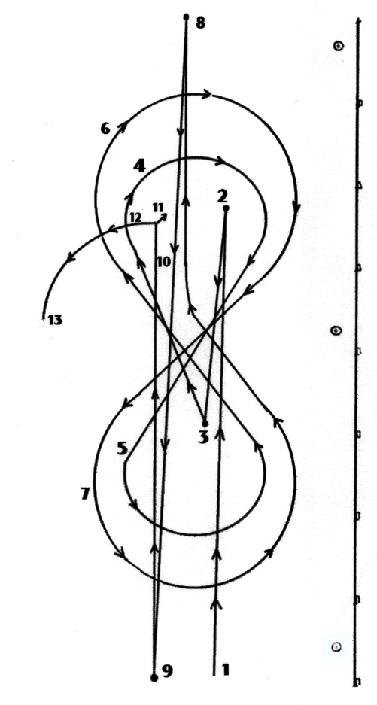
Ride pattern as follows:
1 to 2 Run with speed past center marker.
2 to 3 Stop and back up to center of pattern.
4 & 5 Ride a small figure eight at slow lope.
6 & 7 Ride a larger figure eight at a faster lope.
8 Left roll back over hocks (should be made
past far end marker).
9 Right roll back over hocks (should be made
past near end marker).
10 Stop (should be made past center marker),
let horse settle and in approximate area of stop,
do a pivot.
11 Pivot, right or left, no more than ninety
(90) degrees.
12 Pivot opposite direction, no more than one
hundred and eighty (180) degrees.
13 Walk to judge and stop for inspection until dismissed.

3. NEMAHC Reining Pattern #2
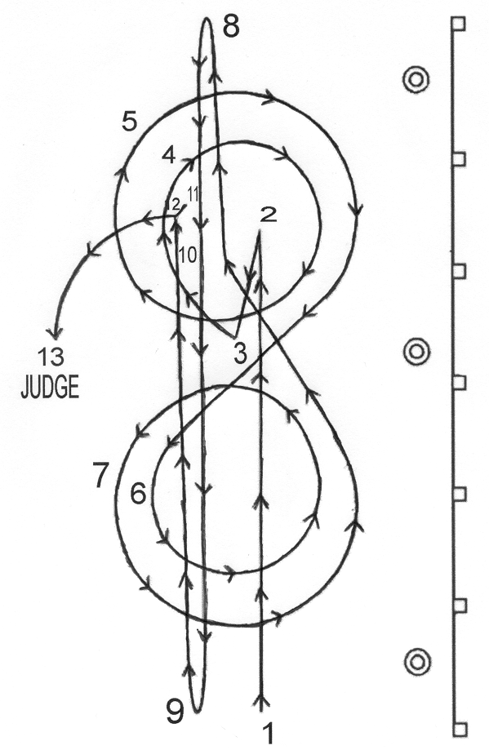
Ride the pattern as follows:
1 to 2 Run with speed past center marker.
2 Stop and back up to center of pattern.
3 Settle horse for approximately ten (10)
seconds. Start lope. Circle should be
made inside the end markers.
4 to 5 Ride two circles to the right, first small
circle, which should be slow and then
second circle, which is larger and faster.
6 to 7 Ride two circles to the left, first circle
small, and should be slow and second
circle larger and faster.
8 Left roll back over hocks (should be
made past far end marker).
9 Right roll back over hocks (should be
made past near end marker).
10 Stop (should be made past center
marker). Let horse settle, then in
approximate area of stop, do the pivots.
11 Pivot right or left no more than ninty
(90) degrees.
12 Pivot opposite direction, no more than
180 degrees.
13 Walk to judge and stop for inspection until dismissed.

4. NEMAHC Reining Pattern #3
Ride pattern as follows:
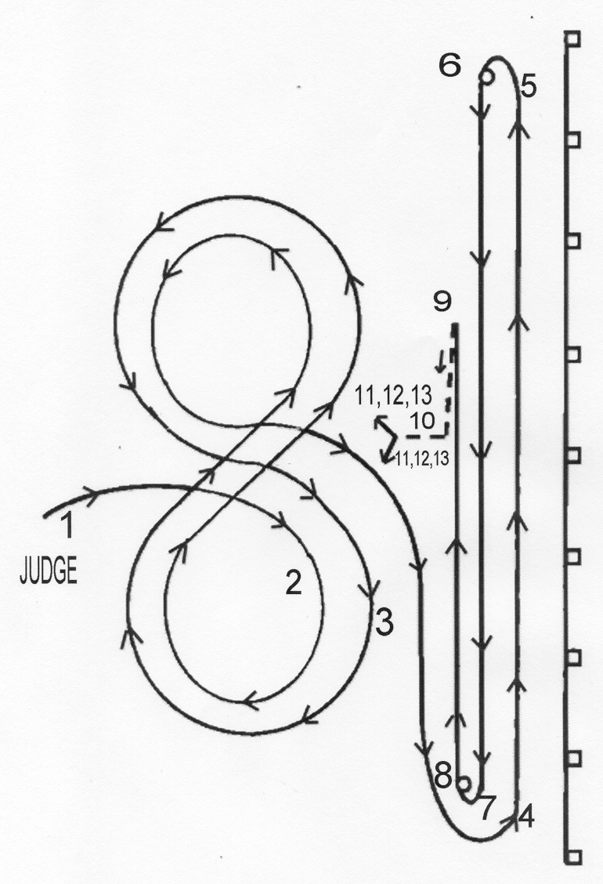
1 First figure eight is slow.
2 Second figure eight is faster (lead
change must take place in center).
3 Proceed from point 3 to point 4 at a
walk or trot.
4 Begin run.
5 Sliding stop.
6 Turn away from the rail, do a spin and
a half, no hesitation. Run to point 7.
7 Sliding stop.
8 Turn away from the rail, do a spin and
a half, no hesitation. Run to point 9.
9 Sliding stop.
10 Back over slide marks. Face judge,
walk a few steps.
11 Pivot right or left, no more than 90
degrees.
12 Pivot the opposite direction, no
more than 180 degrees.
13 Pivot in direction taken in 11, no
more than 180 degrees.
- Walk to judge and stop for
inspection until dismissed.

Section 6 – Gaited Performance Horses of the Pleasure/Plantation and Performance/Show/Park variety will be shown together English/Western/Spanish or Show Costume style. (1996)
a. Horses shall be shown both ways of the ring at a First Gait and Second Gait. Third Gait if applicable to age/breed.
b. Horses should maintain a smooth, steady, 4-beat gait that is ground covering but unhurried. Third gait should show extension or change of speed and/or gait.
c. Horses judged on gait and ring work for the individual style and breed being shown. Gaited horses should exhibit pride, style, elegance, enthusiasm, ready response, and good manners. Animated and brilliant if of the Performance/Show/Park horse type.
d. Back-up and appointments of the horse/rider according to NHSC/AHSA/PFHA breed standards.
e. Exhibitor expected to show copy of their breed standards in case of dispute.

Section 7 – Pleasure Driving (1981)
a. A class of single-hitch horses, horses shall be shown at a walk, trot and road gait both directions of the ring, back willingly, and stand quietly.
b. To be judged on the horse's way of going, brilliance and manners. Excessive speed to be penalized.
c. Vehicle: The horse may be driven to any two or four wheeled pleasure vehicle of wood or metal. These include jog carts, viceroys, sulkies and light weight antique buggies. No justin buggies, surries, wagons, or covered vehicles may be used. The final decision as to suitability of vehicle to horse rest with the judge.
d. Harness: The harness shall be well fitted, clean and made of leather, nylon or other suitable material. Mandatory components are a headstall, lines, harness saddle, crupper, tug, breast strap/collar, traces, and at least one bit of the snaffle or Liverpool variety.
e. The inclusion of any of the following components shall not constitute a fault in the judging of the class: Side or over check (to be connected to a T or C on the harness saddle), check bit (to be a smooth bradoon snaffle or bar), cavesson, running martingale, breeching, thimbles, open headstall, blind headstall (any shape of blinders is acceptable), hand holds on the lines, lap robe, whip (up to five (5) foot) to stand in socket or held in hand.
f. One header per horse may be used in the final line-up. No time given for repairs or replacements.
g. Reversing shall be done across the arena.
h. Horse must be shod according to applicable breed specifications.
i. No spike cavessons, shanked curb bits, quarter boots, chains or rattlers.
j. The driver shall dress appropriately for the breed of horse and vehicle driven. No period costumes.

Section 8 – Speed Classes (1979, 2000)
a. General Rules for speed classes.
1. Appropriate clothing to match the style of riding (English or Western) shall be worn.
2. Safety helmet required in accordance with Article III, Section 6.
3. An electric timer shall be used in all timed events. In case of mechanical failure or other unforeseen failure of electric timer, at least two timers will use stopwatches to time event.
4. In all timed events, time shall start when the horse’s nose crosses the starting line and shall stop when the horse’s nose crosses the finish line.
5. A five (5) second penalty will be added to the time of each contestant for each barrel/pole knocked over in the following events: Pole Bending, Speed and Action, and Cloverleaf.
6. Placings shall be selected by using the fastest times plus any penalty (if penalty occurs).
7. Disqualifications:
A. Failure to begin the course within one minute after the ready signal.
B. Failure to enter arena in a controlled manner.
C. Loss of course includes negotiating obstacles in other than the specified order or in the wrong direction.
D. Loss of forward motion includes: stopping, circling, backing, or reversing the direction of movement to correct the improper passing of an obstacle.
E. Fall of the horse or rider while on course.
F. Spurring, striking, or beating the horse in any manner whatsoever forward of the cinch after entering the arena. Touching the horse will not be considered striking or beating the horse.
G. Horse behaving in an unruly manner or out of control.
H. Any kind of cruelty to the horse whether or not specifically mentioned in these rules, will disqualify the competitor.
I. Leading a horse or pony through any speed event pattern (animal may be lead through the arena gate). (2005)
8.Ties:
A. In case of ties in the timed events, the following rule applies: Any two or more contestants whose time is tied for first place will be required to run off the tie and the best time will be awarded first place, the next best time, second place and so on according to the number who have qualified. A contestant running off ties must make a time within one second of the original time in order to qualify. Contestants not qualifying will be counted foul. If the first contestant should foul, other than by time, and the second should not make the required time, both will be considered foul and the tie will have to be run off again.
B. The above rule applies to any other ties for second, third or fourth places. In the event that two contestants should tie for a second time, a coin will be flipped to determine the winner.

b. Pole Bending:
Six (6) poles are to be used. Poles (stakes) should be approximately 1 ½ inches in diameter and made of a safe material that will not splinter. They should be 6 to 7 feet in height, with a safe, stable stand for ballast. Stand should be no more than 14 inches in diameter. The first pole is to be set twenty-five (25) feet from starting line, each pole thereafter will be set at twenty-two (22) feet apart on the center in a straight line. Center to be designated by chalk marks on the ground to assure accuracy. Contestant may start to either the right or left of the first pole, but will be disqualified if he/she runs off pattern, breaks timer or fails to keep forward motion. There will be a five (5) second penalty added for each pole knocked over. Contestant may hold up pole in pole bending.
c. Keyhole:
Horses will have a running start through the timer. The horse will then go 100 feet, enter the base of the keyhole pattern which is five (5) feet long and five (5) feet wide, turn around in the circle which is twenty-two (22) feet in diameter and return through timer. Contestant is disqualified if the horse steps over the chalk line which forms the keyhole. Judge will determine disqualification.

d. Speed and Action:
Seven (7) buckets and flour are needed. Horses are to have a running start through the 12 x 24 foot oblong box. Horse must go 200 feet to three (3) pails parallel to the start line. The pails will be six (6) feet apart on the outside. The horse will go around the center pail and return to the center of the oblong box. There will be a five (5) second penalty for knocking over any pail. Contestant will be disqualified if he/she does not come to a complete stop within the starting area or if the horse steps out of the chalk line in the starting box. No more than a 180 degree turn in box is allowed. Judge will determine disqualification.

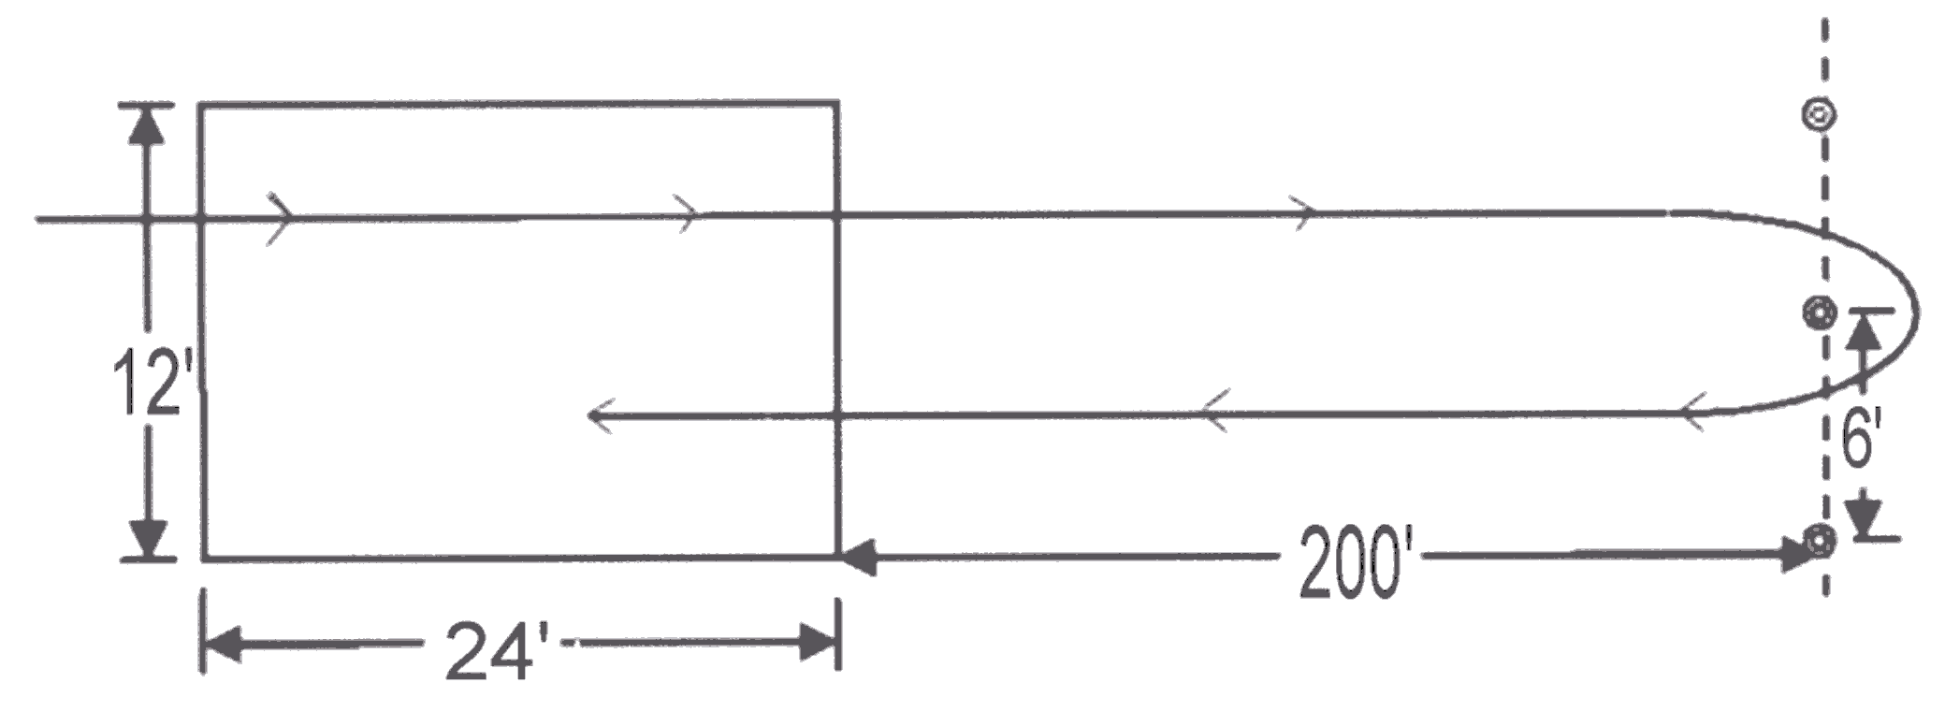
e. Cloverleaf:
Three (3) fifty gallon drums are needed. Horses are to have a running start through timer. The pattern size may vary to size or arena. Small arena pattern must be fifteen (15) feet from the fence, so it may be reduced. Regular size of the pattern should be 105 feet ( or 35 yards) between the first and second barrel, 120 feet (or 40 yards) between the second and third barrel, 120 feet (or 40 yards) between the first and third barrel, and 75 feet (or 25 yards) from the timer to the first barrel. Contestants may start either to the right or left. Contestants will be disqualified for improper pattern or loss of forward motion. A five (5) second penalty will be given for each barrel knocked down. The contestant may touch the barrel with their hand.

Section 9 – Showmanship (1975)
a. Open to both horses and ponies of any age and can be shown either english or western style.
b. Conformation of the animal is not to be considered.
c. Horses shall enter the ring and be lined up at the discretion of the judge.
d. The judge will designate a pattern to demonstrate the exhibitor’s ability to handle and show the horse to the greatest advantage.
e. If the exhibitor is showing in western style, the horse must be shown in a halter and lead. A chain may be used on the lead. The chain of the lead may run under the jaw or over the nose of the horse.
f. If the exhibitor is showing in either saddleseat or huntseat english style, horses over 2 years of age may be shown in the appropriate bridle to match the exhibitor’s english style. Any age of horse may also be shown in a halter appropriate to the breed of horse.
g. Exhibitor shall dress appropriately to match the style and breed of the horse, including a hat, long-sleeved shirt, pants, boots, and jacket if appropriate.

Section 10 – English Equitation (1976)
a. At the judge’s discretion, a pattern or individual tests may be required to demonstrate the exhibitor’s ability to handle and show the horse to the greatest advantage.
b. Conformation of the animal is not to be considered.
c. Open to both horses and ponies of any age and can be shown either saddleseat or huntseat style.
d. All horses will be required to walk, trot or second gait, canter or third gait both directions of the ring, and back with the following exceptions:
1. If a pattern is required by the judge, the judge may opt to work horses on the rail in only one direction, provided all required gaits are performed.
2. If a pattern is required by the judge and the pattern calls for a back, the horses are not required to back again during the rail work portion of the class.
e. The judge may ask for an extension of any gait.
f. If a hand gallop is called, there shall be no more than eight (8) horses on the rail at one time.
g. The reverse may be either toward or away from the rail.
h. Rider to be judged on seat, hands and legs and balance in relationship to guiding and controlling horse. The body always should appear to be comfortable, relaxed and flexible. The method of holding the reins should be consistent with the type of equipment being used.
i. Horses must be serviceably sound.
j. English tack and saddle should fit horse and rider. Tack and saddle should be clean, properly adjusted and safe.
k. Hackamore bits, running martingales, tie-downs, draw reins and mechanical hackamores are prohibited.
l. Spurs and crops are optional.
m. The exhibitor’s clothing and horse’s tack must be appropriate to their style of riding.

Section 11 – Western Equitation – Horsemanship and Stockseat
a. At the judge’s discretion, a pattern or individual tests may be required to demonstrate the exhibitor’s ability to handle and show the horse to the greatest advantage.
b. Conformation of the animal is not to be considered.
c. Open to both horses and ponies of any age.
d. All horses will be required to walk, jog or second gait, lope or third gait both directions of the ring, and back with the following exceptions:
1. If a pattern is required by the judge, the judge may opt to work horses on the rail in only one direction, provided all required gaits are performed.
2. If a pattern is required by the judge and the pattern calls for a back, the horses are not required to back again during the rail work portion of the class.
e. The judge may ask for an extension of any gait.
f. If an extended lope is called, there shall be no more than eight (8) horses on the rail at one time.
g. The reverse should be away from the rail.
h. Rider to be judged on seat, hands and legs and balance in relationship to guiding and controlling the horse. The body always should appear comfortable, relaxed and flexible. Hands do not touch saddle or horse.
i. Horse must be serviceably sound.
j. Western tack and saddle should fit horse and rider. Tack and saddle should be clean, properly adjusted and safe.
k. Mechanical hackamore bits, running martingales, tie-downs, draw reins and cavesson type nosebands are prohibited.
l.. Chaps are optional.
m. Spurs are optional.
n. Riders should wear appropriate western attire.
o. Junior horses may be ridden with two (2) hands if ridden in bosal or snaffle bit.

Section 12 – Leadline Equitation
a. At the judge’s discretion, a pattern or individual tests may be required to demonstrate the exhibitor’s ability to handle and show the horse to the greatest advantage.
b. Conformation of the animal is not to be considered.
c. Open to both horses and ponies of any age.
d. All horses will be required to walk only in both directions of the ring and back.
e. Rider to be judged on seat, hands and legs and balance in relationship to guiding and controlling the horse. The body always should appear comfortable, relaxed and flexible. Hands do not touch saddle or horse.
f. Horse must be serviceably sound.
g. All tack should fit horse and rider. Tack and saddle should be clean, properly adjusted and safe.
h. Chaps are optional.
i. Spurs are optional.
j. Horses or ponies may be ridden english or western.
k. All tack and exhibitor clothing must be appropriate for the style chosen (english or western).
l. Leadline participants are not permitted to ride in any other NEMAHC point approved class including speed events. (2005)
Section 13 – Walk Trot Equitation
a. At the judge’s discretion, a pattern or individual tests may be required to demonstrate the exhibitor’s ability to handle and show the horse to the greatest advantage.
b. Conformation of the animal is not to be considered.
c. Open to both horses and ponies of any age.
d. All horses will be required to walk and trot or jog in both directions of the ring and back.
e. Rider to be judged on seat, hands and legs and balance in relationship to guiding and controlling the horse. The body always should appear comfortable, relaxed and flexible. Hands do not touch saddle or horse.
f. Horse must be serviceably sound.
g. All tack should fit horse and rider. Tack and saddle should be clean, properly adjusted and safe.
h. Chaps are optional.
i. Spurs are optional.
j. Horses or ponies may be ridden english or western.
k. All tack and exhibitor clothing must be appropriate for the style chosen (english or western).
l. Walk/Trot participants are not permitted to ride in any other NEMAHC point approved class including speed events. (2005)

ARTICLE XIV – Amendments to NEMAHC By-Laws

Section 1 – Changes to the By-Laws (1972)
Written proposals to changes the by-laws must be presented by the governing board and sent to all members not less than 30 days before the Annual Business Meeting. A favorable vote of two-thirds of the members present and voting at the Annual Business Meeting shall be required to approve any proposal to change the by-laws.

Section 2 – Word Clarifications
Any word clarification not pertaining to rule changes can be done by the officers and delegates without approval of membership. (1987)
APPENDIX 1 – NEMAHC Area Map

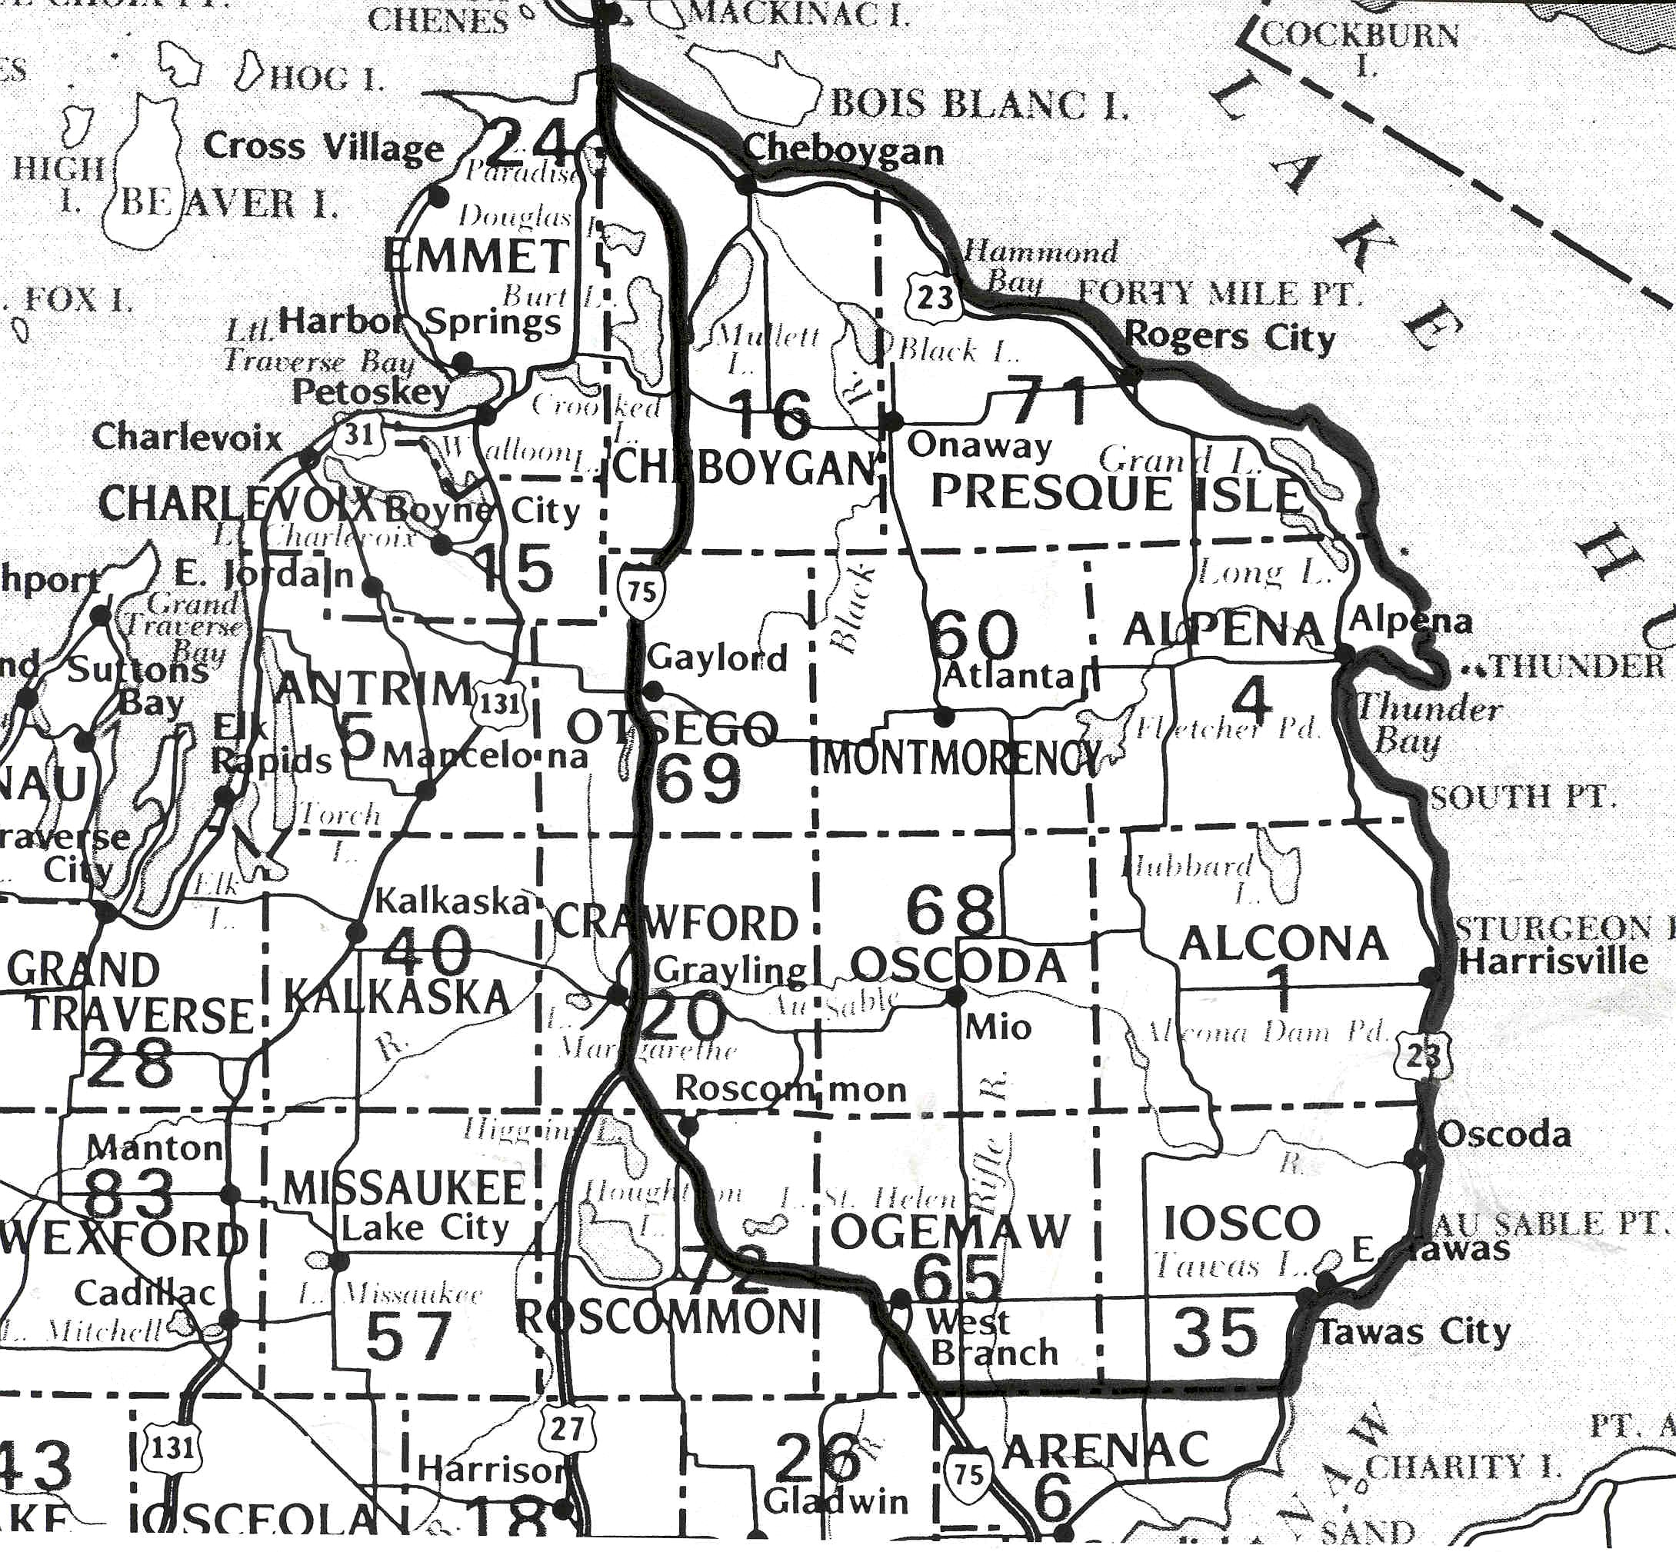
APPENDIX 2 – Glossary of Terms

Amendment: corrections of errors, improvements, a revision or change proposed or made.

Appendix: added material at the end of a book.

Association: fellowship, partnership, an organization or society.

Consecutive Days: days following in regular or unbroken order.

Counter Canter: false lead, done at least 15 feet off rail.

Decorum: proper, propriety and good taste in behavior, speech, etc.

Definition: a defining or being defined, a statement of meaning, of a word, clarity of outline, sound.

Diagonals: refers to the forefoot of the horse moving in unison with the opposite hind foot at the trot; when posting, the rider should rise as the forefoot on the outside of a turn comes forward (rise and fall with the leg on the wall).

Delegates: representatives of the member clubs and are not elected by the general membership.

Exhibitor: handler of a horse in a class when the merits of the horse are considered, in horsemanship and equitation class “exhibitor” refers to the rider.

Family Household: all individuals in a household, regardless of their age or relationship.

Horsemanship: used to distinguish children’s class from an adult’s class, a man skilled in the riding or care of horses.

Hunter Hack: class in which a horse and rider are called upon to go over two jumps individually and then perform work on the flat as part of a group.

Lead (loping or cantering): the foreleg that is reaching out the furthest at a lope or canter; when circling to the right, the horse should be on its right lead, that is the right foreleg should reach out slightly ahead of the left foreleg.

Longe: the act of excercising a horse on the end of a long line, usually in a circle.

Quorum: a number of people fixed by a rule, that must be present to make valid the proceedings of meeting; a sufficient and predetermined number of officers and delegates, both elected and appointed, in attendance at any official meeting of the association shall constitute a quorum, with the exception of the president who will serve as the tie-breaking vote.

Ratcatcher: a tie worn at the neck in English apparel, generally wraps around the collar and may be held in place with a pin.

Stock Tie or Pin: a tie or pin worn at the neck in western or english riding apparel.

Stallion: an unaltered (non-castrated) male horse.

Trailer: an assistant to the exhibitor in halter class who encourages draft horses and donkeys to move out energetically.
APPENDIX 3 – Pony Height Measurement

When measuring the height of a pony:
  - Stand the animal on a smooth, level surface so the front legs are vertical and back of the hocks are in a vertical line with the point of the horse’s hip (see figure 1).
  - Hold the animal’s head only low enough to reveal the highest point of the withers and no lower. With the horse in this position, measure the vertical distance from the highest point of the withers to the ground.
  - Place the arm of the measuring standard over the highest point of the wither; no measurement taken at any other part of the horse’s body shall be accepted.
  - The standard shall be a straight, rigid, official measuring stick and should be provided with a plumb bob or spirit level to make sure the standard is perpendicular from the withers to the ground and that the crosspiece is parallel to the ground.
  - NEMAHC ponies must measure 54 inches or less at the withers. Shod ponies will be allowed ½ inch for the thickness of the shoes.

