Brewster 312 house research

“
BREWSTER, NY (PUTNAM) **NATURAL GAS LEAK** RT 312 AND ZIMMER RD. FD O/S WITH A GAS LINE RUPTURE N.Y.S.G&E O/S NY51. 9:56a.m.”
http://forums.firehouse.com/showthread.php?t=76018
Wednesday, November 23, 2005

Wonder if the train tracks we were looking at were involved in this derailment. Patterson is 13 minutes away from Dykemans.
“Distance Maps 1: Start out going EAST on NY-312 toward ICE POND RD. 2.4 miles Map 2: Turn LEFT onto NY-22. 6.2 miles Map 3: Turn LEFT onto NY-311. 0.8 miles Map 4: Turn RIGHT onto ORCHARD ST. <0.1 miles Map 5: End at Patterson, NY US”
Article:
Patterson, and particularly Towners, seemed a magnet for train mishaps and wrecks. In June, 1911, a spectacular derailment involved 18 of 36 freight cars and caused $25,000 in damage. The early afternoon wreck occurred east of the Towners Station as "Extra # 441", heading eastbound from Hopewell Junction for Danbury, was traveling down the steep grade before the Towners Station at a speed of 35 mph. Two hundred feet west of the station, a problem occurred in the wheel assembly of a gondola car filled with coal. The car was fifteen cars back from the engine. The car derailed on a switch for a siding, dragging the following boxcar with it. The box car then broke free of the gondola car, splitting the train in two. The gondola was dragged by the front half of the train, destroying the track bed. The rest of the freight cars followed, led by the derailed box car. The front portion of the train passed over a 35 foot long bridge carrying the tracks over the road now known as NYS Route 164, about 100 feet west of the Towners Station. The gondola car went over the side of the bridge and tumbled onto the road below. The rest of the train followed, with some cars falling off the bridge into the roadway or down the embankment, while others smashed into each other. Some boxcars were pierced by rails. Patterson resident James E. Towner had just passed under the bridge moments before the wreck occurred and escaped injury. Four men stealing a ride aboard a boxcar escaped injury after the boxcar they were in tumbled down the embankment. Towners Station Agent William Raymond also escaped uninjured as the debris rained on the station platform. Raymond had just stepped off the platform. 300-400 feet of track were destroyed. Dozens of freight trains were delayed by the wreck, and passenger traffic was routed around the wreck, with passengers required to walk a half mile around the accident site.
http://www.historicpatterson.org/Exhibits/ExhRailroads2.php

Interesting article found here. Wonder how far away from the house we were looking at was this:
“Posted: Wed Feb 14, 2007 9:50 am Post subject: This sickens me...

I do not care that the woman was Spanish speaking...it is just the fact that scumbag is now running around and is possibly a sexual predator...wtf is happening here...I know I know...illegals...
I do hope they find him before anything else happens...
Southeast woman attacked by intruder in her home
By YARON STEINBUCH
THE JOURNAL NEWS
SOUTHEAST - A 19-year-old woman was injured yesterday during a fight with a man who entered her home, threatened to sexually assault her and slashed her with shards of a ceramic coffee mug, authorities said.
The woman was alone in the downstairs apartment of a bilevel duplex on Route 312 in the Dykemans section of town when the man entered the home through an unlocked rear door and confronted her in her kitchen about 10 a.m., Putnam County Sheriff Donald Smith said.
The man, wearing a ski mask, grabbed the woman and struggled with her. He slashed at her arms and legs, inflicting cuts and bruises - knocking her to the floor and choking her with his hands, police said.
The victim broke free and ran out the rear door to the home of a neighbor, where she contacted a man with whom she lives. He called 911.
Sheriff's deputies, state troopers and nearby patrols of the Metropolitan Transportation Authority Police rushed to the victim's home and canvassed the area in search of the intruder. Troopers deployed canines to try to track the suspect, but the dogs lost the man's trail a short distance away from the house, near the Metro-North railroad tracks.
The victim was taken to Putnam Hospital Center in Carmel for treatment of injuries suffered in the attack, including cuts and scrapes, and soreness in her neck. She was not sexually assaulted.
The woman speaks only Spanish, and the man spoke to her in Spanish.
Sheriff's investigators, with the assistance of Spanish-speaking investigators from the state police, interviewed the victim. She described the man as about 5 feet 8 inches tall, weighing about 180 pounds and last seen wearing a ski mask, gloves, sweater and pants - all black.
Authorities ask anyone having information about the crime to call the Sheriff's Department at 845-225-8060.
In light of the incident, Smith reminded residents to take sensible steps in protecting themselves against being victimized in their homes. "All in all, Putnam County is statistically among the safest places to live in the nation, but our residents would be prudent to lock the doors of their residences - even while at home - and to install and use alarm systems and security lighting to help deter opportunistic criminals," he said.”
http://forums.nyjournalnews.com/viewtopic.php?p=40514&sid=1b81d011769fc580f7cd8d5d094122e5

Found the train line runs but a station no longer exists:
“Oh yeah, one other item: The choise of CP name "DYKE" has nothing to do with poking fun at anybody's sexual orientation. This is the spot where the ex-New Haven Maybrook Line (now "Beacon secondary") comes alongside the Harlem Line about 1/4 mile or so north of the Rt. 312 crossing. Penn Central installed a crossover there in 1975 --- there had never been any previous connection between the two railroads at that spot --- and gave it a name. Why "DYKE?" Well, the NYC had a station located at the Rt. 312 crossing called "Dykeman's." It was in use until about 1966 or so.”
And this from the same page:
“Actually Dykemans was a station stop in the New York Central days
apparently right up to the Penn Central days. The last New York Central
Upper Harlem timetable dated December 28, 1967 shows trains still
stopping there but the first Penn Central timetable dated february 5, 1968
does not even show Dykemans in the passenger timetable. Apparently, it
got closed quite quickly, often stations of this nature got one less train
most every time change but this one went from a good number of trains
stopping there to no trains stopping there.”
http://railroad.net/forums/viewtopic.php?t=24640&postdays=0&postorder=asc&start=15&sid=860882de4ffcac01822fbf15ff724f05

http://world.nycsubway.org/perl/show?61713 This includes a photo of the train there taken in 2007.
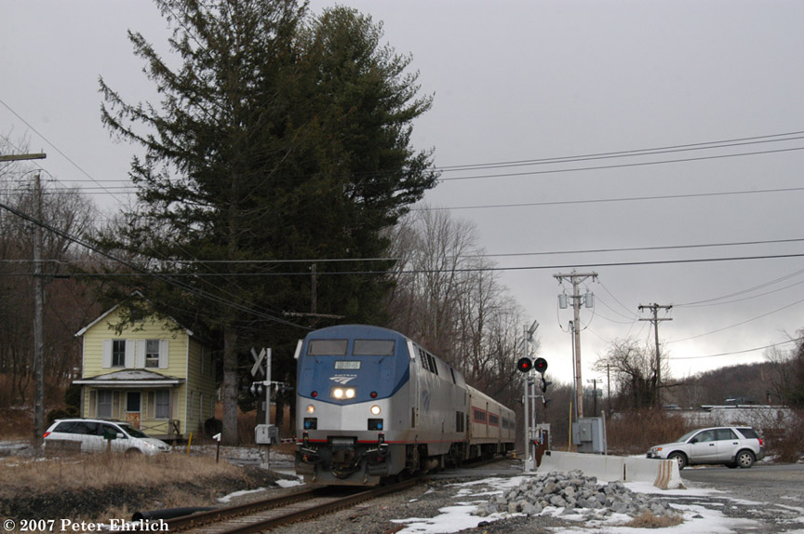

Based on Rusty’s information about Jill Garrett
“an example: in 1979, a tall, good-looking, and dimwitted stable hand at
benedict farms in brewster, new york, picked up a hitchhiker,
15-year-old jill garrett, on route 6 in nearby carmel. what happened
immediately thereafter is not clear, but the result was the partially
clad body of jill garrett, her head bashed in, near a small creek on
benedict farms. a day or so later, morrison was brought in for
questioning. he was, as i said, about 11 donuts shy of a baker's dozen,
and he was completely freaked out. the putnam county sheriff's office
lacked any place to question suspects, so they were questioning him in
the coffee room. finally, morrison said he wanted a lawyer. the deputy
who had been questioning him left to phone the lawyer. morrison was
left in the coffee room. it was shift change and deputy terry intrary,
coming on duty, stopped for a cup of coffee. he knew morrison, they
were something of friends. "hey, frank," he said, "what are you doing
here?" morrison replied that he had picked up this girl who wanted to
go off and make out with him and then she got all scared and jumped
away and fell off the little bridge and her head got smashed on the
rock below, and he was scared and gathered up her clothes and took them
someplace and buried them and now he was in all kinds of trouble.

well. intrary reported what he had been told. deputies went to the place
morrison said he had buried the clothes and they were there. he was
instantly charged with second-degree murder -- murder one in new york
was, at that time, limited to the killing of a cop or the killing of
another inmate by a prisoner already serving life.

his lawyer, richard maher, immediately moved to have the clothing, the
confession, the whole thing thrown out, because it came in response to
a question asked by a law officer after the suspect had requested a
lawyer. he prevailed. because putnam is a small, close-knit county --
maybe too close-knit; many of the people there look kind of like amy
carter -- maher sought and received a change of venue. so in january
1980 trial began in new city, county seat of neighboring rockland
county. the prosecution knew morrison had done it (well, to the extent
that something had been done; by morrison's account, if accurate, he
might have gotten nicked on something like attempted statutory rape),
but had no evidence. they got some jailhouse informant to testify that
morrison had confessed while in jail -- but the informant turned while
on the witness stand and claimed that he had been threatened with
beatings if he did not testify as the prosecution told him to testify.
(the prosecutor was james rooney, and nobody who knew him believed this
for a minute.) the informant was in jail because he had burned down a
home containing his grandmother. morrison did not testify. the jury
never saw or heard of the clothing. the jury never heard of morrison's
story. the jury saw evidence that a crime had been committed but never
saw or heard evidence as to who might have done it.

inflamatory pictures of little naked dead jill were shown to the jury,
and the prosecution made the case into a vote on whether the jury
thought little dead naked girls ought to be just out in the woods like
that. the jury was asked to decide less whether franklin morrison was
guilty than it was whether the murder of little girls is a bad idea.

so, absent evidence beyond a reasonable doubt, franklin morrison was
nevertheless found guilty of murder and rape. he may get out next year.

now. he had certainly proved he was there, but that evidence was thrown
out. jury never saw it. never heard his account of things, which were
(in my estimation, anyway) against penal interest in that they placed
him there. the case was not proved in court, but he was convicted
anyway.

the morrison case, though unique as to the specifics, is fairly typical
of cases that go to trial. when it's slam-dunk, there's usually a plea.
it's the doubtful cases that go to trial. and in my experience, for all
the near-religion attached to trial by jury, most juries instantly upon
being sworn utterly forget any notions of reasonable doubt. there are
people in prison convicted largely on the fact that the jury didn't
like the look of them. certainly, there are far more in prison on a
preponderance of the evidence than there are due to its having been
proved that they were guilty beyond reasonable doubt.

and guess what? that someone was wrongly convicted -- that the jury
simply did not properly weigh evidence -- is not a ground for appeal.

this goes on all the time, every day, and we never hear about it because
the crimes didn't take place on christmas near a bored and heavily
staffed network news bureau. if scott peterson, who did everything he
possibly could to look guilty, is in fact innocent, too bad: he's
guilty now. and if he did it, well, good that he was convicted.

still, one hopes that at the sentencing hearing the jury decides on the
death penalty -- for geraldo and greta and every other failed lawyer
who now makes a living speculating on television about court cases.”
http://mailman.jtan.com/pipermail/os2-right-stuff-l/2004-November/002027.html

