Mac OS X Software
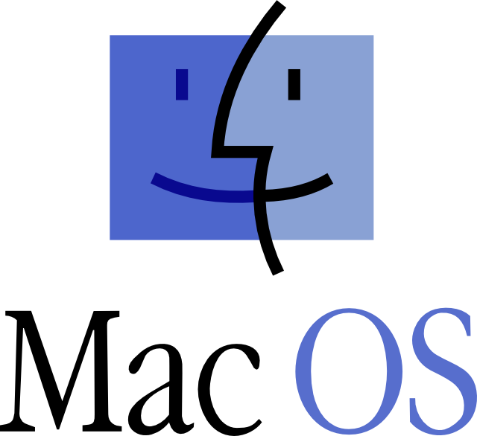

http://geocities.ws/mrmac/software/macintosh

