Meghan Bush

Artist Portfolio

[meghan.bush@snhu.edu](mailto:meghan.bush@snhu.edu)

Sitemap



Wireframes

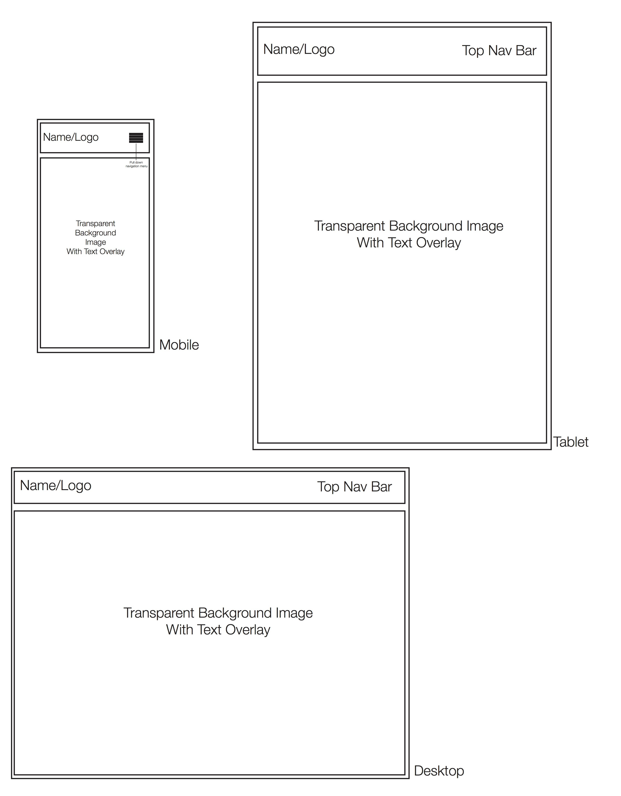

User Experience

User experience, or UX, is defined as the way a person feels when interfacing with a system, such as a website or web application. (Jacob Goub.) UX is an extremely important factor to consider when it comes to designing a website. Without a good user experience, the users will most likely not return to the website, and therefore the website will be useless. With the amount of changes that are being made to the web, such as the increasing amount of users, multiple devices, and the importance of accessibility, user experience has become increasingly important. The websites that stand out are the ones that are pleasant to use. While user experience will not be the same for one person as it is for another, the goal of the designer should be to create a website that is user friendly, and created a positive user experience.

Engaging content is one of the most important factors when it comes to a positive user experience. Ensuring that the content is not boring will keep users coming back to use the website over and over again. For my website, I am going to try to make the content engaging by putting a story with certain pieces of art or design. I would also like to include a small personal back-story about myself. I’m hoping that by doing this users will continue to revisit my website.

Audience interaction is another important factor that web designers have to take into consideration. One way to study audience interaction is to take a poll to see how users feel about the website. This could be effective for my personal website because it will allow the audience to voice how they feel about their experience with the site. Learning how the audience feels about a website is one of the most important tasks of a designer. If a designer does not make the necessary changes to create a user-friendly website, the website will be useless. In my experience, websites with a positive user experience are the websites that I visit more often. These websites often consist of simple layouts, fast-loading pages, easy accessibility, and a strong design. These are the goals I am going to keep in mind when creating my own website.

Goub,Jacob. “What is User Experience Design? Overview, Tools and Resources.” October 5, 2010. <https://www.smashingmagazine.com/2010/10/what-is-user-experience-design-overview-tools-and-resources/>

Digital MockUps

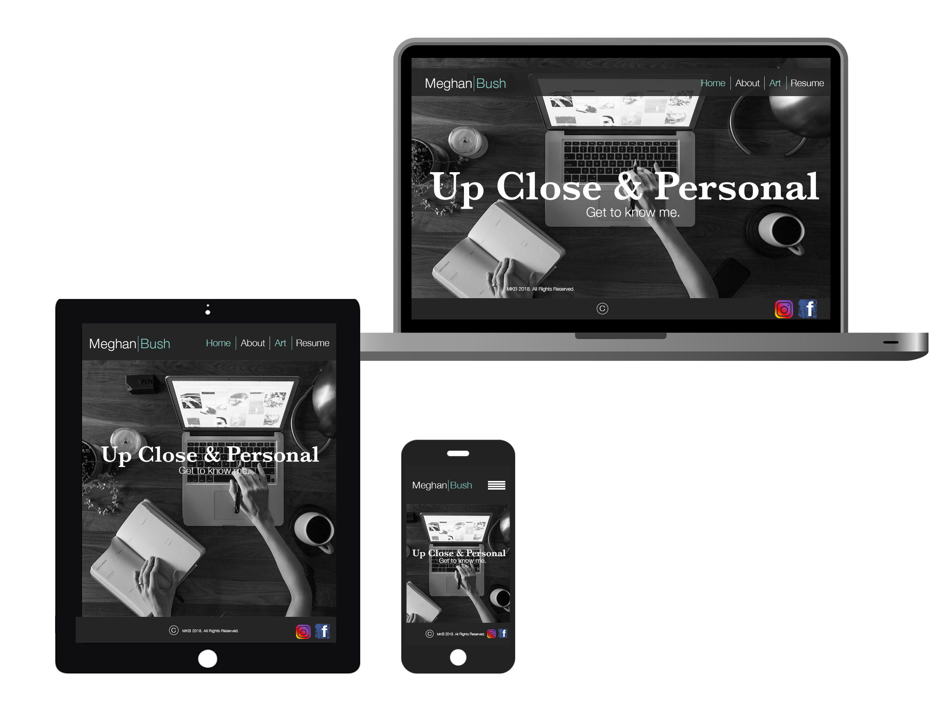

JavaScript Screenshots

