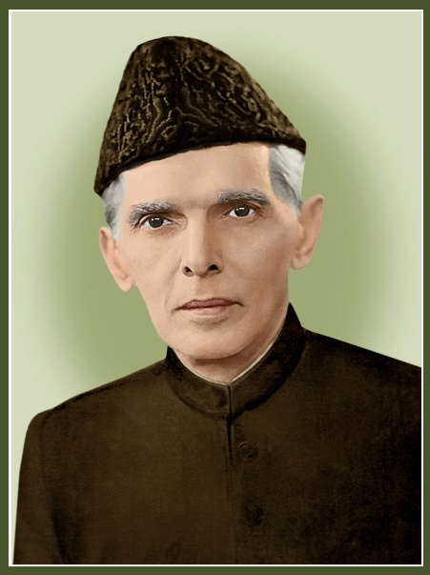
Muhammad Ali Jinnah (born 25 December 1876 – 11 September 1948)
Muhammad Ali Jinnah was a barrister, politician and the founder of Pakistan. Jinnah served as the leader of the All-India Muslim League from 1913 until the inception of Pakistan on 14 August 1947, and then as the Dominion of Pakistan 's ﬁrst governer-general until his death. Born at Wazir Mansion in Karachi, Jinnah was trained as a barrister at Lincoln’s Inn in London, England. Upon his return to India, he enrolled at the Bombay High Court, and took an interest in national politics, which eventually replaced his legal practice. Jinnah rose to prominence in the Indian National congress in the ﬁrst two decades of the 20th century. In these early years of his political career, Jinnah advocated Hindu-Muslim Unity, helping to shape the 1916 Lucknow Pact between the Congress and the All-India Muslim League, in which Jinnah had also become prominent. Jinnah became a key leader in the All India-Home Rule league, and proposed a fourteen points constitutional reform plan to safeguard the political rights of Muslims in the India Subcontinent. In 1920, however, Jinnah resigned from the Congress when it agreed to follow a campaign of satyagrah, which he regarded as political anarchy. By 1940, Jinnah had come to believe that the Muslims of the subcontinent should have their own state to avoid the possible marginalised status they may gain in an independent Hindu–Muslim state. In that year, the Muslim League, led by Jinnah, passed the Lahore Resolution, demanding a separate nation for India Muslims.
During the Second World War, the League gained strength while leaders of the Congress were imprisoned, and in the Provincial elections held shortly after the war, it won most of the seats reserved for Muslims. Ultimately, the Congress and the Muslim League could not reach a power-sharing formula that would allow the entirety of British India to be united as a single state following independence, leading all parties to agree instead to the independence of a predominantly Hindu India, and for a Muslim-majority state of Pakistan. As the ﬁrst governor-general of Pakistan, Jinnah worked to establish the new nation's government and policies, and to aid the millions of Muslim migrants who had emigrated from neighbouring India to Pakistan after the two state’s independence, personally supervising the establishment of refugee camps. Jinnah died at age 71 in September 1948, just over a year after Pakistan gained independence from the United Kingdom. He left a deep and respected legacy in Pakistan. Several universities and public building in Pakistan bear Jinnah's name. He is revered in Pakistan as the Quaid-e-Azam ("Great Leader") and Baba-e-Qaum ("Father of Nation"). His birthday is also observed as a national holiday in the country. According to his biographer, Stanley Wolpert, Jinnah remains Pakistan's greatest leader.
Constitutional Struggle:
In subsequent years, however, he felt dismayed at the injection of violence into politics. Since Jinnah stood for "ordered progress", moderation, gradualism and constitutionalism, he felt that political violence was not the pathway to national liberation but, the dark alley to disaster and destruction. In the ever-growing frustration among the masses caused by colonial rule, there was ample cause for extremism. But, Gandhi's doctrine of non- cooperation, Jinnah felt, even as Rabindranath Tagore(1861-1941) did also feel, was at best one of negation and despair: it might lead to the building up of resentment, but nothing constructive. Hence, he opposed tooth and nail the tactics adopted by Gandhi to exploit the Khilafat and wrongful tactics in the Punjab in the early twenties. On the eve of its adoption of the Gandhian programmed, Jinnah warned the Nagpur Congress Session (1920): "you are making a declaration (of Swaraj within a year) and committing the Indian National Congress to a programme, which you will not be able to carry out". He felt that there was no short-cut to independence and that any extra-constitutional methods could only lead to political violence, lawlessness and chaos, without bringing India nearer to the threshold of freedom.
The future course of events was not only to conﬁrm Jinnah's worst fears, but also to prove him right. Although Jinnah left the Congress soon thereafter, he continued his eﬀorts towards bringing about a Hindu-Muslim entente, which he rightly considered "the most vital condition of Swaraj". However, because of the deep distrust between the two communities as evidenced by the country-wide communal riots, and because the Hindus failed to meet the genuine demands of the Muslims, his eﬀorts came to naught. One such eﬀort was the formulation of the Delhi Muslim Proposals in March, 1927. In order to bridge Hindu-Muslim diﬀerences on the constitutional plan, these proposals even waived the Muslim right to separate electorate, the most basic Muslim demand since 1906, which though recognized by the Congress in the Luckhnow Pact, had again become a source of friction between the two communities. surprisingly though, the Nehru Report (1928), which represented the Congress-sponsored proposals for the future constitution of India, negated the minimum Muslim demands embodied in the Delhi Muslim Proposals.
In vain Jinnah argued at the National Convention of Congress in 1928 that "What we want is that Hindus and Mussalmans should march together until our objective is achieved...These two communities have got to be reconciled and united and made to feel that their interests are common". The Convention's blank refusal to accept Muslim demands represented the most devastating setback to Jinnah's life-long eﬀorts to bring about Hindu- Muslim unity, it meant "the last straw" for the Muslims, and "the parting of the ways" for him, as he confessed to a Parsee friend at that time. Jinnah's disillusionment at the course of politics in the subcontinent prompted him to migrate and settle down in London in the early thirties. He was, however, to return to India in 1934, at the pleadings of his co-religionists, and assume their leadership. But, the Muslims presented a sad spectacle at that time. They were a mass of disgruntled and demoralized men and women, politically disorganized and destitute of a clear-cut political programme.
Next Page

