Manuel Rivera

GRA 410 Process Book

Manuel.rivera3@snhu.edu

Sitemap
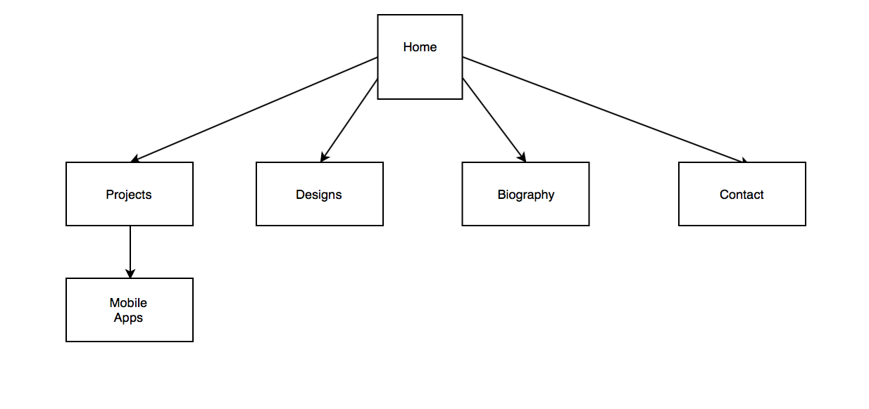

Wireframe Sketch

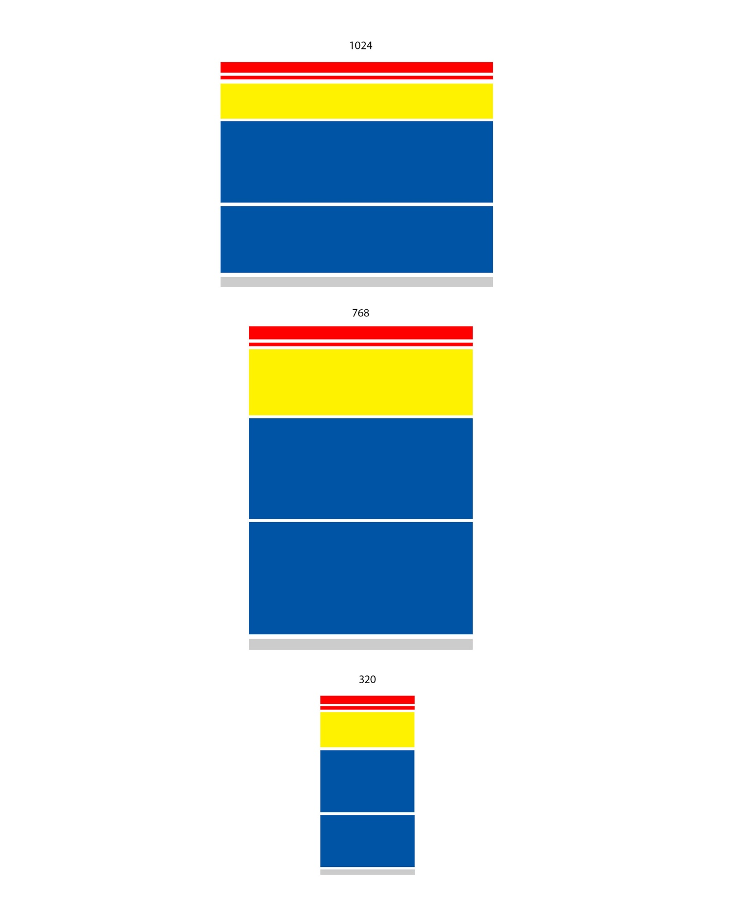

User Experience

User experience is a large part of why a website is there in the first place. The end user wants to find information about a particular person or product offering and searches the web for such. Once the user finds the information they are ultimately looking for they have a choice to go back to that same website or use another website to find the information. User experience plays a role in whether or not the person coming to the website will come back and if they found the experience they had pleasant or not.
The target audience plays a vital role in what content is displayed and how it is displayed. Content meant for a child may contain more colorful words and larger buttons in order to accommodate for easier ease of use. While websites such as banking platforms may want to convey a sort of sleek and more advanced user interface in order to cater to those who want more complicated options. Although a design is thought to be perfect for one product and then moved onto another to be used as a template in essence the website might not hit the target audience like the original website might have and therefore loose a number of visitors.
Websites also need to evolve as their user base evolves as well and constantly needs to be updated to keep the users interested. Great examples of this include Amazon.com and Hulu.com. Both websites had early beginnings when client devices were overweight and out of reach and mobile websites were almost nonexistent. Over time though the websites evolved in order to gain the trust of more customers while retaining existing customers. A significant improvement of both websites was the use of mobile platforms in order to leverage the overwhelming amount of users without complete desktops at home.
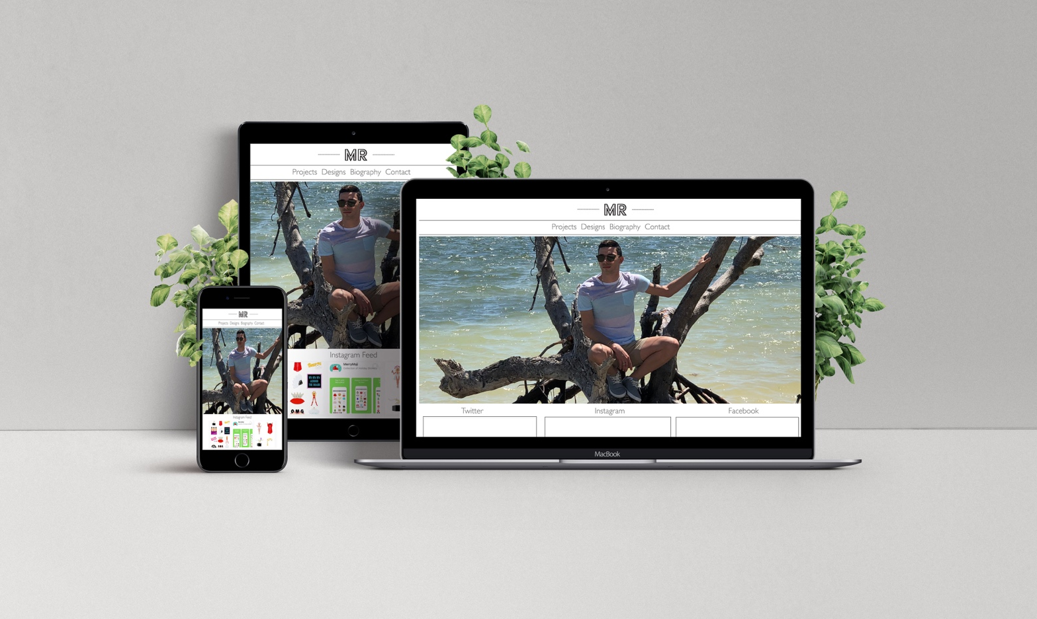
Digital Mockup

