

FACULTY OF SCIENCE INFORMATION SYSTEM MANAGEMENT UNIVERSITY TECHNOLOGY MARA
CAMPUS PUNCAK PERDANA SHAH ALAM

BACHELOR OF INFORMATION SCIENCE INFORMATION SYSTEM MANAGEMENT
IMS456
Basic Web Design And Content Management

ASSIGNMENT 1
E·PORFOLIO WEBSITE

PREPARED BY:
MOHD IZWANE WAHED - 2019583255

GROUP:
NIMBSF3A

PREPARED FOR:
Madam Farrah Diana Saiful Bahry

SUBMITION DATE: 08 November 2019
Table of Content

Bil. Content Page
1.0 | Introduction | 2
2.0 | Web Content Plan | 2
2.0.1 | Home (Website Page 1) | 2
2.0.2 | Personal (Website Page2) | 2
2.0.3 | Academic (Website Page3) | 2
2.0.4 | Experience (Website Page4) | 2
2.0.5 | Skills (Website Page5) | 3
2.0.6 | Contact Me (Website Page6) | 3
2.1 | Navigation Structure | 3
2.2 | Page Layout | 4
3.0 | Required Items | 7

- INTRODUCTION
Regarding to our first assignment for IMS456 (BASIC WEB DESIGN AND CONTENT MANAGEMENT) subject, we are needed to create a personal resume website which is known as e-Portfolio of ourselves. Our created website is meant to exposed our future company know about our qualifications. Some of the subject matter that to be included our personal details, job experience, academic profile, skills and family or anything else that related to this task. Since it is a personal resume website, we are allowed to decide our own theme, layout and content.

Web Content Plan
2.0.1 Home (Web page 1)
  - Header
  - Nav/Home
  - Picture
  - Name: Mohd Izwane Bin Wahed
  - Short Address: Gombak, Selangor
  - Quote
  - Footer

2.0.2 Personal ( Web page 2)
  - Header
  - Nav/Personal
  - Personal Background
  - Footer

2.0.3 Academic
• Header
• Nav/Academic
• School: UPSR
• Schoo: SPM
• Diploma: UiTM
• Footer

2.0.4 Experience
• Header
• Nav/Experience
• University Malaya
• FRIM
• FRIM

2.0.5 Skills
• Header
• Nav/Skills
• Skills
• Footer

2.0.6 Contact Me
• Header
• Nav/Contact Me
• Sosial Media Link
• Footer

2.1 Navigation Structure

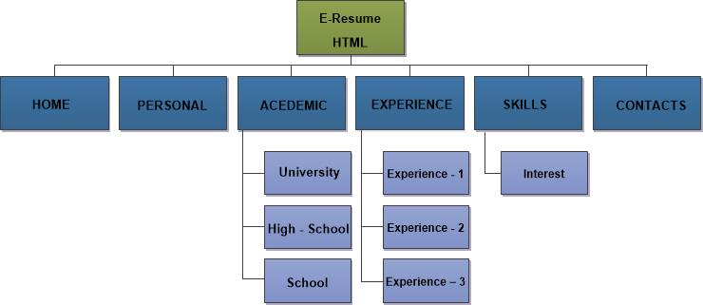

2.2 Page Layout
Resume.html
Home Header
 | Home | Personal | Academic | Experience |  | Skills | Contact Me
 |  |  | My Resume
 |  |  | Name
 |  |  | Picture
 |  |  | Address
 |  | Send Me Message |  |  | Download My CV
Footer

Personal.html
Personal Background Header
 | Home | Personal | Academic | Experience | Skills | Contact Me
 |  |  | Picture
 |  |  | About Me
 |  |  | Objective
 |  |  | Quotes
 |  |  | Song
Footer

Acedemic.html
Acedemic Header
 | Home |  | Personal |  | Academic | Experience | Skills | Contact Me
Acedemic Qualification
 |  | School  (Picture to Clicks) |  | High-School  (Picture to Clicks) |  |  | University  (Picture to Clicks)
 |  |  |  | Click the Picture
Footer

experience.html
Experience Header
 | Home |  | Personal | Academic |  | Experience | Skills |  | Contact Me
Work Eperience
 |  | Experience 1  (Picture to Clicks) |  |  | Experience 2  (Picture to Clicks) |  |  | Experience 2  (Picture to Clicks)
Clicks the logo
Footer
Skills.html
skills Header
 | Home |  | Personal | Academic |  | Experience | Skills |  | Contact Me
Skills
Details about skills

Interest
(Picture to Clicks)
Clicks the logo
Footer

Contact.html
Contact. Header
 | Home |  | Personal |  | Academic | Experience |  | Skills | Contact Me
Acedemic Qualification
 |  | Contact |  | Facebook |  |  | Twitter |  | Linkend
 |  |  |  | Click the Picture
 |  |  |  | Footer
- Required Items
No. | ITEM | REMARK
1 | Header Image (Header tag) | <div id="header">  <div id="logo"><a href="#"><img src="images/logo.png">  </a></div>
2 | Content Area | Includes test, header, image , links etc.
3 | Navigation area | Consistent area containing links, announcement, etc. that appear on every pages
Menu bar of home, personal, academic, experience, skills, and contact
4 | Dislaimer area (footer tag) | Declares copyright ©, recommended browser  & resolution, last update.
<footer> <center>Details
<p> This website is for IMS456 course teaching resources</p>
<p> Best Viewed: Google Chrome<br> Best Display:1920x1080 <br> Last update:November 2019</p><center> </footer>
5 | Interactive features | Audio, video, form, multimedia object
<audio controls autoplay>
<source src="mp3/Yiruma-River Flows In You.mp3" type="audio/mpeg">
Your browser does not support the audio tag.
6 | HTML Latest version | HTML5 Doctype declaration, HTML5 semantic layout tag
7

