
Ecommerce Purchase Flow
November 19, 2012
Created by: Laxman Shetty
Approved by:
Final Approved by:

Purchase flow for purchasing products through Customer Website:
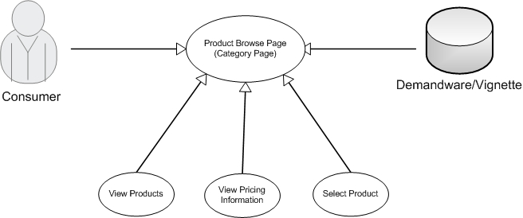

New Template for homepage developed through Demand-ware - http://www.motorola.com/us/consumers/home
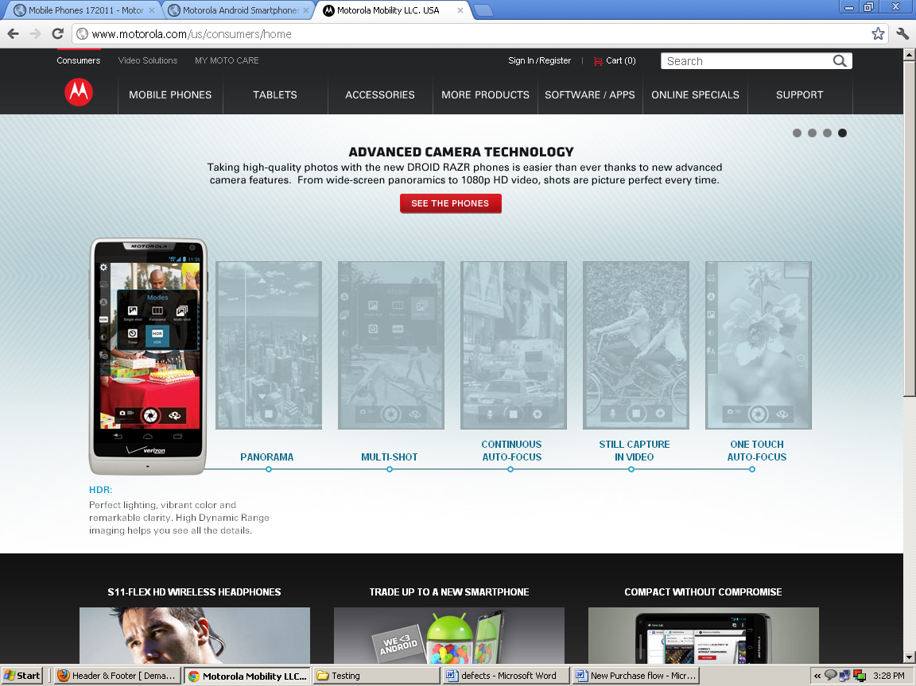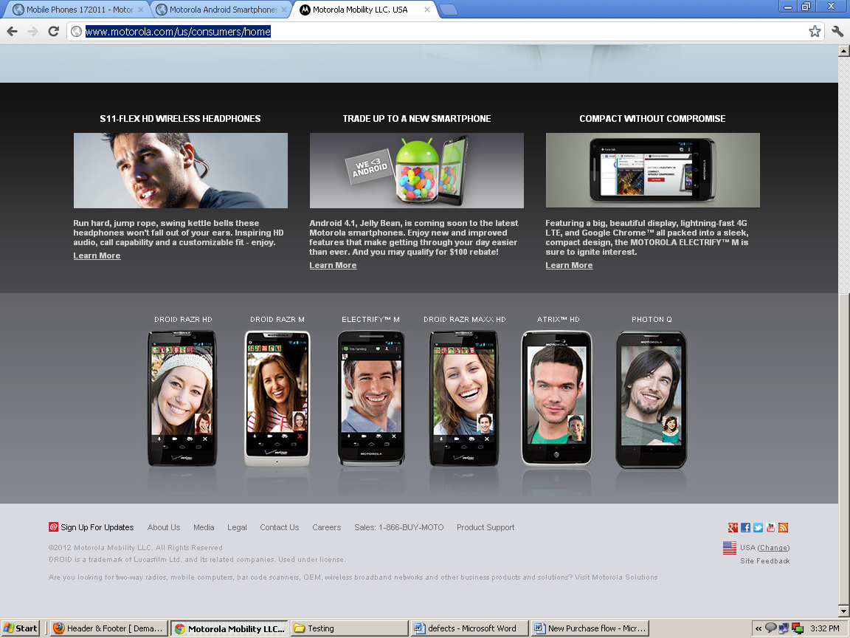
Introduction to Demand ware
Introduction:
Welcome to Demandware. This is an introduction to an integrated system that has many parts. Let’s start by looking at some of the most important aspects.

About Demandware:
Demandware (NYSE: DWRE) is a leading provider of software-as-a-service (SaaS) Ecommerce solutions that enable companies to deliver customized shopping experiences to consumers in the digital world. Customers use our highly scalable and integrated Demandware Ecommerce platform to more easily launch and manage multiple Ecommerce sites, initiate marketing campaigns more quickly, and improve Ecommerce traffic. Demandware clients include industry leaders such as Bare Escentuals, Barneys New York, Callaway Golf, Columbia Sportswear, Crocs, Hanover Direct, Jewelry Television, Jones Apparel Group, L’Oreal, Lands’ End, Lifetime Brands, Michaels Stores, Panasonic, Reitmans, Theory and Tory Burch.

Hardware:
Demandware has both hardware and software components. The hardware is owned and provided by Demandware through a worldwide network of datacenters that provide PCI compliance, site availability of 99.98%, and scalability to handle seasonal peaks in traffic.
SaaS:
The software is owned by Demandware and provided to customers and partners as a service. This practice of “Software as a Service” (or SaaS) means that our customers don't buy a software product that becomes outdated in six months. Instead, our customers and partners receive internet access to a growing system that provides additional capabilities to help them to sell more products easily. At any time, they can use a web browser to make secure changes to their hosted Ecommerce platform.
Sites:
Why can’t I just set up a web site to sell my products? Say that you attend a baseball game. Would you say that the numbers you see on the score board are the same as the game? No way. The baseball game has many components including two teams, rules, actions, salaries, suppliers, location, media, advertising channels and more. Similarly, a Demandware site is much more than a web site. If you only had a handful of products, a simple site would suffice. Our customers need much more. Demandware provides integrated access to products, including inventory, pricing, recommendations, merchandizing, creative content (images, swatches, assets), administrations, campaigns/promotions (coupons, source codes, customer groups), security, QA and analytics.
Instances:
Demandware provides a POD or "point of delivery", containing multiple instances of a site. In this manner, visitors can see products and purchase them in production while enhancements are being developed, tested and staged for the future. A developer can work in a sandbox creating code while a merchant can work in staging to create and schedule a promotion. A Quality Assurance person can test (in a separate development instance) what will be released to production. They are all working separately, but they're working together toward improving their site.

Mobile:
Our mobile commerce application includes a customizable mobile storefront with everything you need to create a compelling shopping experience on mobile devices, such as the iphone, ipad or android.
Security:
People and their roles can be added and changed as needed. Roles are created by an administrator to allow access to the many modules used by marketers and merchants. Without explicit access, menus and their modules are not displayed when the user logs in.
Multi Site:
Multiple sites can be managed from one central platform. This is an important point because large companies have organizations and sales that span the globe. They want their Ecommerce sites to do the same. Think of this as a way to replicate the success of a site in a single country while avoiding the problem of doubling/tripling/quadrupling the effort as they deliver support to more countries.
Retail Practice:
Our Retail Practice team will coach and direct you to help you to take advantage of the features that will allow you to make the most money.
One approach is to start small and grow over time.
Business Manager:
Developers, merchandisers and marketers use the Demandware Business Manager User interface to control their Ecommerce storefronts.
SiteGenesis:
A SiteGenesis application/storefront is bundled with the Demandware platform. It demonstrates a fully functional storefront, and is useful for building a new storefront and verifying the functionality of the Demandware platform.
Almost every new Demandware client uses SiteGenesis as a data foundation.
Custom Development:
One customer said that they like the split between content and merchandizing. He said, “developers can set it up once and let marketing do their thing."
Demandware contains an integrated development environment (IDE), which developers can use to build, customize, test, debug, deploy, integrate and extend their application.
The development platform provides many features for authoring, modifying, deploying and debugging. It includes access to a library of pre-built business processes in the reference store, and contains all the necessary tools to edit them.
Using a server-side scripting language, you can add logic to business processes, create custom objects, Web services calls, integration to back-end systems and XML data processing.
Business processes within the development platform are graphically illustrated as pipelines and are edited via simple drag-and-drop, making it easy for web developers to quickly integrate with other applications and modify the customer experience as necessary.
Third Parties:
Third party integrations provide a way to grow your site by adding best-in-class solutions. Our Demandware LINK program makes it easy for clients to adopt innovative third party technologies. Through Demandware XChange, our clients have access to information and expertise across a vast network of clients, partners and employees.
Summary:
The Demandware platform is not just a web site. It is a system based on SaaS with integration and feeds from other software systems.
You can use Demandware to create and manage:
- Multiple sites including microsites in multiple spoken languages across multiple countries
- Multiple brands with thousands of products, pricing and inventory
- Multiple promotions scheduled for today or in the future
- Multiple instances
- Integration with multiple third party offerings
Demandware provides services to help our customers to create Ecommerce sites manage them coherently and enhance them over time for increased revenue.

Ecommerce product purchase on Product Kernel page developed through Demandware
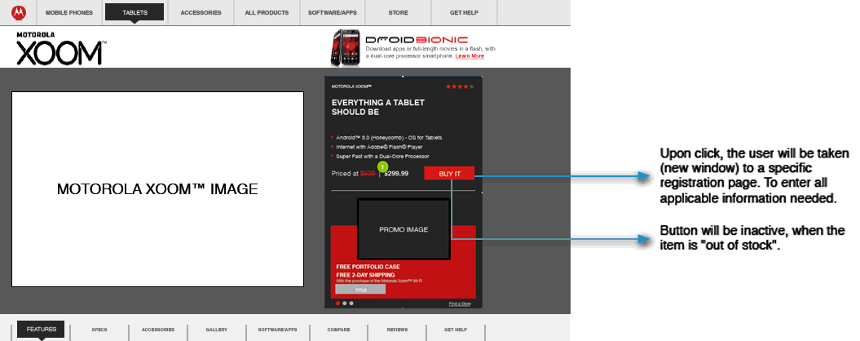

Out of Stock Messaging on Product Page and Overlay
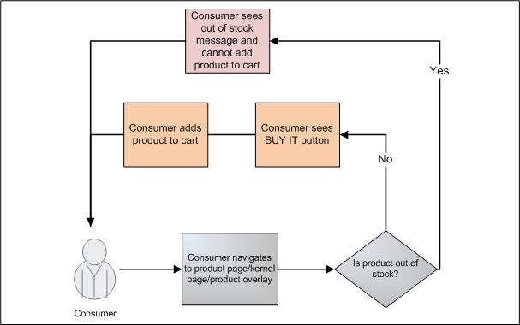

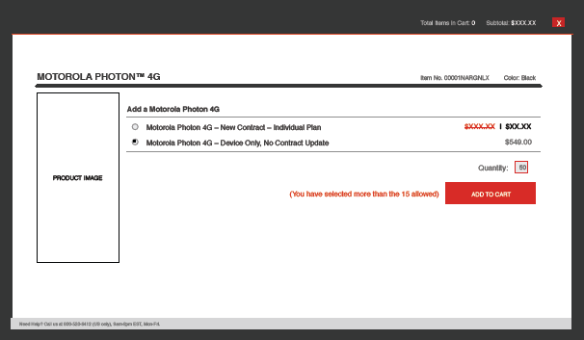
Select product and click on “ADD TO CART” Button
Click on “PROCEED TO CHECKOUT” Button to continue purchase flow.

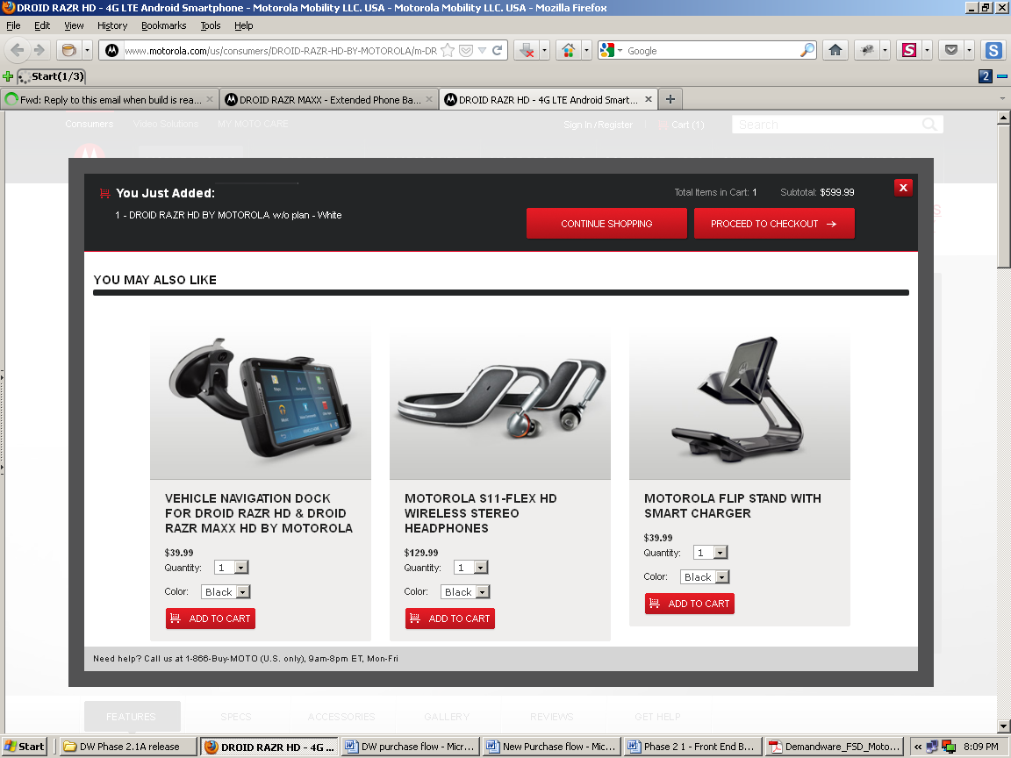

Click on “CONTINUE TO CHECKOUT” Button to continue purchase flow.

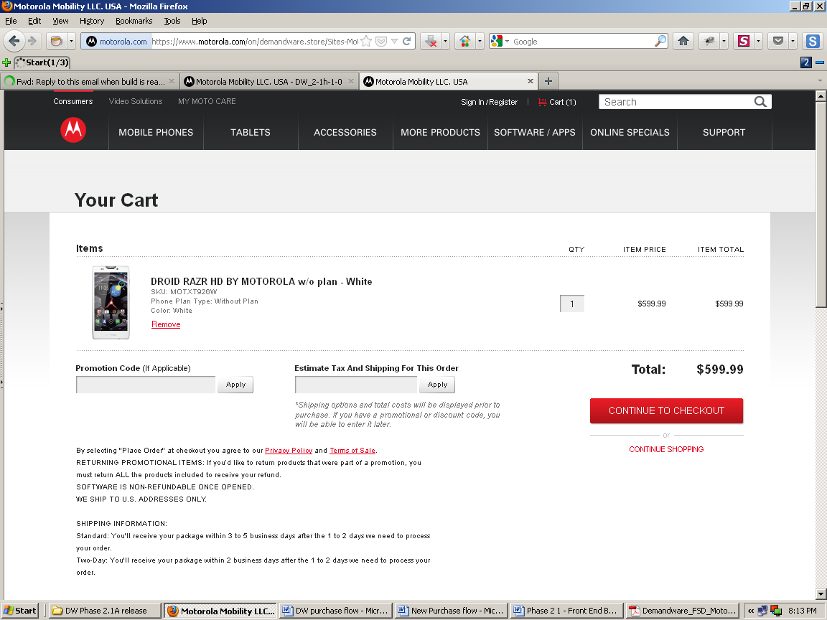

Sign In as Existing Customer:
User can create New Account by clicking on “CREATE ACCOUNT” button, or Sign In as an “Existing customer” or as a “Guest Checkout”.
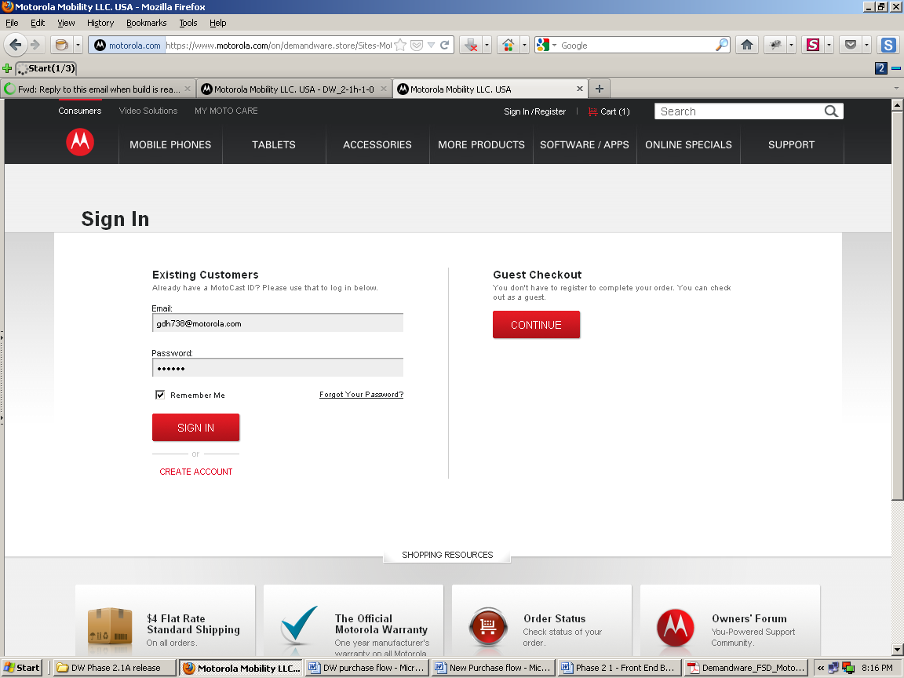

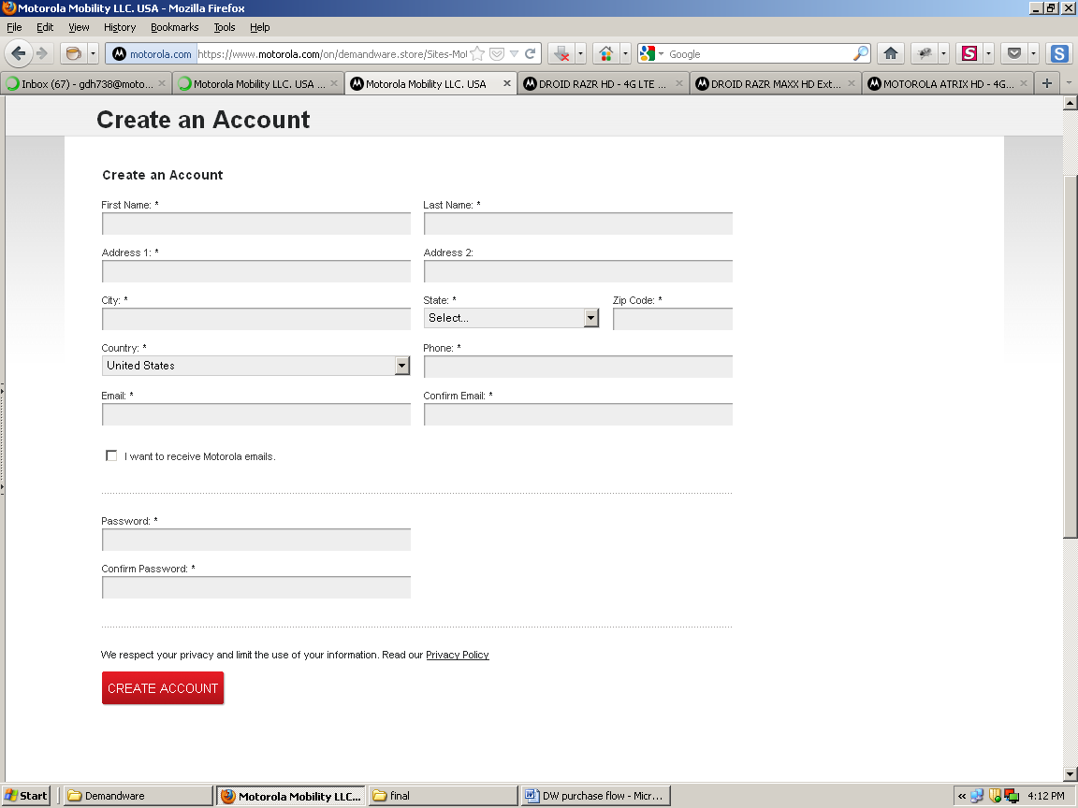User creates New Account for Sign In:

Sign In as Guest Checkout:
When user Sign In as Guest Checkout he doesn’t have option to select saved Addresses so he needs to fill all required fields in Shipping Address & Click on “CONTINUE” button which takes him to Billing Address page.

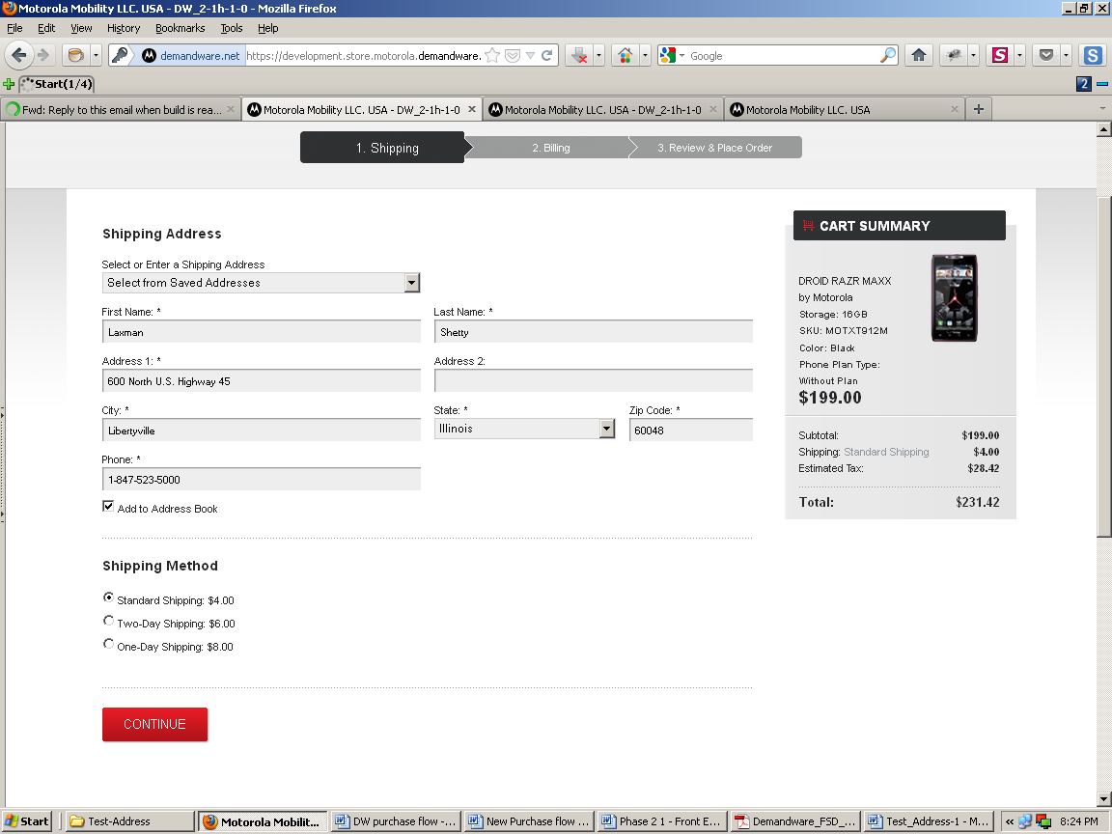
Provide all required Information properly and click on “Continue” button
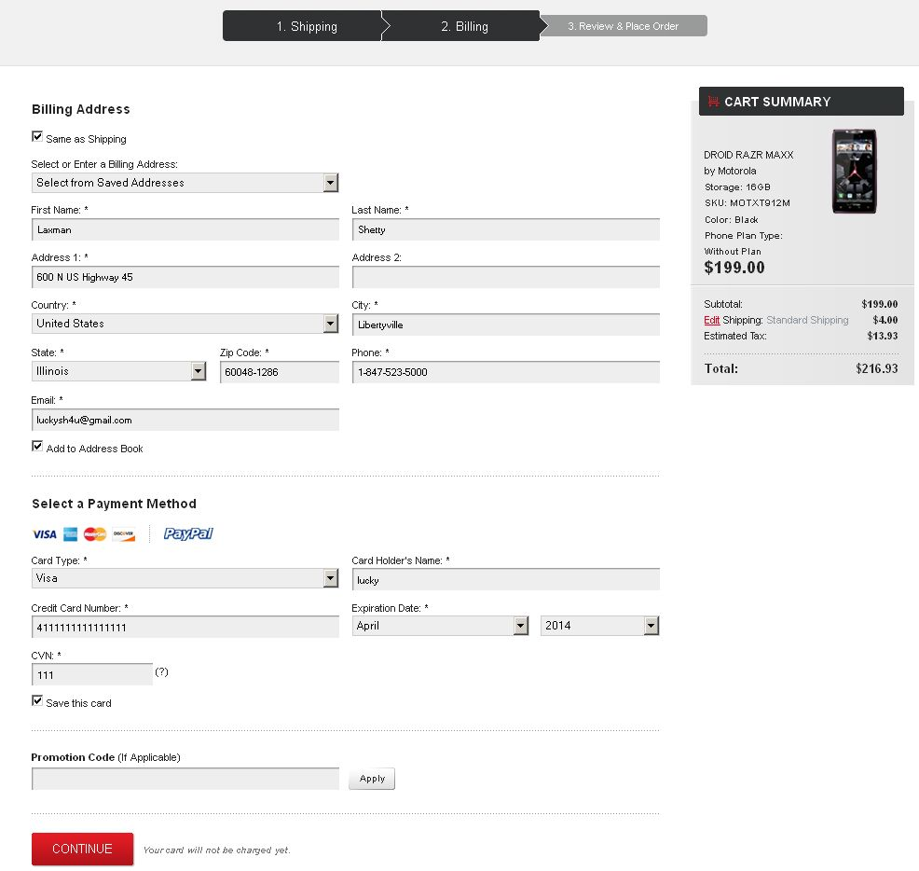
Apply your Promotion code available and click on “CONTINUE” button
Select your Payment Method and fill the entire required field.

Review your Shipping Address, Billing Address, Payment Method, Product Purchased, Total Price etc... Then click on “PLACE ORDER” button

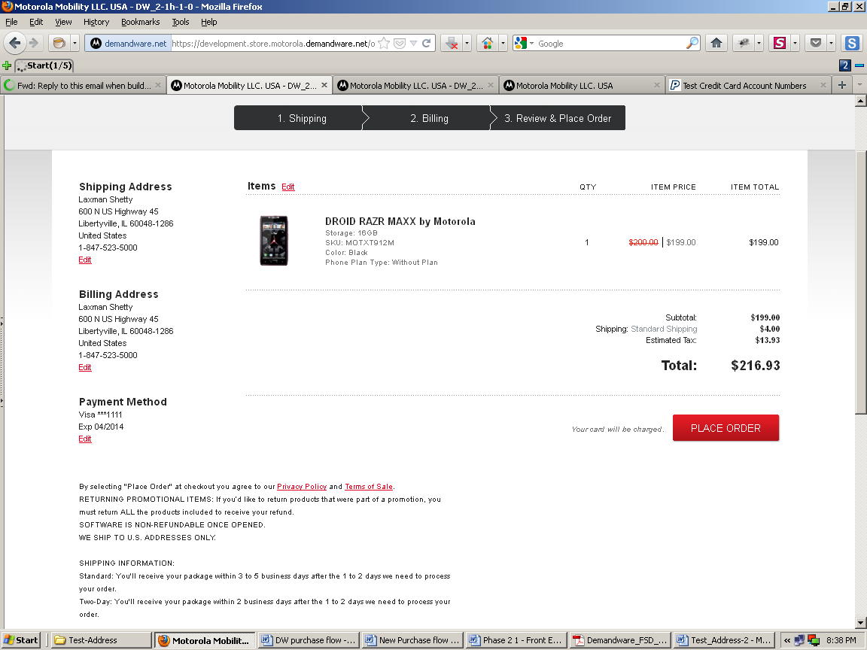

Thank you for your order!
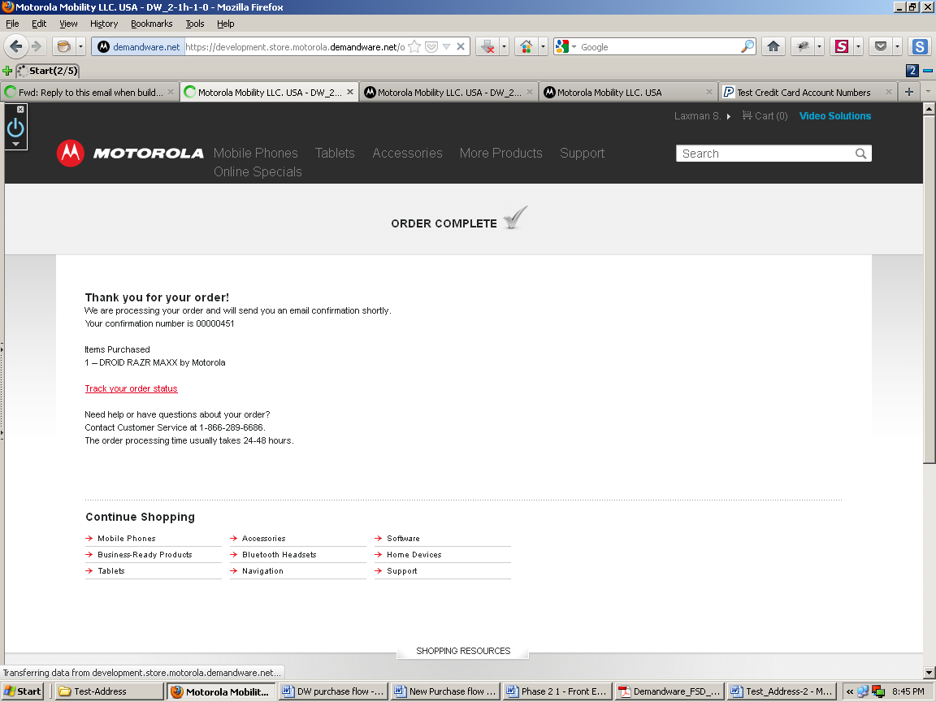

Order handling process, inventory management & pricing are maintained through “R12 Oracle Database”.

Demand-ware Purchase flow:

