Management Philosophy
Building a new future and realizing humanity's dreams by thinking creatively and tackling challenges head on
- 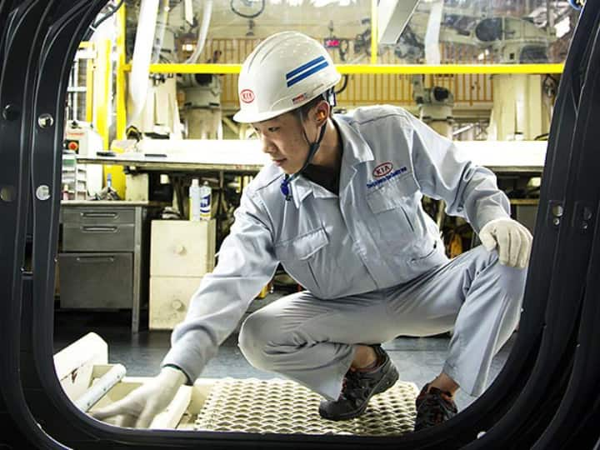

Unlimited sense of responsibility

- 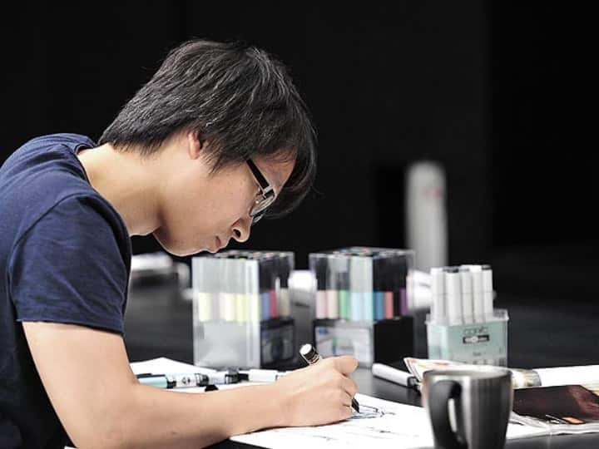Realization of possibilities
- Respect for mankind
- A business management philosophy outlines a company's reason for being while serving as a fundamental guideline that shapes the mindset and behavior of employees. The following three key phrases sum up Kia’s management philosophy: full accountability, realizing potential, and practicing humanity. These key values are encapsulated in a single mantra: 'Building a new future and realizing humanity's dreams by thinking creatively and tackling challenges head on.

Vision

Together for a better future
In 2011, Hyundai Motor Group established a new corporate vision: 'Respecting people and practicing environmental management to maximize value creation and pursue balanced and shared growth with stakeholders.' All subsidiaries will cooperate to fulfill this vision and turn Hyundai Motor Group into a top-tier global automotive group that provides customers with new value. With the greater value we create by pooling our competencies, we will strengthen the soundness of partner firms and local communities while contributing to the sustainability of humankind.

Lifetime partner in automobiles and beyond
Under the Group-level corporate vision are detailed vision statements for each key business area. For the automobile business, the vision statement is 'Providing a new space that makes life more convenient and enjoyable by realizing superlative mobility based on innovative people-oriented, eco-friendly technologies and comprehensive services. Kia will offer products and services that befit this vision of turning cars from mere modes of transport into new lifestyle spaces.

Core Values
- The core values comprise the code of conduct for employees and the organization at large. They also represent the corporate culture we strive for and the promise we make to ourselves and stakeholders. We become one by sharing the same values and applying them consistently in our decision making processes. Kia will tackle challenges head on through mutual cooperation and respect while fulfilling our pledges and embracing talent and diversity to build a distinct corporate culture.
Customer first
We promote a customer- driven corporate culture by providing the best quality and impeccable service with all values centered on our customers.
Challenges
We refuse to be complacent, embrace every opportunity for greater challenge, and are confident in achieving our goals with unwavering passion and ingenious thinking.
Communication & collaboration
We create synergy through a sense of "togetherness " that is fostered by mutual communication and cooperation within the company and with our business partners.
People
We believe the future of our organization lies in the hearts and capabilities of individual members, and will help them develop their potential by creating a corporate culture that respects talent.
Globality
We respect the diversity of cultures and customs, aspire to be the world's best at what we do, and strive to become a respected global corporate citizen.

