Mission
P.A.C. Ramasamy Raja Polytechnic College aims to provide high quality, need-based, employment oriented programs to cater to the emerging needs of industries. It strives to build creativity, innovation and distinction in students.
We aim to make our Polytechnic "An Avenue of Excellence".
Vision
Being a renowned and inevitable engineering department that attracts, trains, equips, rewards, and retains outstanding faculty, students, and staff.
We aim to mould our students as "Technocrats with Self commitment and Social responsibility".

HOD Desk
Greetings!
The department concentrates only on continuous and consistent improvement of students during their period of study here. The students are given equal / and sometimes / more opportunity to make the teaching learning process to be better and more effective.
Being an autonomous institution, we revise and update the curriculum as per the current needs of the industries. In this regard, periodical Programme Apex Committee meetings are being convened. Students are thoroughly trained in CAD/CAM software and given hands-on experience in CNC Machines. Adequate number of guest lectures, industrial visits are organised for the benefits of students. Intensive in-plant training is given to the students to be abreast of the technological advances during their summer and winter vacation holidays. The students are trained to analyse and rectify the problems of important equipment that are used in industries.
We want to make our students to be well educated, skill-trained and more applications oriented.
Goals
Short Term Goals
- To get accreditation status
- To conduct more number of industry oriented training programs
Long Term Goals
- To become a research centre in the field of Robotics
- To become an incubation centre for emerging entrepreneurs
- To become an industrial consultancy centre for turnkey project implementations, testing and training, etc.
About Us (Mechanical Engineering)
Year of establishment: 1963
About Laboratories:
The Mechanical Engineering department has full-fledged lab facilities to cater the needs of the curriculum described by the DoTE, Chennai. As an autonomous institution, we are updating the equipment for our laboratories / workshops very often to cater the needs of the industries.
About Faculty:
The department has a full strength of highly motivated and skilled faculty members, rendering their dedicated services to mould the students.
Courses offered:
Regular:
- Diploma in Mechanical Engineering
- Diploma in Mechanical Engineering (Self Finance)
Continuing Education:
- CNC part programming – Lathe & Mill
- Structural Glazing (in collaboration with Glass Academy, a sister concern of Saint-Gobain India limited, Chennai)
- Basic & Advanced Electro pneumatics

Student Strength

First Year | 60 + 60 (SF) students
Second year | 72 + 72 (SF) students
Third year | 72 + 72 (SF) students

Activities
Staff / Department activity
Publications:
Year | Name of the Staff | Details of the Publication | Title of the Article
2009-2010 | R.Karthikeyan | International journal of Technology and Engineering System, Vol.No.1, Jan-June 2010 | Industry Linkages and Partnership to Institute

Sponsored programs
Consultancy
Collaboration (Industrial/ Institutional):
In Collaboration with M/s ETA-ASCON, Dubai, one of our faculties was deputed to conduct training programs for their employees at their Dubai office.
Sl.  No. | Name of the staff | Title | Duration
1 | G. Ganesh Kumar | Advanced CAD Training on MEP | 3rd to 22nd January 2008
2 | G. Ganesh Kumar | Advanced CAD Training on MEP | 13th to 22nd May 2010

Collaboration with M/s ETA-ASCON, Dubai and M/s VOLTAS, Dubai to provide technical training for their Mechanical Foremen & Supervisors. Academic part of the training is provided in our premises by our department faculties and field training is given at their project site.
Batch | Entry  Level | Training Period | Duration
ETA Batch 1 | HSC/ITI | 15.09.2004 to 9.12.2006 | 2 Years & 3 Month
ETA Batch 2 | HSC/ITI | 01.08.2005 to 9.08.2007 | 2 Years
ETA Batch 3 | HSC/ITI | 04.01.2007 to 3.01.2008 | 1 Year
ETA Batch 4 | DME | 07.05.2007 to 8.07.2007 | 3 Months
ETA Batch 5 | HSC/ITI | 24.09.2007 to 19.09.2008 | 1 Year
ETA Diploma 2 | DME | 16.10.2007 to 5.01.2008 | 3 Months
ETA Batch 1 | HSC/ITI | 20.10.2008 to 10.10.2009 | 1 Year
Voltas Batch 1 | DME | 12.09.2005 to 09.03.2006 | 6 months
Voltas Batch 2 | ITI | 04.02.2008 to 24.05.2008 | 4 Months
Voltas Batch 3 | DME | 28.04.2008 to 27.08.2008 | 1 Year
Voltas Batch 4 | DME | 01.07.2010 to 02.11.2010 | 4 Months

Conference, Seminars & Staff development programme

Year | No. of faculty members deputed
2007 – 2008 | 6
2008 – 2009 | 8
2009 – 2010 | 8
2010– 2011 | 12

Student Activity
Department Association, IE (I) & ISTE Student’s chapter
Year |  | 2008 – 2009 | 2009 - 2010 | 2010 - 2011
Name of the activity | PACR Tech Fest | Yearly once | Yearly once | Yearly once
Name of the activity | INPLANT Trainning for II year students | 2 semesters | 2 semesters | 2 semesters
Name of the activity | Guest Lecture | 3 | 4 | 3
Name of the activity | Class room seminars | 1 | 3 | 3
Name of the activity | Paper Presentation | 2 | 1 | 1
Name of the activity | Educational tour | 1 | - | 1
Name of the activity | Industrial visit | 7 | 20 | 9
Name of the activity | Film Show | 2 | 2 | 2
Name of the activity | Alumni interaction | 1 | 1 | 1
Name of the activity | Technical quiz | 1 | 1 | 1
Name of the activity | Model Making contest | 1 | 1 | 1

Special Guest lectures
Year | Topic
2011-2012 | Electrical Drive systems for CNC Machines
2011-2012 | Play with Success
2011-2012 | Sky is Attainable
2011-2012 | Structural Glazing
2011-2012 | Power Plant Engineering
2011-2012 | Eco friendly Welding Process
2011-2012 | Structural Glazing
2011-2012 | Way to success
2011-2012 | Personality Development
2010-2011 | Fire Safety & Personal Protective Equipment
2010-2011 | Entrepreneurship Skills
2010-2011 | Merchant Navy
2010-2011 | Engine Management System
2009-2010 | Renewable Energy Resources
2009-2010 | Disaster Management
2009-2010 | Green Earth
2009-2010 | Computer Networking
2009-2010 | Water Treatment Plants
2009-2010 | Power Transmission System
2008-2009 | Entrepreneurship Development Program
2008-2009 | Yoga for youth excellence
2008-2009 | Occupational Health & Safety
2008-2009 | Fire Safety & Personal Protective Equipments
2008-2009 | An overview of Computers & Networking

Awards
Staff award
Year | Award | Guide/Staff Name
2004 – 2005 | State Level second prize and Regional level first prize for the project work ‘ Label printer for container’ | R.Balasubramanian
2009 - 2010 | Best paper award under Qualitative Analysis at the International conference on “Advances in Industrial Engineering Applications” held at Anna University, Chennai | R.Karthikeyan
2010-2011 | “ISTE Best Polytechnic College Teacher Award’ in the 14th ISTE State Level Convention held at Mahendra Engineering College, Namakkal. | R.Karthikeyan

Student award
a) In Inter-Departmental Competitions:
Nature of Activity | Number of Students enrolled  (6 students/project) | Recognition /Awards  received, if any
Project work contest  2008-09 | 18 | Cash award ( 6 students )
Paper presentation contest | 4 | -
Project work contest  2009-10 | 18 | Cash award ( 6 students )
Paper presentation contest | 4 | -
Project work contest  2010-11 | 18 | Cash award ( 6 students )
Paper presentation contest | 4 | -

b) In Inter-Institutional Competitions:
Nature of Activity | Number of Students Enrolled | Recognition / Awards  received, if any
2008-09  Paper presentation contest | 1 | -
Project work contest | 12 | -
2009-10  Technical paper presentation contest | 8 | II Prize - 1
Project work contest | 6 | -
2010-11  State level Technical symposium | 3 | Runner(1)
Quiz contest | 2 | -

17.0 EXTRA-CURRICULAR ACTIVITIES OF THE STUDENTS:
a) In Inter-Departmental Competitions:
Nature of Activity | Number of Students enrolled | Recognition /Awards  received, if any
2008-09
NSS | 20 | -
NCC | 20 | Got ‘C’ certificate(2)
2009-10
Football | 2 | Runner
NSS | 16 | -
NCC | 19 | Got ‘C’ certificate(4)  Got ‘B’ certificate(1)0
2010-11
NCC | 18 | Got ‘C’ certificate(2)
NSS | 22 | -
Athletics | 10 | Winner - 7  Runner – 3
Chess | 2 | Winner

b) In Inter-Institutional Competitions:

Nature of Activity | Number of Students enrolled | Recognition /Awards  received, if any
2008-09
Divisional Kho-Kho | 2 | Winner
Divisional basket ball | 4 | Winner
State level Kho-Kho | 2 | Runner
Divisional Cricket | 1 | -
Divisional Ball Badminton | 2 | -
Athletics | 2 | -
2009-10
Divisional basket ball | 2 | Runner
Divisional Ball Badminton | 1 | Runner
Divisional Kho-Kho | 2 | Runner
Divisional Hockey | 2 | -
Divisional Cricket | 1 | -
Divisional Handball | 1 | -
2010-11
Divisional basket ball | 1 | -
Dance | 1 | Runner
Chess | 3 | -
Painting | 2 | -

PLACEMENT:

Year(Y) | No. of companies | Number of students selected | Average salary/Annum | Highest salary offered/Annum
2010-2011 | 11 | 53 | 96,000 | 2,54,568
2009-2010 | 11 | 63 | 87,000 | 1,56,000
2008-2009 | 10 | 39 | 63,300 | 95,0000
2007-2008 | 14 | 61 | 64,920 | 1,28,000

Facilities
(a) Laboratories:
- Fitting & Heat Engines Lab
- Carpentry, Foundry & Smithy lab
- Lathe & Welding Workshop
- Special Machines Workshop
- Sheet Metal & Automobile Lab
- CNC Machines Lab
- Computer Centre (CAD Design Suite)

(b) Major Equipment in the laboratories ( costing >=Rs.50,000 /-)
- Cochran Boiler
- TIG Welding Machine
- Rectifier welding m/c
- Hydraulics Power Hacksaw
- Medium Duty Lathe – Payal, Crown Brand
- Radial Drilling Machine - Master
- Vertical Milling Machine - Batliboi
- Single Spindle Automatic Lathe – Chera
- Hydraulic Surface Grinding Machine - Master
- CNC-Train Master Lathe – HMT
- Maxturn CNC lathe – MTAB
- Horizontal Universal Milling Machine – Master
- CNC Milling – MTAB
- Manual surface grinding machine – Parrot
- Universal Gear Hobbing Machine - Laxmi Joyt
- Universal Milling Machine – Hanspal
- Cylindrical Grinding Machine - Devco

DEPARTMENTAL LIBRARY:
Number available in the department
Books | Journals |  | CDs, VCDs Multimedia | Any other, please specify
Books | National | International | CDs, VCDs Multimedia | Any other, please specify
285 | 2 | - | CDs – 16Nos | Project Reports - 81

Faculty

Faculty Profile: (Full Time – Regular)

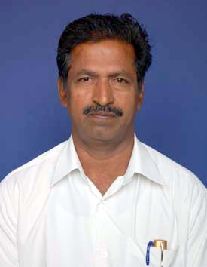
Name | : | V.Balakrishnan
Date of Birth | : | 19.06.62
Designation | : | Lecturer (SG)
Highest Qualification | : | BE
Date of Joining the Present Post | : | 19.08.09
Date of Joining the Institution | : | 16.06.89
Mobile Numbers | : | 9150825624

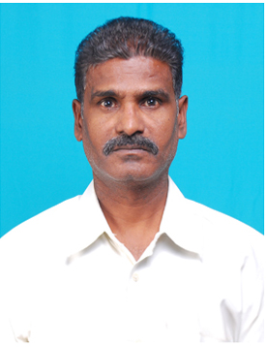
Name | : | K.Sundararaj
Date of Birth | : | 15.01.61
Designation | : | Workshop Superintendent
Highest Qualification | : | BE
Date of Joining the Present Post | : | 22.11.04
Date of Joining the Institution | : | 17.08.84
Mobile Numbers | : | 9150780565

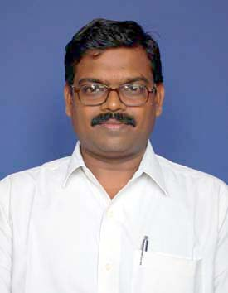
Name | : | R.Karthikeyan
Date of Birth | : | 28.05.72
Designation | : | Lecturer (HOD Incharge / Mechanical Engg. – SF )
Highest Qualification | : | ME
Date of Joining the Present Post | : | 14.06.04
Date of Joining the Institution | : | 14.06.04
Mobile Numbers | : | 9894732731

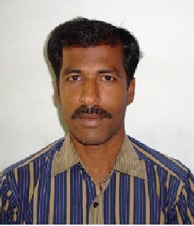
Name | : | S.Selvakumar
Date of Birth | : | 03.05.77
Designation | : | Lecturer
Highest Qualification | : | ME
Date of Joining the Present Post | : | 28.02.11
Date of Joining the Institution | : | 28.02.11
Mobile Numbers | : | 9976936396

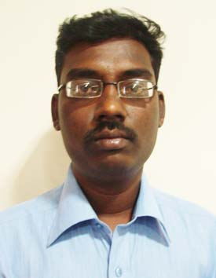
Name | : | R.Senthilkumar
Date of Birth | : | 18.12.82
Designation | : | Lecturer
Highest Qualification | : | BE
Date of Joining the Present Post | : | 09.03.11
Date of Joining the Institution | : | 09.03.11
Mobile Numbers | : | 8220699990

Faculty Profile: (Full Time – Self Finance)
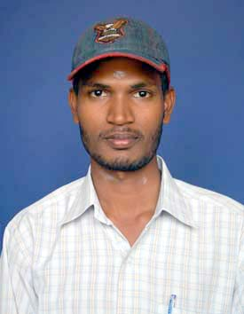
Name | : | P.Pon Mareeswaran
Date of Birth | : | 16.06.88
Designation | : | Lecturer (SF)
Highest Qualification | : | BE
Date of Joining the Present Post | : | 02.09.10
Date of Joining the Institution | : | 02.09.10
Mobile Numbers | : | 9791266336

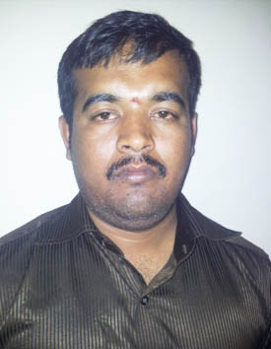
Name | : | B.Mariselvam
Date of Birth | : | 08.04.83
Designation | : | Lecturer (SF)
Highest Qualification | : | BE
Date of Joining the Present Post | : | 28.11.11
Date of Joining the Institution | : | 28.11.11
Mobile Numbers | : | 9941323695

Non-Teaching Staff (technical) profile:

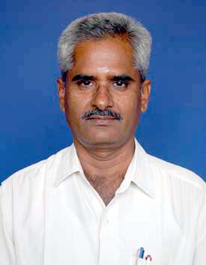
Name | : | R.Balasubramanian
Date of Birth | : | 03.05.56
Designation | : | JDO
Highest Qualification | : | DME
Date of Joining the Present Post | : | 07.04.97
Date of Joining the Institution | : | 06.08.77
Mobile Numbers | : | 9843425065

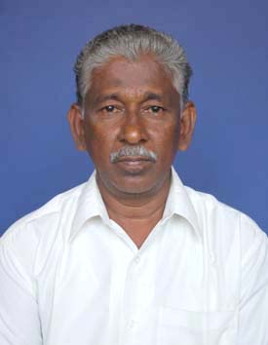
Name | : | A.Pathianathan
Date of Birth | : | 05.03.57
Designation | : | Workshop Instructor
Highest Qualification | : | ITI
Date of Joining the Present Post | : | 15.07.09
Date of Joining the Institution | : | 17.08.79
Mobile Numbers | : | 9150872348

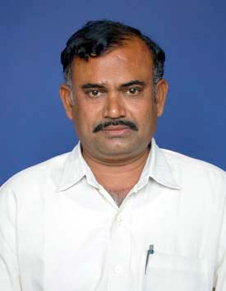
Name | : | K.Murugan
Date of Birth | : | 08.05.59
Designation | : | Workshop Instructor
Highest Qualification | : | ITI
Date of Joining the Present Post | : | 01.03.10
Date of Joining the Institution | : | 21.08.86
Mobile Numbers | : | 9865367004

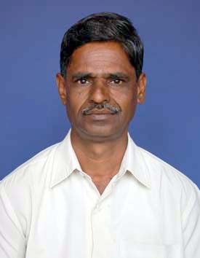
Name | : | P.Raju
Date of Birth | : | 15.05.61
Designation | : | Workshop Instructor
Highest Qualification | : | ITI
Date of Joining the Present Post | : | 01.03.11
Date of Joining the Institution | : | 02.12.81
Mobile Numbers | : | 9865806831

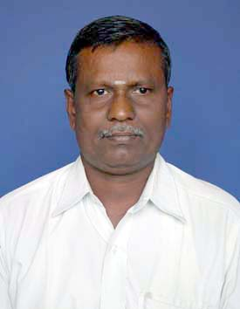
Name | : | A.Mariappan
Date of Birth | : | 26.05.64
Designation | : | Workshop Instructor
Highest Qualification | : | ITI
Date of Joining the Present Post | : | 01.04.11
Date of Joining the Institution | : | 13.06.90
Mobile Numbers | : | 9789512299

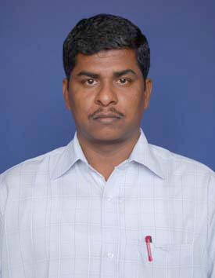
Name | : | G.Ganeshkumar
Date of Birth | : | 12.07.76
Designation | : | Workshop Instructor & System Administrator
Highest Qualification | : | BE
Date of Joining the Present Post | : | 22.06.11
Date of Joining the Institution | : | 22.06.11
Mobile Numbers | : | 9894155580

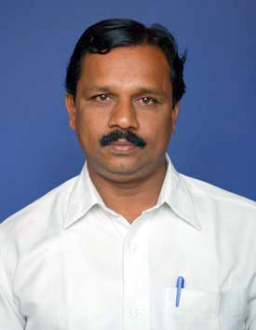
Name | : | P.Selvaraj
Date of Birth | : | 19.04.69
Designation | : | Lab Assistant
Highest Qualification | : | ITI
Date of Joining the Present Post | : | 23.08.89
Date of Joining the Institution | : | 23.08.89
Mobile Numbers | : | 9788673821

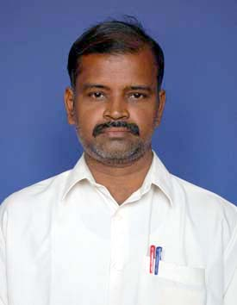
Name | : | S.Sithick
Date of Birth | : | 17.05.69
Designation | : | Skilled Assistant
Highest Qualification | : | HSC, ITI
Date of Joining the Present Post | : | 03.01.90
Date of Joining the Institution | : | 03.01.90
Mobile Numbers | : | 9943743630

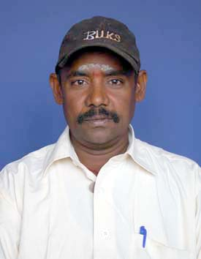
Name | : | M.Kathiresan
Date of Birth | : | 21.05.69
Designation | : | Skilled Assistant
Highest Qualification | : | ITI
Date of Joining the Present Post | : | 01.07.98
Date of Joining the Institution | : | 01.07.98
Mobile Numbers | : | 9597685943

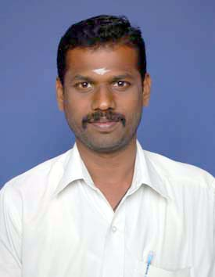
Name | : | K.Chandrasekaran
Date of Birth | : | 03.05.75
Designation | : | Skilled Assistant
Highest Qualification | : | ITI
Date of Joining the Present Post | : | 01.02.99
Date of Joining the Institution | : | 01.02.99
Mobile Numbers | : | 8428307779

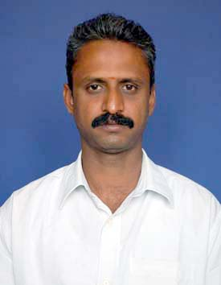
Name | : | N.Krishna Kumar
Date of Birth | : | 24.05.74
Designation | : | Lab Assistant
Highest Qualification | : | ITI
Date of Joining the Present Post | : | 01.09.99
Date of Joining the Institution | : | 01.09.99
Mobile Numbers | : | 9894899920

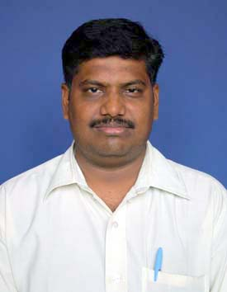
Name | : | P.Velmurugan
Date of Birth | : | 16.05.75
Designation | : | Skilled Assistant
Highest Qualification | : | ITI
Date of Joining the Present Post | : | 20.08.10
Date of Joining the Institution | : | 20.08.10
Mobile Numbers | : | 9789160839

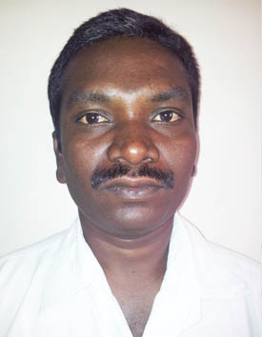
Name | : | I.Masilamani
Date of Birth | : | 28.05.77
Designation | : | Skilled Assistant
Highest Qualification | : | ITI
Date of Joining the Present Post | : | 21.03.11
Date of Joining the Institution | : | 21.03.11
Mobile Numbers | : | 9444708814

