Introduction to pavement design
Introduction:
A highway pavement is a structure consisting of superimposed layers of processed materials above the natural soil sub-grade, whose primary function is to distribute the applied vehicle loads to the sub-grade. The pavement structure should be able to provide a surface of acceptable riding quality, adequate skid resistance, favorable light reflecting characteristics, and low noise pollution. The ultimate aim is to ensure that the transmitted stresses due to wheel load are sufficiently reduced, so that they will not exceed bearing capacity of the subgrade. Two types of pavements are generally recognized as serving this purpose, namely flexible pavements and rigid pavements.

Requirements of a pavement:
An ideal pavement should meet the following requirements:
- Sufficient thickness to distribute the wheel load stresses to a safe value on the sub-grade soil,
- Structurally strong to withstand all types of stresses imposed upon it,
- Adequate coefficient of friction to prevent skidding of vehicles,
- Smooth surface to provide comfort to road users even at high speed,
- Produce least noise from moving vehicles,
- Dust proof surface so that traffic safety is not impaired by reducing visibility
- Impervious surface, so that sub-grade soil is well protected, and
- Long design life with low maintenance cost.
Types of pavements:
The pavements can be classified based on the structural performance into two, flexible pavements and rigid pavements. In flexible pavements, wheel loads are transferred by grain-to-grain contact of the aggregate through the granular structure. The flexible pavement, having less flexural strength, acts like a flexible sheet.
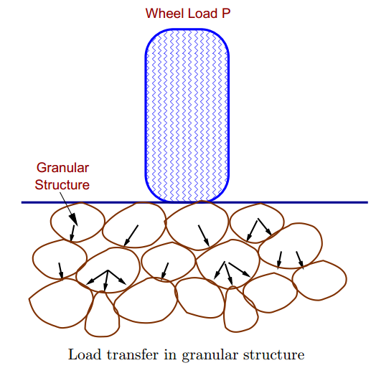
On the contrary, in rigid pavements, wheel loads are transferred to sub-grade soil by flexural strength of the pavement and the pavement acts like a rigid plate (e.g. cement concrete roads). In addition to these, composite pavements are also available. A thin layer of flexible pavement over rigid pavement is an ideal pavement with most desirable characteristics. However, such pavements are rarely used in new construction because of high cost and complex analysis required.
Flexible pavements:
Flexible pavements will transmit wheel load stresses to the lower layers by grain-to-grain transfer through the points of contact in the granular structure. The wheel load acting on the pavement will be distributed to a wider area, and the stress decreases with the depth. Taking advantage of this stress distribution characteristic, flexible pavements normally has many layers. Hence, the design of flexible pavement uses the concept of layered system. Based on this, flexible pavement may be constructed in a number of layers and the top layer has to be of best quality to sustain maximum compressive stress, in addition to wear and tear. The lower layers will experience lesser magnitude of stress and low quality material can be used. Flexible pavements are constructed using bituminous materials. These can be either in the form of surface treatments (such as bituminous surface treatments generally found on low volume roads) or, asphalt concrete surface courses (generally used on high volume roads such as national highways). Flexible pavement layers reflect the deformation of the lower layers on to the surface layer (e.g., if there is any undulation in sub-grade then it will be transferred to the surface layer). In the case of flexible pavement, the design is based on overall performance of flexible pavement, and the stresses produced should be kept well below the allowable stresses of each pavement layer.
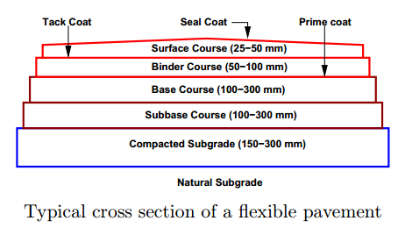

Types of Flexible Pavements:

