Quantity Survey and Contract Documents

DEFINITION OF ESTIMATING AND COSTING:
Estimating is the technique of calculating or Computing the various quantities and the expected Expenditure to be incurred on a particular work or project.
In case the funds available are less than the estimated cost the work
is done in part or by reducing it or specifications are altered, the following requirements are necessary for preparing an estimate.
- Drawings like plan, elevation and sections of important points.
- Detailed specifications about workmanship & properties of materials etc.
- Standard schedule of rates of the current year.
NEED FOR ESTIMATION AND COSTING:
Estimate give an idea of the cost of the work and hence its
Feasibility can be determined i.e.
- Whether the project could be taken up with in the funds available or not.
- Estimate gives an idea of time required for the completion of the work.
- Estimate is required to invite the tenders and Quotations and to arrange contract.
- Estimate is also required to control the expenditure during these execution of work.
- Estimate decides whether the proposed plan matches the funds available or not.
DATA REQUIRED TO PREPARE AN ESTIMATE:
- Drawings i.e. Plans, elevations, sections etc.
- Specifications.
- Rates
DRAWINGS:
If the drawings are not clear and without complete dimensions the
Preparation of estimation become very difficult. So, It is very essential
Before preparing an estimate.
SPECIFICATIONS
- General Specifications: This gives the nature, quality, class and work and materials in general terms to be used in various parts of work. It helps no form a general idea of building.
- Detailed Specifications: These gives the detailed description of the various items of work laying down the Quantities and qualities of materials, their proportions, the method of preparation workmanship and execution of work.
RATES:
For preparing the estimate the unit rates of each item of work are required.
- For arriving at the unit rates of each item.
- The rates of various materials to be used in the construction.
- The cost of transport materials.
- The wages of labour, skilled or unskilled of masons, carpenters, Mazdoor, etc.
COMPLETE ESTIMATE:
Most of people think that the estimate of a structure includes cost of land, cost of materials and labor, But many other direct and indirect costs included and is shown below.
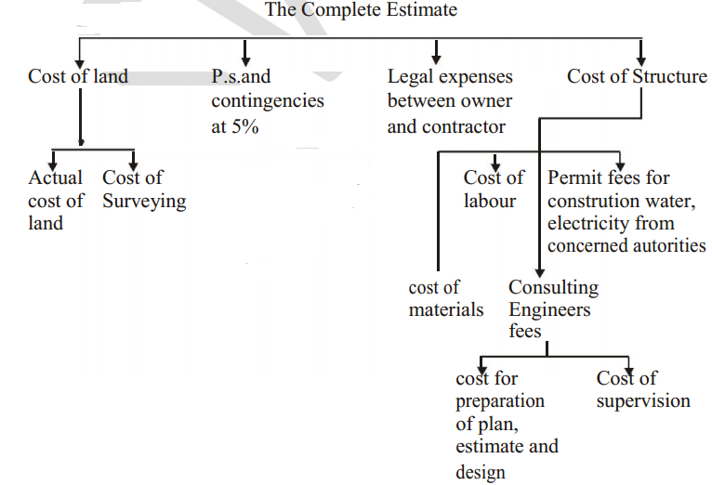

LUMPSUM:
While preparing an estimate, it is not possible to work out in detail in case of petty items. Items other than civil engineering such items are called lumpsum items or simply L.S.Items.
The following are some of L.S. Items in the estimate.
- Water supply and sanitary arrangements.
- Electrical installations like meter, motor, etc.,
- Architectural features.
- Contingencies and unforeseen items.
In general, certain percentage on the cost of estimation is allotted for the above L.S.Items.
WORK CHARGED ESTABLISHMENT:
During the construction of a project considerable number of skilled supervisors, work assistance, watch men etc., are employed on temporary basis. The salaries of these persons are drawn from the L.S. amount allotted towards the work charged establishment. That is, establishment which is charged directly to work. An L.S.amount of 1 to 2% of the estimated cost is provided towards the work charged establishment.

UNITS OF MEASUREMENTS:
The units of measurements are mainly categorized for their nature, shape and size and for making payments to the contractor. The principle of units of measurements normally consists the following:
- Single units work like doors, windows, trusses etc. are expressed in numbers.
- Works consists linear measurements involve length like cornice, fencing, hand rail, bands of specified width etc., are expressed in running meters (RM)
- Works consists areal surface measurements involve area like plastering, white washing, partitions of specified thickness etc., are expressed in square meters (m2)
- Works consists cubical contents which involve volume like earth work, cement concrete, Masonry etc are expressed in Cubic metres.

