Days Sales Outstanding - DSO

DEFINITION of 'Days Sales Outstanding - DSO'
A measure of the average number of days that a company takes to collect revenue after a sale has been made.
A low DSO number means that it takes a company fewer days to collect its accounts receivable.
A high DSO number shows that a company is selling its product to customers on credit and taking longer to collect money.
Days sales outstanding is calculated as:
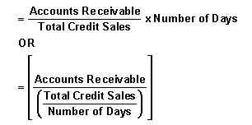

INVESTOPEDIA EXPLAINS 'Days Sales Outstanding - DSO'
Due to the high importance of cash in running a business, it is in a company's best interest to collect outstanding receivables as quickly as possible.
By quickly turning sales into cash, a company has the chance to put the cash to use again - ideally, to reinvest and make more sales.
The DSO can be used to determine whether a company is trying to disguise weak sales, or is generally being ineffective at bringing money in.
For most businesses, DSO is looked at either quarterly or annually.
For more on DSO and how to lower it, read Understanding The Cash Conversion Cycle and Speed Up Receivables To Avoid A Cash Crunch
Refine Your Financial Vocabulary
Gain the Financial Knowledge You Need to Succeed.
Investopedia’s FREE Term of the Day helps you gain a better understanding of all things financial with technical and easy-to-understand explanations.
Click here to begin developing your financial language with this daily newsletter.

