GRA 310 Uploading Your Files to Geocities

- If you have not done so already, create a free account at Geocities.ws, as shown in Figure 1.1.

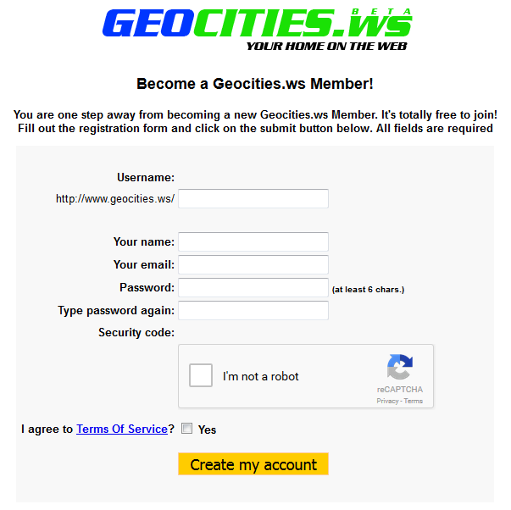
Figure 1.1

Note: Do not use a password that is associated with any other accounts (email, Facebook, etc.). This is not only a best practice, but crucial in this case because Geocities uses an unsecured FTP connection and this password will be transmitted in an unsecure fashion.

- As shown in Figure 1.2, log into your new account at members.geocities.ws and you will see the following information:

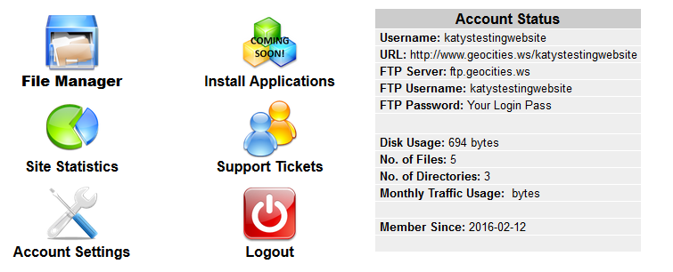
Figure 1.2

- Note the details in the Account Status table and open Cyberduck.

- As shown in Figure 1.3, click the Open Connection button at the top left of the window and enter the server details. When you are finished, click the Connect button.

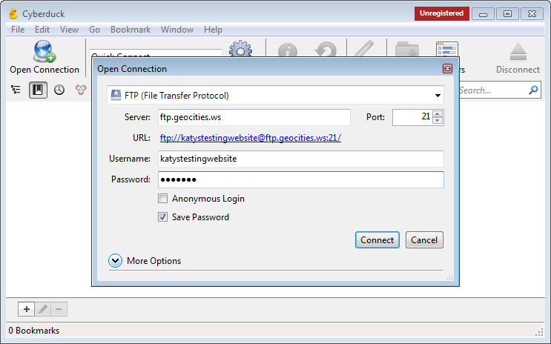
Figure 1.3

Note: Make sure the connection type is “FTP (File Transfer Protocol)” and the Port is set to 21.

- As shown in Figure 1.4, a dialog box will appear warning of an unsecured FTP connection. Click Continue.

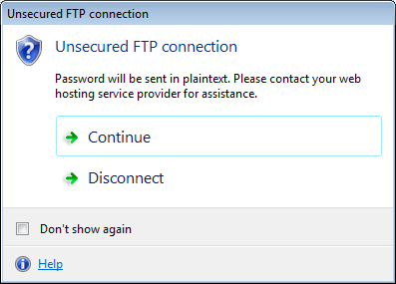
Figure 1.4

- As shown in Figure 1.5, if this is your first time using Geocities.ws, you will see one file (index.php) in the root folder. This is a pre-generated file that the hosting provider creates for all new accounts. This file may be deleted and replaced with your own work. To delete this file, right-click on it and click Delete.

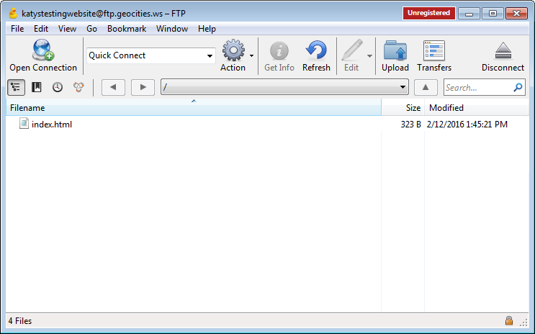
Figure 1.5

- As shown in Figure 1.6, to upload your files, open the local folder on your computer and drag the desired folders to Cyberduck. You may also click the Upload button in Cyberduck and navigate to the desired file/folder(s).

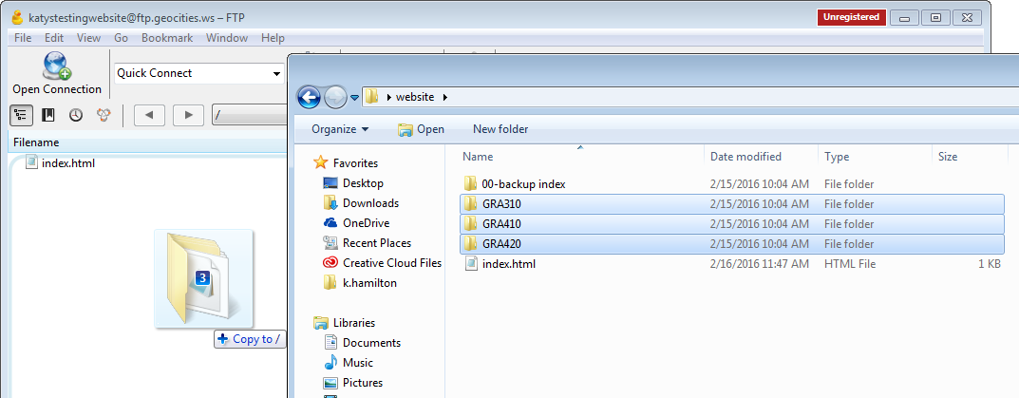

Figure 1.6

Note: Make sure each site’s files are inside a folder with the class number (e.g., GRA310, GRA410, etc.). If you only have one class website, this page should only need one link.

- As shown in Figure 1.7, a dialog box showing your file transfers will appear. You may close this when your transfers are complete.

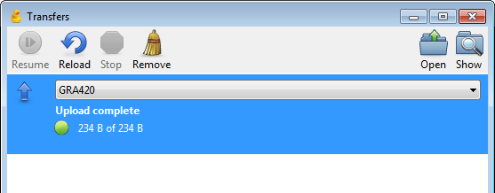
Figure 1.7

- As shown in Figure 1.8, if you have not done so already, create a barebones main navigation page named index.html with a link to each of your class websites and place it in the root folder.

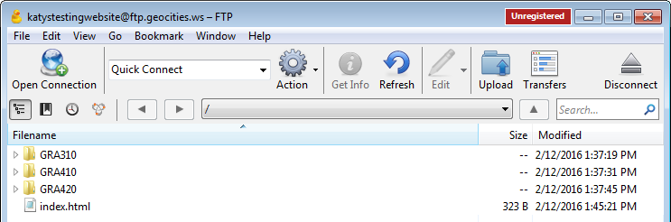

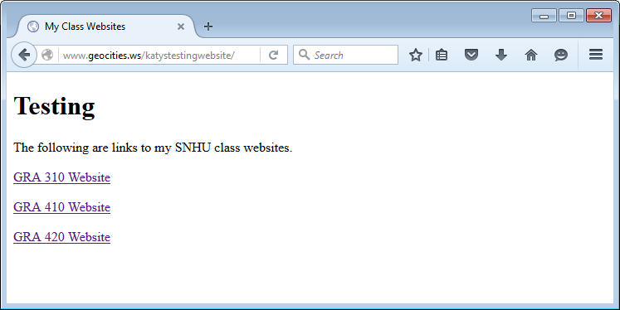
Figure 1.8

Note: Your website can be accessed by visiting www.geocities.ws/[YOUR ACCOUNT NAME] where YOUR ACCOUNT NAME is the name of the account you created when you signed up for web hosting.

