JPI Group of Colleges Faisalabad
Time: 30 mint Jinnah College of Science ,Commerce & Technology Marks:20
Subject Name: Electronics 1 Paper: (Objective)
Note: Encircle the correct Answer. Use of lead pencil, over cutting and rewriting are not allowed
- An atom consists of
- One nucleus and only one electron c)One nucleus and one or more electrons
- Protons, electrons, and neutrons

- Valence electrons are
- In the closest orbit to the nucleus c) In the most distant orbit from the nucleus
- In various orbits around nucleus d) Not associated with a particular atom
- The most widely used semiconductive material in electronic devices is

- Germanium (b)Carbon (c)Copper (d)Silicon

- The current in a semiconductor is produced by
- Electrons only b)Holes only c)Negative ions
d)Both electrons and holes

- The process of adding an impurity to an intrinsic semiconductor is called
- Dopping b)Recombination c)Atomic modification d)Ionization

- A pn junction is formed by
- The recombination of electrons and holes
- Ionization
- The boundary of a p-type and an n-type material
- The collision of a proton and a neutron

- The depletion region is created by
- Ionization (b) Diffusion c) Recombination d) a&b&c

- The term bias means
- The ratio of majority carrier to minority carriers
- The amount of current across a diode
- A Dc voltage is applied to control the operation of a device
- Neither a,b or c

- The depletion region consists of
- Nothing but minority carrier c) Positive and negative ions
- No majority carriers d) Answer (b) and (c)

- When a diode is forward bias
- The only current is hole current
- The only current is electron current
- The only current is produced by majority carrriers
- The current is produced by both holes and electrons

- Although current is blocked in reverse bias,
- There is some current due to majority carriers
- There is a very small current due to minority carriers
- There is an avalanche current

- For a silicon diode, the value of the forward bias voltage typically
- Must be greater than 0.3V
- Must be greater than 0.7V
- Depends on the width of the depletion region
- Depends on the concentration of majority carriers

- When forward baised, a diode
- Blocks currents b)Conducts current c) Has a high resistance d) Drops a large voltage

- When a voltmeter is placed across a forward biased diode, it will read a voltage approximately equal to
- The bias battery voltage c) 0V
- The diode barrier potential d) The total circuit voltage

- The positive lead of an ohmmeter is connected to the anode of a diode and the negative lead is connected to the cathode. The diode is
- Reversed biased b)Open c)Forward biased d)Fautly

- the average value of a half wave rectified voltage with a peak value of 200V is
- 63.7 V (b)127.3 V (c)141 V (d)0 V

- When a 60 Hz sinusoidal voltage is applied to the input of a full wave rectifier, the output frequency is
- 120 Hz (b)60 Hz (c)240 Hz (d)0 Hz

- The total secondary voltage in a center tapped full wave rectifier is 125 V. neglecting the diode drop, the output voltage is
- 125 V (b)177 V (c)100 V (d)62.5 V

- The ideal dc output voltage of a capacitor input filter is equal to
- The peak value of the rectified voltage
- The average value of the rectified voltage
- The rms value of the rectified voltage

- If the load resistance of a capacitor filtered full wave rectifier is reduced, the ripple voltage
- Increases b)Decreases c) Is not affected d) Has a different frequency

JPI Group of Colleges Faisalabad
Time: 1:30hrs Jinnah College of Science ,Commerce & Technology Marks:30
Subject Name: Electronics 1 Paper: (Subjective)

Question # 2
- Determine the forward voltage and forward current for the diode in figure (a) for each of the diode models. Also find the voltage across the limiting resistors in each case. Assume r`d=10Ω at the determined value of forward current.
- Determine the reverse voltage and reverse current for the diode in figure (b) for each of the diode models. Also find the voltage across the limiting resistor in each case. Assume Ir=1µA.
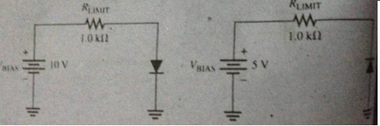

Question # 3
Determine the ripple factor for the filtered bridge rectifier with a load as indicated in figure.
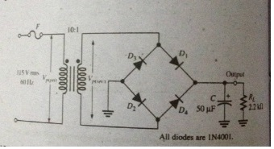

Question # 4
- What would you expect to see displayed on an oscilloscope connected across RL in the limiter shown.
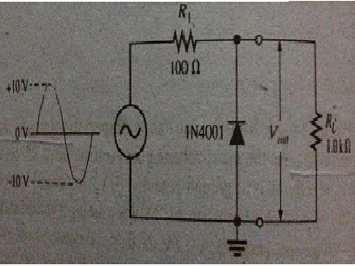
- Describe the output voltage waveform for the diode limiter in figure below.
