Perpetual Inventory System

When the perpetual inventory system is used, there is a continuous or perpetual record of inventory recorded in the inventory account.

When a company purchases product, it is immediately recorded as inventory.
When the products are sold, the inventory balance is immediately reduced (credited) and recorded in cost of goods sold.

Whereas the periodic inventory system uses the purchases account and its contra accounts to record net purchases throughout the year (purchases less returns and discounts in the contra accounts), the perpetual inventory system records all transactions affecting inventory directly in the inventory account, including all purchases, sales, inventory returns and inventory discounts.

Inventory Accounting: Periodic Inventory vs.
Perpetual Inventory Reporting

Using the perpetual inventory system has several distinct advantages over periodic inventory:
1.
Perpetual inventory provides for an immediate measure of inventory throughout the year to meet demand, as opposed to only once a year.
2.
Perpetual inventory does not rely on an end of year count to determine cost of goods sold.
3.
Perpetual inventory does not assume anything outside of the ending inventory balance was part of cost of goods sold.
Perpetual inventory can better measure theft, damage, and other causes of inventory shortages by comparing items sold with items on hand.

Small business accounting software packages make it much simpler and cost-effective to monitor inventory levels using the perpetual inventory system throughout the year.

Perpetual Inventory and the Inventory Count

Though an inventory count should be taken once a year to measure and match inventory records, the perpetual inventory system does not depend on this count to determine cost of goods sold, but is used to verify inventory records.
Therefore, a potentially costly and time-consuming year-end inventory count that may interfere with normal business operations is not required.
Rather, when a company uses the perpetual inventory system, a physical inventory count can be made routinely throughout the year to match perpetual inventory reporting records.

Perpetual Inventory Accounting Examples

The following journal entries illustrate the perpetual inventory system.
The two main differences between the perpetual inventory journal entries and the periodic inventory journal entries are that:
1.
The periodic inventory system uses a purchases account, whereas perpetual inventory uses the inventory account directly.
2.
Using perpetual inventory adds another journal entry after a sale to reduce the inventory balance, whereas the periodic inventory system adjusts the inventory balance at year end after a physical count of inventory items.

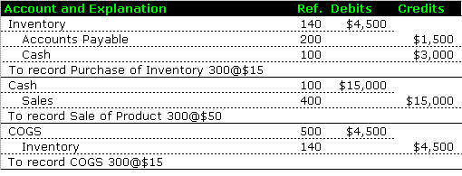

Perpetual Inventory Accounting Examples: Inventory Purchase and Sale

Items purchased for resale are recorded directly in the inventory account in the perpetual inventory system.
Additionally, a journal entry is added to reduce the inventory balance based on the number of items sold, in this case 300 units @$15 each.

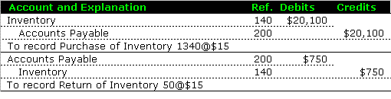

Perpetual Inventory Accounting Examples: Inventory Returns

In the above example, a return of inventory directly reduces the inventory balance with a credit for the returned items.
Companies using periodic inventory, on the other hand, reduce the purchases account with a credit to the contra account purchase returns.

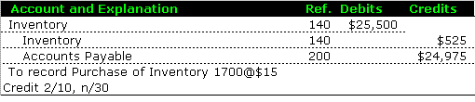

Inventory Accounting: Perpetual Inventory and Discounts

