Jasmine Shaw
Professor Williams
GRA 410
30 July 2023
4-1 Final Project Milestone 3: Digital Mock-Ups of Web Design

Widescreen Desktop
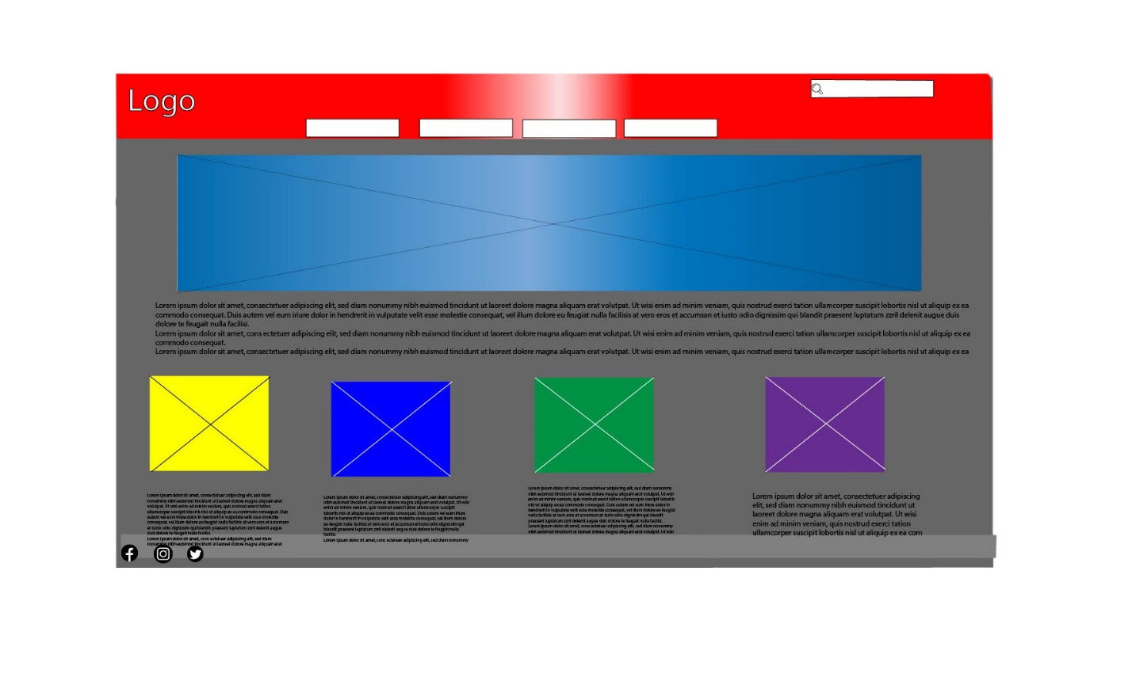

Mobile Portrait
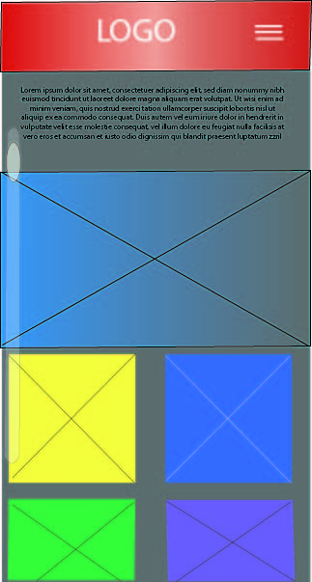
Final Digital Mock-Up 