Jacob Northfield
GRA 410 Process Book
j.northfield@snhu.edu

Sitemap

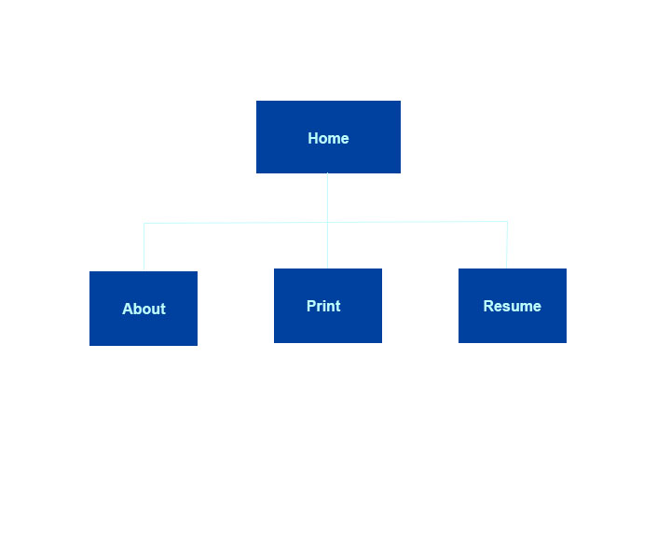
Comments:

Wireframe Breakpoints
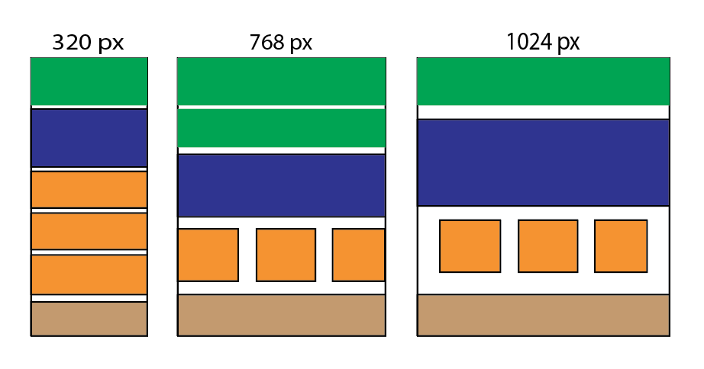
Comments:

Short Paper:
User Experience

When designing a website there are multiple perspectives that need to be considered. The first perspective is often that of the stakeholders. In the beginning of the design process it is important to understand the needs of the business. What elements must be present in order to drive traffic and increase business? But, as we move through the process it becomes imperative to also consider the needs of the user. Now that we know the end goal of the site, how do we get the user there? Without considering the user experience this becomes difficult if not impossible.
User experience, or UX, describes how a user feels while they are on a site (Gube, 2010). This is important to take into account because different fonts or color schemes will influence how one feels when browsing, and different emotions may determine whether the user acts in the desired way. For example, a site to mobilize a demographic to action would likely benefit more from vibrant, active colors than from a drab and dreary scheme. If the user is excited by the look and feel of the site, then they will be more likely to respond to the call to action.
Color scheme is just a small example of how a website can contribute to the emotions of the user. UX designers take into consideration factors such as usability and efficiency when designing an effective site (Gube, 2010). Sites like Amazon present thousands of options to the user, and a skilled UX designer can help companies determine how to display these options in a way that is not confusing and allows the user to easily find what they are looking for, making it easier for the business needs to be met. Things from drop-down menus to search bars can determine the user experience. A clunky and confusing checkout process could deter a user from making a purchase and could lead them to going elsewhere. Thinking about the target audience can help determine how to best design the site. While a university might assume that users are younger and therefore relatively tech savvy, a site for a nursing home might want to be more streamlined and not include a lot of links to social media, for example.
Ultimately, user experience is only one thing to be considered when designing a website, but when it comes to meeting business needs, the design can make or break the site. Even the most modern looking site can fail if the user does not feel like the operation of the site or the navigation of the site is pleasant. While different sites will have different needs, and different projects will vary in scope of design, user experience will always play some role in good design.

References:
@. (2016). What Is User Experience Design? Overview, Tools And Resources – Smashing Magazine. Retrieved November 20, 2016, from https://www.smashingmagazine.com/2010/10/what-is-user-experience-design-overview-tools-and-resources/

Comments:

Digital Mock-Ups
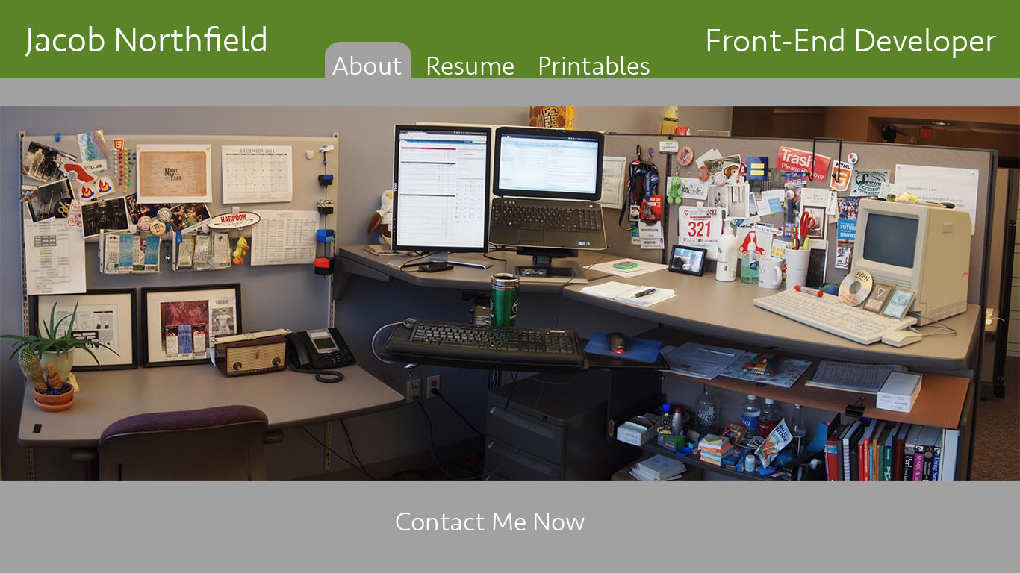

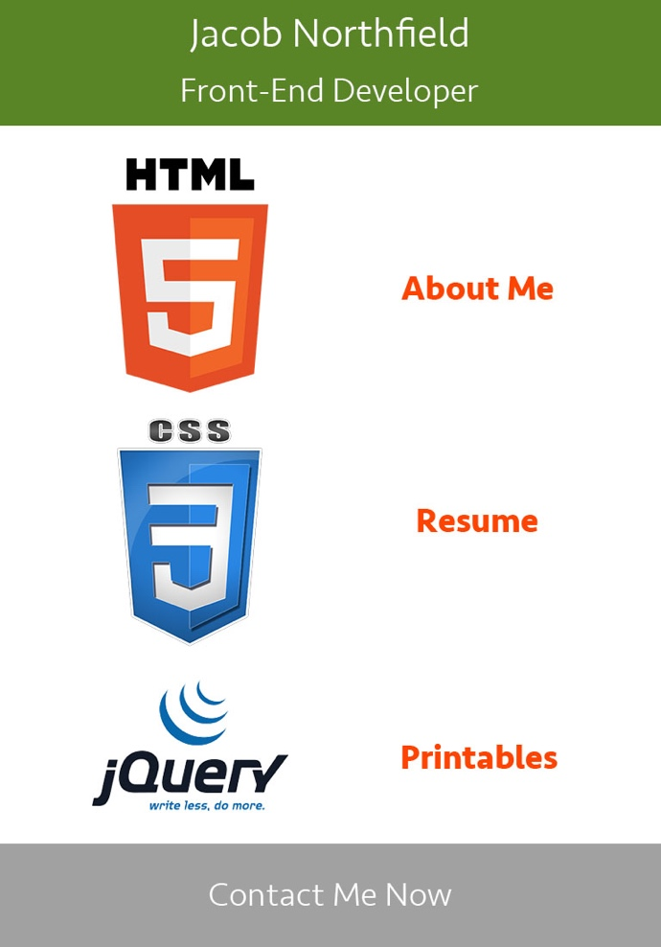
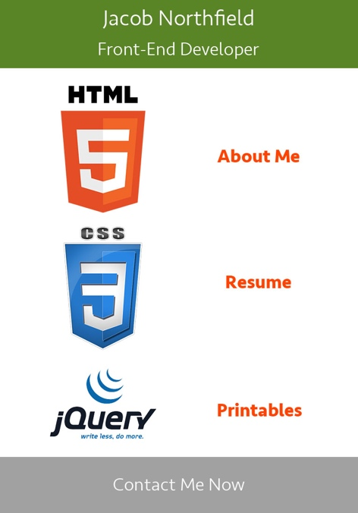

Comments:

Screenshot of
Coding Snippets
Bootstrap Container Snippet
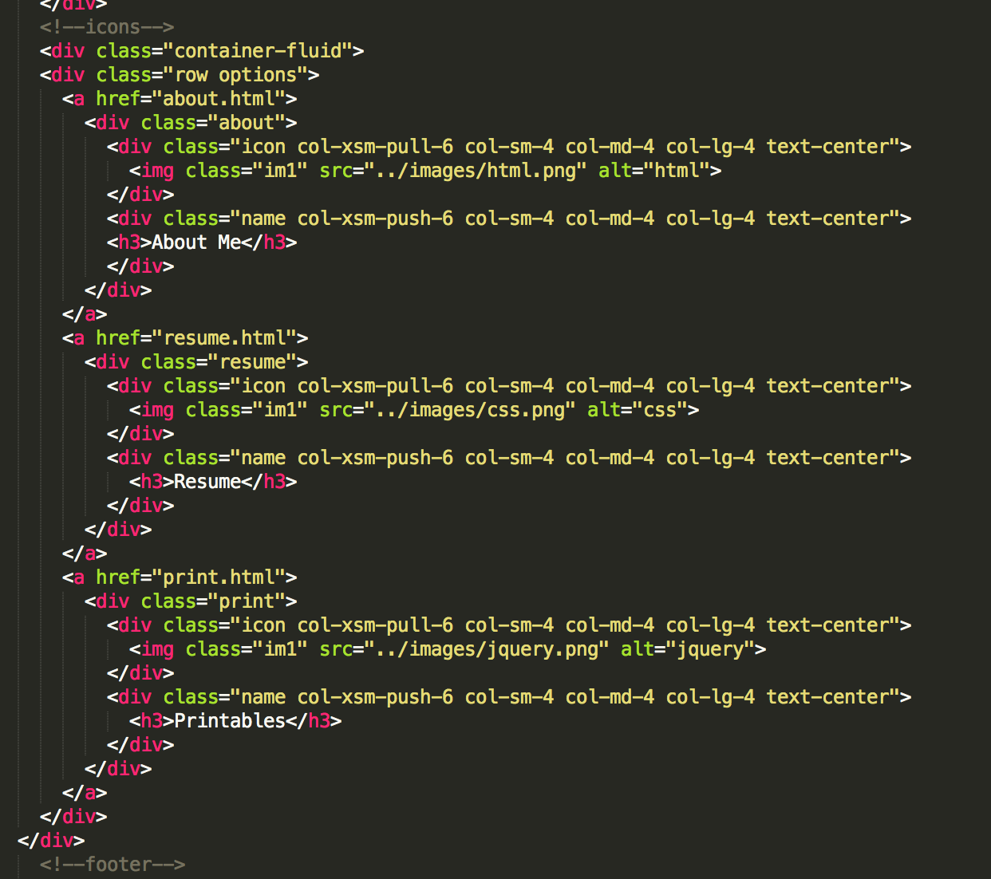
Bootstrap Javascript Snippet
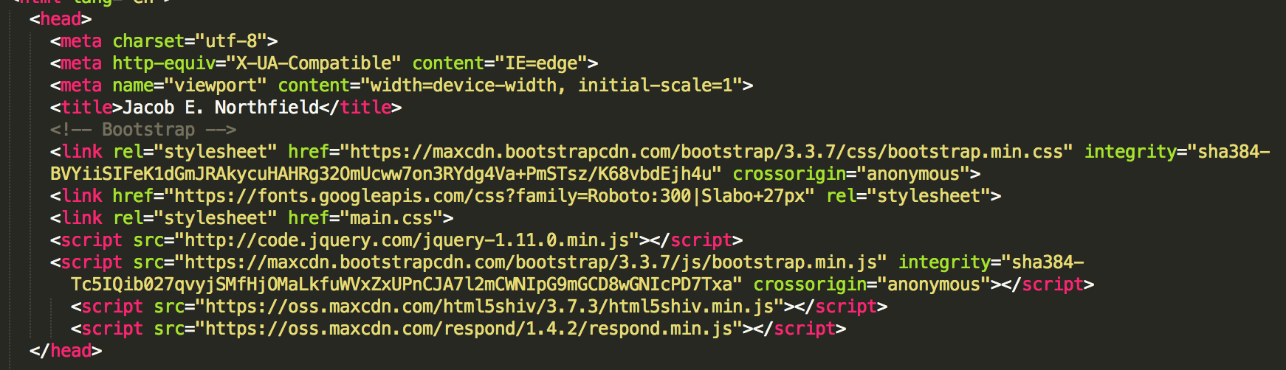
Bootstrap Accordion Snippet
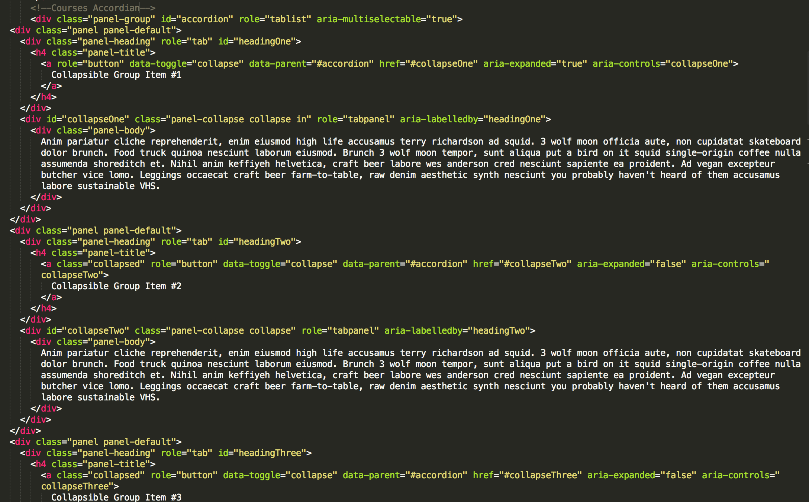

Comments:

Troubleshooting Screenshots of
Website

Comments:

Live Link to
Website Online

Comments:

