Jacqueline Powers
Jacqueline.powers@snhu.edu
Powers Collection of Designs

Sitemap
Milestone One (Module One)

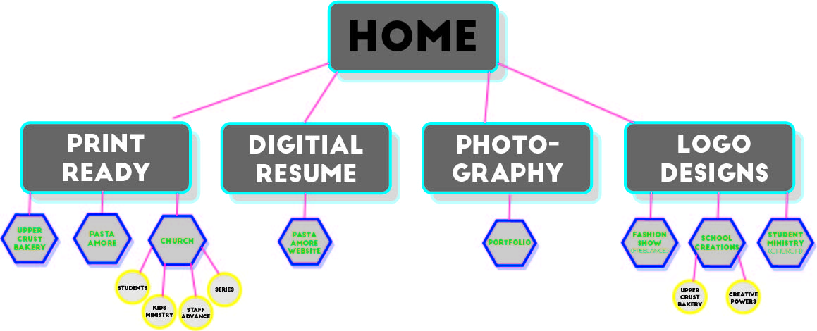

Comments:
At first, this task was a bit daunting to me. I started out completely confused with no idea what to do. Come to find out, I just wasn’t looking in the right places. Once I found the correct rubric, I was able to follow the steps and figure out what was required of me to do. I will say, it was a little difficult trying to remember everything that I’ve created in all of my classes. I hope that I didn’t leave anything out, but I will go back and add if I find that I did miss something.

Wireframe Breakpoints
Milestone Two (Module Two)

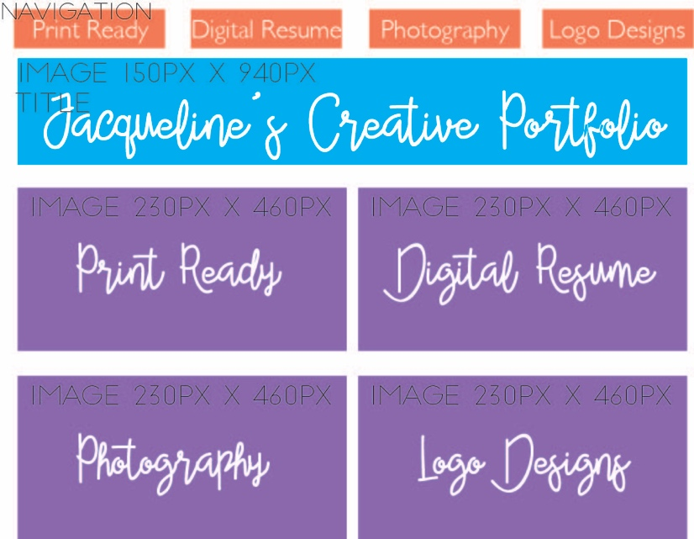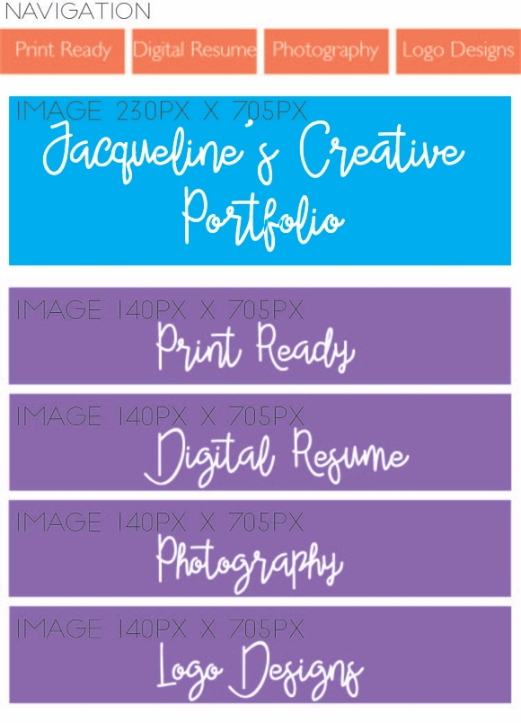

Desktop-Widescreen Tablet-Portrait

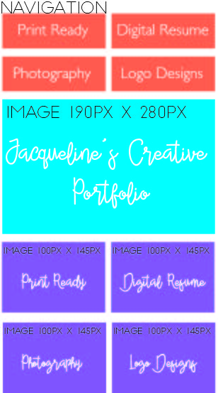Mobile-Portrait

Comments:
The wireframe breakpoints were a little difficult to figure out at first. I wanted to start with the mobile website, but I knew I would probably get frustrated with it. So, I started with the desktop version. I’m glad I chose to do it this way, because I was able to scale everything down from what the big picture was. I think the issue I may face now is finding photos that fit into the different size boxes without issues.

Short Paper: User Experience
Short Paper Assignment (Module Three)

User Experience
Jacqueline Powers
GRA-410
Professor Betsy Berger
May 28, 2017

When it comes to websites, user experience (UX) is an extremely important aspect to consider. After all, these are the people viewing the website day in and day out. When creating a website, it’s important that the user doesn’t feel overwhelmed when they look at the page or try to navigate around it. Often times, if a website is too difficult to navigate, the user will leave the page and never look back. Because of this, UX must be top notch in order to keep the users coming back to the website and telling others about it.
Creating a website can be a daunting task in itself, but making sure everyone who clicks on the website is happy is another task that can seem to be a little difficult. UX was “coined by Dr. Donald Norman, a cognitive science researcher who was also the first to describe the importance of user-centered design” (Gube, 2010). He was the first to take the user into mind when creating a website. He truly believed that all websites should be focused around the user of the website. UX goes all the way from just opening up the page, to the checkout process where you purchase something from a website. The internet has proven itself to be increasingly popular as the years go on, and this puts more emphasis on UX. Anyone today can go and make a website, it doesn’t take much, “but websites have become so complex and feature-rich that, to be effective, they must have great user experience designs” (Gube, 2010). UX spans a variety of different things when it comes to a website. One big part of UX is accessibility. How and when can the user open the website? Is it accessible through a mobile device or through different browsers? Does the user have to have an updated phone to have access to the website? All of these and more are questions that clearly address UX before a user even gives the website a good look. If a user pulls up a website on an older model iPhone and the page is all jumbled because you need a newer version to view the site, that’ll likely make the user a little frustrated and close the site.
Once accessibility is figured out to benefit the user, the next thing to think about is the actual website design, “Systems that involve a myriad of user tasks must be perceived as being valuable, pleasant and efficient. Designers risk big losses in revenue by neglecting the user experience” (Gube, 2010). Many people will likely choose the Amazon website because it is well organized all throughout the site and has UX in mind. If a person goes to look up an item one day and chooses not to buy it just yet, the next time they pull up Amazon, there will be recommendations for a similar product or it will show you that the price has changed. This is all UX, what will bring someone back to the website and what will keep them happy while they’re here? UX isn’t something that is a solution for everyone. People aren’t all the same and “What works for one person might have the opposite effect on another. The best we can do is design for specific experiences and promote certain behaviors, but we can’t manufacture, impose or predict the actual experience itself” (Gube, 2010).
For my website, I want people to be able to sense creativity right when they look at the page. I want to have large images that span the whole page to draw the attention of the user and hook them in. I don’t want to have an overwhelmingly large amount of words, because this entire website is about what I’ve created, and I want to showcase that with images of each creation. I will have a few sentences explaining what each one is and what it was for, but for the most part, I want the designs I’ve created to be the forefront. This will allow people to see how I work and what my designs typically come out to look like. If I gave my website to a potential employer, this would allow them to see all of the work that I’ve done. They’ll know from going through it whether or not I’m what they’re looking for.
Audience interaction doesn’t necessarily mean I have to have some type of survey that each person who visits the website has to fill out. However, one thing I can do is have certain features, like when the user goes to click on a new page, have the word light up or the background behind it change colors. I could have the word bounce once it’s clicked. For example, if someone wants to go to the ‘Photography’ section, they click on it and the word ‘Photography’ would jump up and down once or twice before actually going to the Photography page. There are a number of audience interactions that someone can choose from and I want each person who visits my page to have a pleasant time and not just view it as yet another portfolio website.
Overall, UX is a great idea when it comes to targeting the right audience. Who do you want to come to your website and share with their friends? After all, when a website is created, it’s for a specific purpose, for someone to view it and to get something out of it; whether that be information, to buy a product, to hire you for a job or any other number of reasons. What will keep a user on the page will be their own doing. However, if the website is attractive, easily accessible and easy to use, the creator of the site is well on their way towards a positive UX.
Works Cited
Gube, J. (2010, October 5). What Is User Experience Design? Overview, Tools And Resources.
Retrieved May 27, 2017, from https://www.smashingmagazine.com/2010/10/what-is-
user-experience-design-overview-tools-and-resources/

Comments:
I liked learning about UX from the article and how it benefits the user and the creator of the website. Having an interactive page allows for more people to be interested in the page and keep coming back for more. One thing I did learn was that UX isn’t for everyone. One page that I like could seem tacky to someone else and that’s something to keep in mind. We can’t please everybody, but we can do our best to attract those who want to come!

Digital Mock-Ups of Web Design
Milestone Three (Module Four)

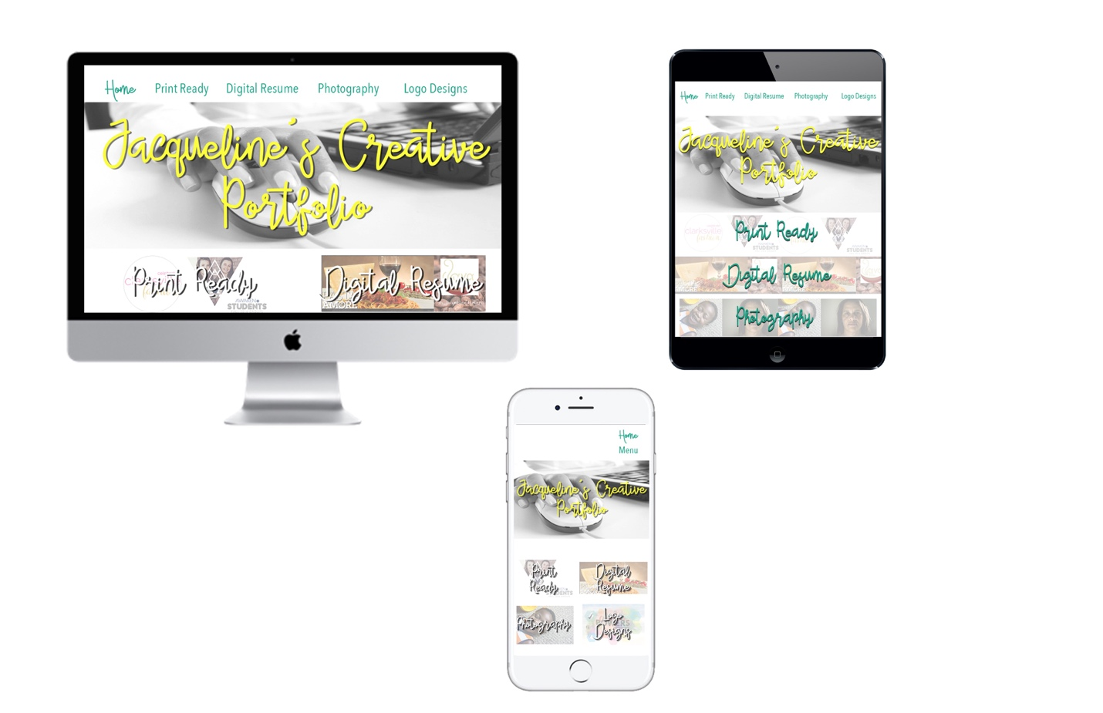

Comments:
I really liked putting each of these mockups together and seeing it come together from a simple wireframe with a bunch of boxes to actual images. I do like how each of these turned out. My favorite one is the desktop. The easiest one to make was the mobile one though. I’m still thinking over the tablet mockup on whether or not I should choose 4 different images for each section, or leave it how I have it now.

Screenshot of Highlighted Coding Snippets in the File Directory
(Module Five)

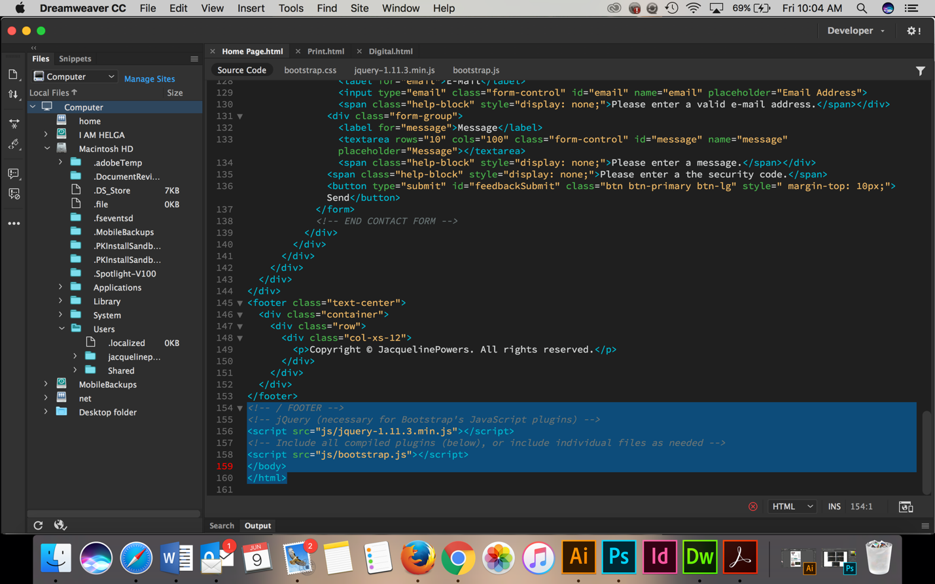

Comments:
Using Bootstrap and Dreamweaver were completely new to me. I was very confused at first on how in the world I was going to get the webpages done! Finally, after watching and re-watching the tutorials, I started to slowly figure it out. I’m starting to get the hang of Dreamweaver and I am really liking that it shows the website as you are adding in the code. I also like that Bootstrap has templates that you can use rather than starting from scratch.

Troubleshooting Screenshots of Website and Live Link to Website
(Module Six)

Comments:

Live Link to Website
(Module Eight)

Comments:

