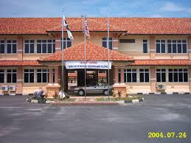

My School | My Teacher | My Friend

