 | Share | Last | Change | %Up
 | BOTRYZEN | 2 | 0 | 25%
 | DAIRYEQUITY | 30 | 3 | 11.11%
 | LIFE | 40 | 4 | 11.11%
 | ANZBANKGRP | 1950 | 145 | 8.03%
 | PIKERIVER | 154 | 10 | 6.94%
 | Share | Last | Change | %Down
 | BLIS | 5.5 | 0 | -8.33%
 | TEMPMARKET | 825 | -50 | -5.71%
 | CALEDONIA | 4894 | -206 | -4.04%
 | NZFSUL | 135 | -5 | -3.57%
 | JPMorgan | 1375 | -45 | -3.17%
 | NZX Most Active updates during Market Hours

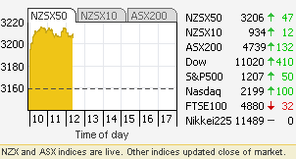


- Investments for cautious kiwis Kiwi Bonds
- View the latest New Investment Opportunities
- Multiply your investment power with Margin Lending


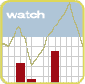
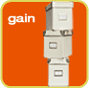

© ASB Securities Limited 2008. ASB Securities Limited is a New Zealand Exchange Firm.  Disclosure Statement pursuant to the Securities Market Act 1988 is available on request  and free of charge. View 'Disclosure Statement'  Terms & ConditionsPrivacy StatementInternet Access TermsNon Residential Disclaimer |  | 

It is crazy how easy it is to be aware of your trade at the moment. For example, today guess who brought the following shares:
BZT, PRC and BLT.

