THE WONDERFUL EDUCATORS OF SMK PELONG

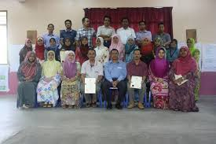
SMK Pelong consist of 36 teachers. Most of them are
Graduate teachers with wise experience in teaching. The teachers
are very helpful and dedicated to ensure the success of the students
both in academic as well curriculum.
Main Page

