SMK PELONG
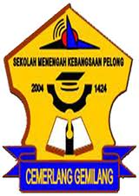
SMK Pelong is located in Setiu, Terengganu. It is single
session school with 16 classes. It is surrounded with greeneries,
beautiful plants and flowers. I love my school very much.

Main Page

