MY WONDERFUL CLASSMATES
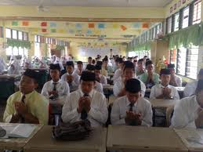
These are my friends of one form is study to gain knowledge.
There are 24 of us in the class. We study well together and help
each other. There are always laugther, co-operation and joy of
success working together.
Main Page

