HARDWARE
1. List down different kind of motherboard for the PC.
- ATX
- MICRO ATX
- BTX
- NLX

2. What is the different between AX and ATX motherboard? Sketch the layout of
the two motherboards.
Ax:
- Old type of layout. The keyboard plug-in is large connector.
- The serial and parallel ports connect to motherboard via cables.
- Processor, memory and expansion slot are all in-line.
- Allow only one or two expansion slot.

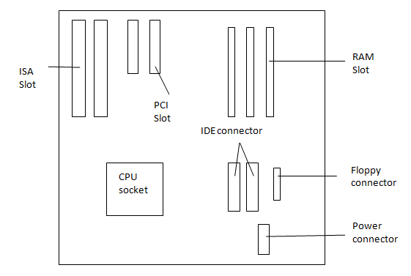

Atx:
- Processor and memory slots at right angle to the expansion cards.
- Allow more than two full length expansion cards.
- Most have 7 expansion slots on the motherboard.
- Have PS/2 keyboard and mouse connections, USB ports and Serial/Parallel ports physically on the motherboard.

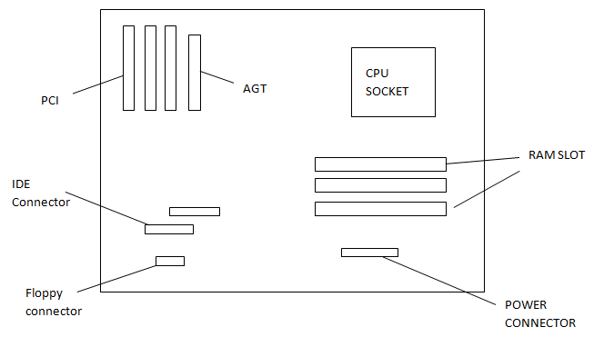

3. List the pins number of various kind of connector on the motherboard and at
the back of the PC.
Connector | Pins
Power Supply | 20
Serial | 15
VGA | 15
IDE | 40
Ribbon Cable | 40
AT keyboard | 5
USB | 4
Parallel Port | 36
Ps/2 | 6
Hard Disk | 40
Floppy Disk | 34
Fireware | 6
Microphone | 3
Audio Connector | 4
Power supply fan | 3
ATX 12V | 24

4. What are the DC voltages we can find from the DC power supply?
- 12V
- 5V
- 3.3V

5. List down the electrical problem we are facing when operating our PC?
- Overheating
- Dust
- Reboot
- Blackout

6. What are ESD, EMI and RFI?
- ESD – Electrostatic Discharge
- EMI – Electromagnetic Interface
- RFI – Radio Frequency Interference

7. List different kind of PC storage.
- RAM
- Flash Drives
- CD/DVD Drive
- External Hard Drives
- Smart Cards(Memory Card)

8. List various kinds of RAM and their pin numbers.
Types | Pins
SDRAM (Synchronous DRAM) | 168
DDR (Double Data Rate SDRAM) | 184
Rambus DRAM (RDRAM) | 184
SIMM (Single in-line memory modules) | 72
DIMM (Dual in-line memory modules) | 168
RIMM (Rambus in-line memory modules) | 232
SODIMM (MicroDIMMs) | 144

OPERATING SYSTEM

- What is the function of OS?
Operating System is the low-level software that supports a computer’s basic functions
such as it takes charge and to manage disk and file behavior, device access, memory
management, input/output, and the user interface.

- List down some of the OS that we can use in a small computer?
- Windows XP
- Windows 98
- Windows 7
- Windows 2003
- Windows 98
- Linux
- Vista
- UNIX
- Mac OS

3. What is the different between text based and graphic base OS?
A text based OS – text only and need command to let the computer do something.
Graphic based OS- doesn’t need command and colourful. Windows 3.1 was the first graphic based OS.

4. List down some of the internal and external command of the text based and
briefly explains the function of these commands.
Internal Dos Command | Function
cd | Change directory
dir | List the content of file directory
copy | Copy files from one location to another
del | Delete files
cls | Clear screen
edit | Edit a file command

External Dos Command | Function
FORMAT | Format of storage drives
ATTRIB | Shows the attributes of files or set one of those
FDISK | Partitioning or modify the hard disk
MOVE | Move files

5. What is FDISK used for and then list down the menu that we can find under FDISK.
FDISK (fixed disk) is commonly used name for a command-line utility that provides disk partitioning functions.
- Create DOS partition or Logical DOS Drive
- Set active partition
- Delete partition or Logical DOS Drive
- Display partition information
- Change current fixed disk drive

6. Explain briefly what File System is.
A file system (or file system) is a means to organize data expected to be retained after a program terminates by providing procedures to store, retrieve and update data as well as manage the available space on the device(s) which contain it. A file system organizes data in an efficient manner and is tuned to the specific characteristics of the device. A tight coupling usually exists between the operating system and the file system. Some file systems provide mechanisms to control access to the data and metadata. Ensuring reliability is a major responsibility of a file system. Some file systems allow multiple programs to update the same file at nearly the same time. File systems are used on data storage devices, such as hard disk drives, floppy disks, optical discs, or flash memory storage devices, to maintain the physical locations of the computer files.

7. What is the different between physical and logical drive?
A physical hard drives is exactly that - a physical unit that can be handled. It is also referred to as a hard drive or HDD (Hard Drive Device)
A logical drive is a subdivision of a physical hard drive and is created using a disk partitioning programme.
A logical drive is unique since it can only be used for storage - it cannot be bootable or active.
A logical drive can only exist within a specialised partition known as an extended partition.
A logical drive can only be created on a physical hard drive - not on a removable disk because of technical reasons.

8. List down the complete steps on how to install Windows 98 OS?
- From the MS-DOS prompt, switch to the CD-ROM drive
- Once in the CD-ROM drive, type CD win 98 and press enter
- Once in the WIN98 directory, type setup and press enter
- Press Enter to start the check and should start the MS Win98 setup installation.
- If you agree with the MS Win98 license agreement, check I accept the Agreement and click the Next button.
- If you using the Win98 SE, Insert your MS Win98 SE product key.
- Win98 will then prompt you to where you wish to install Win98. Unless you wish for a different directory, leave it at the default C:\Windows directory and click Next.
- Choose Install the most common component (Recommended) and click Next.
- If you do not wish to create a startup disk, Click Cancel, otherwise put a blank diskette in the computer and click Ok.
- Click Ok when prompted to remove the disk.
- Click Next to start copying files.
- Once ready, click Ok to restart the computer. Make sure if any diskette is in the computer that it is removed from the computer.
- If you are installing the original Win98, you may be prompted for the Product Key after the computer restarts; insert your Win98 product key and click Next.
- Continue through the remainder of the setup answering each of the questions.

9. What is the different between basic and dynamic disk?
Basic Disk: uses partition table that are supported by MS-DOS, Microsoft Windows 95, Microsoft Windows 98, Microsoft Windows Edition (Me), Microsoft Windows NT, Microsoft Windows 2000 and Windows XP. A disk initialized for basic storage is called basic disk. A basic disk contains basic volumes such as primary partitions, extended partition and logical drives.
Dynamic Disk: supports both Windows 2000 and Windows XP Professional. A disk that is initialized for dynamic storage called dynamic disk that contains dynamic volumes such as simple volumes, spanned volumes, stripped volumes, mirrored volumes and RAID-5 volumes.

