MEMORIAL SLOAN-KETTERING CANCER CENTER
DEPARTMENT OF PEDIATRICS

RESIDENTS MANUAL

2007-2008

RICHARD J. O’REILLY, M.D.
CHAIRMAN

PAUL A. MEYERS, M.D.
VICE-CHAIRMAN
Welcome to Memorial!

We want to make your time here a solid educational experience, as well as help you provide excellent pediatric care for our patients who are now your patients.

Caring for oncology patients is challenging but incredibly educational. While the major problem your patient faces is cancer, their problems are also those you would encounter on any general pediatrics ward. You will see and manage infectious, respiratory, cardiac, renal, hepatic, gastrointestinal, and fluid/electrolyte problems. This rotation provides a wonderful opportunity to learn how to manage patients with multiple medical problems.

As such, a lot is expected of you. These patients are very sick and their management is complicated. However, you are never alone. There is always a fellow, chief fellow, chief resident, and an attending on duty with you. In addition, there are experienced pediatric oncology nurses and nurse practitioners. We all are available to you at any time, day or night. Anytime you are uncertain regarding what to do (or just want to confirm your decision) ask. In fact, everyone at MSKCC expect and appreciate being involved early with your concerns. If you feel, at any time, that you need help in evaluating or managing a patient, just ask.

Most pediatric clinical services are located on the Ninth floor of Memorial Hospital, referred to as M9. The floor is divided into 2 teams consisting of the attending, a fellow, nurse clinician/nurse practitioners, and residents. The Green Team is the general oncology service. The Blue Team covers bone marrow transplant. All teams are made up of residencies in NYC.

The call schedule is made up in advance by the Pediatric Chief Resident, Dr. Tawana Winkfield-Royster. Essentially, call is every third to fourth day. We try to be fair and balance the distribution of calls. Some changes are made because of “clinic day.” If there is a problem with the schedule please let the Tawana know early so changes can be made. If you must miss a day due to illness, you must contact Tawana at 917-205-4091 (office and cell phone numbers provided with your call schedule). Please remember to leave a number where you can be reached. We also expect you to call your chief resident to notify them of your situation.

Finally, although this is a demanding rotation we truly want you to have a good experience with us. Our patients demand hard work, conscientiousness and professional demeanor. In return, we hope that when you finish your rotation, you feel that you have learned a lot and helped your patients. If problems arise please let us know so that we can improve the rotation.

Thank you.

Sincerely,

Alexander Chou, MD Tawana Winkfield-Royster, MD
Attending, Sarcoma Team Pediatric Chief Resident

To Pediatric Residents:

The Memorial Sloan-Kettering Cancer Center endorses the Bell Commission in both letter and spirit. We are committed to ensuring that you do not engage in patient care duties beyond the time limitations specified by the Bell Commission. At the same time, we recognize that both your education and commitment to patient care may occasionally require you to spend time in addition to direct patient care. This is recognized and allowed for in the Bell Commission regulations as “transitional time”. We wish to be sure that you understand the difference between patient care time and transitional time to ensure that our patients receive the very best care and that you receive the very best possible experience at this center.

The period when this is most problematic arises following a 24 hour rotation when you have been on call. It is essential that you cease all direct patient care at the end of a 24 hour shift. At the completion of 24 hours, you should not examine patients, you should not prescribe for patients, and you should not be in direct communication with patients or their families. You are permitted to write notes on your patients, to sign out to the resident who will be assuming responsibility for your patients, and to participate in rounds, as long as those rounds are not at the patient bedside. We feel that your education is best served if you do have the opportunity to present the patients you admitted the previous night to the attending physician and review your findings with that attending physician.

Both we and the Bell Commission anticipate that transitional time will not last more than 3 hours. It should last significantly less than 3 hours and time in excess of 3 hours should occur only in exceptional circumstances and with the express authorization of your attending physician. Obviously, none of these limitations apply to a case of legitimate emergency and we are certain that you would respond to an emergency to the fullest of your abilities at any time regardless of the number of hours worked.

Thank you very much.

Sincerely yours,
Paul A. Meyers, MD
Vice Chairman, Department of Pediatrics

MEMORIAL SLOAN-KETTERING CANCER CENTER

RESIDENT EDUCATIONAL GOALS AND OBJECTIVES
PEDIATRIC ONCOLOGY and
PEDIATRIC BONE MARROW TRANSPLANTATION

At the end of their 4-week rotation at MSKCC, residents will be expected to:
- Demonstrate knowledge of the epidemiology, presenting signs and symptoms, differential diagnosis, diagnostic procedures (imaging studies and laboratory tests), principles of current therapy (including indications for surgical intervention, chemotherapy, stem cell transplantation), prognosis, and long-term complications for the following common pediatric oncologic conditions:
  - Acute lymphoblastic leukemia, acute myelogenous leukemia
  - Brain tumors
  - Hodgkin’s and non-Hodgkin’s lymphoma
  - Neuroblastoma
  - Wilms’ tumor
  - Retinoblastoma
  - Soft tissue sarcomas
  - Bone tumors
Competencies Addressed: Patient Care, Medical Knowledge, Practice-Based Learning and Improvement, Systems-Based Practice

- Demonstrate knowledge of the diseases for which stem cell transplantation is indicated and become familiar with the principles of stem cell transplantation.
Competencies Addressed: Patient Care, Medical Knowledge, Systems-Based Practice

- Explain the findings on clinical history and examination that suggest a hematologic or oncologic disease which requires further evaluation and treatment.
Competencies Addressed: Patient Care, Medical Knowledge, Practice-Based Learning and Improvement, Systems-Based Practice

- Recognize the common acute and long-term side effects of frequently used chemotherapeutic drugs including but not limited to cyclophosphamide, ifosfamide, cytarabine, vincristine, anthracyclines, methotrexate, cisplatin, 6-mercatopurine, thioguanine, prednisone, and antibody-base therapies.
Competencies Addressed: Patient Care, Medical Knowledge, Practice-Based Learning and Improvement, Systems-Based Practice

- Demonstrate knowledge of supportive measures (medications, blood product support) that are employed in treating the side-effects of chemotherapy.
Competencies Addressed: Patient Care, Medical Knowledge

- Develop an efficient approach to finding information resources related to pediatric oncology (i.e.., internet resources, medical literature, textbooks) to obtain rapid information relevant to a presenting patient problem.
Competencies Addressed: Medical Knowledge, Practice-Based Learning and Improvement, Interpersonal and Communication Skills, Systems-Based Practice

- Demonstrate skills for assessing and managing pain both in the acute setting as well as in cases of chronic pain:
  - Use of age-appropriate pain scales.
  - Describe indications for use and side effects of common narcotic and non-narcotic analgesics.
  - Administer medication to control pain in appropriate dose, frequency, and route.
  - Utilize behavioral techniques, supportive care from child life specialists, and other non-pharmacologic methods of pain control.
Competencies Addressed: Patient Care, Medical Knowledge, Practice-Based Learning and Improvement, Interpersonal and Communication Skills, Professionalism, Systems-Based Practice

- Understand the role that research (clinical, translational, basic sciences) plays in the treatment of pediatric cancers. This includes consideration for issues such as informed consent for medical research and end-of-life care.
Competencies Addressed: Patient Care, Medical Knowledge, Practice-Based Learning and Improvement, Interpersonal and Communication Skills, Professionalism, Systems-Based Practice

- Identify personal learning needs related to pediatric oncology, systematically organize relevant information resources for future reference and demonstrate a commitment for continuing acquisition of knowledge and skills.
Competencies Addressed: Medical Knowledge, Practice-Based Learning and Improvement, Systems-Based Practice

- Facilitate the learning of medical students and other health care professionals in the pediatric oncologic unit.
Competencies Addressed: Practice-Based Learning and Improvement, Interpersonal and Communication Skills, Professionalism

- Become actively involved in a feedback process, including open discussion with preceptors and other faculty members, and opportunities to implement a plan of action with specific goals aimed at overall improvement.
Competencies Addressed: Practice-Based Learning and Improvement, Systems-Based Practice

- Provide emotional, social, and culturally sensitive support to the patient and family.
Competencies Addressed: Interpersonal and Communication Skills, Professionalism

- Understand the key aspects of health-care systems (i.e., cost control, mechanisms for payment) as they relate to the inpatient setting, and advocate on behalf of patients experiencing challenges with health-care system complexities.
Competencies Addressed: Practice-Based Learning and Improvement, Systems-Based Practice

Memorial Sloan-Kettering Cancer Center
Goals and Objectives for PGY-3 Resident on General Oncology Service

In addition to the general goals and objectives of the rotation, the PGY-3 on General Oncology will provide additional support and supervision of the PGY-1 and PGY-2 residents who rotate through M9. Working closely with the fellow-on-service, the PGY-3 will be expected to follow and know all of the patients on the General Oncology Service. The responsibilities of the PGY-3 will include but are not restricted to:

- Working closely with the Pediatric Fellow on-service, the Pediatric Attending on-service, and Pediatric Chief Resident in taking care of patients on the General Oncology Service
- Supervising all PGY-1 and PGY-2 residents on the rotation
- Being responsible for knowing all of the patients on the General Oncology Service
- Taking on patients of their own (i.e., taking admissions, following their own census of patients) when necessary
- Aiding in the distribution of admissions to members of the General Oncology Team
- Taking in-house, overnight call 3-4 times a month (at least one Friday and one Saturday)
- Attending their own continuity clinic at their home institution. Up to two clinics can be canceled based on resident need (you have already been informed in advance by your chief resident when the schedules were e-mailed)
- Attending Tuesday and Friday Morning Report in addition to all resident conferences (core lectures, tumor boards, grand rounds)
- Serving as a knowledgeable resource of general pediatrics to PGY-1 / PGY-2 residents, nursing staff, and NPs
- Preparing one 30-60 minute Power Point Presentation on a Hematology-Oncology topic of your choice to be presented during resident lectures. Floor attendings will be invited to attend.
MEMORIAL SLOAN-KETTERING CANCER CENTER

M9 Inpatient Responsibilities

Hours of Duty
- MSKCC is committed to complying with ACGME guidelines for resident work hours. As such, the following rules will be strictly adhered to:
  - Duty Hours.
    - Duty hours are defined as all clinical and academic activities related to the residency program, ie, patient care (both inpatient and outpatient), administrative duties related to patient care, the provision for transfer of patient care, time spent in-house during call activities, and scheduled academic activities such as conferences. Duty hours do not include reading and preparation time spent away from the duty site.
    - Duty hours will be limited to 80 hours per week, averaged over a four-week period, inclusive of all in-house call activities.
    - Residents will be provided with 1 day in 7 free from all educational and clinical responsibilities, averaged over a 4-week period, inclusive of call. One day is defined as one continuous 24-hour period free from all clinical, educational, and administrative activities.
    - Adequate time for rest and personal activities must be provided. This should consist of a 10 hour time period provided between all daily duty periods and after in-house call.
  - On-Call Activities. At MSKCC, all on-call duties will be in-house call.
The objective of on-call activities is to provide residents with continuity of patient care experiences throughout a 24-hour period. In-house call is defined as those duty hours beyond the normal work day when residents are required to be immediately available in the assigned institution.
    - In-house call will occur no more frequently than every third night, averaged over a four-week period.
    - Continuous on-site duty, including in-house call, will not exceed 24 consecutive hours. Residents may remain on duty for up to three additional hours to participate in didactic activities, transfer care of patients, conduct outpatient clinics, and maintain continuity of medical and surgical care as defined in Specialty and Subspecialty Program Requirements.
    - No new patients, as defined in Specialty and Subspecialty Program Requirements, may be accepted after 24 hours of continuous duty.
- On the first day of their rotation, residents are expected to arrive by 7AM to receive orientation to the inpatient unit (M9) and receive sign-out from the post-call resident. Orientation (including computer training, obtaining MSKCC ID tags, etc.) will take place after attending rounds on the first day of the rotation.
- During the weekdays, residents are expected to receive sign-out from the post-call resident between 7-8AM. Weekday sign-out takes place at 5PM with the on-call resident taking over at that time. On weekends, sign-out takes place between 7-8AM.
- All expected absences must be cleared with the fellow on-service as well as the pediatric chief resident. In cases of medical illness or other emergencies, the chief resident must be informed as soon as possible and the residency program should then find replacement for that resident.

B. Conferences
- Core teaching conferences will occur Monday through Friday. Mondays, Wednesdays, and Fridays from 1:30PM-2:30PM. Tuesdays from 12:30PM-1:30PM, and Thursdays from 1PM-2PM. Due to the overlapping schedules of the residencies represented at MSKCC, conference topics will remain the same each month, covering basic areas of knowledge in pediatric oncology and general pediatrics. Conferences will be in the form of lectures, case presentations, and journal clubs. Lunch will be provided. As attendance is mandatory, residents will be excused from their floor responsibilities during that time.
- Pediatric grand-rounds occur on Thursdays between 8:30AM – 9:30AM. Residents are strongly encouraged to attend.

C. Patient Care
- Each resident will take care of approximately 4-5 patients (possibly more or less based on patient volume and number of rotating residents). Despite the complexity of the pediatric oncology patient, each resident is expected to be the primary caretaker of their panel of patients. The pediatric oncology fellow on service will provide direct supervision of all residents. For continuity of care, residents are expected to be familiar with all patients on their respective teams (Oncology Team, and BMT Team).
- Attending rounds take place at 9AM everyday where each patient will be presented and management decisions made. Before attending rounds, residents are expected to have seen and examined their census of patients. Each resident is expected to evaluate common signs and symptoms in the hospitalized pediatric oncology patient under the supervision of a pediatric oncologist. Residents will perform a physical examination of the acutely ill pediatric patient and identify both normal and abnormal findings.
- Radiology rounds take place Monday through Friday at 11am to go over imaging studies from the previous day and night. Residents will be expected to briefly present the patient(s) and the rationale for the imaging study.
- Residents will be informed of any admissions by the Senior Resident and/ or fellow on service. When patients are admitted to the inpatient unit, each resident is expected to perform a thorough history and physical. A general management plan for the admission will be devised in collaboration with the fellow on service and the primary outpatient team. Subsequently, daily progress notes are expected; problem oriented S.O.A.P. notes are preferred. Residents will obtain and interpret information relevant to the hospitalized pediatric oncology patient.
- Discharges are planned in conjunction with the pediatric fellow on service as well as the primary team and the inpatient nurse case manager. Relevant prescriptions should be written and turned in to the MSKCC pharmacy to be filled, preferably on the night before discharge. The resident is expected to complete the discharge instructions as well as writing a discharge note summarizing the patient’s inpatient course. Arrangement for post-hospitalization follow-up should be done in collaboration with the on-service fellow.
- When appropriate, all orders for non-chemotherapy medications should be written by the resident taking care of the patient. In addition to the Harriet Lane Handbook, MSKCC-specific guidelines will serve as references for the appropriate drug dosages and routes of administration.
- Residents are expected to begin to develop the ability to formulate a daily plan for each patient and provide clinical reasoning for the plan. In addition, they are expected to use and interpret clinical information that may have specific application to the pediatric oncology patient.
- Patient care on M9 often requires input from multiple medical specialties. It is the responsibility of the resident to call consults when appropriate, and to be able to provide the rationale (i.e., the question to be addressed) for the consultation.
- Residents will be oriented to their responsibilities with relation to MSKCC procedures for medication reconciliation as mandated by the JCAHO.
D. Evaluations
      - Residents will be evaluated during their rotations by the fellow on service and the attending on service. In addition, evaluations will be obtained from the nursing and ancillary staff from the Pediatric Inpatient Unit.
      - Evaluations are based on the recommendations from the ACGME guidelines for competencies

Resident Check-In

1 Please familiarize yourself with the general orientation of the pediatric unit and your responsibilities. We have provided an orientation checklist. It is essential that you go over this checklist with one of the “old time” residents and your fellow on your first day here.

2. You need to learn our procedures for accessing a broviac and drawing blood. You will be taught and certified by a nurse.

IV/Chemo nurse

3. You need to review with the pharmacist our requirements for IV fluids and medication orders.

Pharmacist

4. You need orientation in infection control. The nurse clinician or charge nurse from the floor will review our hand washing and isolation procedures with you. This issue, as you will come to appreciate, is critically important for the care of our patients.

M9 Nurse Clinician

- You need to register for the rotation. This must be done on your FIRST DAY with us. You will receive your hospital DEA #, photo ID and HIS and lab access codes. You will receive a general stores requisition to obtain lab coats and gray scrubs.

Graduate Education Office
Room Memorial 2101A
Ext. 6788

- You must take the MSKCC HIPAA course on-line and give the completion print-out to the chief resident.
Resident Orientation
Key Points

- House Staff Office (HSO)
Memorial 21 Floor (take elevator to 20th Floor then walk up 1 flight)
* Paperwork for computer codes, Hospital ID and DEA number, white lab coats and gray scrubs, will be provided for you on your first day here at MSKCC. Other housestaff information can be found in by contacting this office.
* Meal tickets (1 per night on call) located in Green Team drawer.

- Computer Healthcare Information System (HIS)
1. Will get code from HSO
Reports: Information from old charts
Scan reports (location of Radiology, Nuclear Med Scan results)
Chemotherapy: access chemotherapy history
Labs

2. Reflection (regular lab system….will get code from HSO)

3. Emergency Sheets
Three copies must be printed out for every patient
# 1 → taped into front of patient bedside chart
# 2 → placed in front of hard copy chart (need for scans and when pt off the floor)
# 3 → attached to sign-out sheets

- Notes: Save daily progress notes, admission and discharge notes under “H” drive – Notes_M9 Blue Team/Green Team

- Other
Contacting Nurses (call button and intercom system)
Important Numbers (to page 1-2-1……., x7886 page operator)
Specimen Box
Isolation Precautions
Pharmacy (location, hours, Vinny and Kenny)

- Blood Drawing
Needle safe Equipment
Technique for blood drawing blood (regular labs and blood cultures)

- Bedside Chart
Review → VS sheet, I/O's, Medexes, PRN, Stat and PCA sheet

- Emergency Equipment
Identify location of emergency equipment and IV supplies

- Discharge
Please complete all prescriptions on day prior to discharge
Contact Case Manager for discharge needs (ie: equipment, home antibiotics, TPN)
Please contact PDH (x6-5948) for PNP for follow-up appointment

- Daily Core Conferences (start times range from 12:30 pm to 1:30 pm)
Tumor Board – Tuesday 2 pm/Thursday 3 pm, room C5 pathology conference room
Pediatric Grand Rounds – Thursday 8:30 am, room M107 (September to June)
General Procedures for In-patient Pediatrics

Part 1. The Pediatric Unit

1. The patient location board
- Lists the patient’s room number, team (green-team 1 or blue team 2), resident, primary nurse, and today’s nurses. NOTE: labels with both the team’s color and pink indicate the patient is also followed by a surgical service.

2. Requisition Forms [rarely in use as all orders are now entered into the computer]
- Addressoplate and stamper
- Location of common forms
- Filling out common forms - stamp, DATE and Time, sign (CBC, chemistry, stat chemistry, cultures, antibiotic levels, UA, creatinine clearance, blood product request, radiology, nuclear medicine, ECHO, ECG) → rarely done as all lab requests done through HIS
- Emergency requisitions

3. Specimens
- Collection (location of equipment, bags, etc.)
- Routine specimen box
- STAT specimen box - call escort
- Night specimen box - after 11:30 pm until 7:00 a.m.

4. Computer order entry
- done through HIS
- please NOTIFY NURSE FOR ORDERS, especially STAT orders

5. Writing prescriptions [usually done on the computer through HIS]
- Plan ahead (submit day before discharge if possible)
- Imprint (NYS law)
- Review with pharmacist

6. The patient room
- Bedside Chart: vital signs, I/O’s (urine: SG, heme, glucose), medications (IV/oral/prn/stat), Black ink indicates dayshift, Red ink indicates night shift
- Closet:
  - patient server (tape, gloves, alcohol)

7. Charts
- Location - Current and Permanent (Please replace when done)
- Organization
- Access old chart through HIS

8. Paging
- Intercom - calling and answering
  - From central station
  - From room
- Beepers
  - Each resident is assigned a short-range MSKCC beeper; please placed them in the beeper drawer at the end of each day
  - In house - dial 121 - wait for beep; dial page number - wait for beep – dial extension - wait for beep then hang up.
  - Long range - dial 9 to get outside line, dial page number - wait for beep – dial telephone number followed by # wait for beep then hang up.

9. Obtaining laboratory results
- Use of the computer
  - ID #s and Passwords will be given to you on your first day
  - Reflections System – Enter User name and password; Function I; Patient’s number
  - HIS – Comprehensive system including labs, old patient records, and radiology results.
- Radiology
  - PACS System Located in the Pediatric Classroom in the PDH
  - Obtaining results by phone - ext 6633 then “#” 1 then code 121121 followed by MRN

10. Admissions Book
- Lists planned admissions for the day as well as pending admissions

11. Requesting Consults
- Check telephone directory or the MSKCC intranet website or the page operator
- Record consultation request in progress note with date, time, and person contacted

__12. The Unit Secretaries
- Help you locate forms
- Provide guidance on how to schedule tests etc.

13. M9 Resident Room is located in room M913
- Space for you to leave non-valuable belongings
- Doubles as on-call room
- You must place dirty linen in bins outside patient room in a.m.
Part 2. The Daily Schedule

Weekdays

7-8 am
- sign in/sign-out with post-call resident
- review bedside chart, “pre-round”
- examine patient
- write any STAT orders
- renew orders (for narcotics and IVF orders, need to renew every 24 hours)
- submit discharge prescriptions

9-12 pm
- attending/teaching rounds

11 am
- radiology rounds
Note: be able to describe your patient in one sentence and tell why the radiology study was requested.

1-2 pm
- Core conference, lunch provided

2-5 pm
- patient care
- write/type progress notes
  - SOAP
  - DATE and TIME ALL NOTES
  - Save notes under Notes – M9 Blue Team; M9 Green Team, on the “H” Drive
- request and review consultations
- plan follow day discharges - RX, F/U, fill out form
- input anticipated AM lab orders for following day
- ADMISSIONS: Note: residents not on call usually take early admissions; review admission orders with your fellow → include type and cross q72 hours, transfusion parameters (Hgb < 8, Plts <10 Oncology; Hgb <8, Plts <20 BMT).
  - update sign out sheets

5PM
- sign out
Note: call is difficult - if signing out any blood draws, etc, please fill out forms (if necessary) and gather appropriate collection supplies for the on-call resident. Try to restrict to emergency blood work only.

On Call at night

Note: at 5PM the on-call fellow arrives. The fellow is available at all times
- you are responsible for the care of only your team’s patients and any emergency admissions.
- meal tickets are provided worth $5.50 for on-call resident. One resident should remain on floor at all times.

5 PM
- brief check-in with fellows; discuss plans, results, to-do lists

11PM
- chart rounds with fellow

Prior to 1AM
- Ask Unit Assistant to release AM blood work after MN, if not already done

__Weekend Call

Note: There is a skeletal staff (inpatient and outpatient fellow, one resident from each team, one attending for each team).
-You are responsible for care of your team’s patients and emergency admissions

Morning - arrive by 7 AM
- sign-in with on call resident
- pre round on unstable/seriously ill patients
-work rounds with fellow and attending

Afternoon - finish examining all patients
- check labs/write orders
- write progress note on every patient

Evening - chart rounds with fellow
Part 3. Resident Responsibilities

1. patient care is your primary responsibility

2. you must examine your patients daily (even if they are asleep)

3. you need to review the chart and write daily progress notes
- use SOAP style
- please summarize in your note the input of all services involved in the care of your patient, for example, nursing and all consulting services
- assuming it is true, of course, please include a statement in your note that you rounded with or discussed your patients with the attending
- DATE, TIME AND SIGN ALL NOTES

4. you need to call and review all consults
- document all consultation requests including date, time and name of person you spoke to
- if in doubt about reason for consult, check with your fellow before calling the consult
__5. you will write all orders - EXCEPT CHEMOTHERAPY and ATG - for your patients; Orders to include date, time, diagnosis, weight in addition to the usual format.

__6. all patients you admit need a complete admission history, physical, admission labs, assessment and plan (may briefly summarize if patient has PDH admit note).
NOTE: all female patients 21 years of age and older must have breast exam and pap smear done on admission or reason that this was not done documented

__7. you must plan and arrange discharge of your patients
- day prior to discharge: discharge summary, prescriptions, follow up appointments
- home care if needed should be arranged with nurse clinician/case manager 2-3 days prior to discharge.

8. if a patient expires: please notify the fellow who will in turn notify the service and primary attendings

9. at end of rotation
- off service notes
- sign out your service to resident coming in

__10. Note:
- please do not leave M9 without letting the unit assistant and fellow know
- make sure there is a member of your team on the floor at all times
- please keep fellow informed of any acute change in your patient’s condition
- you are responsible only for the care of inpatients, occasionally you will receive calls (by mistake) about outpatients, please refer those calls to the fellow.
- the playroom is neutral territory for our patients. Please feel free to use it to get to know your patients, however, no “doctor work” is permitted.

_11. Dress Code:
- Please dress in a professional manner. If you choose to wear a white lab coat, please ensure that it is clean. Scrubs are only to be worn when on-call at night and must be gray scrubs issued by MSKCC.

Part 4. Fellow to Resident Checklist

You will probably want to check with the fellow about:
(In general, if in doubt about anything at anytime, please ask)

1. Indications for blood product use
a. RBC
b. Platelet
Note: pediatric patients receive only irradiated blood products
c. CMV status
d. Premedication guidelines

2. Dealing with life-threatening values
a. Notify fellow - take appropriate action
b. Repeat test

3. Management of common problems
a. Hypokalemia
- use of boluses
b. Pain management
c. Reactions to amphotericin B
d. Isolation procedures
e. Sepsis
f. Unexpected fever

__4. Discharges
- medication needed for discharge
- prescriptions
- follow up plan

GUIDELINES FOR ADMISSION ORDERS

- Admissions should contain the patient’ weight, height and any allergies. If none, then state NKDA.

- Medications need to be ordered in mg/kg, etc., NOT tab, cap, teaspoon etc., unless it a combination drug, e.g. Percocet.

- All orders must be rewritten after patient comes back from the OR or another floor.

- ANTIBIOTICS
- please indicate mg/kg used:
for example – cefepime is 50 mg/kg/dose  Q8º with 2gm/dose maximum
- Please round off odd doses: example – make 22.3mg either 22 or 23
- If a patient is on antibiotics, please discontinue them prior to discharge.
- A hold order is considered a D/C; it must be rewritten when you want to re-start it.
- Restricted antibiotics must be approved by Infectious Disease, and the approving physician must be identified on the order. Beeper #1100

- LARGE VOLUME PARENTERALS (LVP, aka IV fluids)
- Electrolytes must be ordered per liter, and units must be indicated
- If any changes are to be made, the LVP order must be re-written. Writing for the addition, deletion or change only, is unacceptable. The only exception is a change in rate.
- If there are 2 lumens, please indicate the rate in each line.
- No more than 80 MEQ of potassium per liter in a peripheral line. Greater amounts must be in a central line.
- Amounts greater than 120 MEQ of potassium per liter require renal (consult) approval.
- Please evaluate fluid requirements of each patient on a daily basis and modify accordingly considering TPN contents.
- Must be re-ordered daily

6. MISCELLANEOUS
- Narcotic Infusion (PCA or drip)
- Must be re-ordered daily
- mg/hr must be specified
- concentration must be specified
- All narcotics must be re-ordered every day if it is needed.
- All chemotherapy must be ordered by the Attending and Fellow Only; and also ATG and Anesthesia Pain Service orders.
- If switching from one route of administration to another, D/C previous order, and completely rewrite order for new route. Simply ordering switch IV to PO is unacceptable.
- When ordering electrolyte boluses, please include latest blood level.
- Please notify RN of all orders
- Medication Order Reviews:
Blue Team – Tuesday
Green Team – Wednesday
- Discharge prescriptions

You can always find the MSKCC guidelines for dosing of frequently used medications for pediatric patients on each workstation by going to:
Start → Reference Manuals and Tutorials → Clinical
Reference Manuals → Pediatric Guidelines

BLOOD DRAWING PROCEDURES FOR CENTRAL LINES USING NEEDLE SAFE SYSTEM

Before drawing blood from the patient:

- Wash your hands
- Observe universal precautions – always wear gloves!
- Clean clave entry site with alcohol and allow to dry

Central Venous Access Device:

- Trace IV lines to determine what is running into which lumen of the catheter. It is preferable to draw blood chemistries from non TPN lines. Don’t draw electrolytes if amphotericin is running. Blood may not be drawn from lines containing medications such as antibiotics, chemotherapy, dopamine, or continuous narcotic drips unless there is no other access available. This will avoid wasting drugs or bolusing patients with drugs.

- Cyclosporin levels are drawn from the Red Lumen

- Turn pumps to “Pause”.

- Clamp IV tubing directly below clave closed to patient when drawing bloods. Clamp off other lumens of broviac for blood draw. Using a hemostat is preferable. This will prevent the contamination of specimens with IV fluids.

- Draw a 10 ml waste; (1 large red top tube). (a total of 10 ml must be drawn before lytes or a CBC can be drawn).

- A broad culture specimen may be obtained from a central venous access device. the volume of blood to be collected per Bactec culture bottles is as follows:
Adults: 8-10 ml Pediatrics: 3-5 ml

- Culture bottles are then labeled with patients label addresograph and sent to microbiology identifying each separate central line lumen from which culture has been drawn

- Using appropriate vacutainer and needless clave, draw your specimen.
One red top tube for screening, lytes, BUN, creatinine
One red top tube for type and cross
One set of culture bottles for blood culture and sensitivity
One small red top tube for levels
One small purple top tube for CBC and cyclosporine
One light blue top tube for coags
Refer to clinical chemistry book for other tests

- Flush IV tubing with prefilled needless 10cc sterile normal saline to clear blood out of tubing.

- Unclamp both IV lines. Press “Start” on pumps. Check that IV’s are infusing.

- Make sure lab label is appropriate (Patient Name, lab test, Date)

- If you experience any difficulty with broviac catheter or IV pump, notify nurse immediately.

Infusaport:

- Same procedure as above but be aware that the huber needle that is in the port comes with a preconnected IV tubing with one Y site, and a clamp. We use this Y site for drawing blood. Clamp both below the Y site and the most proximal clamp on the regular V tubing. Draw blood from clave using above stated technique.

Flushing a Capped Broviac:

- Flush with prefilled needless 10 ml normal saline following any blood drawing.

- Flush with prefilled needless 5 ml heparin solution: 10units/ml

Flushing a capped Infusaport:

- Flush with 10 ml sterile normal saline

- Flush with 3 ml heparin solution: 100units/ml

- Infusaports must always be heparinized before huber needle is removed.
Sample Admission Orders

Admit to M9
Diagnosis
Condition
Allergies
Current Weight --BSA
Vital Signs
Diet
IV Access Broviac Mediport Peripheral No Access

Blood Products:
- PRBC → Transfuse 10-15 mL per kg for Hgb < 8

- Platelets → Transfuse 1 Unit per 10 kg for Plt's < 10,000 (Green team); < 20,000 (Blue Team)

****All Blood Products need to be irradiated
√ CMV Status for Bone Marrow Transplant Patients….may need CMV negative products

Premedications for Blood Products:
(ie Benadryl and Tylenol)

IV Fluids
Medications
Emergency Sheets

To access Pediatric Emergency Medication Worksheet:
Start menu → Office Automation → MSKCC Intranet under “table of contents” on the left, click All entries. Under “P”, access Pediatric Emergency Medication Worksheets.

- From here, you’ll find “Medical Calculators/ Drip Dose Calculators”

- This is the NYH Cornell Pediatric Critical Care Medicine Site. Go under
“Emergency Medications” This will give you a template for entering patient information

- Enter: Name→ Age→ Weight→ Signature→then calculate.

- From here, the patient’s emergency medicine worksheet will be completed automatically.

- Print page

- Tape emergency worksheet in the inside of the patient’s BEDSIDE chart

- ALL PATIENTS SHOULD HAVE EMERGENCY SHEETS IN THEIR
BEDSIDE CHARTS **This is part of their admission

Medication Reconciliation
A 2005/2006 JCAHO National Patient Safety Goal

Objectives
- State the National Patient Safety Goal related to medication reconciliation
- Define medication reconciliation
- Explain the rationale for reconciling a patient’s medications
- Describe the process for medication reconciliation that will be implemented at MSKCC
- Effective May 15, 2006: Due to JCAHO issued mandate

2006 National Patient Safety Goal
- Accurately and completely reconcile medications across the continuum of care.
  - Implement a process for obtaining and documenting a complete list of the patient’s current medications upon the patient’s admission to the organization with the involvement of the patient.
  - This process includes a comparison of the medications the organization provides at admission, transfer, and discharge to the medications on the list.
- Definition
  - A process for obtaining a complete and accurate list of the patients’ current home medications , including OTC’s and herbals, and comparing the practitioner’s admission, transfer, and/or discharge orders to that list.

Why is Medication Reconciliation Important?
- Studies show over half of patients have discrepancies between home medications and medications ordered at admission, many with potentially serious results
  - 54% of patients; 39% potentially serious (Cornish, Arch Intern Med 2005)
  - 59% could have caused harm if the error continued after discharge (Gleason, Am J Health Sys Pharm 2004)
- Poor communication of medical information at transition points is responsible for more than 50% of all medication errors and up to 20% of ADE’s. (Rozich JD, JCOM. 2001;8(10):27-34)

Examples of Common Errors
- Inadvertent omission of needed home medications
- Failure to restart home medications following transfer and discharge
- Duplicate therapy at discharge (the result of brand/generic combinations or formulary substitutions)
- Errors associated with incorrect doses or dosage forms

Medication Reconciliation Implementation Strategies for MSKCC May 2006

INPATIENT VISIT - ADMISSION

- Admission through the PEDIATRIC DAY HOSPITAL:

  - E-SIG NOTES
- The outpatient clinician is responsible for reviewing and reconciling the patient’s home medications prior to admission.
- The outpatient clinician will print the last E-Sig Progress Note which includes the most recently updated E-Sig Medication List
- The outpatient clinician will review the list of medications listed on the “E-Sig Medication List” form with the patient and/or family.
- The clinician will write an Admission Note which will include the Medication List (1) as reviewed with the patient and (2) after reconciliation with the Medication List documented on the most recent E-Sig Progress Note from PDH visit prior to admission.
- The clinician must enter the following statement in the Admission note: “The medications were reviewed and reconciled with the patient and/or family.”
- The admission note from the outpatient clinician will be given directly to the Inpatient Clinician.
- For admission to the Inpatient Unit, a copy of the most current “E-Sig Medication List” form will be given to the inpatient clinician along with the outpatient clinician’s patient Admission Note.
- The inpatient clinician will place the most recently updated patient’s “E-Sig Medication List” in the front of the Progress note section of the inpatient chart.

2. STANDARD REGISTER NOTES
- The outpatient clinician is responsible for reviewing and reconciling the patient’s home medications prior to admission.
- The outpatient clinician will print the most recently updated “Home Medication List” from the Smart Doc. Set
- The outpatient clinician will review the list of medications listed on the “Home Medication List” form with the patient and/or family.
- The clinician will write an admission which will include the Medication List (1) as reviewed with the patient and (2) after reconciliation with the most recently updated Home Medication List .
- The clinician must enter the following statement in the Admission note: “The medications were reviewed and reconciled with the patient and/or family.”
- The admission note from the outpatient clinician will be given directly to the inpatient clinician.
- For admission to the Inpatient Unit, a copy of the most current “Home Medication List” form will be given to the inpatient clinician along with the outpatient clinician’s patient admission note.
- The inpatient clinician will place the newly admitted patient’s “Home Medication List” in the front of the Progress note section of the inpatient chart.

- Admission from Areas Other than PDH
(UCC, PACU – TRANSFER FROM OTHER HOSPITAL, NYPH-PICU):

  - E-SIG NOTES
- The admitting clinician will print the most current E-Sig note with the most recently updated E-Sig Medication List from the Electronic Medical Record.
- The E-Sig Medication List will be reviewed with the patient and/or family to confirm accuracy of the information
- The clinician will write an Admission Note which will include the Medication List (1) as reviewed with the patient and (2) after reconciliation with the Medication List documented on the most recent E-Sig Progress Note from PDH visit prior to admission.
- A copy of the patient’s E-Sig Medication List will be placed in the patient’s chart in the front of the Progress note section.
- The admitting clinician must enter the following statement in the admission note: “The medications were reviewed and reconciled with the patient and/or family.”

  - STANDARD REGISTER NOTES
- The admitting clinician is responsible for reviewing and reconciling the patient’s home medications prior to admission.
- The most recently updated “Home Medication List” is printed from the Smart Doc. Set by the admitting clinician.
- The admitting clinician will review the list of medications listed on the “Home Medication List” form with the patient and/or family.
- The clinician will write an admission which will include the Medication List (1) as reviewed with the patient and (2) after reconciliation with the most recently updated Home Medication List .
- A copy of the patient’s “Home medication list” will be placed in the patient’s chart in the front of the Progress note section.
- These medications will be included in the patient’s admission orders as medically necessary.
- The clinician must enter the following statement in the Admission note: “The medications were reviewed and reconciled with the patient and/or family.”
- The admission note from the outpatient clinician will be given directly to the Inpatient Clinician.

- DISCHARGE FROM INPATIENT UNIT
- The discharge process from the Inpatient Unit will remain the same.
- The “Home Medication List” is not required to be updated upon discharge.
- Home medications will be reviewed and reconciled by primary care team
at next outpatient visit as previously described.

Medication Reconciliation Summary
- Document a complete list of the patient’s home medications upon admission to the hospital, with involvement of the patient.
- Compare the admission orders to the patient’s home medication list.
- Upon transfer of level of care, compare active medication list with new transfer medication orders.
- Prior to discharge home or to another setting (i.e. rehab, alternate care facility), compare the patient’s home medications, in-hospital medications, and discharge medications for accuracy and completeness.

SAMPLE (shrunk) = Copy of Home Medication List

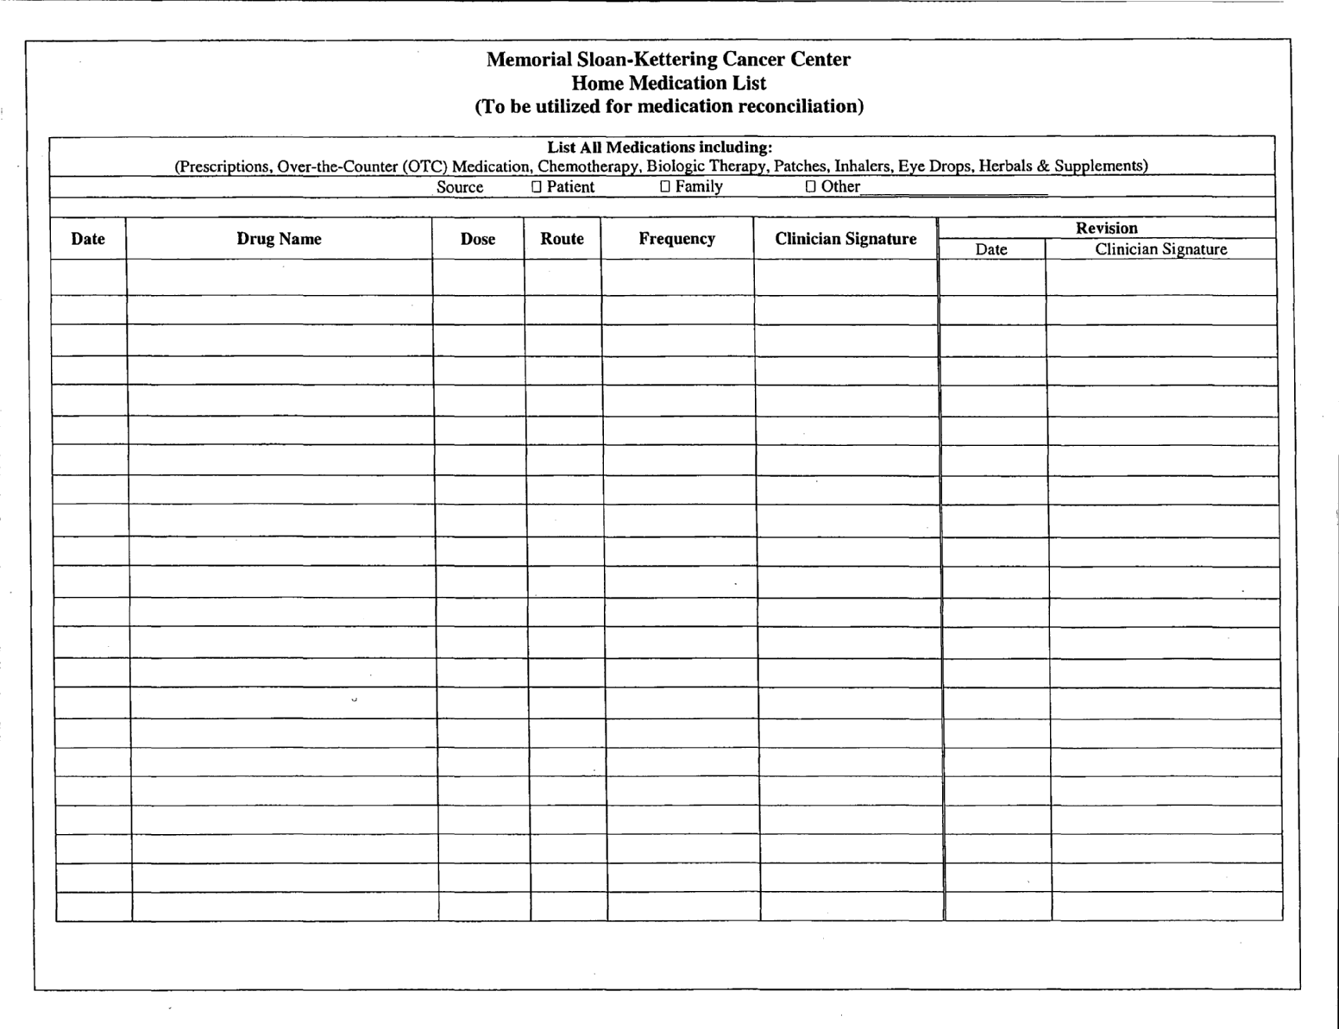
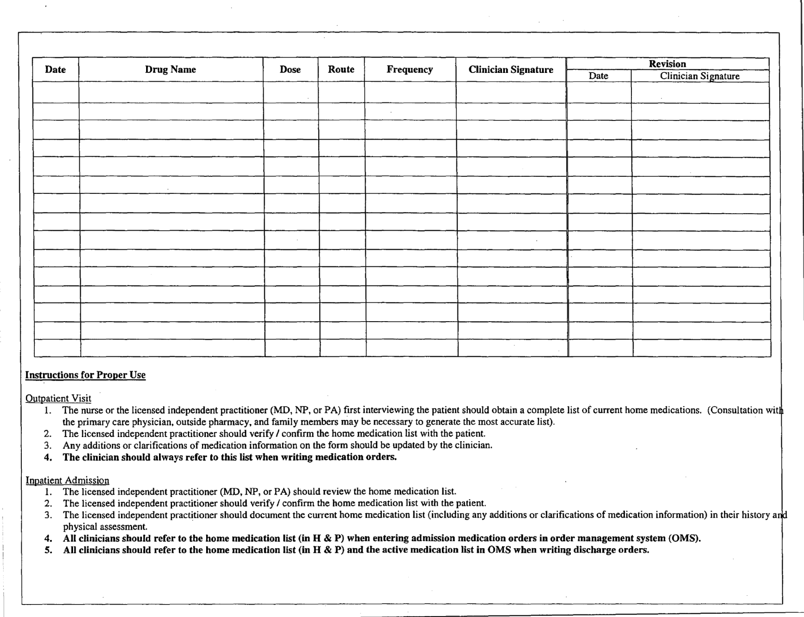
COMPLETED SAMPLES

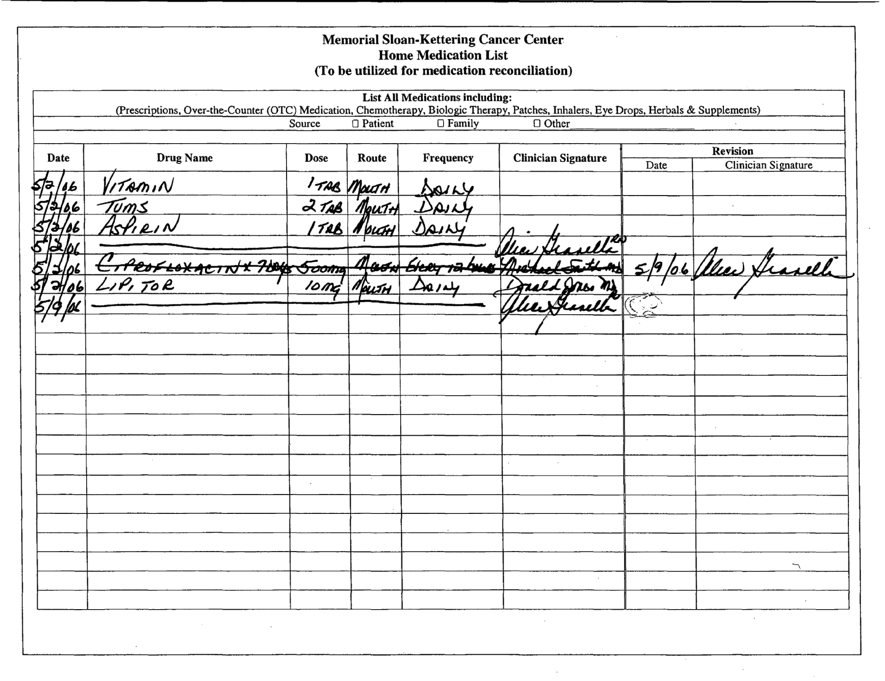
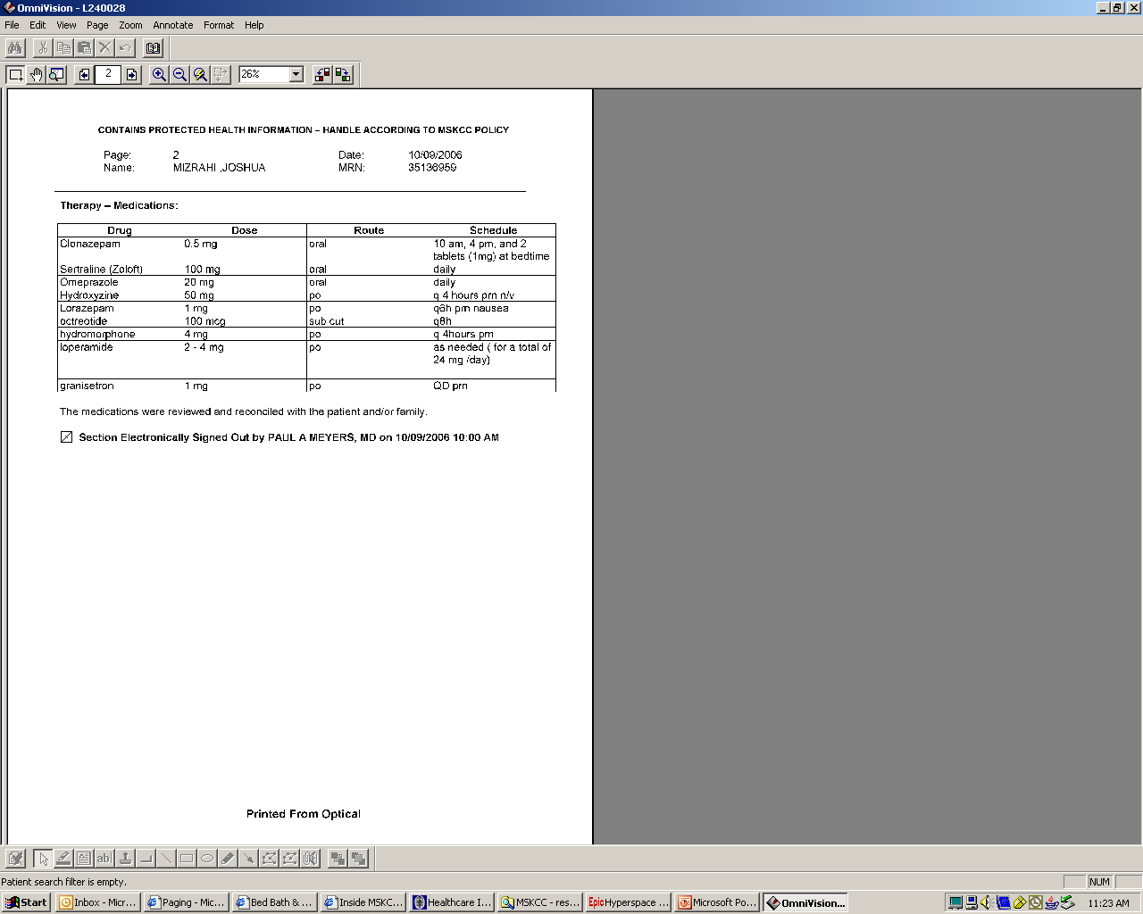

MEMORIAL SLOAN KETTERING CANCER CENTER
DEPARTMENT OF PEDIATRICS

Beeper System: 121 - beeper # - extension you are at

Admitting | 7876 (days)
Anesthesia Scheduling | 8752
Audiogram | 8184
Back up Fellow | LRB: 917 897 5341
Blood Bank | 7825 or 7826
CAT scan | 7280
Chemistry Regular/STAT | 5967 or 5973
Chief Fellow | LRB: 917 57 0331
Cytogenetics | 7099
Dental | 7644
Dermatology | 5806 or 7577
Donor Room | 7648 or 7643
ECHO – Peds/ Adults | 8120 or 7695
EEG (New York Hospital) | 746-2340
EKG/technician | 7096 / Beeper 1530
Endocrine Dr. Sklar | 8138 or Adult Endocrine fellow on call
ENT | 8990 or 5840 or 7232
Escort & STAT Messenger | 7101/after 11pm 6895
GYN | 8644
Immunology | 2704
Infection Control | B 3514 (M. Rogers) / B 1036 (S. Stone)
ID | 7810 or 7809 or 7814
Hematology Lab | 7058 or 7059
Microbacteriology / Microbiology | 7806 / Special Mirco 7811
MRI | 8200
New York Presbyterian, Cornell Campus – PICU - General Information | 212-746-0308  212-746-5454
Neuro/Dr. Khakoo | Ext 8292 / Beeper 5368 or Neuro Fellow Beeper 1444
Nuclear Medicine | 7377
Nutrition | Beeper 3015
Ophthalmology | 7237
O.R.  PACU Recovery | 5924  7566
Page Operator | 7886, 7900
PAIN – Neuro (chronic cancer pain, PCA mucositis) | Beeper 1694 Consult
PAIN-Anesthesia (epidurals, postoperative pain, chronic pain) | Page operator
Patient Rep Karen Cresti | Ext 8014; B 1182
Pediatric Day Hospital (PDH) | Ext 5948
Pediatric Education Office – Wendy Werner | Ext 5966
Playroom | Ext 2223
Procedure Fellow | LRB: 917 218 6990 B: 2870
Pulmonary Function /Test | 8380 or 8492
Psychiatry | 3900
Radiation | 2575 or 5976
Respiratory/Pentamidine | 6846/ Beeper 1551/1553
Renal | 8212
Rehab-physical therapy | 7833
Ronald McDonald House | 639-0100
Surgical Nurse Practitioners | 5948
TPN Consult | 8013 (Faye Scott; Pat Brown)
Ultrasound | 7885
X-ray: Days/Nights | 7298 or 7300
Radiology Results | 6633 then (#) 1 then 121121 followed by Pts MRN
Volunteer Office –Translators | 5980

