CLIMATIC CHANGE AND THE GULF STREAM
by
Hans J. Stolle

University of Wisconsin-Madison

Geography 858
Professor Reid Bryson

May 1975

TABLE OF CONTENTS
LIST OF | ILLUSTRATIONS............................ | Page  iii
I | INTRODUCTION ......................... | 1
II | THE GULF STREAM ..................... | 3
III | THE GULF STREAM AS DESCRIBED BY
 | FROBISHER AND OTHERS ................ | 3
IV | GULF STREAM STUDIES BY FRANKLIN
 | AND OTHERS | 10
V | MODERN GULF STREAM SURVEYS .......... | 23
VI | C ONCLUSION ........................... | 26
REFERENCES ................ |  | 29

ii

LIST OF ILLUSTRATIONS

Figure | Page
1 | The Gulf Stream system 1942 ................ | 3
 | Mean annual temperature and number of
 | weeks with drift ice for Iceland............ | 4
3 | H.P. Resen, Map of the North................ | 6
4 | Sigudur Stefansson, Map of the North........ | 7
5 | Eskimo hunting sea-birds from John White.... | 8
6 | Dionyse Settle, A True report of the late
 | voyage into the West and Northwest regions, | 8
 | 1577.
7 | Map of America by Athanasius Kircher........ . | 10
8 | A Chart of the Gulf Stream, B. Franklin..... | 12
 | A Chart of the Atlantic Ocean, exhibiting
 | the course of the Gulf Stream .............. | 13
10 | Thermometer measurements of the Atlantic.... | 17
11 | Section of the Atlantic Ocean and the
 | Gulf Stream by Truxtun...................... | 18
12 | Bottle Drift Chart by Rennel................ | 18
13 | Bottle Drift Chart by Becher................ | 20
14 | Temperature comparisons of the North Atlantic | 21
15 | Gulf Stream and Drift by Maury | 22
16 | The Gulf Stream 1845-1860, U.S.C.G.S. ...... | 24
17 | Variation in Gulf Stream course 1947-60..... | 25
18 | Variation in Gulf Stream course 1947-74..... | 26
19 | Gulf Stream direction azimuths ............. | 27
20 | Mean annual temperature and number of
 | weeks with drift ice for Iceland | 27
.
iii

INTRODUCTION

Paleoclimatology is the branch of climatology that is concerned with the study of the earth's past climates. As the climate of a specific area is a synthesis of its collective weather conditions during a specific interval of time, studies of climate analyze great amounts of accurate temperature, pressure, and precipitation data.

Since instrumental data are, however, limited to the past two hundred years or so (thermometer: Reamur 1683-1757, Fahrenheit 1686-1736, Celsius 1701-1744, barometer: Toricelli 1608-1647), many paleoclimatic studies must rely on climatic evidence gleaned from climate data substitutes or proxies. For that reason paleo-climatologists have learned to detect and decode some of the earth's latent records of its past climates. In that fashion developments in research and methodology have led to the discoveries that land-forms, sediments, fossils and pollen, as well as tree rings, oxygen and carbon content of fossilized organisms, and many other proxies bear the imprints of paleoclimatic chronologies.

And since the advent of man a wide variety of information through early archeological evidence and later graphic and written sources attest further to the variability of past climates. By combining the information collected from all sources, an knowledge base of the world's past climates is revised, expanded and verified.

2

It is known that climates of the world are always changing. There have been ages of ice, times of great rains, and prolonged periods of drought. Most paleoclimatic inquiries attempt to identify and explain these variations.

It is the purpose of this paper to investigate the relationship of change in climate and flow of ocean currents, with specific reference to the Gulf Stream during the past four hundred years. Because of the writer's principal interest in maps and mapping, this study is primarily based on available historic records of ocean current cartography which will be evaluated and compared with existing temperature and drift ice chronologies of Iceland.

In "The Role of Atmosphere and Oceans in Relation to Climate Changes and the Growth of Ice-sheets on Land" H. H. Lamb made the following comments about this relationship.
“ Examination of atmospheric circulation patterns back to 1750 suggest that storm tracks across the North Atlantic were displaced well south of the 20th century position at the times of glacier advance in Iceland, Norway and the Alps. These displacements are in the same directions as those that have long been suggested as characterizing the difference between glacial and interglacial periods. Some parallelism between displacement of wind and ocean currents is not only to be expected in theory but is one of the most obvious aspects of the climatic changes since 1750-1800 - a result which probably implies that in the major ice ages the colder Gulf Stream was strongly impelled almost due east towards southern Portugal or northwest Africa.^{”1}

3

THE GULF STREAM
"The Gulf Stream is part of a general clock-wise rotating system of currents in the North Atlantic. It is fed by the westward flowing North Equatorial Current moving from North Africa to the West Indies. As Caribbean Current it reemerges into the Atlantic through the 95mile wide Straits of Florida between the Florida Keys and Cuba. It is then deflected to the northeast by the submerged Great Bahama Bank southeast of the Florida Peninsula. North of the Bahamas it is joined by the Antilles Current and flows roughly parallel to the eastern coast of the United States to about Cape Hatteras. Here it veers more to the east and passes close to the Grand Bank south of Newfoundland, before turning eastward as the North Atlantic Drift (or current). The drift later subdivides. One branch moves southeast and south as the relatively cool Canary Current, while the warm North Atlantic Drift continues northeast off the British Isles and into the North and Norwegian seas." ²

The position of the Gulf Stream system in 1942 is seen in Figure 1.³
Figure 1

4

THE GULF STREAM AS DESCRIBED
BY
FROBISHER AND OTHERS
During the past four hundred years great variations in temperatures and drift ice occurrences of Iceland, as seen on chronologies^{4,5} (Figure 2), seem to suggest corresponding variations in the effect of the Stream's warm waters. Assuming the Gulf Stream's warmth and volume to be relatively
Figure 2
constant, it is hypothesized that similar variations in current flow direction (thus reaching Iceland, bypassing it, or remaining at southern latitudes) should be shown on maps made during the four centuries. As accurate and complete descriptions of Gulf Stream flow patterns for the entire period do not exist, evidence of more or less fragmented facts from maps, measurements, and mariners' accounts must suffice.
The history of the Gulf Stream and its influence on man and navigation from its recorded discovery at the turn of the 15th century to modern

5
times has been compiled by J.G. Kohl. In his Geschichte des Golf-
stroms, ⁶ which is the translated and revised publication of his research done for the U.S. Coast and Geodetic Survey in 1854-1857, he has retraced the accounts of early explorers through the works of Medina⁷, Martyr⁸, Lescarbot⁹, Herrera^{l0}, Hakluyt¹¹, Navarette¹², and others.

For want of original cartographic representation of the Gulf Stream and its early exploration, Kohl had undertaken the formidable task to reconstruct a map from major voyages, the Gulf Stream, and reports of its discoveries.¹³ Depicting the Gulf Stream from the Bahamas to the Azores, the northern branch of the Stream and its relation to the island and climate of Iceland is unfortunately not shown. Kohl's first mention of Gulf Stream currents in the northern parts is made through Best's account of Frobisher's voyage in 1577.¹⁴

"On the eyght of June we sette sayle agayne (from the Orkney Islands) ...keeping oure course West Northwest.... we trauersed these seas by the space of .26. dayes, without sight of any land, and met with much drift wodde, and whole bodyes of trees.¹⁵

Reference to an existing map of this voyage and its account was obtained from Professor Bryson. This cartographic rendition by H.P. Resen, bishop of Copenhagen 1605 (Copenhagen Koneglige Bibliotek) is a map of the North Atlantic which shows the northern
7
branch of the Gulf Stream through a string of trees floating from Newfoundland to Iceland,^{16,17} (see Figure 3). An explanatory note, next to the trees, refers to Frobisher's voyage of 1577 (Vide Navigationem Frobisheri A° 1577). Pertinent parts of the map's analysis by Cummins, Skelton, and Ouinn read: In the title of his map, which is drawn with east to the top, Resen refers to his sources: first, ‘an ancient map crudely drawn centuries ago by Icelanders, to whom that land (Greenland) was then well-known'; and second, 'the observations of seamen of our day'. The survival of any medieval Icelandic map is doubtful, and Resen’s map—like those drawn by Icelanders at that time-- is another attempt to adjust the cartography of the Norse voyages, as deduced from Icelandic literature, to the geography of Greenland and North America based on sixteenth century explorations. In spite of its larger scale, greater elaboration, and wealth of written annotation, the depiction of Resen's shorelines is identical to that in the map of Sigudur Stefansson (Figure 4), drawn about ten years earlier. In both, Greenland has the same orientation and outline. The southern part of the mainland shows three bays forming two broad peninsulas, 'Helleland' and 'Markland'. The 'Promontorium Vinlandae’ has a deep bay to the west. All features have

Figure 4

the same shape and location at 50°N. To this base map Resen has added American coastal place-names from Mercator's world map of 1569 and numerous notes on later exploratory voyages, especially Frobisher's...... A symbol x and note tells of Frobisher taking of a man, woman and child

8

taken hence to England in 1577. Three little drawings of Eskimo life, circled on Figure 3, are plainly copied from a woodcut in Dionyse Settle's account of the 1576 voyage, shown here in Figure 5.

Figure 5
Best's report on the 1577 voyage is cited by Resen as his source for the representation of tree-trunks drifted from America across Denmark Strait to Iceland.¹⁸

As a photocopy of Settle's original account was available, its description of floating trees (the North Atlantic Drift of the Gulf Stream) was found and is here reproduced as Figure 6.

9
A comparison of Resen’s map inscription :
In... a Pinus que dicitus evulse ex novis terris ad litora videtur sipe Navtis q.. per guendam alveum ferri in marl versus islandiam. Vide Navigationem Frobisheri A°'1577.

with Figure 6 shows much greater similarity and agreement than is found for Best's account (see page 5). This seems to indicate that Resen's note (Vide Navigationem Frobisheri A° 1577) does not make reference to additional sources of information but instead documents the source that he had used for the map.

Transferring the course of the drifting tree trunks onto a Mercator projection results in an azimuth of 48° or a NE compass course. Comparisons with the 1942 outline of the North Atlantic Drift (Figure 1) show some displacement to the south. Both Iceland chronologies (Figure 2) indicate that Resen's Gulf Stream occurred after a century of little ice and relatively high temperatures. The Gulf Stream of the 20th century, on the other hand, was preceded by a century of much ice and relatively low temperatures. An additional reason for the difference in Golf Stream course despite the warmer temperatures in 1942 is given later by Benjamin Franklin and others.
On a map of the Americas, Athanasius Kircher shows the Gulf Stream in 1678. Although Figure 7 is a greatly reduced copy, a northeast current can barely be seen to continue beyond the Island of Newfoundland.¹⁹
Figure 7

GULF STREAM STUDIES BY FRANKLIN AND OTHERS
With the invention of many scientific instruments, scientific inquiry of the 18th century flourished and more accurate measurements and observations of the Gulf Stream became available. In reply to a complaint from the board of customs at Boston in 1769, that mail ships from Falmouth to New York took fourteen days longer than merchant ships from Rhode Island to London, Benjamin Franklin, then manager of the American Post Office, engaged in investigating its reason. Seeking the advice of experienced Nantucket sailors, Franklin
11
made the acquaintance of a captain Folger from whom he learned of the Gulf Stream and its influence on fishing and sailing. Realizing at
once the significance of this information, Franklin asked for the Stream's accurate delineation on a map which he had engraved and published.²⁰ A copy of this map is shown in Figure 8. The course of the Gulf Stream is seen to extend north from the Straits of Florida to a latitude of 30°N, where it changes to a northeastward direction, which it maintains up to the latitude 41°20'N. Here, at the Gulf Stream's bend, it turns to the east and east southeast. The North Atlantic circulation pattern, shown on the map's inset, is not explained by the map or its text. Prompted by curiosity, this writer searched for more of Franklin's publications. Eventually the answer was found on a large Gulf Stream map (not shown) of the entire North Atlantic.²¹ It’s Gulf Stream appears in a more northern course with northern and southern branches starting at 50°W longitude. In a footnote added to the text, identical to that of the first publication in the Trans-actions, Franklin explains that this map intends to show the theory of the Gulf Stream and the theory of the migration of fish. The search had also turned up a smaller third version of the Gulf Stream map (Figure 9) which in its major characteristics resembles those of the second version. It also provided an explanatory note detailing the reasons for the Gulf Stream's modification in course and direction.

13
Figure 9

14
"The chart here given has been constructed with a view to give a more comprehensive idea of the course of the Gulf Stream. Volney very plausibly suggests, that earth deposited by the Gulf Stream SE of Newfoundland, has formed the Great Banks; and that the accumulation there has given the stream a new or more eastwardly direction.”²²

Inasmuch as Franklin did not provide a reference to the source of Volney's theory, the evidence of a former, or more northward direction of the Gulf Stream could not be established with certainty. Nonethe-less in a chapter on the Gulf Stream, found in the English translation of The Soil and Climate of the U.S., Volney refers to a publication by Stricklander:

"This observer (Stricklander) adds, that he has noticed a branch of the Gulf Stream, in the parallel of Jaaquet Island, latitude 47°north, longitude 30° west, and he dwells on the probability of the products of the tropics, being conveyed by the current to the coast of Ireland. He has given new force to my conjecture, that the Bank of Newfoundland is the bar of this river, whose current before these sands were collected together, pursued a straight course to Ireland, but after the obstacle was formed by the gradual accessions of many ages, was compelled to turn off to the east. The gravel of this bank 'might be compared, with some advantage, to that of the .Atlantic coast."²³

In 1843 Redfield concurred with a similar theory for the counter currents:

`"It is well known that extensive fields and packs of ice, including many icebergs of vast magnitude, are constantly carried by the polar currents toward the lower latitudes. On reaching certain regions, such as the Banks of Newfoundland, the ice is brought into proximity or contact with the warm counter currents of the system, which flow from the torrid zone, where the ice is soon dissolved. The numerous masses of earth, rocks, beach boulders, and sedimentary matter, which are borne by the ice in great profusion from the cliffs, the shores and the see bottom of the Arctic regions, are thus added continually to the vast submarine deposits which there accumulate."²⁴

15
While it is quite possible that deposits from northern and southern currents may have affected the direction of the Gulf Stream to some extent, none of the obtained sources provided definite knowledge of a former, more northern flow.

Comparing Franklin's Gulf Stream maps with the chronology of temperatures in Iceland for the 1770-1818 period are found to be correspondingly low in temperatures and Gulf Stream latitudes.

As Franklin's maps and letters had helped to rediscover the Gulf Stream, increasing interest in the Stream gave rise to a number of thermometer studies. On his Europe (1775) and later Atlantic crossings (1776 and 1785), Franklin continued his interest in the Gulf Stream by making observations of air and water temperatures. ²⁵ In a paper on the heat of the water in the Gulf Stream 'Charles Blagden, an army physician, reports of locating the Stream with the help of a thermometer during Atlantic voyages in 1776 and 1778.²⁶ Jonathan, a nephew of Benjamin Franklin who had assisted his uncle in the Atlantic temperature studies, continued the work independently and published the results with a map.²⁶ Other water and air temperature records of the North Atlantic were published by Billing's (1791)27, Stricklander (1798)²⁸, Hamilton (1817)²⁹,

16

and Rensselaer (1819)³⁰. For this paper, all of their measurements were combined and mapped in Figure 10. Each observation was plotted by its latitude and longitude. Hollow circles show warmer air temperatures and solid circles represent warmer temperatures of the water, or the Gulf Stream. Once the tabulated data, which did not show any spatial pattern, was mapped it clearly depicted the width, configuration, and latitudinal position of the Current. Moreover, a sufficiently large number of warmer air temperature samples located along the northern fringe of the study area assures that the northern edge of the Gulf Stream was not missed by lack of samples. A map from Truxtun's Remarks, Instructions and Examples Relating to the Latitude and Longitude of 1794,³¹ (see Figure.11) shows an even more southern flow of the Gulf Stream without any northern branch.

An almost easterly direction (azimuth of about 70° to 75° of the Stream, as identified by the thermometer analysis, and Truxtun's eastern and southeastern flow reconfirm, to some extent, the correspondence found for the Iceland chronologies and Benjamin Franklin's maps.

Investigations of the Gulf Stream continued with a number of drift bottle experiments which charted tracks of over one hundred

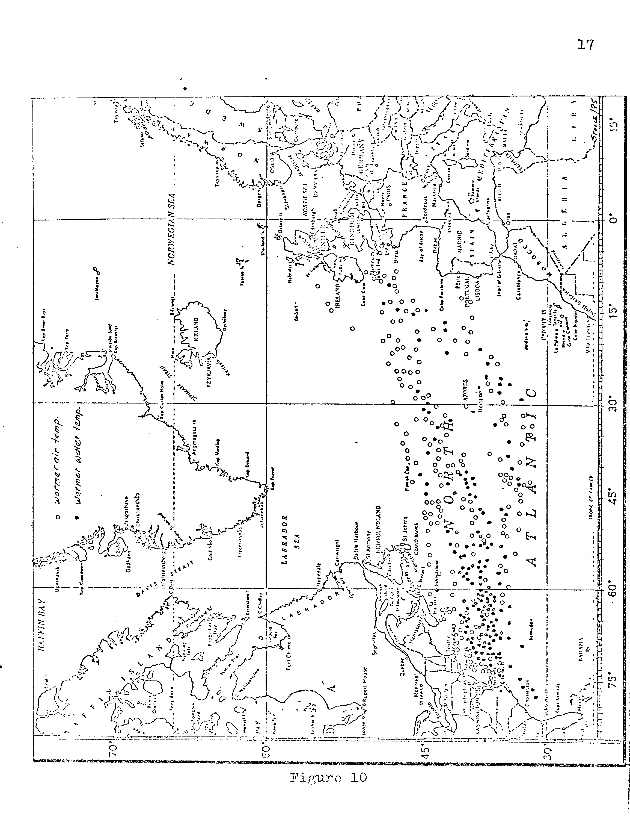
Hans J. Stolle © 1975
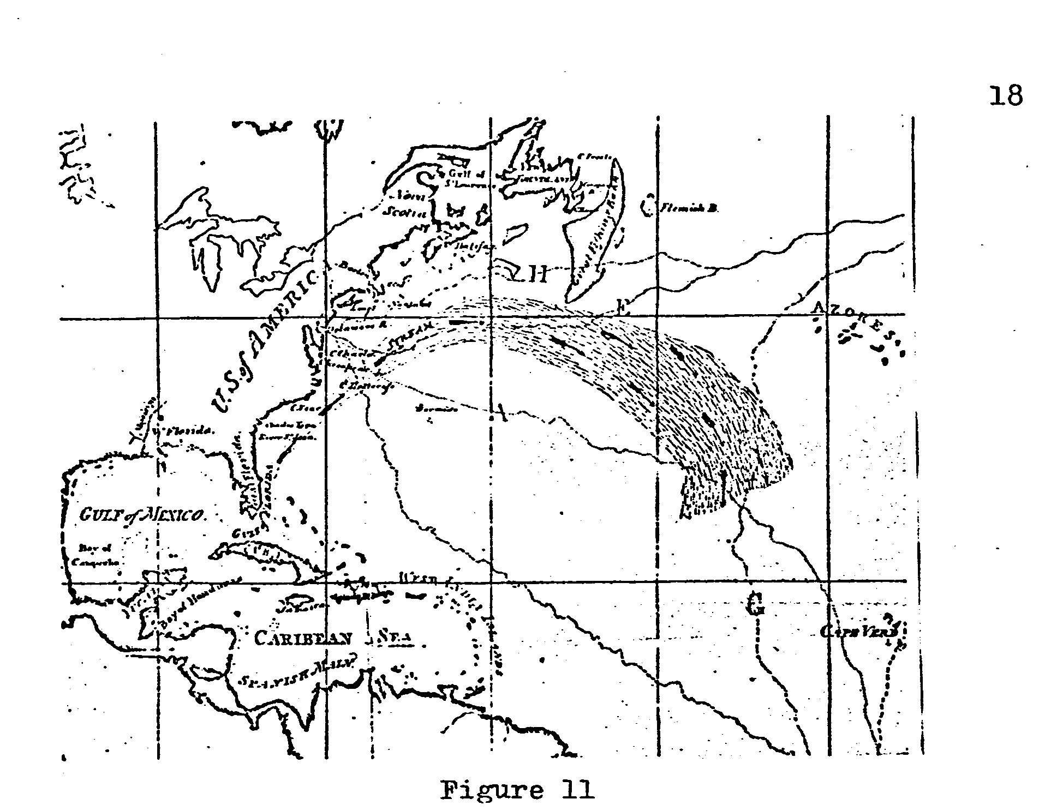
bottles across the Atlantic. Figure 12 shows a very general pattern of bottle tracks for 1802-1831.³² Figure 13, on the other hand, was

19
constructed from bottle records recorded for 1808-1852.³³ Although the shown lines of direction on both bottle charts do not represent the actual lines of bottle flow, but connect the positions of bottle sending and receiving, a pronounced ENE or azimuths of 60°-80° can be inferred. These directions are also in general agreement with the Gulf Stream maps by Franklin. The observed east or east southeast flows of several bottles from the southern tip of Greenland straight across the Atlantic to Norway, Scotland, and Ireland attest to the absence of any strong currents of the Golf Stream toward Iceland.

At this time, other Gulf Stream observations were undertaken by von Humboldt (1814)³⁴, Sabine (1825 )³⁵, Rennel (1832)³⁶, Redfield (1843)³⁷, Maury (1856)³⁸ and others. Unfortunately, von Humboldt's map and Rennel's work An Investigation of the Currents of the Atlantic Ocean could not be obtained for this study. However, maps of sea temperature distribution comparisons, based on Rennel's data for
(a) January and (b) July observations are shown in Figure 14, whose
patterns show that the Gulf Stream was farther south than now and
tended to turn away south before reaching the coast of Europe"³⁹

A map of the Gulf Stream taken from Maury's study The Phvsical Geography of the Sea ⁴⁰ , Figure 15, is the first map with specific reference to seasonal displacement of the Gulf Stream, which
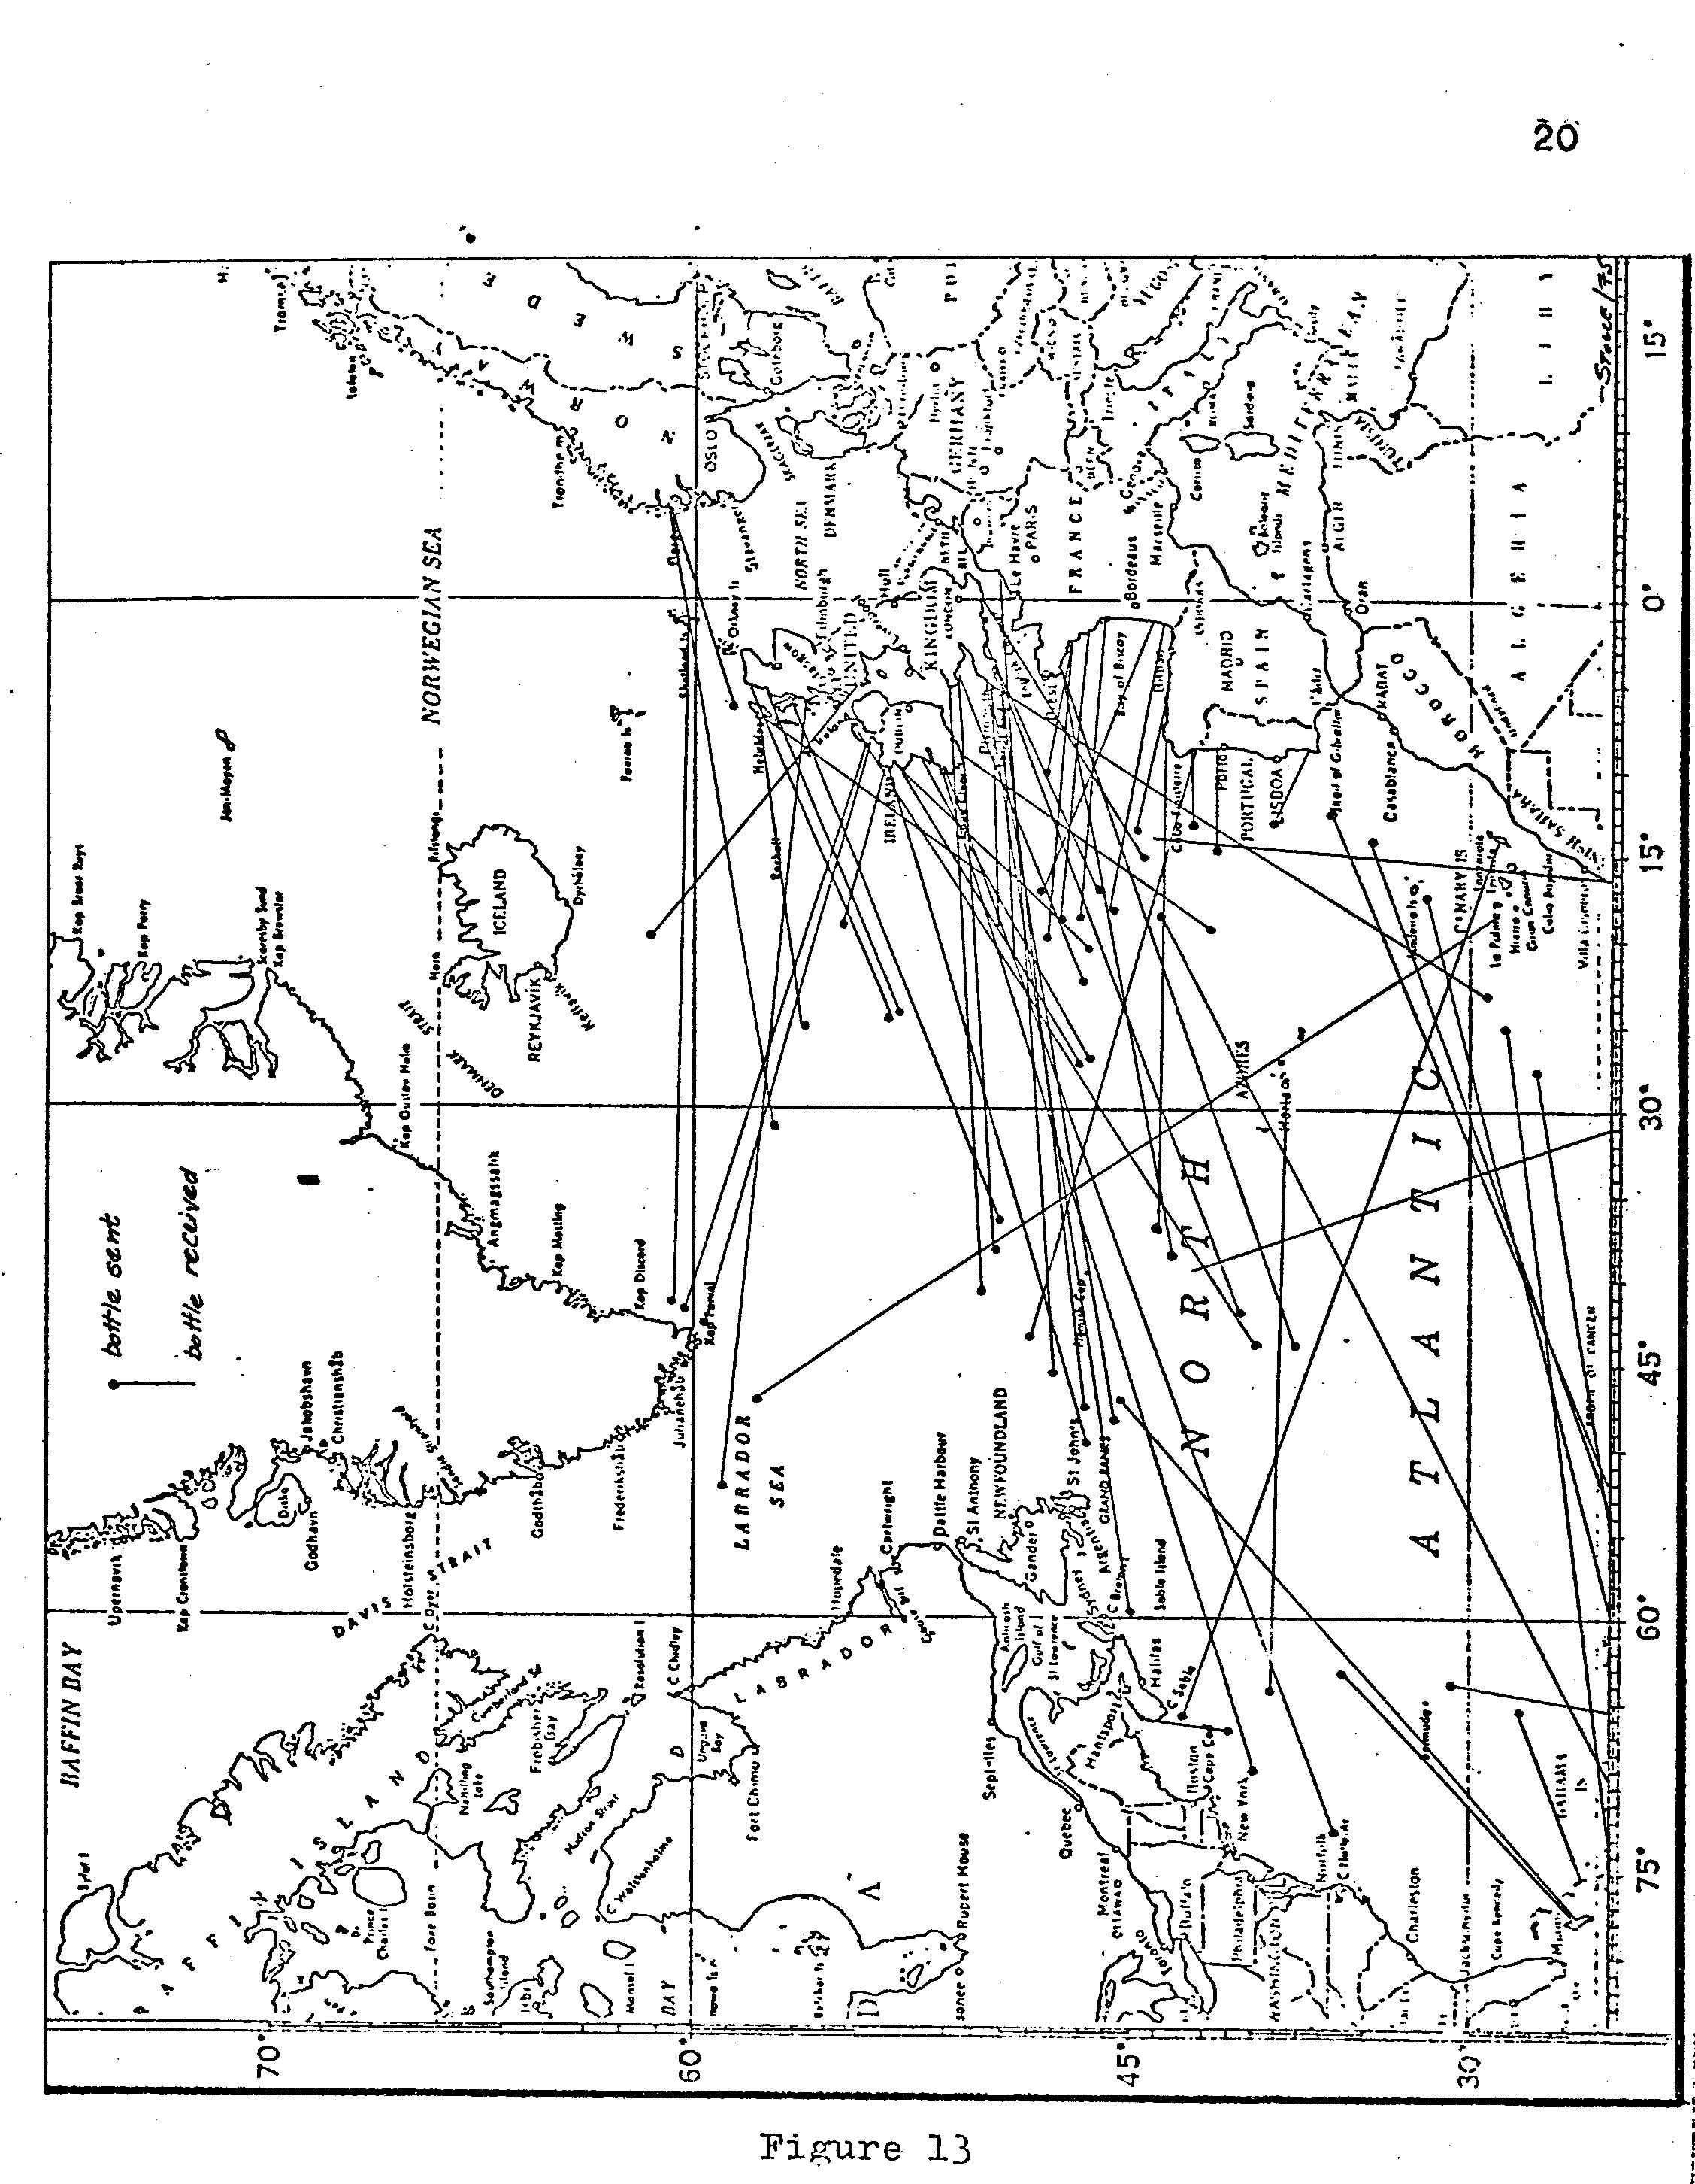 Hans J. Stolle © 1975
21
Maury describes:

"As the Gulf Stream leaves the coast of the United States, it begins to vary its position according to the seasons; the limit of its northern edge, as it passes the meridian of Cape Race, being in winter about latitude 40-41°N, and in September, when the sea is hottest, about latitude 45-46°N. The part of the Gulf Stream which stretches over toward the Grand Bank of Newfoundland is, as the temperature of the water of the ocean changes, first pressed down toward the south, and then again up toward the north, according to the season of the year.⁴⁰

Figure 14

Both chronologies of Iceland show a marked increase in temperature and decrease in drift ice occurrences during the time of Maury's study (1850-1860). A comparison of Maury's map with its more northern flow, especially for the summer months, does therefore correspond with the Iceland chronologies.

23

M0DERN GULF STREAM SURVEYS

Modern surveys of the Gulf Stream commenced in 1844 with the work of the U.S. Coast and Geodetic Survey under the direction of B. Franklin's great-grandson, A. D. Bache.⁴¹ Based on several temperature sections, surveyed between Tortugas and Nantuckett, survey ship cruises discovered the existence of cold veins within the Stream which are charted on the map of 1860, Figure 16.⁴² As the shown Gulf Stream does not extend beyond its bend at 38°- 40°N, a comparison of Gulf Stream location and Iceland chronologies could not be made.
With the establishment of the Woods Hole Oceanographic Insti-tution in the 1930's, more intensive surveys of the Gulf Stream began to produce more specific and detailed maps and charts of the Current.⁴³

Variations in Gulf Stream course, as observed by Woods Hole studies in 1947, 1948, 1950, and 1960⁴⁴ for a 120,000 square mile area approximately 600 miles off shore, are mapped in Figure 17. Although limited to a short segment, the four courses of the Stream's northern edge show a gradual progression toward the northeast from 1947 to1960. Considering the regularity in annual displacement to the northeast seems to make this pattern of progression due to chance unlikely. To compare Figure 17 with later Woods Hole studies of 1964⁴⁵, 1968 and 1969⁴⁶ and Gulf Stream data obtained from satellite imagery and ship observations for September 1974⁴⁷, Figure 18 was compiled
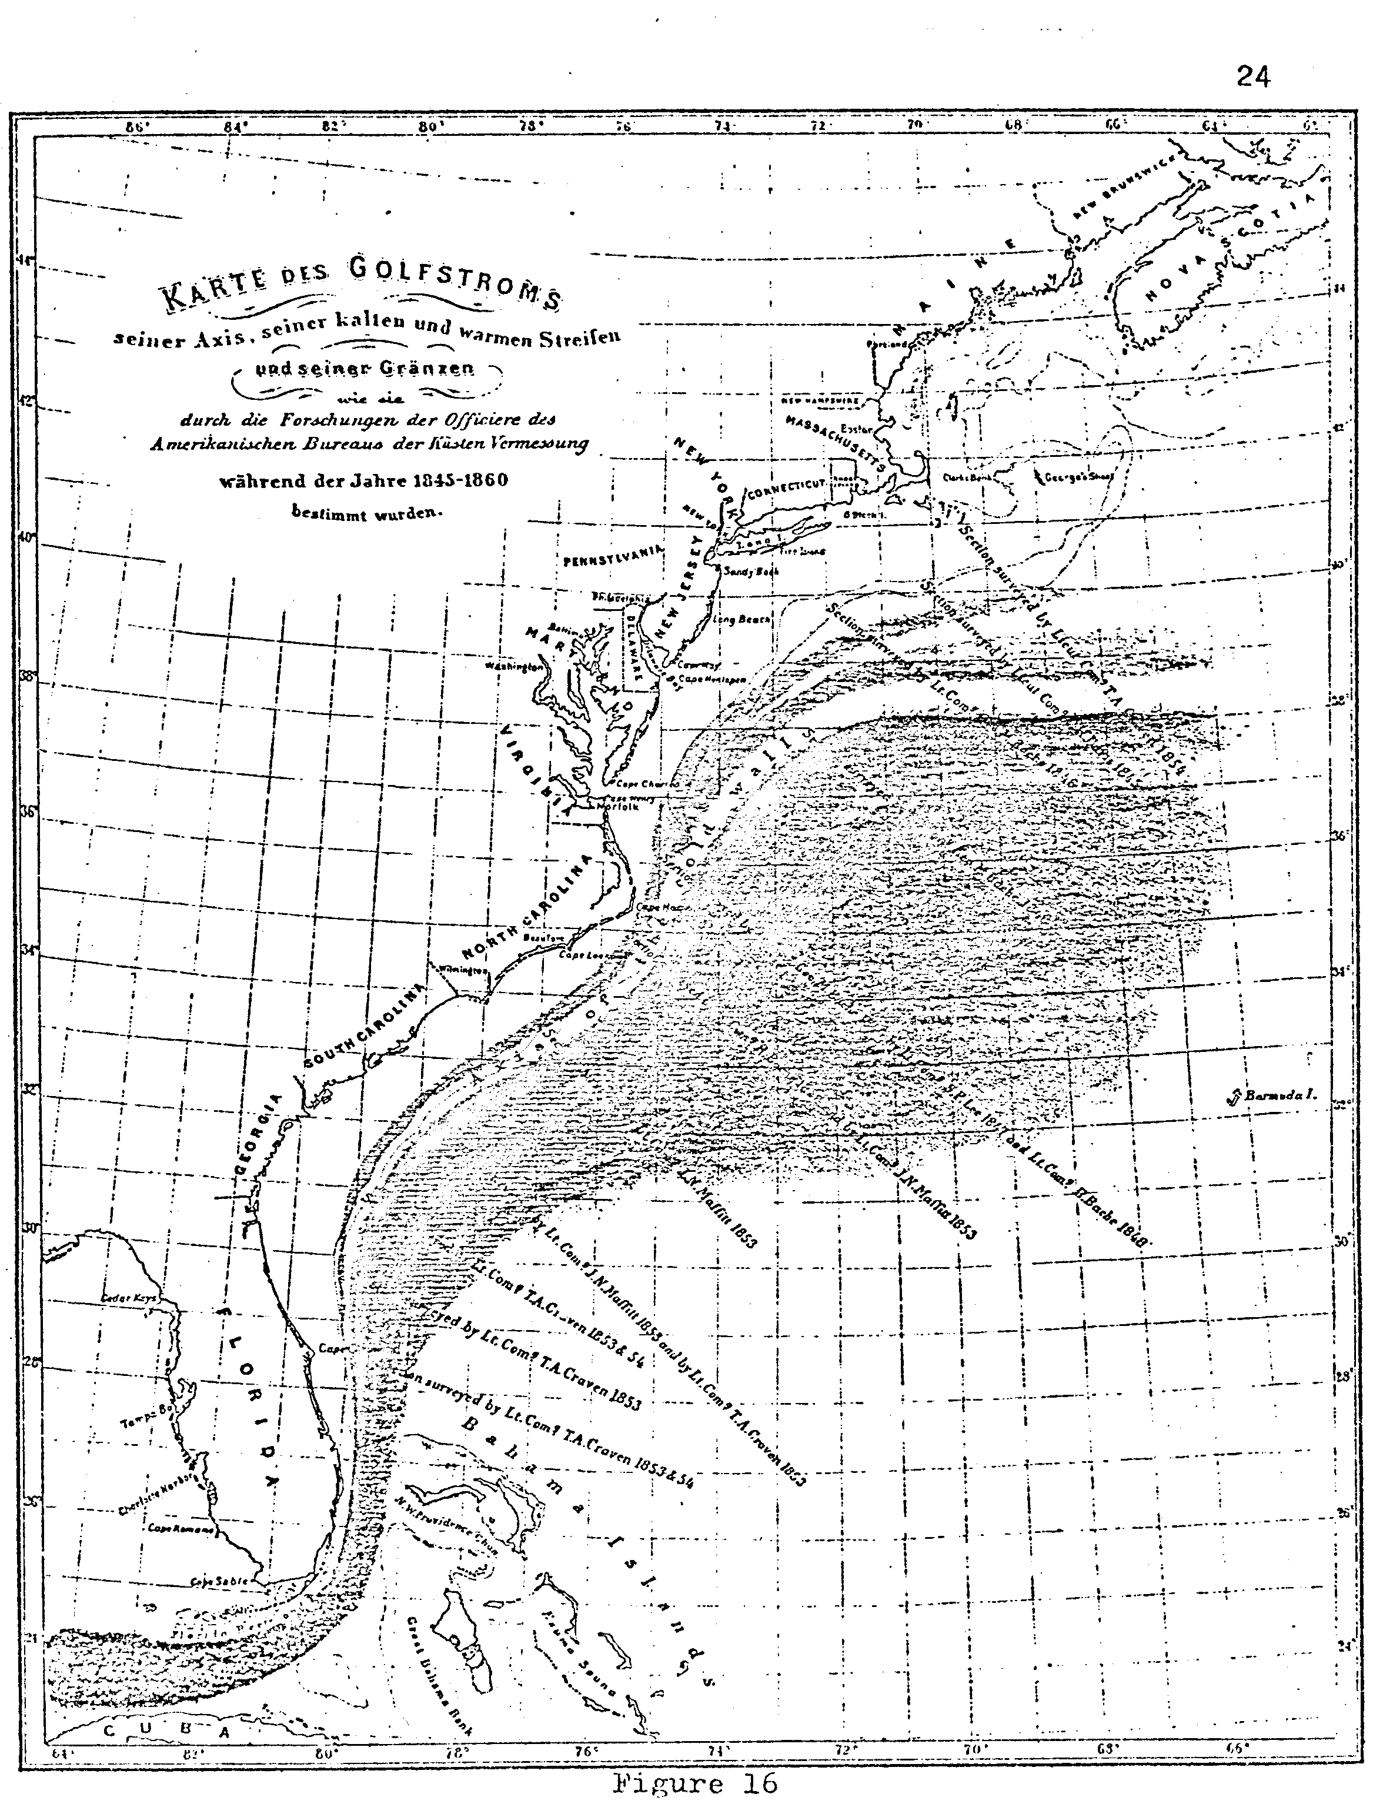

for this study. It can be observed that the northeastward progression of the Gulf Stream, observed for the 1947-1960 period, has reversed itself since 1964. Inside the study area all of the post 1960 Gulf Stream’s northern edges are below the latitudes of the 1960 maximum
Looking back to the Iceland chronologies, one finds general agreements in temperature increase and drift ice decrease for the 1940-1960 period. A rather rapid return to lower temperatures (ice data not available) in Iceland since its temperature maxima in
1950-1960, coincides with the observed lowering of Gulf Stream latitudes shown in Figure 18.

CONCLUSION

Evaluations of the available cartographic evidence of the Gulf Stream and its location for the past four hundred years and
comparisons with established chronologies for Iceland temperatures and drift ice occurrences were found to agree to some extent. As shown in Figure 19 and Figure 20, Resen' s representation of North

27
Hans J. Stolle © 1975

28

Atlantic Drift to Iceland coincides with high temperatures and very low numbers of drift ice weeks. A slight increase in Gulf Stream flow azimuths (measured clockwise from north), as shown by Kircher, roughly coincides with decreasing temperatures. The very large flow direction azimuths of over 100° of Franklin's and Truxtun's Gulf Stream agree with the chronology's peak in drift ice. The Gulf Stream course, as determined by thermometer measurements, drift bottles, Franklin's second and third map, and the Stream's course, particularly in summer, as shown by Maury reflect the general temperature increase in the 1850-60's. Gulf Stream maps for the end of the 19th century were not found, however, the Stream's outline, as shown in Figure 1 for 1942, shows further decrease in flow azimuth which corresponds with the warming trend shown by the temperature chronology. Since the modern data, as indicated earlier, were limited to a very short segment of the Stream, they are not included in Figure 19. Nonetheless, some corresponding trends of the modern data were recognized and pointed out.

Considering the inaccuracies of early cartography and the fact that most maps do not represent the conditions existing at the time of publication, the results of this paper appear quite satisfactory. The use of historic records of cartography as proxies for paleoclimatotological studies proved to be beneficial and seems to indicate promise for future studies.
29

Acknowledgments
The extensive collection of the Wisconsin State Historical Society provided most of the historical materials used for this study. Granting me access to the rare documents collection was especially helpful.

FOOTNOTES
¹H.H. Lamb "The Role of Atmosphere and Oceans in Relation to Climate Changes and the Growth of Ice-sheets on Land" Problems in Paleoclimatology (New York: Interscience Publishers, 1965) p. 34I.
²Encyclopaedia Britannica, Macrobaedia Knowledge in Depth (Chicago: W. Benton Publisher, 1974) pp. 386-87.
³Sverdrup, Johnson, and Fleming in The Gulf Stream by H. Stommel (Berkeley: University of California Press: 1965) p. 23.
⁴P. Bergthorsson, in R.A. Bryson "A Perspective on Climatic Change" Science, Vol. 184 (May, 1974) p. 755.
⁵L. Koch "The East Greenland. Ice" Medd. om Groenland Vol. 130, No. 3 (1945)
⁶J.G. Kohl, Geschichte des Golfstroms and seiner Erforschung (Amsterdam: Meridian Publishing Company, reprint of the 1868 Bremen edition, 1966)
⁷P. de Medina, Arte de Navigar (Valladolid: 1545)
⁸Peter Martyr von Anghiera, The Decades of the Ocean , English Edition by Eden, London: 1577)
⁹Lescarbot, Histoire de la Nouvelle France (Paris: 1612)
^{1O}Herrera, Descripcion de las Indias (Madrid: 1730)
¹¹Hakluyt, Travels of the English Nation (London: 1810)
¹²Navarette, Historia de la Nautica (Madrid: 1841)
¹³J.G. Kohl Ibid, p. 79.
¹⁴J.G. Kbhl Ibid, p. 58.

¹⁵V. Stefansson, The Three Voyages of Martin Frobisher, I, in the search of a passage to Cathay and India is by the North-West, A.D. 1576-8. from the original 1578 text of George Best. (London: The Argonaut Press, 1938) p. 54

30
¹⁶R.A. Skelton, T.E. Marston and G.D. Painter, The Vinland Map and the Tartar Relation (New Haven: Yale University Press, 1965) p. 147.

¹⁷W. P. Curmming, R.A. Skelton, D.B. Quinn, The Discovery of North America (New York: The American Heritage Press, 1971) p. 226.

¹⁸Ibid, p. 227.

¹⁹T.F. Gaskell, The Gulf Stream (London: Cassell & Companv Ltd., 1972) p.84 .

²⁰B. Franklin "A Letter from Dr. Benjamin Franklin to Mr. Alphonsus le Roy, Member of several Academies, at Paris. Containing sundry Maritime Observations" Transactions Am. Phil. Soc. Vol. II (1786) p. 330.

²¹B. Franklin, Memoirs of Benjamin Franklin (Philadelphia: M'Carty & Davis, 1834) p. 373.

²² B. Franklin and W.T. Franklin, Memoirs of the Life and Writings of Benjamin Franklin, LL.D. (London: H. Colburn, l8!8) pp. 543-551.

²³C.F. Volney, A View of the Soil and Climate of the United States of America, translated by C.B. Brown, (Philadelphia: Conrad & Co., 1804)
p. 178.

²⁴Redfield "Mr. Redfield on the Currents of the Atlantic" American Journal of Science and Arts, Vol. XLV (1843) P. 297.

²⁵B. Franklin, "A Letter from..." pp. 325-328.
²⁶ C. Blagden "On the Heat of the Water in the Gulf-stream" Philosophical Transactions of the Royal Soc. of London, Vol. LXXI (1781) pp. 334-344.
J. Williams "Memoir of Jonathan Williams, on the use of the thermometer in discovering banks, soundings, etc." Transactions of the Am. Phil. Soc, Vol. III, (1793) pp. 82-100.

²⁷ W. Billings "A Thermometrical Journal of the Temperature of the Atmosphere and Sea, on a Voyage to and from Oporto, with explanatory observations thereon" Transactions Am. Phil. Soc., Vol. 111.(1793) pp. 194202.

²⁸W. Stricklander "On the Use of the Thermometer in Navigation"' Transactions, Am. Phil. Soc., Vol. V. (1802), pp. 90-103.

31 .
²⁹J. Hamilton "Tables of Observations on the Winds, the Currents, the Gulph Stream, the Comparative Temperature of the Air and Water...." Transactions, Am. Phil. Soc., Vol. II new series (1825) pp. 140-155.

³⁰J. van Rensselaer "On the Natural History of the Ocean, with two sea journals" The American Journal of Science and Arts, Vol. V (1822) pp. 128-140.

³¹T. Truxtun, Remarks, Instructions, and Examples Relating to the Latitute and Longitude (Philadelphia: 1794)

³²H.H. Lamb, Climate, Present, Past and Future, I (London: Methuen & Co., 1972) p. 335.

³³ A.B. Becher "Bottle Chart of the Atlantic Ocean" The Nautical Magazine for 1843, pp. 181-184. Nautical Magazine for 1852, pp. 568-572.

³⁴A.von Humboldt, Reise in die Aequinoctial Gegenden des neuen Continents (Stuttgart: Cotta'scher Verlag, 1874) pp. 18-28.

³⁵E Sabine, An Account of Experiments to determine the Figure of the Earth
1825
³⁶J. Rennel, An Investigation of the Currents of the Atlantic Ocean (London: Rivington, 1832.)
³⁷Redfield, Ibid

³⁸M.F. Maury, The Physical Geography of the Sea (New York: Harper an
Brothers, 1856)
³⁹H.H. Lamb, The Changing Climate (London: Methuen Company, 1966 p. 15.

⁴⁰M..F. Maury, Ibid, plate VI, and pages 45-46.

⁴¹H. Stommel, The Gulf Stream (Berkeley: University of California Press, 1965) p. 8.

⁴² J.G . Kohl, Ibid, p. 182.

⁴³H, Stommel, Ibid, p. 11

32
⁴⁴F.C. Fuglister "Gulf Stream '60" Progress in Oceanography, Vol. I (1963) pp. 265-295.

⁴⁵F.C. Fuglister and A.D. Voorhis "A New Method of Tracking the Gulf Stream" Limnology and Oceanography, Vol. 10, Supplement, (November, 1965) pp. R115 -R124.

⁴⁶C.E. Parker "Some Direct Observations of Currents in the Gulf Stream" Deep-Sea Research, Vol. 19 (1972) pp. 879-893.

⁴⁷U.S. Naval Oceanographic Office, The Gulf Stream Monthly Summary, Vol. 9, No. 9 (September,1974).

