HelloWorld.jsp

<HTML>
<HEAD>
<TITLE>Hello World</TITLE>
</HEAD>
<BODY>
<H1>Hello World</H1>
Today is: <%= new java.util.Date().toString() %>
</BODY>
</HTML>

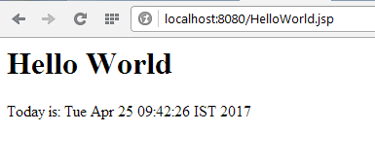

first.jsp

<html>
<head><title>First JSP</title></head>
<body>
<%
double num = Math.random();
if (num > 0.95) {
%>
<h2>You'll have a luck day!</h2><p>(<%= num %>)</p>
<%
} else {
%>
<h2>Well, life goes on ... </h2><p>(<%= num %>)</p>
<%
}
%>
<a href="<%= request.getRequestURI() %>"><h3>Try Again</h3></a>
</body>
</html>

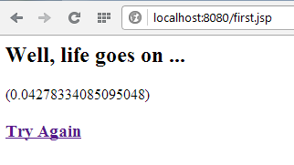

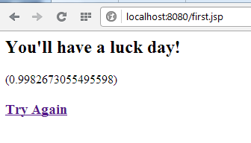

abc.jsp

<HTML>
<HEAD>
<TITLE>JSP Expressions: Predefined Objects</TITLE>
</HEAD>
<BODY>
<H1>Using Predefined Objects</H1>
<UL>
<LI> Your Hostname: <%= request.getRemoteHost() %>
<LI> Your Session ID: <%= session.getId() %>
<LI> The value of INFO parameter: <%= request.getParameter("INFO") %>
</BODY>
</HTML>

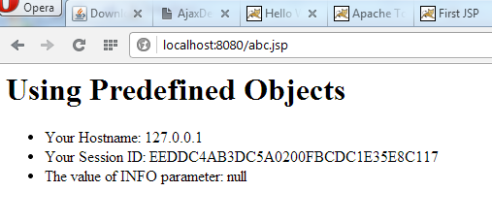

bgcolor.jsp

<HTML>
<HEAD>
<TITLE>JSP: Scriptlets</TITLE>
</HEAD>
<%
String bgColor = request.getParameter("COLOR");

if (bgColor == null)
bgColor = "WHITE";

%>
<BODY BGCOLOR="<%= bgColor %>" >
<H1>Example Scriptlet: Sets background color</H1>

</BODY>
</HTML>

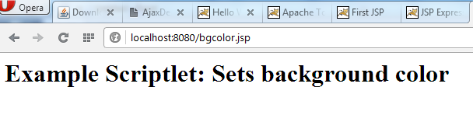

bgcolor2.jsp

<HTML>
<HEAD>
<TITLE>JSP: Scriptlets 2</TITLE>
</HEAD>
<% String bgColor = request.getParameter("COLOR"); %>

<% if (bgColor == null) { %>
<BODY BGCOLOR="FFFFFF" >
<% } else { %>
<BODY BGCOLOR="<%= bgColor %>" >
<% } %>

<H1>Example Scriptlet: Conditionally sets background color</H1>
<% if (bgColor == null) { %>
You did not supply a color, I used white.
<% } else { %>
Here is the color you requested.
<% } %>

</BODY>
</HTML>

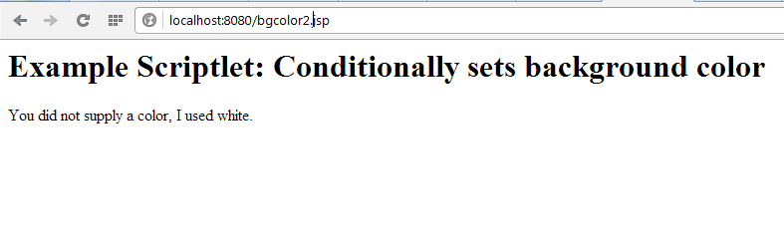
declare.jsp

<HTML>
<BODY>
<%!
private int hitCount = 0;
String randomColor() {
java.util.Random random = new java.util.Random();
int R = (int) (random.nextFloat() * 255);
int G = (int) (random.nextFloat() * 255);
int B = (int) (random.nextFloat() * 255);
return "#" + Integer.toString(R, 16)
+ Integer.toString(G, 16)
+ Integer.toString(B, 16);
}
%>
<FONT COLOR="<%= randomColor() %>" >
This page has been accessed <%= ++hitCount %> times.
</FONT>
</BODY>
</HTML>

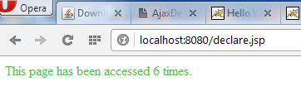

date.jsp

<%@ page language="java" contentType="text/html" %>
<HTML>
<HEAD>
<TITLE>JSP: Beans Example 1</TITLE>
</HEAD>
<BODY BGCOLOR="WHITE">
<H1>JSP: Example of using a Bean</H1>

<jsp:useBean id="today" class="java.util.Date" />
The current date and time is:
<UL>
<LI> Date: <jsp:getProperty name="today" property="date" />
<LI> Month: <jsp:getProperty name="today" property="month" />
<LI> Year: <jsp:getProperty name="today" property="year" />
<LI> Hours: <jsp:getProperty name="today" property="hours" />
<LI> Minutes: <jsp:getProperty name="today" property="minutes" />
</UL>
</BODY>
</HTML>
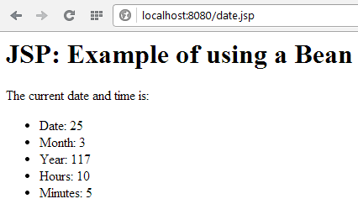

choices.jsp

<HTML>
<BODY BGCOLOR="WHITE">
<FORM ACTION="choices.jsp">
<INPUT type="checkbox" name="music" value="Classical"> Classical<BR>
<INPUT type="checkbox" name="music" value="Rock"> Rock<BR>
<INPUT type="checkbox" name="music" value="Jazz"> Jazz<BR>
<INPUT type="checkbox" name="music" value="Blues"> Blues<BR>
<INPUT type="checkbox" name="music" value="DC-GoGo"> DC GoGo<BR>
<INPUT type="submit" value="Submit">
</FORM>
<%
String[] selected = request.getParameterValues("music");

if (selected != null && selected.length != 0) {
%>
You like the following kinds of music:
<UL>
<%
for (int i = 0; i < selected.length; i++) {
out.println("<LI>" + selected[i]);
}
%>
<UL>
<% } %>
</BODY>
</HTML>

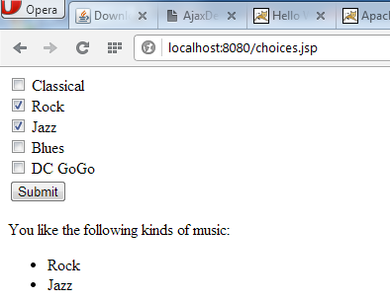

indexes.html and formAction.jsp

<HTML>
<HEAD>
<TITLE>Submitting Radio Buttons</TITLE>
</HEAD>

<BODY>
<H1>Submitting Radio Buttons</H1>
<FORM ACTION="formAction.jsp" METHOD="post">
<INPUT TYPE="radio" NAME="radios" VALUE="radio1" CHECKED>
Radio Button 1
<BR>
<INPUT TYPE="radio" NAME="radios" VALUE="radio2">
Radio Button 2
<BR>
<INPUT TYPE="radio" NAME="radios" VALUE="radio3">
Radio Button 3
<BR>
<INPUT TYPE="submit" VALUE="Submit">
</FORM>
</BODY>
</HTML>

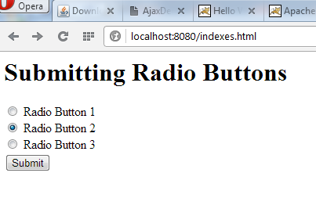

<HTML>
<HEAD>
<TITLE>Reading Radio Buttons</TITLE>
</HEAD>

<BODY>
<H1>Reading Radio Buttons</H1>
<%
if(request.getParameter("radios") != null) {
if(request.getParameter("radios").equals("radio1")) {
out.println("Radio button 1 was selected.<BR>");
}
else {
out.println("Radio button 1 was not selected.<BR>");
}
if(request.getParameter("radios").equals("radio2")) {
out.println("Radio button 2 was selected.<BR>");
}
else {
out.println("Radio button 2 was not selected.<BR>");
}
if(request.getParameter("radios").equals("radio3")) {
out.println("Radio button 3 was selected.<BR>");
}
else {
out.println("Radio button 3 was not selected.<BR>");
}
}
%>
</BODY>
</HTML>

