import java.applet.*;
import java.awt.*;
import java.awt.event.*;

public class convert extends Applet
{
public void paint (Graphics g)
{
setBackground(Color.yellow);
g.drawString("Applet to Application",100,10);
g.drawString("Alt + f4 for close", 10, 60);
}

public static void main(String args[])
{
myframe m = new myframe();
convert c = new convert();
c.init();
m.add("Center",c);
m.show();
}
}

class myframe extends Frame
{
public myframe()
{
setTitle("Quit for Click close Button");
setSize(300,200);
//addWindowListner(new WindowAdapter());
class myWindowAdapter extends WindowAdapter
{
public void windowClosing(WindowEvent e)
{
System.exit(0);
}
}
}
}

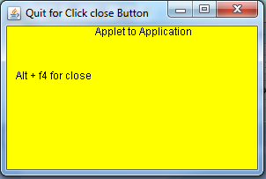

import java.awt.*;
import java.applet.*;
import java.awt.event.*;
public class student extends Frame implements ActionListener
{
String msg;
Button b1=new Button("save");
Label l11=new Label("Student details",Label.CENTER);
Label l1=new Label("Name:",Label.LEFT);
Label l2=new Label("age:",Label.LEFT);
Label l3=new Label("Sex(M/F):",Label.LEFT);
Label l4=new Label("Address:",Label.LEFT);
Label l5=new Label("Course:",Label.LEFT);
Label l6=new Label("Semester:",Label.LEFT);
Label l7=new Label("",Label.RIGHT);
TextField t1=new TextField();
Choice c1=new Choice();
CheckboxGroup cbg=new CheckboxGroup();
Checkbox ck1=new Checkbox("Male",false,cbg);
Checkbox ck2=new Checkbox("Female",false,cbg);
TextArea t2=new TextArea("",180,90,TextArea.SCROLLBARS_VERTICAL_ONLY);
Choice course=new Choice();
Choice sem=new Choice();
Choice age=new Choice();
public student()
{
addWindowListener(new myWindowAdapter());
setBackground(Color.cyan);
setForeground(Color.black);
setLayout(null);
add(l11);
add(l1);
add(l2);
add(l3);
add(l4);
add(l5);
add(l6);
add(l7);
add(t1);
add(t2);
add(ck1);
add(ck2);
add(course);
add(sem);
add(age);
add(b1);
b1.addActionListener(this);
add(b1);
course.add("BSc c.s");
course.add("BSc maths");
course.add("BSc physics");
course.add("BA English");
course.add("BCOM");
sem.add("1");
sem.add("2");
sem.add("3");
sem.add("4");
sem.add("5");
sem.add("6");
age.add("17");
age.add("18");
age.add("19");
age.add("20");
age.add("21");
l1.setBounds(25,65,90,20);
l2.setBounds(25,90,90,20);
l3.setBounds(25,120,90,20);
l4.setBounds(25,185,90,20);
l5.setBounds(25,260,90,20);
l6.setBounds(25,290,90,20);
l7.setBounds(25,260,90,20);
l11.setBounds(10,40,280,20);
t1.setBounds(120,65,170,20);
t2.setBounds(120,185,170,60);
ck1.setBounds(120,120,50,20);
ck2.setBounds(170,120,60,20);
course.setBounds(120,260,100,20);
sem.setBounds(120,290,50,20);
age.setBounds(120,90,50,20);
b1.setBounds(120,350,50,30);
}
public void paint(Graphics g)
{
g.drawString(msg,200,450);}
public void actionPerformed(ActionEvent ae)
{
if(ae.getActionCommand().equals("save"))
{msg="Student details saved!";
setForeground(Color.red);
}
}
public static void main(String g[])
{
student stu=new student();
stu.setSize(new Dimension(500,500));
stu.setTitle("student registration");
stu.setVisible(true);
}
}
class myWindowAdapter extends WindowAdapter
{
public void windowClosing(WindowEvent we)
{
System.exit(0);
}
}

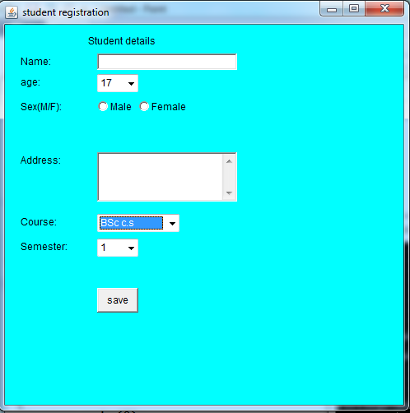

import java.awt.*;
import java.applet.*;
import java.awt.event.*;
public class myapp extends Applet
{
TextField name,pass;
Button b1,b2;
public void init()
{
Label n=new Label("Name:",Label.CENTER);
Label p=new Label("password:",Label.CENTER);
name=new TextField(20);
pass=new TextField(20);
pass.setEchoChar('$');
b1=new Button("submit");
b2=new Button("cancel");
add(n);
add(name);
add(p);
add(pass);
add(b1);
add(b2);
n.setBounds(70,90,90,60);
p.setBounds(70,130,90,60);
name.setBounds(280,100,90,20);
pass.setBounds(200,140,90,20);
b1.setBounds(100,260,70,40);
b2.setBounds(180,260,70,40);

}
public void paint(Graphics g)
{
repaint();
}
}

import java.awt.*;
import java.awt.event.*;
import java.applet.*;
public class Loginform extends Frame implements ActionListener
{
Label l1=new Label("user name");
Label l2=new Label("password");
Label l3=new Label(" ");
TextField t1=new TextField();
TextField t2=new TextField();
Button b= new Button("Submit");
public Loginform()
{
add(l1);
add(t1);
add(l2);
add(t2);
add(b);
add(l3);
l1.setBounds(20,45,70,20);
t1.setBounds(180,45,200,20);
l2.setBounds(20,95,70,20);
t2.setBounds(180,95,200,20);
b.setBounds(310,145,70,20);
b.addActionListener(this);
t2.setEchoChar('*');
addWindowListener(new mwa());
}
public void actionPerformed(ActionEvent e)
{
l3.setText("Welcome "+t1.getText());
}
public static void main(String s[])
{
Loginform l=new Loginform();
l.setSize(new Dimension(600,600));
l.setTitle("Login");
l.setVisible(true);
}
}
class mwa extends WindowAdapter
{
public mwa(){}
public void windowClosing(WindowEvent e)
{
System.exit(0);
}
}

