Government Engineering Collage, Patan,Gujarat,India

11
Light-Sensitive Alarm Project
B.E ECE 4TH SEM
Gajjar TEJAS

AIM:

- TO MAKE Light-sensitive Alarm Project USING IC Light-sensitive Alarm Project 7555 low-power timer IC

Parts Required:

- resistors: 10k, 47k, 1M ×3
- presets: 100k, 1M
- capacitors: 0.01µF, 0.1µF, 10µF 25V radial
- transistor: BC108 (or equivalent)
- 7555 low-power timer IC
- 8-pin DIL socket for IC
- LDR (light-dependant resistor) type ORP12
- bleeper 9-12V
- on/off switch
- battery clip for 9V PP3
- strip board 12 rows × 25 holes
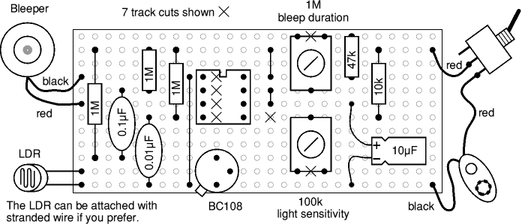
Stripboard Layout:

Circuit diagram:
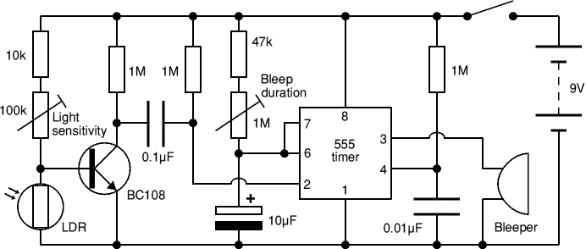

Theory:

The 8-pin 555 timer must be one of the most useful ICs ever made and it is used in many projects. With just a few external components it can be used to build many circuits, not all of them involve timing!
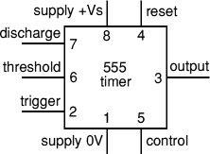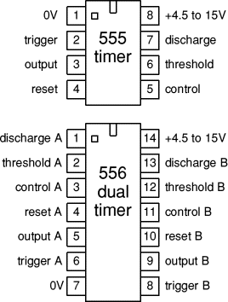

A popular version is the NE555 and this is suitable in most cases where a '555 timer' is specified. The 556 is a dual version of the 555 housed in a 14-pin package, the two timers (A and B) share the same power supply pins. The circuit diagrams on this page show a 555, but they could all be adapted to use one half of a 556.
Low power versions of the 555 are made, such as the ICM7555, but these should only be used when specified (to increase battery life) because their maximum output current of about 20mA (with a 9V supply) is too low for many standard 555 circuits. The ICM7555 has the same pin arrangement as a standard 555.
The circuit symbol for a 555 (and 556) is a box with the pins arranged to suit the circuit diagram: for example 555 pin 8 at the top for the +Vs supply, 555 pin 3 output on the right. Usually just the pin numbers are used and they are not labelled with their function.
The 555 and 556 can be used with a supply voltage (Vs) in the range 4.5 to 15V (18V absolute maximum).
Standard 555 and 556 ICs create a significant 'glitch' on the supply when their output changes state. This is rarely a problem in simple circuits with no other ICs, but in more complex circuits a smoothing capacitor (eg 100µF) should be connected across the +Vs and 0V supply near the 555 or 556.
The input and output pin functions are described briefly below and there are fuller explanations covering the various circuits:
- Astable - producing a square wave
- Monostable - producing a single pulse when triggered
- Bistable - a simple memory which can be set and reset
- Buffer - an inverting buffer (Schmitt trigger)
- Output of 555/556
- The output of a standard 555 or 556 can sink and source up to 200mA. This is more than most ICs and it is sufficient to supply many output transducers directly, including LEDs (with a resistor in series), low current lamps, piezo transducers, loudspeakers (with a capacitor in series), relay coils (with diode protection) and some motors (with diode protection). The output voltage does not quite reach 0V and +Vs, especially if a large current is flowing.
- To switch larger currents you can connect a transistor.
- The ability to both sink and source current means that two devices can be connected to the output so that one is on when the output is low and the other is on when the output is high. The top diagram shows two LEDs connected in this way. This arrangement is used in the Level Crossing project to make the red LEDs flash alternately.
- Loudspeakers

- A loudspeaker (minimum resistance 64) may be connected to the output of a 555 or 556 astable circuit but a capacitor (about 100µF) must be connected in series. The output is equivalent to a steady DC of about ½Vs combined with a square wave AC (audio) signal. The capacitor blocks the DC, but allows the AC to pass as explained in capacitor coupling.
- Piezo transducers may be connected directly to the output and do not require a capacitor in series.
- Relay coils and other inductive loads
- Like all ICs, the 555 and 556 must be protected from the brief high voltag
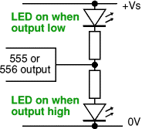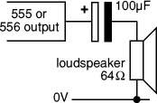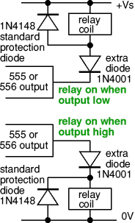

555/556 Astable
555 astable output, a square wave
(Tm and Ts may be different)
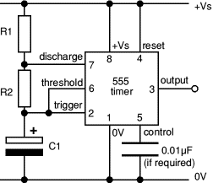
555 astable circuit
An astable circuit produces a 'square wave', this is a digital waveform with sharp transitions between low (0V) and high (+Vs). Note that the durations of the low and high states may be different. The circuit is called an astable because it is not stable in any state: the output is continually changing between 'low' and 'high'.
The time period (T) of the square wave is the time for one complete cycle, but it is usually better to consider frequency (f) which is the number of cycles per second.
T = 0.7 × (R1 + 2R2) × C1 and f = | 1.4
 | (R1 + 2R2) × C1
T = time period in seconds (s)
f = frequency in hertz (Hz)
R1 = resistance in ohms ()
R2 = resistance in ohms ()
C1 = capacitance in farads (F)
The time period can be split into two parts: T = Tm + Ts
Mark time (output high): Tm = 0.7 × (R1 + R2) × C1
Space time (output low): Ts = 0.7 × R2 × C1
Many circuits require Tm and Ts to be almost equal; this is achieved if R2 is much larger than R1.
For a standard astable circuit Tm cannot be less than Ts, but this is not too restricting because the output can both sink and source current. For example an LED can be made to flash briefly with long gaps by connecting it (with its resistor) between +Vs and the output. This way the LED is on during Ts, so brief flashes are achieved with R1 larger than R2, making Ts short and Tm long. If Tm must be less than Ts a diode can be added to the circuit as explained under duty cycle below.
Choosing R1, R2 and C1
555 astable frequencies
C1 | R2 = 10k  R1 = 1k | R2 = 100k  R1 = 10k | R2 = 1M  R1 = 100k
0.001µF | 68kHz | 6.8kHz | 680Hz
0.01µF | 6.8kHz | 680Hz | 68Hz
0.1µF | 680Hz | 68Hz | 6.8Hz
1µF | 68Hz | 6.8Hz | 0.68Hz
10µF | 6.8Hz | 0.68Hz  (41 per min.) | 0.068Hz  (4 per min.)
R1 and R2 should be in the range 1k to 1M. It is best to choose C1 first because capacitors are available in just a few values.
- Choose C1 to suit the frequency range you require (use the table as a guide).
- Choose R2 to give the frequency (f) you require. Assume that R1 is much smaller than R2 (so that Tm and Ts are almost equal), then you can use:
R2 = | 0.7
 | f × C1
- Choose R1 to be about a tenth of R2 (1k min.) unless you want the mark time Tm to be significantly longer than the space time Ts.
- If you wish to use a variable resistor it is best to make it R2.
- If R1 is variable it must have a fixed resistor of at least 1k in series
(this is not required for R2 if it is variable).

Astable operation
With the output high (+Vs) the capacitor C1 is charged by current flowing through R1 and R2. The threshold and trigger inputs monitor the capacitor voltage and when it reaches ²/₃Vs (threshold voltage) the output becomes low and the discharge pin is connected to 0V.
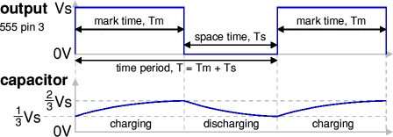
The capacitor now discharges with current flowing through R2 into the discharge pin. When the voltage falls to ¹/₃Vs (trigger voltage) the output becomes high again and the discharge pin is disconnected, allowing the capacitor to start charging again.
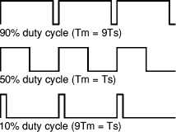
This cycle repeats continuously unless the reset input is connected to 0V which forces the output low while reset is 0V.
An astable can be used to provide the clock signal for circuits such as counters.
A low frequency astable (< 10Hz) can be used to flash an LED on and off, higher frequency flashes are too fast to be seen clearly. Driving a loudspeaker or piezo transducer with a low frequency of less than 20Hz will produce a series of 'clicks' (one for each low/high transition) and this can be used to make a simple metronome.
An audio frequency astable (20Hz to 20kHz) can be used to produce a sound from a loudspeaker or piezo transducer. The sound is suitable for buzzes and beeps. The natural (resonant) frequency of most piezo transducers is about 3kHz and this will make them produce a particularly loud sound.

Duty cycle
The duty cycle of an astable circuit is the proportion of the complete cycle for which the output is high (the mark time). It is usually given as a percentage.
For a standard 555/556 astable circuit the mark time (Tm) must be greater than the space time (Ts), so the duty cycle must be at least 50%:
Duty cycle = | Tm | = | R1 + R2
 | Tm + Ts |  | R1 + 2R2

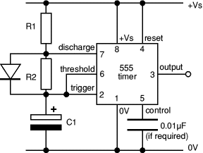
555 astable circuit with diode across R2
To achieve a duty cycle of less than 50% a diode can be added in parallel with R2 as shown in the diagram. This bypasses R2 during the charging (mark) part of the cycle so that Tm depends only on R1 and C1:
Tm = 0.7 × R1 × C1 (ignoring 0.7V across diode)
Ts = 0.7 × R2 × C1 (unchanged)
Duty cycle with diode = | Tm | = | R1
 | Tm + Ts |  | R1 + R2
Use a signal diode such as 1N4148.

Example projects using 555 astable: Flashing LED | Dummy Alarm | Heart-shaped Badge | 'Random' Flasher

Top of page | Inputs | Output | Astable | Duty Cycle | Monostable | Edge-trigger | Bistable | Buffer

555/556 Monostable
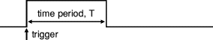
555 monostable output, a single pulse
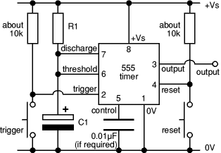
555 monostable circuit with manual trigger
A monostable circuit produces a single output pulse when triggered. It is called a monostable because it is stable in just one state: 'output low'. The 'output high' state is temporary.
The duration of the pulse is called the time period (T) and this is determined by resistor R1 and capacitor C1:
time period, T = 1.1 × R1 × C1
T = time period in seconds (s)
R1 = resistance in ohms ()
C1 = capacitance in farads (F)
The maximum reliable time period is about 10 minutes.
Why 1.1? The capacitor charges to ²/₃ = 67% so it is a bit longer than the time constant (R1 × C1) which is the time taken to charge to 63%.
- Choose C1 first (there are relatively few values available).
- Choose R1 to give the time period you need. R1 should be in the range 1k to 1M, so use a fixed resistor of at least 1k in series if R1 is variable.
- Beware that electrolytic capacitor values are not accurate, errors of at least 20% are common.
- Beware that electrolytic capacitors leak charge which substantially increases the time period if you are using a high value resistor - use the formula as only a very rough guide!
For example the Timer Project should have a maximum time period of 266s (about 4½ minutes), but many electrolytic capacitors extend this to about 10 minutes!

Monostable operation
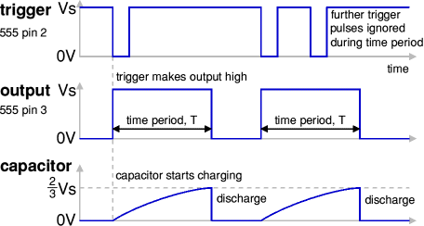
The timing period is triggered (started) when the trigger input (555 pin 2) is less than ¹/₃ Vs, this makes the output high (+Vs) and the capacitor C1 starts to charge through resistor R1. Once the time period has started further trigger pulses are ignored.
The threshold input (555 pin 6) monitors the voltage across C1 and when this reaches ²/₃ Vs the time period is over and the output becomes low. At the same time discharge (555 pin 7) is connected to 0V, discharging the capacitor ready for the next trigger.
The reset input (555 pin 4) overrides all other inputs and the timing may be cancelled at any time by connecting reset to 0V, this instantly makes the output low and discharges the capacitor. If the reset function is not required the reset pin should be connected to +Vs.
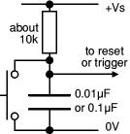
Power-on reset or
trigger circuit

Power-on reset or trigger
It may be useful to ensure that a monostable circuit is reset or triggered automatically when the power supply is connected or switched on. This is achieved by using a capacitor instead of (or in addition to) a push switch as shown in the diagram.
The capacitor takes a short time to charge, briefly holding the input close to 0V when the circuit is switched on. A switch may be connected in parallel with the capacitor if manual operation is also required.
This arrangement is used for the trigger in the Timer Project.

Edge-triggering
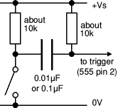
edge-triggering circuit
If the trigger input is still less than ¹/₃ Vs at the end of the time period the output will remain high until the trigger is greater than ¹/₃ Vs. This situation can occur if the input signal is from an on-off switch or sensor.
The monostable can be made edge triggered, responding only to changes of an input signal, by connecting the trigger signal through a capacitor to the trigger input. The capacitor passes sudden changes (AC) but blocks a constant (DC) signal. For further information please see the page on capacitance. The circuit is 'negative edge triggered' because it responds to a sudden fall in the input signal.
The resistor between the trigger (555 pin 2) and +Vs ensures that the trigger is normally high (+Vs).

555/556 Bistable (flip-flop) - a memory circuit
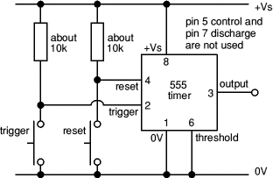
555 bistable circuit
The circuit is called a bistable because it is stable in two states: output high and output low. It is also known as a 'flip-flop'.
It has two inputs:
- Trigger (555 pin 2) makes the output high.
Trigger is 'active low', it functions when < ¹/₃ Vs.
- Reset (555 pin 4) makes the output low.
Reset is 'active low', it resets when < 0.7V.
The power-on reset, power-on trigger and edge-triggering circuits can all be used as described above for the monostable.

555/556 Inverting Buffer (Schmitt trigger) or NOT gate
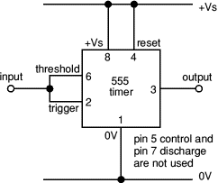
555 inverting buffer circuit
(a NOT gate)
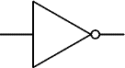
NOT gate symbol
The buffer circuit's input has a very high impedance (about 1M) so it requires only a few µA, but the output can sink or source up to 200mA. This enables a high impedance signal source (such as an LDR) to switch a low impedance output transducer (such as a lamp).
It is an inverting buffer or NOT gate because the output logic state (low/high) is the inverse of the input state:
- Input low (< ¹/₃ Vs) makes output high, +Vs
- Input high (> ²/₃ Vs) makes output low, 0V
When the input voltage is between ¹/₃ and ²/₃ Vs the output remains in its present state. This intermediate input region is a deadspace where there is no response, a property called hysteresis, it is like backlash in a mechanical linkage. This type of circuit is called a Schmitt trigger.
If high sensitivity is required the hysteresis is a problem, but in many circuits it is a helpful property. It gives the input a high immunity to noise because once the circuit output has switched high or low the input must change back by at least ¹/₃ Vs to make the output switch back.

Sign of Teacher

