Fall 2020
Course Instructor: FARHAN KHALID
Department of Electrical Engineering and Technology
Government College University Faisalabad
Course File
EET-505 Industrial Drives & PLC

COURSE FILE
Department | Electrical Engineering and Technology | Program | BSc Electrical Engineering Technology
Course Title | Industrial Drives & PLC | Course Code | EET-505
Session | 2018-2022 | Semester | 5th
Pre-Requisites | Industrial Electronics, Electrical Machines | Credit Hours | 3 ( 2-1)
Course Instructor | Engr. Farhan Khalid | Course Lab Engineer | Engr. Farhan Khalid

Table of Contents
1. Outcome Based Education Course Outline 1
1.1 Assigned Program Learning Outcomes 1
1.2 Course Learning Outcomes 2
1.3 CLO-PLO Mapping 2
1.4 Course Material 2
2. Assessment Criteria 3
2.1 Course Assessment Breakdown 3
2.2 CLO to PLO Weighted Contributions 3
3. Weekly Course Plan 4
4. Lecture-Wise Topic Breakdown 4
5. Timetable 6
6.Lab Work: 6
6.1 List of Experiments 6
6.2 Marking Rubric 6
7. Quiz 7
7.1 Quiz 1 7
7.1.1 Question Paper 7
7.1.2 Solution 7
7.1.3 Student Response Samples 7
7.2 Quiz 2 7
7.2.1 Question Paper 7
7.2.2 Solution 7
7.2.3 Student Response Samples 7
8. Assignment 8
8.1 Assignment 1 8
8.1.1 Question Paper 8
8.1.2 Solution 8
8.1.3 Student Response Samples 8
8.2 Assignment 2 8
8.2.1 Question Paper 8
8.2.2 Solution 9
8.2.3 Student Response Samples 9
9. Exams 9
9.1 Mid Exam 9
9.1.1 Question Paper 9
9.1.2 Solution 9
9.1.3 Student Response Samples 9
9.2 Final Exam 10
9.2.1 Question Paper 10
9.2.2 Solution 10
9.2.3 Student Response Samples 10
10. Student Attendance 10
11. OBE-based Aggregate Award Sheet 11
12. Course Completion Certificate 11
ANNEXTURE 12
A. Program Learning Outcomes Formulation 12
B. Course/Program Learning Outcome Domains and Taxonomy levels 13
Cognitive Domain (Bloom’s Revised Taxonomy): 13
Psychomotor Domain (Bloom’s Revised Taxonomy): 14
AFFECTIVE Domain (Bloom’s Revised Taxonomy): 16

1. Outcome Based Education Course Outline

1.1 Assigned Program Learning Outcomes

Check List Sr#  1. | Course Objective/s | - To teach basics of PLC & to program it to develop various electrical systems.  - To provide basic understanding of Motor Drives & Torque-Speed Characteristics with different types of load.

Check List Sr# | PLO No | Assigned Program Learning Outcome (PLO) | Domain and Level | Tool
2. | 1 | Engineering Knowledge: An ability to apply knowledge of mathematics, science and engineering fundamentals and an engineering specialization to the solution of complex engineering problems. | C3, P3 | A, Q, M, F, Lab
2. | 2 | Program Analysis: To analysis of different industrial automation processes, challenges faced in working & maintenance of automatic systems. | C3,P3 | A,Q,M,P
2. | 5 | Modern Tool Usage: An ability to create, select and apply appropriate techniques, resources, and modern engineering and IT tools, including prediction and modeling, to complex engineering activities, with an understanding of the limitations. | A3 | Lab
NOTE:
Domain: C = Cognitive, P = Psychomotor, A = Affective.
Assessment Tool: A = Assignment, Q = Quiz, M = Midterm, F = Final, P = Presentation, Laboratory = Lab, CEP = Complex Engineering Problem.

1.2 Course Learning Outcomes
Check List Sr# | CLO No | Course Learning Outcome (CLO) Statements | CLO Domain | Mapped PLO | Tool
3. | CLO-1 | Apply & Learn Fundamental knowledge of Industrial drives & basic tools of Programmable logic controller. | C3  (Applying) | PLO 1 | A1, Q1, Q2, M, F
3. | CLO-2 | Apply knowledge to design basic engineering systems using programming language (ladder logic) & working of motor drives | C3  (Applying) | PLO 1 | A2, F
3. | CLO-3 | Apply procedural knowledge of different control systems & interfacing of different tools to PLC & motor drives. | P3  (Guided Response) | PLO 5 | Lab
3. | CLO-4 | Illustrate knowledge of programming tools investigate to implement circuits using simatic manager. | P3  (Guided Response) | PLO 5 | Lab
3. | CLO-5 | Effectively Demonstrate / Report the performed activity/activities | A3  (Valuing) | PLO 10 | Lab
NOTE:
Domain: C = Cognitive, P = Psychomotor, A = Affective.
Assessment Tool: A = Assignment, Q = Quiz, M = Midterm, F = Final, P = Presentation, Laboratory = Lab, CEP = Complex Engineering Problem.

1.4 Course Material
Text Book 1  (TB1) | Title | Electrical Motor & Drives
Text Book 1  (TB1) | Author | Austin Hughes
Text Book 1  (TB1) | Publisher | Elsevier Ltd
Text Book 2  (TB2) | Title | Programmable Logic Controller
Text Book 2  (TB2) | Author | W. Bolton
Text Book 2  (TB2) | Publisher | Elsevier Newnes
Reference Book 2  (RB2) | Title | Siemens & Mitsubishi PLC Manuals
Reference Book 2  (RB2) | Author
Reference Book 2  (RB2) | Publisher | Siemens, Mitsubhishi

2. Assessment Criteria

2.1 Course Assessment Breakdown

CLOs | CLO Activity weights
CLOs | Theory (60 Marks) |  |  |  |  | Practical (20 Marks)
CLOs | Sessionals (20%) |  |  | Midterm Exam (30%) | Final Exam (50%) | Lab Performance (60%) | Lab Report (10%) | Viva/ CEA (30%)
CLOs | Presentations | Quizzes | Assignments
 | 2 | 2 | 4 | 12 | 20 | 12 | 2 | 6
NOTE:
The corresponding weights of every activity/ CLO are in small brackets ‘( )’

2.2 CLO to PLO Weighted Contributions
PLOs | CLO to PLOs weighted contributions |  |  |  |  |  | PLO weightage
PLOs | CLO 1 | CLO 2 | CLO 3 | CLO 4 | CLO 5 | CLO 6 | PLO weightage
TOTAL

3. Weekly Course Plan
Check List Sr# | Week | Course Contents /Topics | Chapter | CLO & PLO Mapping
1 | 1 | Intorduction to PLC,  1.1 Controllers  1.2 Hardware  1.3 Internal architecture  1.4 PLC systems | Programmable Logic Controller  Chapter # 1 | PLO1,CLO1
2 | 2 | Intorduction to PLC,  2.1 Input devices  2.2 Output devices  2.3 Examples of applications  I/O processing  4.1 Input/output units  4.6 inputs I/O addresses | Programmable Logic Controller  Chapter # 2 & 4 | PLO1,CLO1
3 | 3 | Ladder and functional block programming  5.1 Ladder diagrams  5.2 Logic functions  5.3 Latching Multiple outputs  5.4 Entering programs  5.5 Function blocks  Programming examples  - And, OR, NAND, NOR Gates  - XOR, XNOR Gates  - Implementation of logic function on PLC | Programmable Logic Controller  Chapter # 5 | PLO2, CLO3
4 | 4 | Timers  9.1 Types of timers  9.2 Programming timers  9.3 Off-delay timers  9.4 Pulse timers  Programming examples  - Flashing of lights  - 1 way traffic light signal  - 2 ways traffic light signal  - Star to delta transformation  - Mixer unit | Programmable Logic Controller  Chapter # 9 | PLO5,CLO3
5 | 5 | Counters  10.1 Forms of counter  10.2 Programming  10.3 Up and down counting  10.4 Timers with counters  Programming examples  - Car Parking Systems  - Production Control System | Programmable Logic Controller  Chapter # 10 | PLO5,  CLO3
6 | 6 | Interfacing of PLC with Machines  - Interfaces of PLC  - HMI Systemns  - Scada Systems | Instructional Manuals of PLC | PLO5,  CLO3
7 | 7 | Mid-Term Examination |  | N/A
8 | 8 | Introduction to Motor Drives  Producing Rotation  Magnetic field and magnetic flux  Magnetic flux density  Force on a conductor  Magnetic Circuits  Magnetomotive force (MMF)  Electric circuit analogy  The air-gap  Reluctance and air-gap flux densities  Magnetic circuits in motors | Electric Motor & Drives  Chapter # 1 | PLO1,CLO1
9 | 9 | Torque Production  Magnitude of torque  The beauty of slotting  Specific Loadings and Specific Output  Specific loadings  Torque and motor volume  Specific output power – importance of speed  Energy Conversion – Motional EMF  Elementary motor – stationary conditions  Power relationships – conductor moving at constant  speed  Equivalent Circuit  Motoring condition  Behaviour with no mechanical load  Behaviour with a mechanical load | Electric Motor & Drives  Chapter # 1 | PLO1,CLO1
10 | 10 | Introduction to Electric Drives  Thyristor D.C. Drives – General  Motor operation with converter supply  Motor current waveforms  Discontinuous current  Converter output impedance: overlap  Four-quadrant operation and inversion  Single-converter reversing drives | Electric Motor & Drives  Chapter # 4 | PLO1, CLO2
11 | 11 | Control Arrangements for D.C. Drives  Current control  Torque control  Speed control  Chopper-Fed D.C. Motor Drives  Performance of chopper-fed d.c. motor drives  Torque–speed characteristics and control arrangements | Electric Motor & Drives  Chapter # 4 | PLO2,  CLO3
12 | 12 | Torque-Speed Characteristics of Mechanical Load  Constant Torque  Linearly Rising  Non Linearly Increasing  Non Linearly Decreasing  Combined Torque Speed Characteristics | Electric Motor & Drives  Chapter # 4 | PLO2,CLO3
13 | 13 | Inverter Fed Induction Motor Drives  Torque-Speed characteristics  Limitations imposed by the inverter –  Constant power and constant torque regions  Limitations imposed by motor | Electric Motor & Drives  Chapter # 8 | PLO2,CLO2
14 | 14 | Control Arrangements for inverter Fed-Drives  Open Loop Speed-Control  Closed loop speed-Control  1.Current Limit Control  2. Closed loop Torque Control  3.Closed loop Speed Control | Electric Motor & Drives  Chapter # 8 | PLO2,CLO3
15 | 15 | Motor/Drive Selection  Load Requirements – Torque Vs Speed characteristics  Constant torque load  Fan & Pump Load  Inertia Matching | Electric Motor & Drives  Chapter # 11 | PLO2,CLO2
16 | 16 | General Application Considerations  Regenerative operation and braking  Duty cycle and rating  Enclosures and cooling | Electric Motor & Drives  Chapter # 11 | PLO2,CLO2
 |  |  |  | N/A

4. Lecture-Wise Topic Breakdown

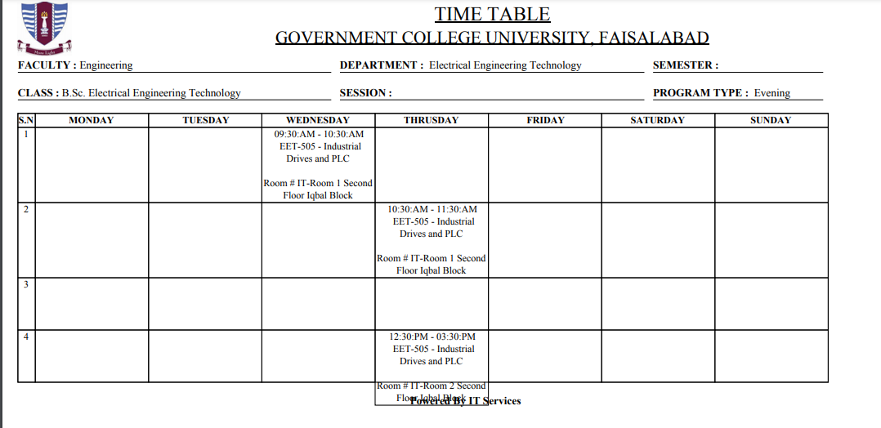
5. Timetable

6.Lab Work:

6.1 List of Experiments
Check List Sr# | Week# | LAB Experiment Description | CLO | PLO
8. | 1. | On – Off operation of plc
8. | 2. | performing of and ,or operation on plc
8. | 3. | performing of and –or operation on plc
8. | 4. | performing of and-or, or-and operation on plc
8. | 5. | performing of pulse timer operation on plc.  (flashing of light)
8. | 6. | performing of trafic light , mixer system on plc
8. | 7. | performing on-delay, off delay operation on plc
8. | 8. | performing of count up, count down, count up/down operation on plc
8. | 9. | performing of flip flop operation on plc
8. | 10. | performing of motor speed control operation on plc
8. | 11.
8. | 12.
8. | 13.
8. | 14.
8. | 15.
8. | 16.
8. | Evaluation of Complex Engineering Activity

6.2 Marking Rubric

- Lab Participation / Attendance
- Lab Report
Attached with file
- Semester Project
- Final Viva

7. Quiz

7.1 Quiz 1

7.1.1 Question Paper

7.1.2 Solution

7.1.3 Student Response Samples

BEST RESPONSE

AVERAGE RESPONSE

WORST RESPONSE

8. Assignment

8.1 Assignment 1

8.1.1 Question Paper

8.1.2 Solution

8.1.3 Student Response Samples

BEST RESPONSE

AVERAGE RESPONSE

WORST RESPONSE

8.2 Assignment 2

8.2.1 Question Paper

8.2.2 Solution

8.2.3 Student Response Samples

BEST RESPONSE

AVERAGE RESPONSE

WORST RESPONSE

9. Exams

9.1 Mid Exam

9.1.1 Question Paper

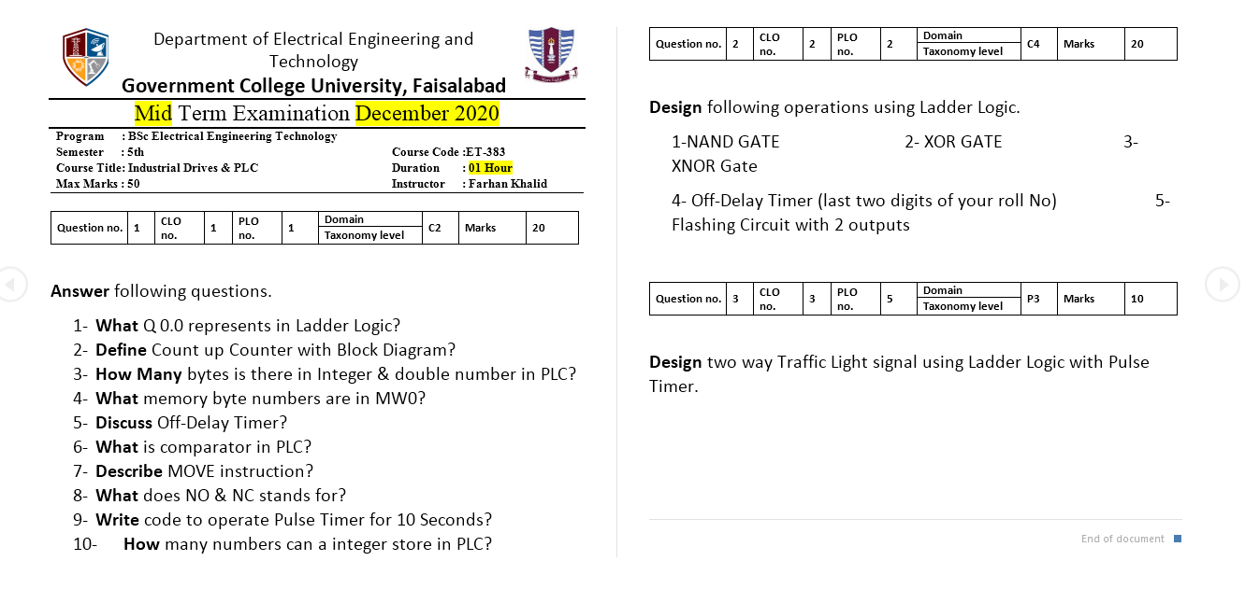

9.1.2 Solution

9.1.3 Student Response Samples

BEST RESPONSE

AVERAGE RESPONSE

WORST RESPONSE

9.2 Final Exam

9.2.1 Question Paper

100 MCQS with solution have been uploaded in GCUF website.

9.2.2 Solution

9.2.3 Student Response Samples

BEST RESPONSE
Conducted online in GCUF portal
AVERAGE RESPONSE
Conducted online in GCUF portal

WORST RESPONSE
Conducted online in GCUF portal

10. Student Attendance

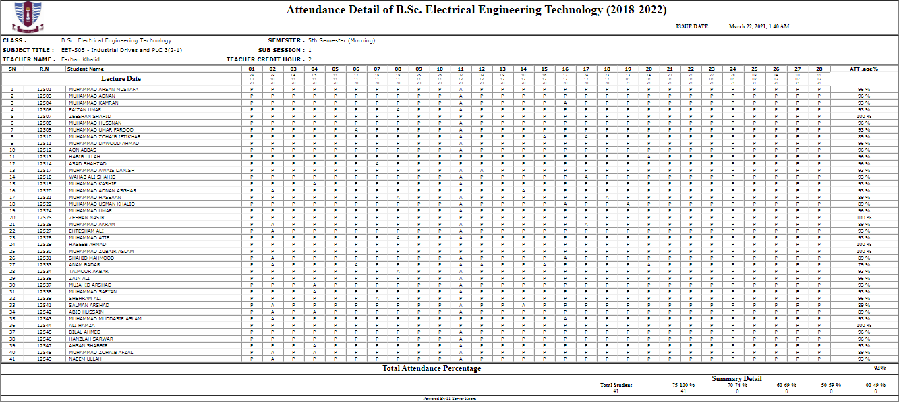

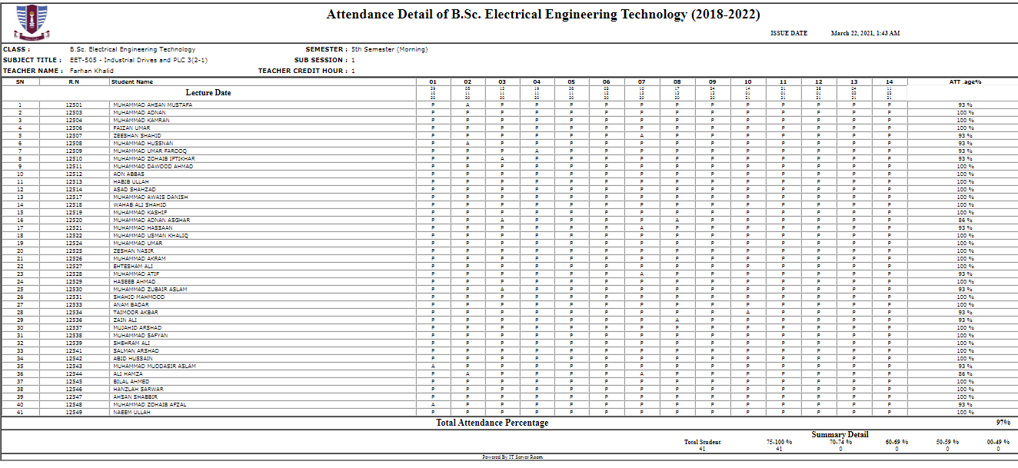

11. OBE-based Aggregate Award Sheet

12. Course Completion Certificate

ANNEXTURE

A. Program Learning Outcomes Formulation
PLO-01: Engineering Knowledge: An ability to apply knowledge of mathematics, science and engineering fundamentals and an engineering specialization to the solution of complex engineering problems.
PLO-02: Problem Analysis: An ability to identify, formulate, research literature, and analyze complex engineering problems reaching substantiated conclusions using first principles of mathematics, natural sciences and engineering sciences.
PLO-03: Design/Development of Solutions: An ability to design solutions for complex engineering problems and design systems, components, or processes that meet specified needs with appropriate consideration for public health and safety, cultural, societal, and environmental considerations.
PLO-04: Investigation: An ability to investigate complex engineering problems in a methodical way including literature survey, design and conduct of experiments, analysis and interpretation of experimental data, and synthesis of information to derive valid conclusions.
PLO-05: Modern Tool Usage: An ability to create, select and apply appropriate techniques, resources, and modern engineering and IT tools, including prediction and modeling, to complex engineering activities, with an understanding of the limitations.
PLO-06: The Engineer and Society: An ability to apply reasoning informed by contextual knowledge to assess societal, health, safety, legal and cultural issues and the consequent responsibilities relevant to professional engineering practice and solution to complex engineering problems.
PLO-07: Environment and Sustainability: An ability to understand the impact of professional engineering solutions in societal and environmental contexts and demonstrate knowledge of and need for sustainable development.
PLO-08: Ethics: Apply ethical principles and commit to professional ethics and responsibilities and norms of engineering practice.
PLO-09: Individual and Team Work: An ability to work effectively, as an individual or in a team, on multifaceted and/or multidisciplinary settings.
PLO-10: Communication: An ability to communicate effectively, orally as well as in writing on complex engineering activities with the engineering community and with society at large, such as being able to comprehend and write effective reports and design documentations, make effective presentations, and give and receive clear instructions.
PLO-11: Project Management: An ability to demonstrate management skills and apply engineering principles to one’s own work, as a member and/or leader in a team to manage projects in a multidisciplinary environment.
PLO-12: Lifelong Learning: An ability to recognize importance of, and pursue lifelong learning in the broader context of innovation and technological developments.

B. Course/Program Learning Outcome Domains and Taxonomy levels
It has three domains as given below:

Cognitive Domain (Bloom’s Revised Taxonomy):
Lorin Anderson, a former student of Bloom, revisited the cognitive domain in the learning taxonomy in the mid-nineties and made some changes, with perhaps the two most prominent ones being, 1) changing the names in the six categories from noun to verb forms, and 2) slightly rearranging them (Anderson, Krathwohl, Airasian, Cruikshank, Mayer, Pintrich, Raths, Wittrock, 2000; Pohl, 2000). This new taxonomy reflects a more active form of thinking and is perhaps more accurate:
Level | Category | Examples | Key Words [Verbs]
C1 | Remembering: Recall previous learned information. | Recite a policy. Quote prices from memory to a customer. Knows the safety rules. | Defines, describes, identifies, knows, labels, lists, matches, names, outlines, recalls, recognizes, reproduces, selects, states.
C2 | Understanding: Comprehending the meaning, translation, interpolation, and interpretation of instructions and problems. State a problem in one's own words. | Rewrites the principles of test writing. Explain in one's own words the steps for performing a complex task. Translates an equation into a computer spreadsheet. | Comprehends, converts, defends, distinguishes, estimates, explains, extends, generalizes, gives an example, infers, interprets, paraphrases, predicts, rewrites, summarizes, translates.
C3 | Applying: Use a concept in a new situation or unprompted use of an abstraction. Applies what was learned in the classroom into novel situations in the work place. | Use a manual to calculate an employee's vacation time. Apply laws of statistics to evaluate the reliability of a written test. | Applies, changes, computes, constructs, demonstrates, discovers, manipulates, modifies, operates, predicts, prepares, produces, relates, shows, solves, uses.
C4 | Analyzing: Separates material or concepts into component parts so that its organizational structure may be understood. Distinguishes between facts and inferences. | Troubleshoot a piece of equipment by using logical deduction. Recognize logical fallacies in reasoning. Gathers information from a department and selects the required tasks for training. | Analyzes, breaks down, compares, contrasts, diagrams, deconstructs, differentiates, discriminates, distinguishes, identifies, illustrates, infers, outlines, relates, selects, separates.
C5 | Evaluating: Make judgments about the value of ideas or materials. | Select the most effective solution. Hire the most qualified candidate. Explain and justify a new budget. | Appraises, compares, concludes, contrasts, criticizes, critiques, defends, describes, discriminates, evaluates, explains, interprets, justifies, relates, summarizes, supports.
C6 | Creating: Builds a structure or pattern from diverse elements. Put parts together to form a whole, with emphasis on creating a new meaning or structure. | Write a company operations or process manual. Design a machine to perform a specific task. Integrates training from several sources to solve a problem. Revises and process to improve the outcome. | Categorizes, combines, compiles, composes, creates, devises, designs, explains, generates, modifies, organizes, plans, rearranges, reconstructs, relates, reorganizes, revises, rewrites, summarizes, tells, writes.

Psychomotor Domain (Bloom’s Revised Taxonomy):
The psychomotor domain includes physical movement, coordination, and use of the motor-skill areas. Development of these skills requires practice and is measured in terms of speed, precision, distance, procedures, or techniques in execution. The seven major categories are listed from the simplest behavior to the most complex: [The Simpson’s and Harrow’s psychomotor domains are especially useful for the development of children and young people, and for developing skills in adults that take people out of their comfort zones like] .
Levels | Category | Examples | Key Words [Verbs]
P1 | Perception (awareness): The ability to use sensory cues to guide motor activity. This ranges from sensory stimulation, through cue selection, to translation. | Detects non-verbal communication cues. Estimate where a ball will land after it is thrown and then moving to the correct location to catch the ball. Adjusts heat of stove to correct temperature by smell and taste of food. Adjusts the height of the forks on a forklift by comparing where the forks are in relation to the pallet. | Chooses, describes, detects, differentiates, distinguishes, identifies, isolates, relates, selects.
P2 | Set: Readiness to act. It includes mental, physical, and emotional sets. These three sets are dispositions that predetermine a person's response to different situations (sometimes called mindsets). | Knows and acts upon a sequence of steps in a manufacturing process. Recognize one's abilities and limitations. Shows desire to learn a new process (motivation). NOTE: This subdivision of Psychomotor is closely related with the “Responding to phenomena” subdivision of the Affective domain. | Begins, displays, explains, moves, proceeds, reacts, shows, states, volunteers.
P3 | Guided Response: The early stages in learning a complex skill that includes imitation and trial and error. Adequacy of performance is achieved by practicing. | Performs a mathematical equation as demonstrated. Follows instructions to build a model. Responds hand-signals of instructor while learning to operate a forklift. | Copies, traces, follows, react, reproduce, responds.
P4 | Mechanism (basic proficiency): This is the intermediate stage in learning a complex skill. Learned responses have become habitual and the movements can be performed with some confidence and proficiency. | Use a personal computer. Repair a leaking faucet. Drive a car. | Assembles, calibrates, constructs, dismantles, displays, fastens, fixes, grinds, heats, manipulates, measures, mends, mixes, organizes, sketches.
P5 | Complex Overt Response (Expert): The skillful performance of motor acts that involve complex movement patterns. Proficiency is indicated by a quick, accurate, and highly coordinated performance, requiring a minimum of energy. This category includes performing without hesitation, and automatic performance. For example, players are often utter sounds of satisfaction or expletives as soon as they hit a tennis ball or throw a football, because they can tell by the feel of the act what the result will produce. | Maneuvers a car into a tight parallel parking spot. Operates a computer quickly and accurately. Displays competence while playing the piano. | Assembles, builds, calibrates, constructs, dismantles, displays, fastens, fixes, grinds, heats, manipulates, measures, mends, mixes, organizes, sketches. NOTE: The Key Words are the same as Mechanism, but will have adverbs or adjectives that indicate that the performance is quicker, better, more accurate, etc.
P6 | Adaptation: Skills are well developed and the individual can modify movement patterns to fit special requirements. | Responds effectively to unexpected experiences. Modifies instruction to meet the needs of the learners. Perform a task with a machine that it was not originally intended to do (machine is not damaged and there is no danger in performing the new task). | Adapts, alters, changes, rearranges, reorganizes, revises, varies.
P7 | Origination: Creating new movement patterns to fit a particular situation or specific problem. Learning outcomes emphasize creativity based upon highly developed skills. | Constructs a new theory. Develops a new and comprehensive training programming. Creates a new gymnastic routine. | Arranges, builds, combines, composes, constructs, creates, designs, initiate, makes, originates.

AFFECTIVE Domain (Bloom’s Revised Taxonomy):
The affective domain (Krathwohl, Bloom, Masia, 1973) includes the manner in which we deal with things emotionally, such as feelings, values, appreciation, enthusiasms, motivations, and attitudes. The five major categories are listed from the simplest behavior to the most complex:
Levels | Category | Examples | Key Words [Verbs]
A1 | Receiving Phenomena: Awareness, willingness to hear, selected attention. | Listen to others with respect. Listen for and remember the name of newly introduced people. | Asks, chooses, describes, follows, gives, holds, identifies, locates, names, points to, selects, sits, erects, replies, uses.
A2 | Responding to Phenomena: Active participation on the part of the learners. Attends and reacts to a particular phenomenon. Learning outcomes may emphasize compliance in responding, willingness to respond, or satisfaction in responding (motivation). | Participates in class discussions. Gives a presentation. Questions new ideals, concepts, models, etc. in order to fully understand them. Know the safety rules and practices them. | Answers, assists, aids, complies, conforms, discusses, greets, helps, labels, performs, practices, presents, reads, recites, reports, selects, tells, writes.
A3 | Valuing: The worth or value a person attaches to a particular object, phenomenon, or behavior. This ranges from simple acceptance to the more complex state of commitment. Valuing is based on the internalization of a set of specified values, while clues to these values are expressed in the learner's overt behavior and are often identifiable. | Demonstrates belief in the democratic process. Is sensitive towards individual and cultural differences (value diversity). Shows the ability to solve problems. Proposes a plan to social improvement and follows through with commitment. Informs management on matters that one feels strongly about. | Completes, demonstrates, differentiates, explains, follows, forms, initiates, invites, joins, justifies, proposes, reads, reports, selects, shares, studies, works.
A4 | Organization: Organizes values into priorities by contrasting different values, resolving conflicts between them, and creating a unique value system. The emphasis is on comparing, relating, and synthesizing values. | Recognizes the need for balance between freedom and responsible behavior. Accepts responsibility for one's behavior. Explains the role of systematic planning in solving problems. Accepts professional ethical standards. Creates a life plan in harmony with abilities, interests, and beliefs. Prioritizes time effectively to meet the needs of the organization, family, and self. | Adheres, alters, arranges, combines, compares, completes, defends, explains, formulates, generalizes, identifies, integrates, modifies, orders, organizes, prepares, relates, synthesizes.
A5 | Internalizing values (characterization): Has a value system that controls their behavior. The behavior is pervasive, consistent, predictable, and most importantly, characteristic of the learner. Instructional objectives are concerned with the student's general patterns of adjustment (personal, social, emotional). | Shows self-reliance when working independently. Cooperates in group activities (displays teamwork). Uses an objective approach in problem solving. Displays a professional commitment to ethical practice on a daily basis. Revises judgments and changes behavior in light of new evidence. Values people for what they are, not how they look. | Acts, discriminates, displays, influences, listens, modifies, performs, practices, proposes, qualifies, questions, revises, serves, solves, verifies.

