OFLAMERON - technology for learning foreign words http://www.shmeleff.com
Print the tape with the text (text box). The student must correctly divide the tape into fragments and make of them a phrase in Spanish
por supuesto - of course
Spanish (learn)
English (native)
porsupuesto - remove spaces
tosupporues - rearrange the fragments of words
Tape for printing
tosupporues
- tape for print

You need to cut the tape into fragments, and to make a phrase “por supuesto”
cuál es tu nombre - what is your name
cuálestunombre - remove spaces
brecuálesomtun - rearrange the fragments of words
Tape for printing
brecuálesomtun

You need to cut the tape into fragments, and to make a phrase “cuál es tu nombre”
donde está la estación de tren - where is the train station
dondeestálaestacióndetren - remove spaces
trendontálaestacdeesiónde - rearrange the fragments of words
Tape for printing
trendontálaestacdeesiónde

You need to cut the tape into fragments, and to make a phrase “donde está la estación de tren”
Cuál es la especial del día? - What is today’s special?
cuáleslaespecialdeldía - remove spaces
díacuálespecialesladel - rearrange the fragments of words
Tape for printing
díacuálespecialesladel

You need to cut the tape into fragments, and to make a phrase “Cuál es la especial del día”

How to learn. Example
sageyerunenvomes
envoyer un message

Qué hora es? - What time is it?
quéhoraes - remove spaces
eshoraqué - rearrange the fragments of words
Tape for printing
eshoraqué
- tape

You need to cut the tape into fragments, and to make a phrase “Qué hora es”
dos porciones de - two portions
dosporcionesde - remove spaces
ondosesdeporci - rearrange the fragments of words
Tape for printing
ondosesdeporci

You need to cut the tape into fragments, and to make a phrase “dos porciones de”
obtener un descuento - get discount
obtenerundescuento - remove spaces
nerobteunentodescu - rearrange the fragments of words
Tape for printing
nerobteunentodescu
- tape

You need to cut the tape into fragments, and to make a phrase “obtener un descuento”
acepte el pedido - take the order
acepteelpedido - remove spaces
teeldoaceppedi - rearrange the fragments of words
Tape for printing
teeldoaceppedi

You need to cut the tape into fragments, and to make a phrase “acepte el pedido”
la dirección de destino - destination address
ladireccióndedestino - remove spaces
estinoladiónreccided - rearrange the fragments of words
Tape for printing
estinoladiónreccided
- tape

You need to cut the tape into fragments, and to make a phrase “la dirección de destino”
la recepción - reception
larecepción - remove spaces
cepónlareci - rearrange the fragments of words
Tape for printing
cepónlareci

You need to cut the tape into fragments, and to make a phrase “la recepción”
unos días - few days
unosdías - remove spaces
unoassdí - rearrange the fragments of words
Tape for printing
unoassdí
- tape

You need to cut the tape into fragments, and to make a phrase “unos días”
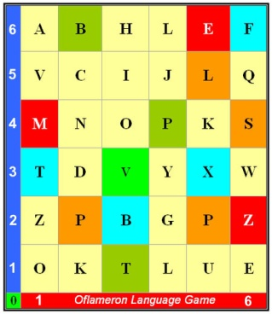 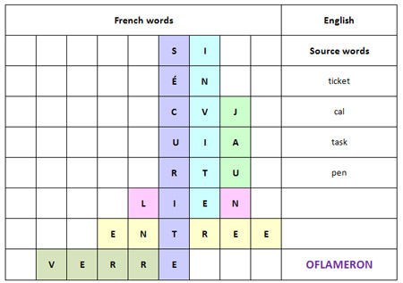 See http://www.shmeleff.com

el acceso abierto - shared
elaccesoabierto - remove spaces
ertoelaccabieso - rearrange the fragments of words
Tape for printing
ertoelaccabieso

You need to cut the tape into fragments, and to make a phrase “el acceso abierto”
el acceso está cerrado - access denied
elaccesoestácerrado - remove spaces
errelaccestácesoado - rearrange the fragments of words
Tape for printing
errelaccestácesoado

You need to cut the tape into fragments, and to make a phrase “el acceso está cerrado”

How to learn. Example 2
ntapeleapruxi
appeler un taxi

- cut the tape

- make a phrase

You need to cut the tape into fragments, and to make a phrase “appeler un taxi”
enviar equipaje - send luggage
enviarequipaje - remove spaces
uipenajeviareq - rearrange the fragments of words
Tape for printing
uipenajeviareq

You need to cut the tape into fragments, and to make a phrase “enviar equipaje”
en la calle - on the street
enlacalle - remove spaces
calenlale - rearrange the fragments of words
Tape for printing
calenlale

You need to cut the tape into fragments, and to make a phrase “en la calle”
© by Valery V Shmeleff http://www.shmeleff.com http://www.oflameron.ru
Blog http://bretell.blogspot.com/

