**OFLAMERON** - technology for learning foreign words http://www.shmeleff.com

**Print the tape with the text (text box). The student must correctly divide the tape into fragments and make of them a phrase in French**

Bien sûr - of course

*French (learn)*

*English (native)*

biensûr - *remove spaces*

bûriens - *rearrange the fragments of words*

Tape for printing

bûriens

**- tape for print**

You need to cut the tape into fragments, and to make a phrase “Bien sûr”

comment t'appelles tu - what is your name

commentt'appellestu - *remove spaces*

lestumentcomt'appel - *rearrange the fragments of words*

Tape for printing

lestumentcomt'appel

You need to cut the tape into fragments, and to make a phrase “comment t'appelles tu”

où est la gare - where is the train station

oùestlagare - *remove spaces*

laestoùgare - *rearrange the fragments of words*

Tape for printing

laestoùgare

**- tape**

You need to cut the tape into fragments, and to make a phrase “où est la gare”

Quel est le plat du jour? - What is today’s special?

quelestleplatdujour - *remove spaces*

lesquetlejourplatdu - *rearrange the fragments of words*

Tape for printing

lesquetlejourplatdu

You need to cut the tape into fragments, and to make a phrase “Quel est le plat du jour”

How to learn. **Example**

sageyerunenvomes

envoyer un message

Quelle heure est-il? - What time is it?

quelleheureest-il - *remove spaces*

stureellequhee-il - *rearrange the fragments of words*

Tape for printing

stureellequhee-il

**- tape**

You need to cut the tape into fragments, and to make a phrase “Quelle heure est-il”

Je ne me sens pas bien - I don't feel good

jenemesenspasbien - *remove spaces*

pasbinemesjeensen - *rearrange the fragments of words*

Tape for printing

pasbinemesjeensen

You need to cut the tape into fragments, and to make a phrase “Je ne me sens pas bien”

Je me sens mal - I feel sick

jemesensmal - *remove spaces*

mesjemalens - *rearrange the fragments of words*

Tape for printing

mesjemalens

**- tape**

You need to cut the tape into fragments, and to make a phrase “Je me sens mal”

Je m’appelle - My name is

jem’appelle - *remove spaces*

lem’apjepel - *rearrange the fragments of words*

Tape for printing

lem’apjepel

You need to cut the tape into fragments, and to make a phrase “Je m’appelle”

Tu viens d'où ? - Where are you from?

tuviensd'où - *remove spaces*

d'oùvietuns - *rearrange the fragments of words*

Tape for printing

d'oùvietuns

**- tape**

You need to cut the tape into fragments, and to make a phrase “Tu viens d'où”

Je reste un semaine - I am staying for one week

jeresteunsemaine - *remove spaces*

maesteujernseine - *rearrange the fragments of words*

Tape for printing

maesteujernseine

You need to cut the tape into fragments, and to make a phrase “Je reste un semaine”

Merci beaucoup - Thank you very much

mercibeaucoup - *remove spaces*

upcibecomerau - *rearrange the fragments of words*

Tape for printing

upcibecomerau

**- tape**

You need to cut the tape into fragments, and to make a phrase “Merci beaucoup”

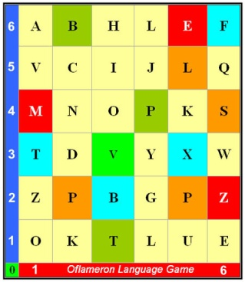 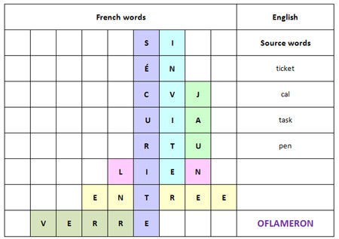 See http://www.shmeleff.com

De rien - You are welcome

derien - *remove spaces*

enderi - *rearrange the fragments of words*

Tape for printing

enderi

You need to cut the tape into fragments, and to make a phrase “De rien”

Tu comprends ? - Do you understand?

tucomprends - *remove spaces*

dsprentucom - *rearrange the fragments of words*

Tape for printing

dsprentucom

You need to cut the tape into fragments, and to make a phrase “Tu comprends”

How to learn. **Example 2**

ntapeleapruxi

appeler un taxi

**- cut the tape**

**- make a phrase**

You need to cut the tape into fragments, and to make a phrase “appeler un taxi”

Oui, je comprends - Yes, I understand

oui,jecomprends - *remove spaces*

comproui,jedsen - *rearrange the fragments of words*

Tape for printing

comproui,jedsen

You need to cut the tape into fragments, and to make a phrase “Oui, je comprends”

Je suis desolé - I am sorry

jesuisdesolé - *remove spaces*

jedesolésuis - *rearrange the fragments of words*

Tape for printing

jedesolésuis

You need to cut the tape into fragments, and to make a phrase “Je suis desolé”



© by Valery V Shmeleff <http://www.shmeleff.com> <http://www.oflameron.ru>

Blog <http://bretell.blogspot.com/>